**DBMS** **LAB**

# **Experiment-5(**Subqueries or Nested Queries)

Tamojit Sarkar

RA1811027010034

CSE-BD Sec-I2

**Aim:** Operating subqueries and nested queries

**Procedure:**

Sub Query can have more than one level of nesting in one single query. A SQL nested query is a SELECT query that is nested inside a SELECT, UPDATE, INSERT, or DELETE SQL query.

1. Select Command Is Used To Select Records From The Table.
2. Where Command Is Used To Identify Particular Elements.
3. Having Command Is Used To Identify Particular Elements.
4. Min (Sal) Command Is Used To Find Minimum Salary.

**Syntax for creating a Table:**

Sql: Create <Obj.Type> <Obj.Name> (Column Name.1 <Datatype>

(Size), Column Name.1 <Datatype> (Size) .............................);

Sql> Create Table Emp2(Empno

Number(5), Ename Varchar2(20),

Job Varchar2(20),

Sal Number(6),

Mgrno Number(4),

Deptno Number(3));

**Syntax for Inserting records into a Table:**

Sql :> Insert Into <Table Name> Values< Val1, ‘Val2’, ..); Insertion

Sql> Insert Into Emp2 Values(1001,'Mahesh','Programmer',15000,1560,200); 1 Row Created. Sql> Insert Into Emp2 Values (1002,'Manoj','Tester',12000,1560,200)

1 Row Created.

Sql> Insert Into Emp2 Values(1003,'Karthik','Programmer',13000,1400,201); 1 Row Created. Sql> Insert Into Emp2 Values(1004,'Naresh','Clerk',1400,1400,201); 1 Row Created.

Sql> Insert Into Emp2 Values(1005,'Mani','Tester',13000,1400,200); 1 Row Created.

Sql> Insert Into Emp2

Values(1006,'Viki','Designer',12500,1560,201); 1 Row Created.

Sql> Insert Into Emp2 Values(1007,'Mohan','Designer',14000,1560,201);1 Row Created. Sql> Insert Into Emp2 Values(1008,'Naveen','Creation',20000,1400,201);

1 Row Created.

Sql> Insert Into Emp2 Values(1009,'Prasad','Dir',20000,1560,202); 1 Row Created. Sql> Insert Into Emp2 Values(1010,'Agnesh','Dir',15000,1400,200); 1 Row Created.

**Syntax For Select Records From The Table:**

Sql> Select * From <Table

Name>; Sql> Select *From Emp2;

Empno Ename Job Sal Mgrno Dptno

1001 Mahesh Programmer 15000 1560 200

1002 Manoj Tester 12000 1560 200

1003 Karthik Programmer 13000 1400 201

1004 Naresh Clerk 1400 1400 201

1005 Mani Tester 13000 1400 200

1006 Viki Designer 12500 1560 201

1007 Mohan Designer 14000 1560 201

1008 Naveen Creation 20000 1400 201

1009 Prasad Dir 20000 1560 202

1010 Agnesh Dir 15000 1400 200

**Table- 2**

**Syntax For Creating A Table:**

Sql: Create <Obj.Type> <Obj.Name> (Column Name.1 <Datatype> (Size), Column Name.1 <Datatype> (Size) ……………………………); Sql> Create Table Dept2(Deptno Number(3),

Deptname Varchar2(10),

Location Varchar2(15));

Table Created.

**Syntax For Insert Records In To A Table:**

Sql :> Insert Into <Table Name> Values< Val1, ‘Val2’,…..);

**Insertion**

Sql> Insert Into Dept2 Values(107,'Develop','Adyar');

1 Row Created.

Sql> Insert Into Dept2

Values(201,'Debug','Uk'); 1 Row Created.

Sql> Insert Into Dept2 Values(200,'Test','Us');

Sql> Insert Into Dept2

Values(201,'Test','Ussr'); 1 Row Created.

Sql> Insert Into Dept2

Values(108,'Debug','Adyar'); 1 Row Created.

Sql> Insert Into Dept2

Values(109,'Build','Potheri'); 1 Row Created.

Syntax For Select Records From The

Table: Sql> Select * From <Table Name>;

Sql> Select *From Dept2;

Deptno Deptname Location

107 Develop Adyar

201 Debug Uk

200.Test Us

201.Test Ussr

108.Debug Adyar

109.Build Potheri

6 Rows Selected.

**General Syntax For Nested Query:**

Select

"Column_Name1" From

"Table_Name1"

Where "Column_Name2" [Comparison Operator] (Select "Column_Name3" From

"Table_Name2"

Where [Condition])

**Syntax Nested Query Statement:**

Sql> Select <Column_Name> From Frorm <Table _1> Where <Column_Name> <Relational _Operation> ‘Value’

(Select (Aggrecate Function) From <Table_1> Where <Column Name> =‘Value’(Select <Column_Name> From <Table_2> Where <Column_Name= ‘Value’));

**Nested Query Statement:**

Sql> Select Ename From Emp2 Where Sal>

(Select Min(Sal) From Emp2 Where

Dptno=(Select Deptno From Dept2 Where

Location='Uk'));

**Nested Query Output:**

Ename

Mahesh

Manoj

Karthik

Mani

Viki

Mohan

Naveen

Prasad

Agnesh

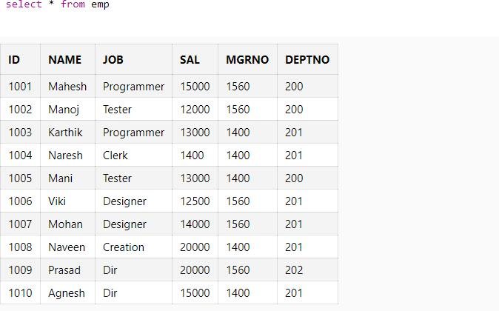

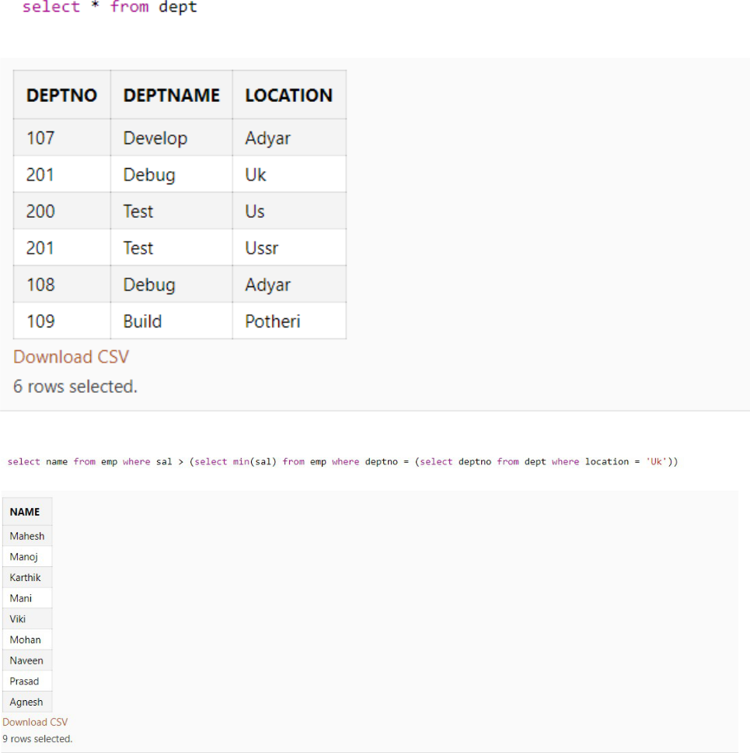

**RESULT:**

Thus the SQL sub query has been executed successfully.