**DBMS** **LAB**

**Experiment-6 (TCL Commands** )

**Tamojit Sarkar**

**RA1811027010034**

**CSE-BD Sec-I2**

**AIM:** To execute the various TCL commands on the database.

**PROCEDURE:**

1. SAVEPOINT

This command is used to identify a point in a transaction to which we can later rollback.

SQL> SAVEPOINT nameofthesavepoint;

1. COMMIT

This command is used to make all changes permanent in database and also marks the end of transaction.

SQL>COMMIT;

Always it is better to commit changes to database at regular intervals since it will help loss of data or loss of work done when computer shuts due to unavoidable reasons.

1. ROLLBACK

This SQL command is used to undo the current transaction

1. Rollback to a previous update.

SQL> ROLLBACK;

1. Rollback to any of the savepoint.

SQL> ROLLBACK TO SAVEPOINT nameofthesavepoint;’

**CODE AND OUTPUT:**

1. **COMMIT:**

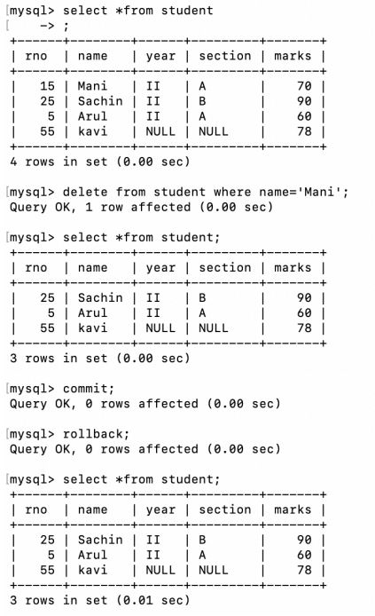

1. **ROLLBACK:**

**i)Rollback to previous update**

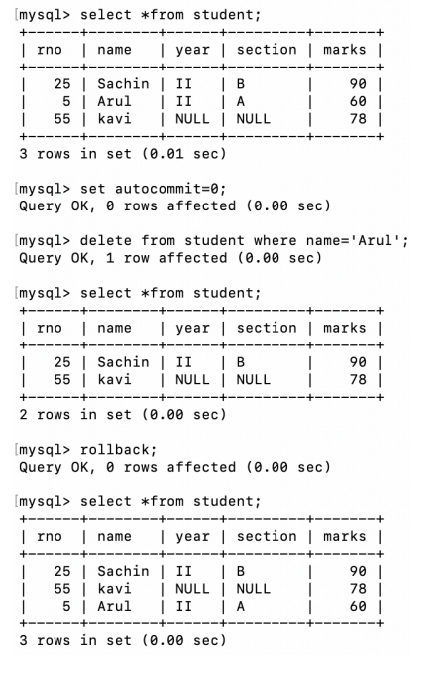

**ii) Rollback to any of the savepoint**

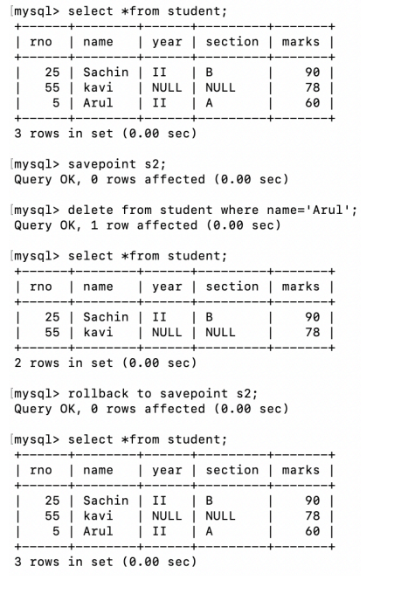

**3) SAVEPOINT:**

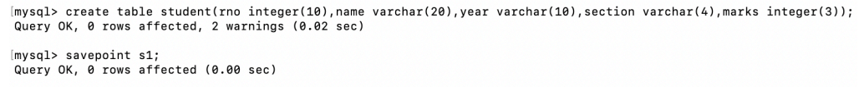

**RESULT:** Thus, the TCL commands have been executed successfully.