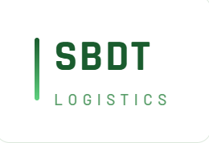 (Scan QR for Terms & Conditions) |  | LR.NO
 |  | Booking Branch |  | PickUp Date |  | Ship Date | VehicleNO
 |  |  |  |  |  |  | Survice Lane
Consigoner |  | Consignee |  |  |  |  | Dest.Pincode
 |  |  |  |  |  |  | No.OfPackages
 |  |  |  |  |  |  | Actual Weight
 |  |  |  |  |  |  | Packing Type
 |  |  |  |  |  |  | 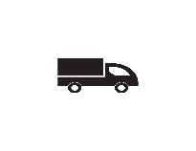
Value/NoOfInnv.₹ |  |  | Invoices:

  (Scan QR for Terms & Conditions) |  | LR.NO
 |  | Booking Branch |  | PickUp Date |  |  | Ship Date | sign | Name | Stamp | Date
Consigoner |  | Consignee
 |  |  |  |  |  |  |  | 
Value/NoOfInnv.₹ |  |  | TotalInv.Value
Innvoicelst |  |  | Total NoOfInnv
 |  |  | PKG/act.wt

  (Scan QR for Terms & Conditions) |  | LR.NO
 |  | Booking Branch |  | PickUp Date |  |  | Ship Date | sign | Name | Stamp | Date
Consigoner |  | Consignee
 |  |  |  |  |  |  |  | 
Value/NoOfInnv.₹ |  |  | TotalInv.Value
Innvoicelst |  |  | Total NoOfInnv
 |  |  | PKG/act.wt

