IST 363

Lab 10

react 1
1. 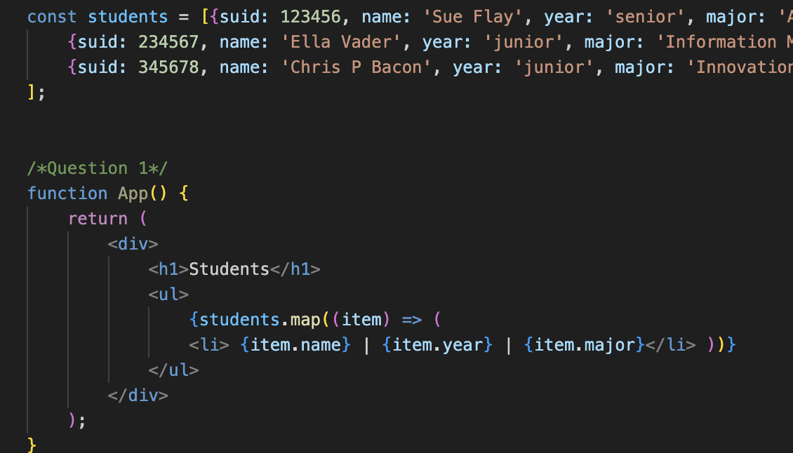
2. 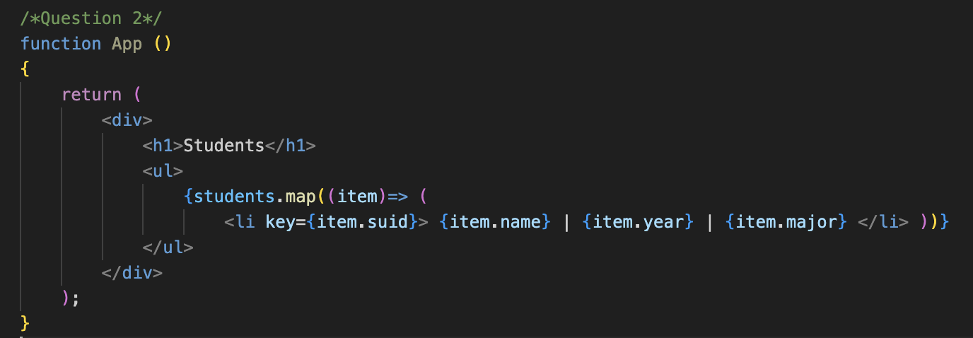
3. 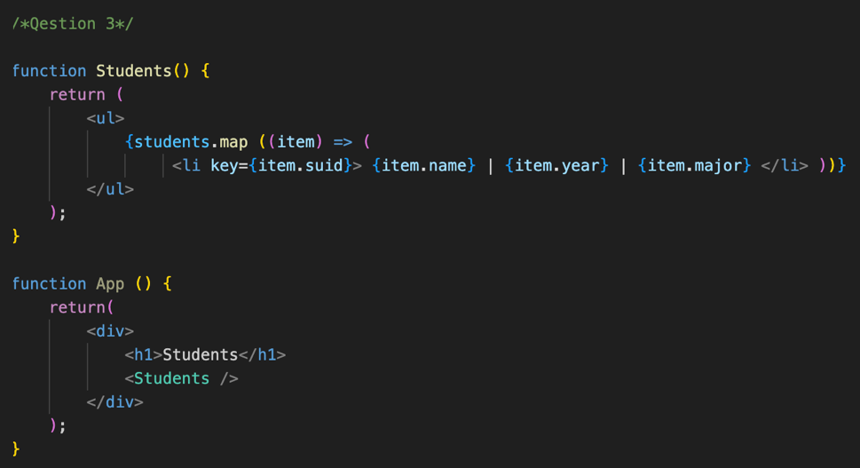
4. 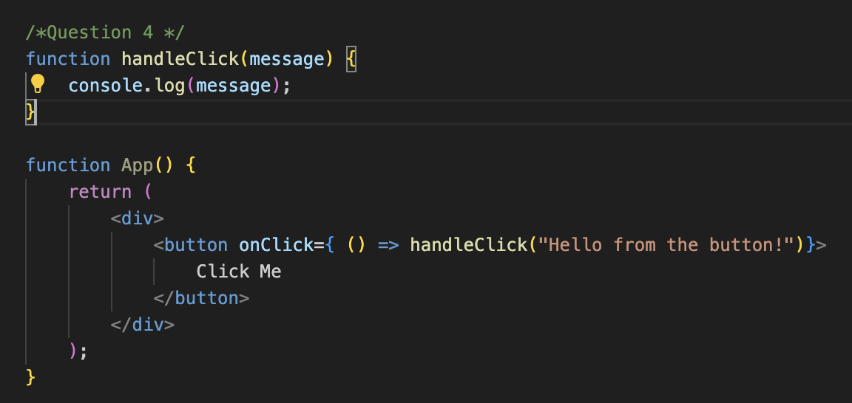
5. 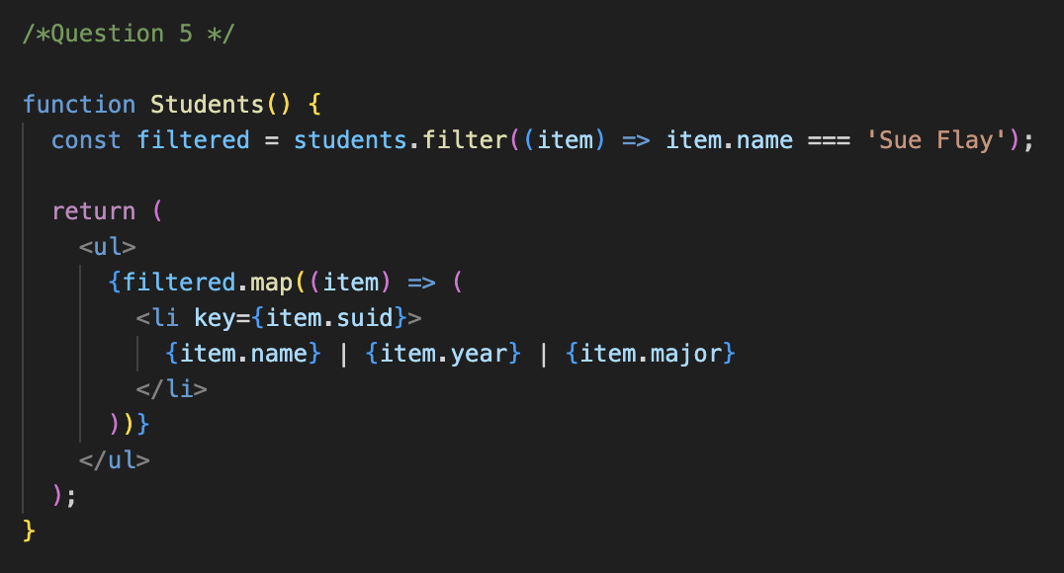
6. write brief answers to the questions below
a. They are stand alone reusable bits of code created in jsx files and the developer creates their meaning. They can be buttons, nav bars, etc. They are important because they make the coding process more efficient and cleaner by being able to reuse, customize, and test functions.
b. They use capital letters so that the code editor interface can differentiate between what is an HTML tag and what is a react name/component.
c. It is an extension similar to JavaScript but written in an HTML format using camelCase and self-closing tags have a slash.
d. Class is already a reserved keyword (pre-defined) in JavaScript.
e. You wrap the JavaScript expression in curly braces {} inside the JSX and will output the value associated with the expression.

f. Smaller components are better because they are more readable, easier to debug, and break up functionality in a balanced fashion.
g. You should split up a component when it is too hard to read or understand by skimming it. Other cases to split could be when part of the component gets repeated in different places, when there is a specific use for the component (header, list, etc.), or of it is a form.
h. Yes. You take its tag and place it where needed on the page. It looks like this: <Students />.
i. React does exactly what the input tells it to. So, every time someone types a character, React updates a variable, and that variable tells the input what to display. React is always in the loop.

