VIETNAM GENERAL CONFEDERATION OF LABOUR
TON DUC THANG UNIVERSITY
FACULTY OF INFORMATION TECHNOLOGY



FINAL PROJECT
SOFTWARE TECHNOLOGY

MOBILE STORE

Instructors: DANG MINH THANG
Students: LE ANH TUAN - 51600098
NGUYEN CHINH HUNNG - 51603129
Class : 16050310
School year : 2016-2020

HO CHI MINH CITY, YEAR 2019
VIETNAM GENERAL CONFEDERATION OF LABOUR
TON DUC THANG UNIVERSITY
FACULTY OF INFORMATION TECHNOLOGY

FINAL PROJECT
SOFTWARE TECHNOLOGY

MOBILE STORE

Instructors: DANG MINH THANG
Students: LE ANH TUAN - 51600098
NGUYEN CHINH HUNNG - 51603129
Class : 16050310
School year : 2016-2020

HO CHI MINH CITY, YEAR 2019

MOBILE STORE

SOFTWARE TECHNOLOGY
By Students:
- 51600098 : Le Anh Tuan
- 51603129 : Nguyen Chinh Hung

Intellectual Property
Copyright 2019 Team H&H.

The following documentation, the content therein and/or the presentation of its information is proprietary to and embodies the confidential processes, designs, technologies and otherwise of Team H&H. All copyright, trademarks, trade names, patents, industrial designs, and other intellectual property rights contained herein are, unless otherwise specified, the exclusive property of Team H&H.

The ideas, concepts and/or their application, embodied within this documentation remain and constitute items of intellectual property which nevertheless belong to Team H&H.

The information (including, but by no means limited to, data, drawings, specification, documentation, software listings, source and/or object code) shall not be disclosed, manipulated, disseminated or otherwise in any manner inconsistent with the nature and/or conditions under which this documentation has been issued.

The information contained herein is believed to be accurate and reliable. Team H&H accepts no responsibility for its use in any way whatsoever. Team Five shall not be liable for any expenses, damages and/or related costs which may result from the use of the information contained herein.
The information contained herein is subject to change without notice.

All Rights Reserved. Copyright herein is expressly protected at common law, statute and under various International and Multi-National Treatises (including, but by no means limited to, the Berne Convention for the Protection of Literary and Artistic Works).

Table of Contents
Intellectual Property 3
Table of Contents 4
I. Executive Summary 5
II. Introduction 5
1. The system was created to serve the management of the mobile store as well as for the customer. 5
2. The system is completed by technologies and languages: 5
III. Analysis Presentation 6
1. Events 6
2. Actors 7
3. Use Case Diagram 7
4. List of Use Cases 7
5. Activity Diagram 8
6. Class Diagram 8
7. ERD Diagram 9
8. Sequence Diagram 10
IV. Design Presentation 11
1. Home: 11
2. Admin 12
V. Implementation 13
1. Model: 13
2. Controller: 13
VI. Reference 14

Executive Summary
The purpose of this document is to provide an overview of the proposed building Mobile Store System.

Introduction
- The system was created to serve the management of the mobile store as well as for the customer.
  - Admin:
- Store managers can easily manage the store, product, warehouse, advertising and customer information.
- The system can generate statistical charts of store information, which can give reasonable strategies for store development....
  - Customer:
  - Customers can easily view the product, search for products, compare prices and configuration of the product.
  - Customers can easily find promotions from the brands, can view the latest information.

- The system is completed by technologies and languages:
  - Front end:
- Html/css
- Jquerry
- Boostrap
- Ajax
- Font-awesome
  - Back end:
  - Java core
  - Spring boot
  - Spring Secury
  - Spring JDBC
  - Thymeleaf
  - Spring JPA
  - MySQL

Analysis Presentation
The theories in this document with the main intent are:
• A Model would be a complete description of a system from a particular perspective
Models
Use Case Diagrams
Class Diagrams
Object Diagrams
Component Diagrams
Deployment Diagrams
Collaboration Diagrams
Sequence Diagrams
State-Chart Diagrams
Activity Diagrams

- An Actor would be someone or something that must interact with the system under development.
- A use case would be a pattern of behavior the system exhibits that each use case is a sequence of related transactions performed by an actor and the system in a dialogue. A flow of events document would be created for each use cases.
- A use case diagram would present an outside view of the system.
- A sequence diagram display would object interactions arranged in a time sequence.
- A class diagram would show the existence of classes and their relationships in the logical view of a system.
- An activity diagram would be a variant of state-chart diagrams organized according to actions, and mainly targeted towards representing the internal behavior of a method.

The following is to present for Video Rental System

Events
List of events and its use case
Event | Use Case
When you want to manage product(add, remove, list, modify) | Manage Product
When you want to manage Order(accept, list, modify, remove ) | Manage Order
When you want to login or logout to system | Login/Logout
When you want change password for your account or for employee | Change Account Password
When you want to create bill for customer | Generate Bill

Actors
- Admin: is a system administrator with rights to manage products, orders, users, customers.
- Viewer: is a person can view product, view cart, create orders.
- System: with the role is authentication login and logout of user.

Use Case Diagram
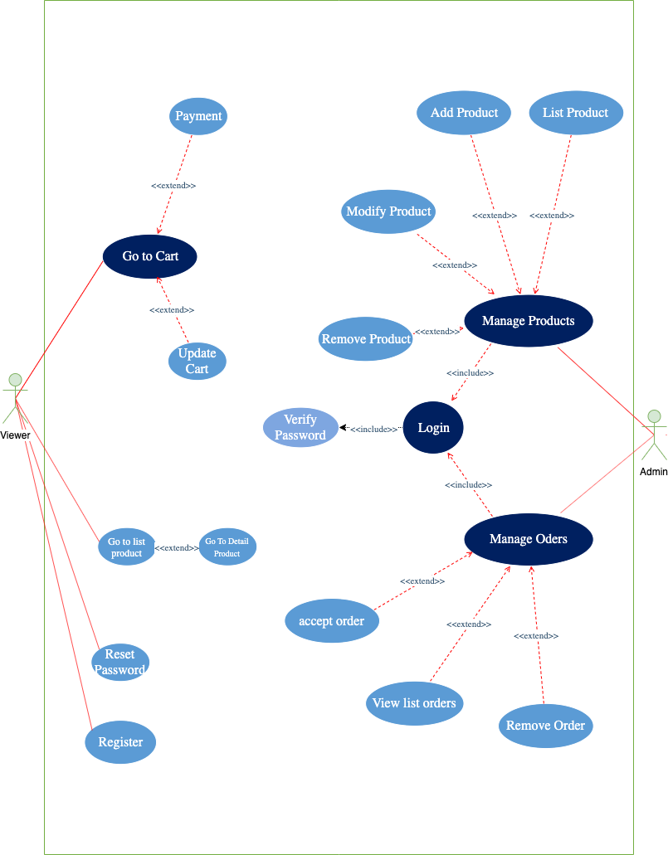

    - Login:
+Input: Username; Password
+Output: Homepage

    - Manage Order:
+Input: Role Admin, request to view list order
+Output: Manage Order page
    - Manage Product:
+Input: Role Admin, request to view list product
+Output: Manage Product page

    - Change password:
+Input current password
+Output: change password successfully
    - Register:
+Input: infomation user
+Output: Register successfully

List of Use Cases
Manage Product: Add new product or delete product, beside can modify product like update information.
Manage Order: Accept new order to save to database, change, remove or edit order rinformation
Login/Logout: Sign in or Sign out system
Change Account Password: Update account password to the new one.

Activity Diagram

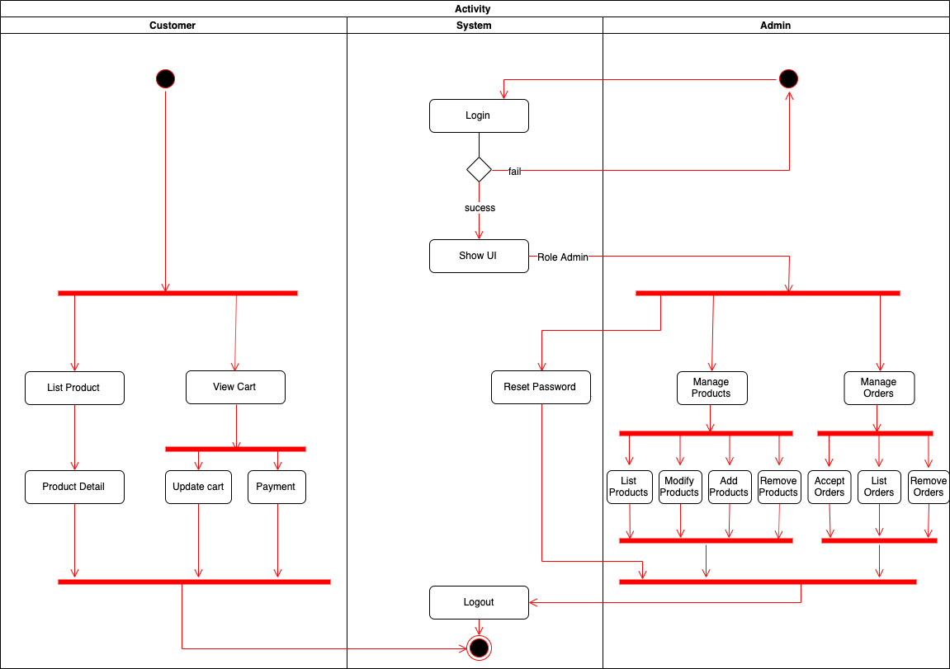

Class Diagram

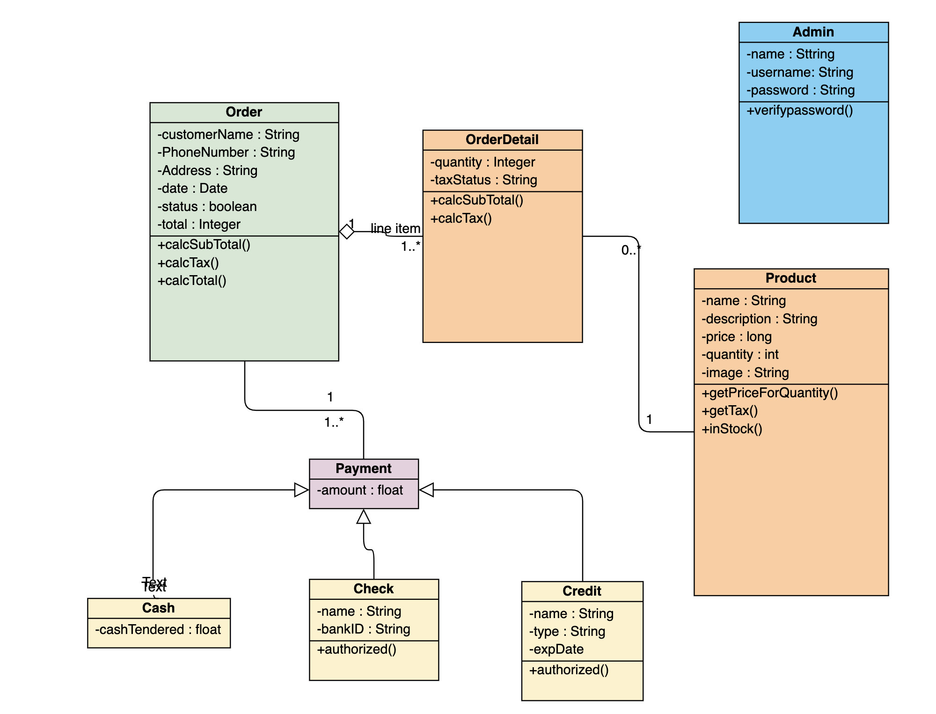

ERD Diagram
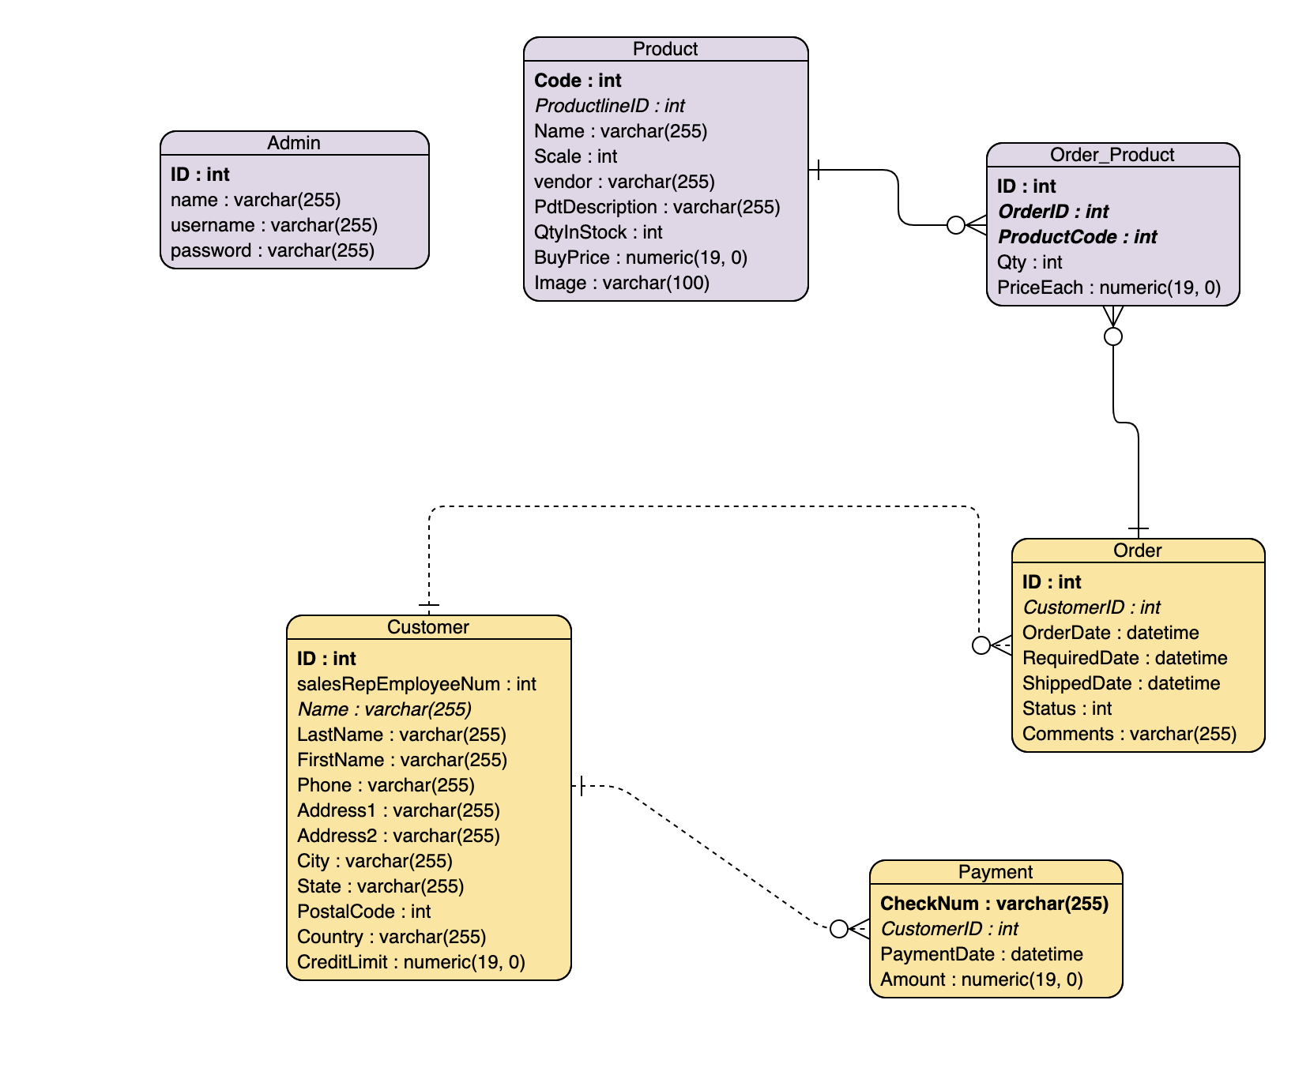

Sequence Diagram
      - Login

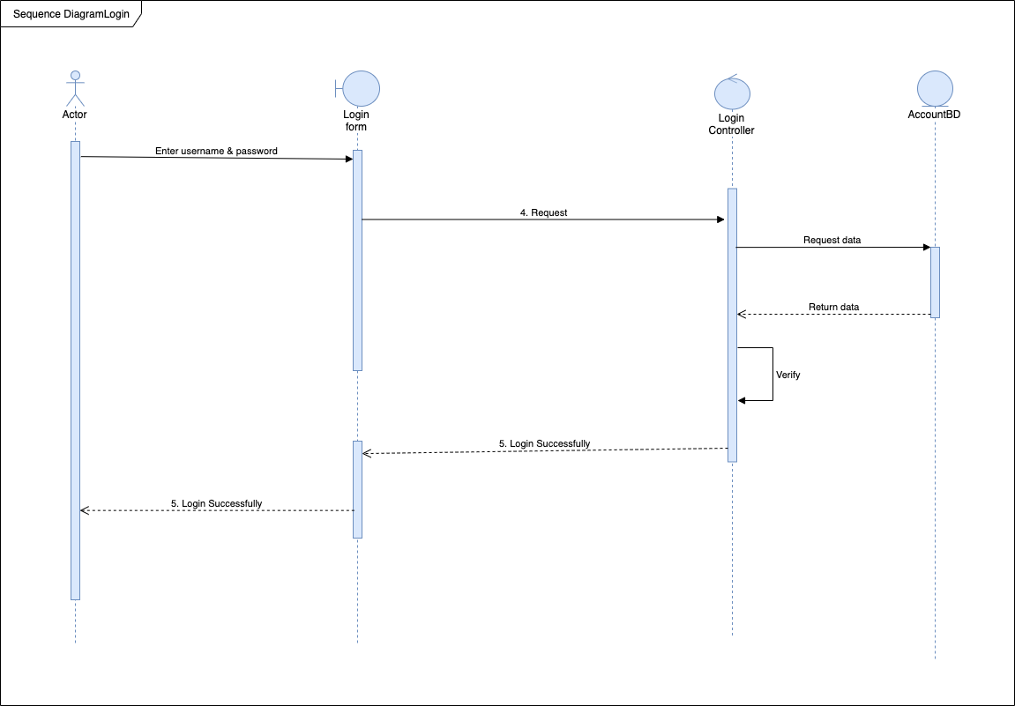

      - Modify Product:

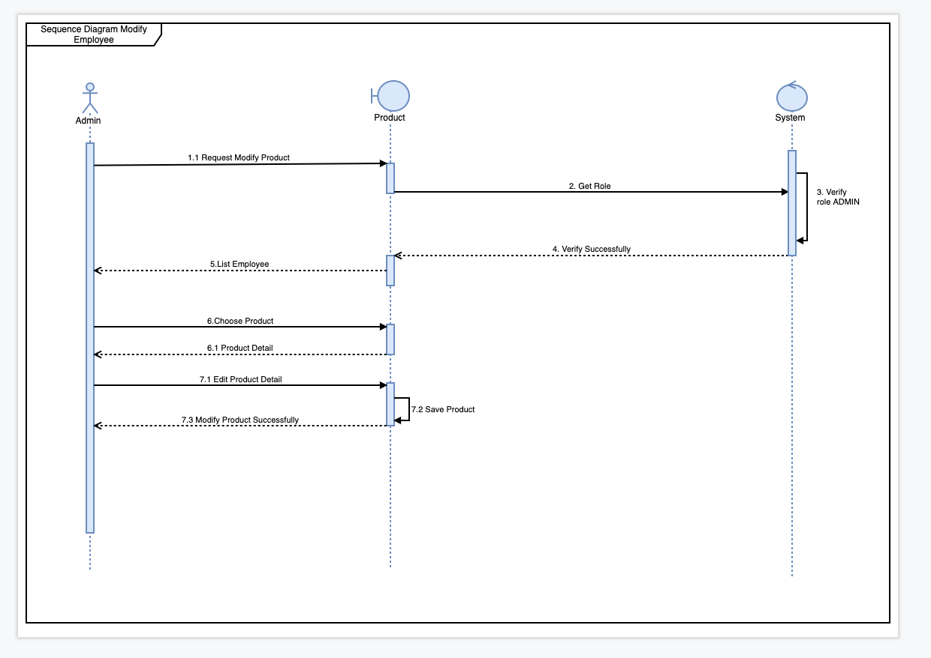

Design Presentation

Home:

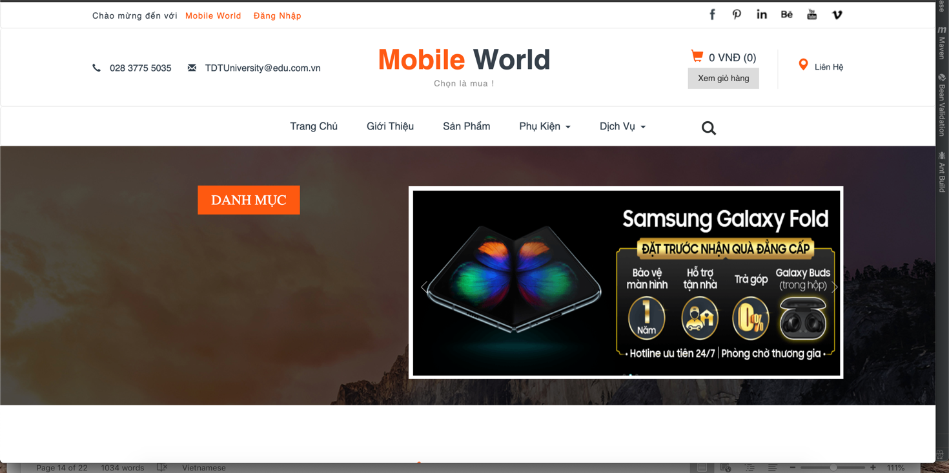

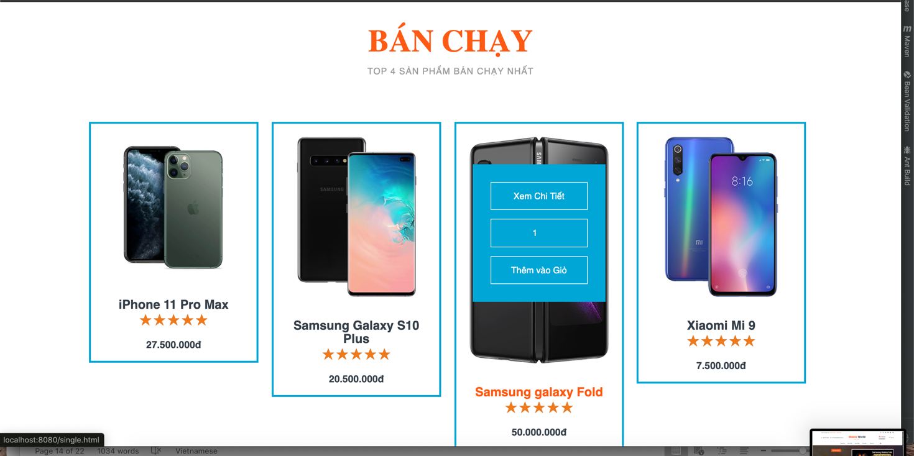

Admin

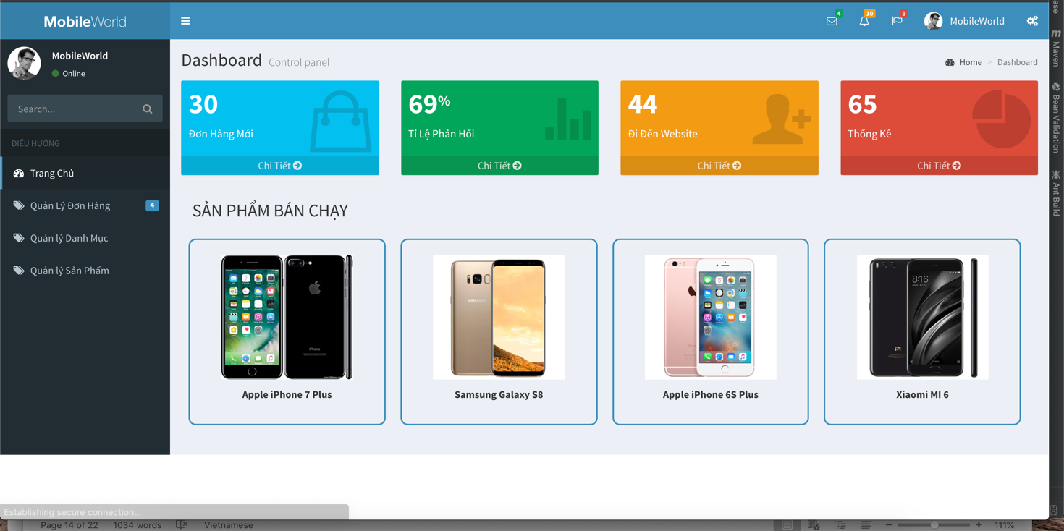

Implementation

Model:
Admin:

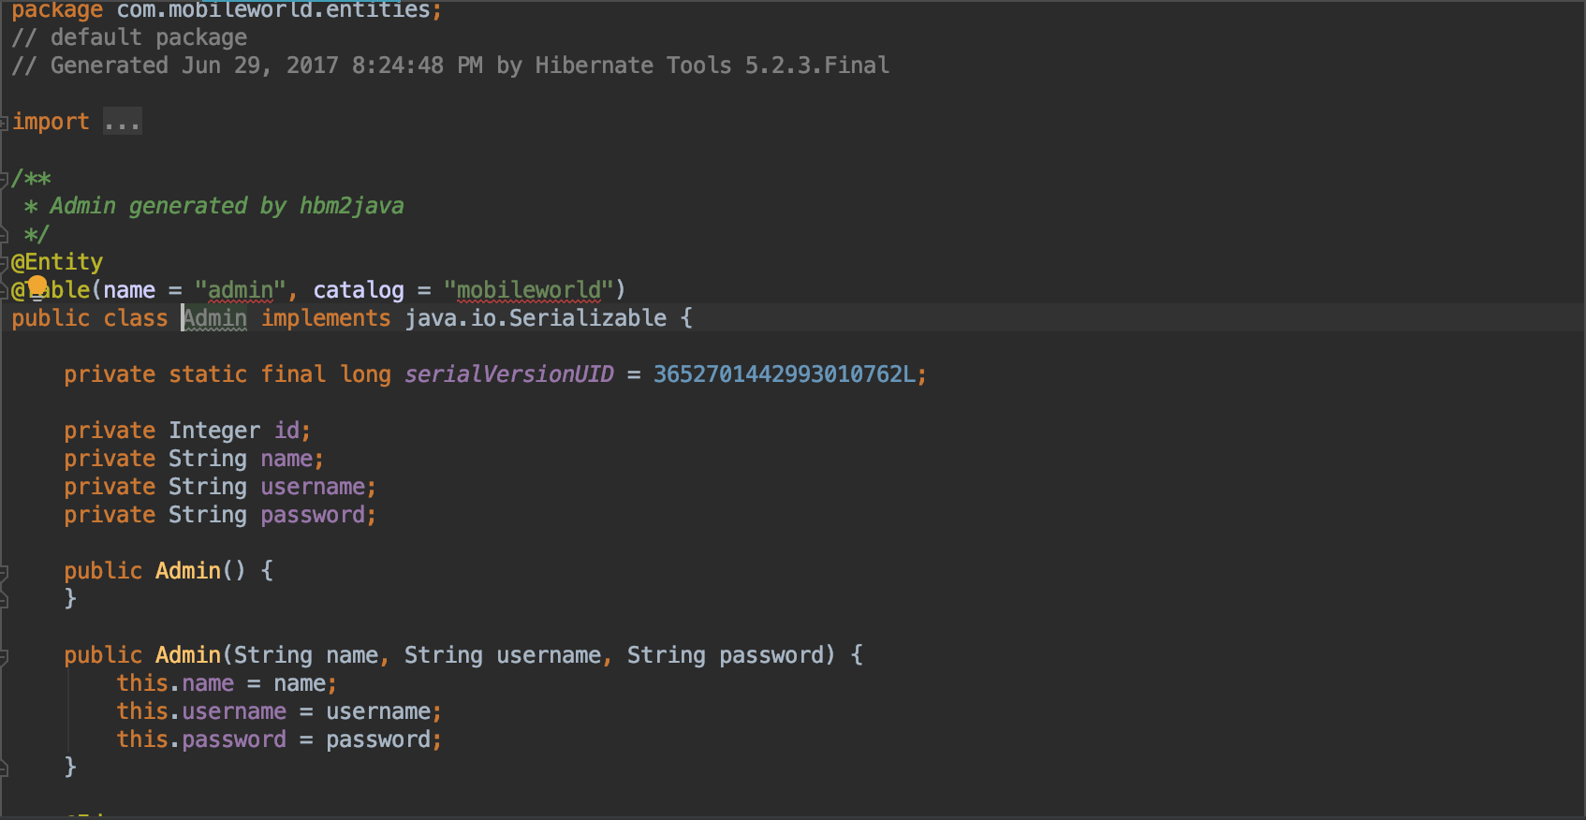
Category:
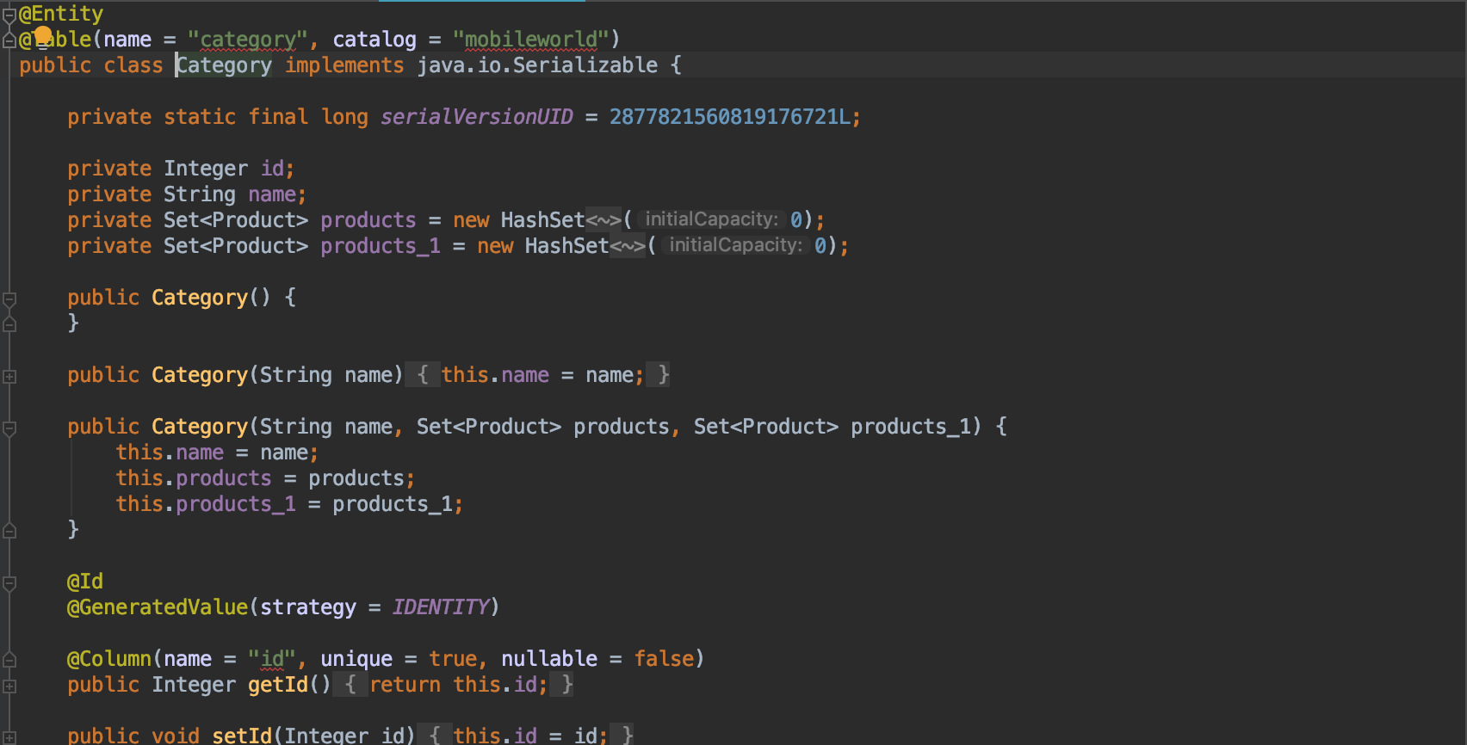

Controller:
Admin controller:
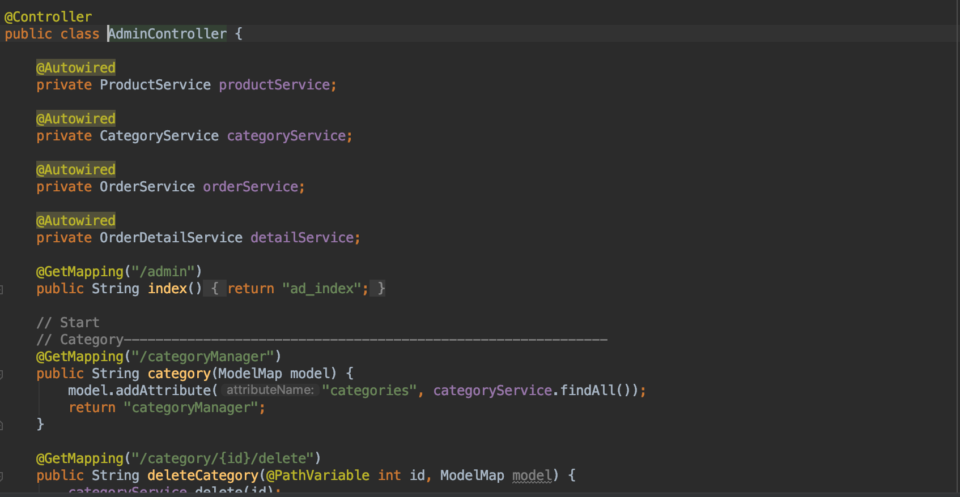

Category controller:

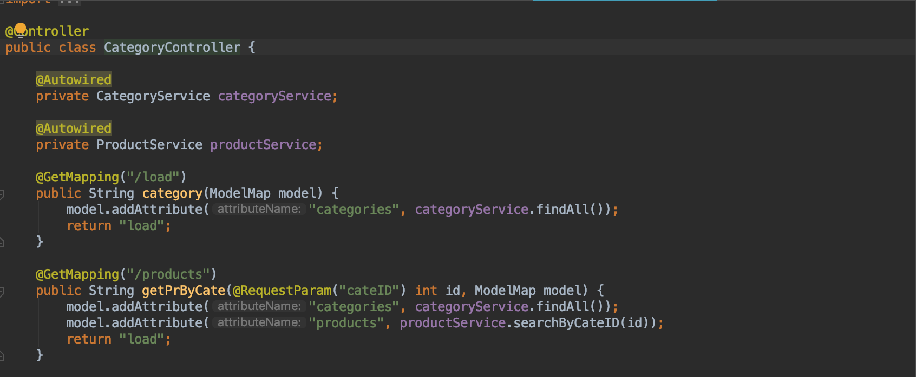

Reference

