

Cs223-03

Lab02

Osman Buğra Aydın

21704100

18 October 2020
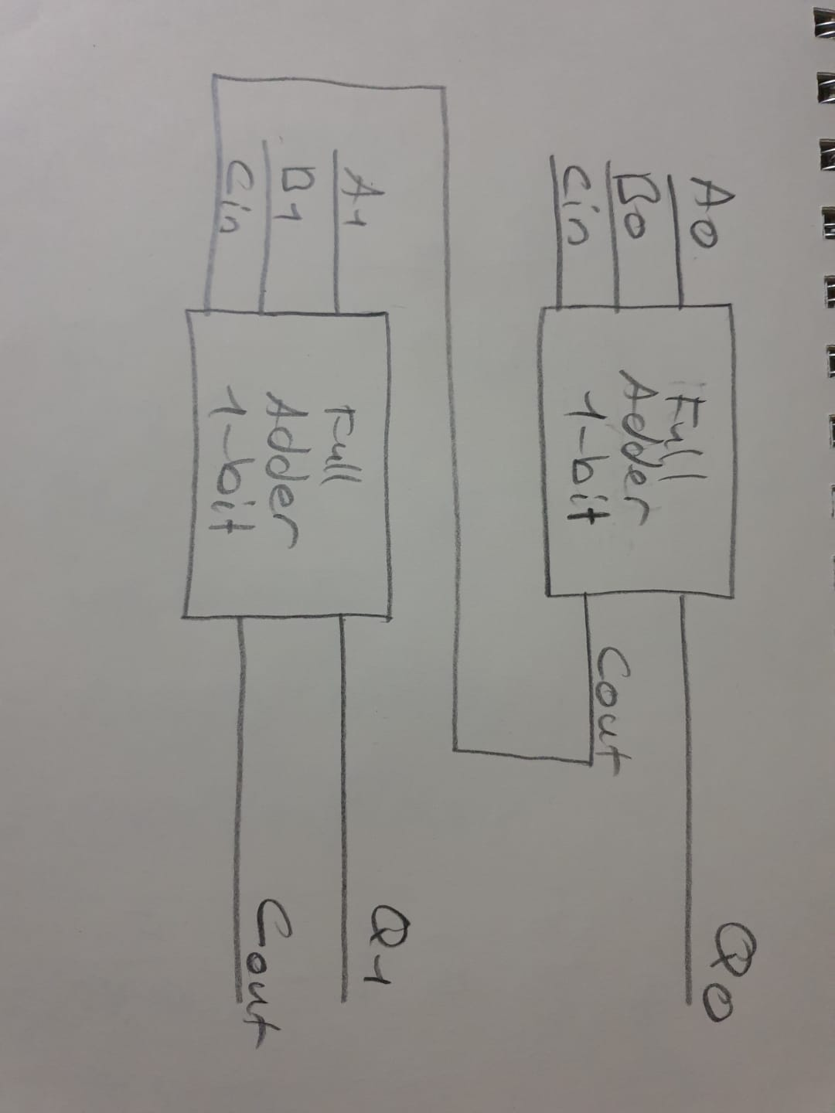

c-) Behavioral Full Adder SystemVerilog

`timescale 1ns / 1ps

module BehavioralFa( input a, b, cin, output sum, cout );

assign sum = ( a ^ b ) ^ cin ;
assign cout = ( a & b ) | ( a ^ b ) & cin ;

endmodule

d-) Structural Full Adder SystemVerilog

`timescale 1ns / 1ps

module Structural_FA( input a, b, cin, output sum, cout );

wire w1, w2, w3;

xor xor1(w1, a, b);
xor xor2(sum, w1, cin);

and and1(w2, a, b);
and and2(w3, w1, cin);

or or1(cout, w2, w3);

endmodule

Testbench

`timescale 1ns / 1ps

module Structural_FA_tb;

reg a, b, cin;
wire sum, cout;

Structural_FA uut(.a(a), .b(b), .cin(cin), .sum(sum), .cout(cout));

initial begin
#300;
#50 a=0; b=0; cin=0;
#50 a=0; b=0; cin=1;
#50 a=0; b=1; cin=0;
#50 a=0; b=1; cin=1;
#50 a=1; b=0; cin=0;
#50 a=1; b=0; cin=1;
#50 a=1; b=1; cin=0;
#50 a=1; b=1; cin=1;
end

initial $monitor($time,,"a=%d,b=%d,cin=%d, sum=%d, cout=%d", a,b,cin,sum,cout);

endmodule

e-) Structural Full Substractor SystemVerilog

`timescale 1ns / 1ps

module Structural_FS( input a, b, bin, output dif, bout );

wire w1;
wire w2;
wire w3;
wire inversedA;
wire inversedXor1;

xor xor1( w1, a, b );
xor xor2( dif, w1, bin );

not not1( inversedA, a );
not not2( inversedXor1, w1 );

and and1( w2, inversedA, b );
and and2( w3, inversedXor1, bin );

or or1(bout, w2, w3);

endmodule

Testbench

`timescale 1ns / 1ps

module Structural_FS_tb;

reg a, b, bin;
wire dif, bout;

Structural_FS uut(.a(a), .b(b), .bin(bin), .dif(dif), .bout(bout));

initial begin
#300;
#50 a=0; b=0; bin=0;
#50 a=0; b=0; bin=1;
#50 a=0; b=1; bin=0;
#50 a=0; b=1; bin=1;
#50 a=1; b=0; bin=0;
#50 a=1; b=0; bin=1;
#50 a=1; b=1; bin=0;
#50 a=1; b=1; bin=1;
end

initial $monitor($time,,"a=%d,b=%d,bin=%d, dif=%d, bout=%d", a,b,bin,dif,bout);

endmodule

F-) Structural 2-bit Full Adder SystemVerilog

`timescale 1ns / 1ps

module FA_TwoBit( input a0, a1, b0, b1, cin, output sum0, sum1, cout );

wire w1;

Structural_FA fullAdder1( a0, b0, cin, sum0, w1 );
Structural_FA fullAdder2( a1, b1, w1, sum1, cout );

endmodule

Testbench

`timescale 1ns / 1ps

module FA_TwoBit_tb;

reg a0, a1, b0, b1, cin;
wire sum0, sum1, cout;

FA_TwoBit uut( .a0(a0), .a1(a1), .b0(b0), .b1(b1), .cin(cin), .sum0(sum0), .sum1(sum1), .cout(cout));

initial begin
#100;
#10 a0 = 0; a1=0; b0=0; b1=0; cin=0;
#10 a0=0; a1=0; b0=0; b1=1; cin=0;
#10 a0=0; a1=0; b0=1; b1=0; cin=0;
#10 a0=0; a1=0; b0=1; b1=1; cin=0;
#10 a0=0; a1=1; b0=0; b1=0; cin=0;
#10 a0=0; a1=1; b0=0; b1=1; cin=0;
#10 a0=0; a1=1; b0=1; b1=0; cin=0;
#10 a0=0; a1=1; b0=1; b1=1; cin=0;
#10 a0=1; a1=1; b0=0; b1=0; cin=0;
#10 a0=1; a1=0; b0=0; b1=1; cin=0;
#10 a0=1; a1=0; b0=1; b1=0; cin=0;
#10 a0=1; a1=0; b0=1; b1=1; cin=0;
#10 a0=1; a1=1; b0=0; b1=0; cin=0;
#10 a0=1; a1=1; b0=0; b1=1; cin=0;
#10 a0=1; a1=1; b0=1; b1=0; cin=0;
#10 a0=1; a1=1; b0=1; b1=1; cin=0;
#10 a0=0; a1=0; b0=0; b1=0; cin=1;
#10 a0=0; a1=0; b0=0; b1=1; cin=1;
#10 a0=0; a1=0; b0=1; b1=0; cin=1;
#10 a0=0; a1=0; b0=1; b1=1; cin=1;
#10 a0=0; a1=1; b0=0; b1=0; cin=1;
#10 a0=0; a1=1; b0=0; b1=1; cin=1;
#10 a0=0; a1=1; b0=1; b1=0; cin=1;
#10 a0=0; a1=1; b0=1; b1=1; cin=1;
#10 a0=1; a1=1; b0=0; b1=0; cin=1;
#10 a0=1; a1=0; b0=0; b1=1; cin=1;
#10 a0=1; a1=0; b0=1; b1=0; cin=1;
#10 a0=1; a1=0; b0=1; b1=1; cin=1;
#10 a0=1; a1=1; b0=0; b1=0; cin=1;
#10 a0=1; a1=1; b0=0; b1=1; cin=1;
#10 a0=1; a1=1; b0=1; b1=0; cin=1;
#10 a0=1; a1=1; b0=1; b1=1; cin=1;
end

initial $monitor($time,,"a0=%b, a1=%b, b0=%b, b1=%b, cin=%b, sum0=%b, sum1=%b, cout=%b", a0,a1,b0,b1,cin,sum0,sum1,cout);

endmodule

