

King of Open Play
Organizer User Guide
Open Play • Skill Ladder • Team Tournament • Offline Scoring

A practical field manual for setting up the event, managing courts, recording results, and protecting session data.

Quick Start
1. Build the event | Choose Open Play, Skill Ladder, or Team Tournament. Configure courts, scoring, and matchmaking.
2. Register participants | Add individual player names or fixed tournament teams.
3. Fill courts | Let the app choose eligible players or scheduled teams.
4. Record results | Track every rally, tap the game winner, or enter the final score.
5. Keep the rotation moving | The next eligible match is assigned automatically.
6. Export before clearing data | Download a JSON backup for important sessions.

1. Build the Event
Select Build an event, New session, or the settings icon. The Event Builder shows what each mode will do before the organizer starts.
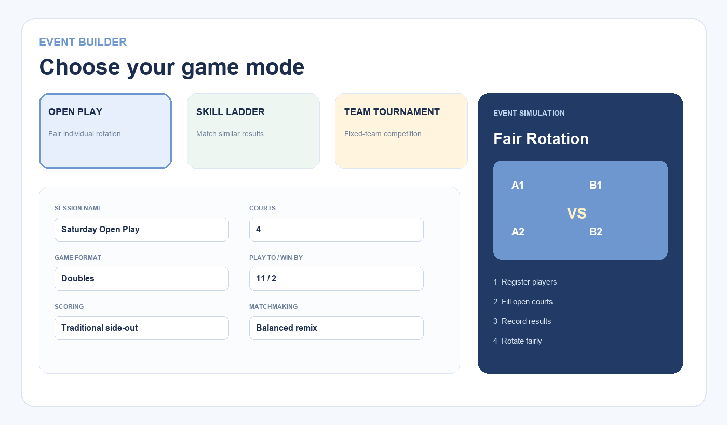
Figure 1. Event Builder and gameplay simulation.
Open Play: Best for social sessions. Players rotate individually and equal playing time is prioritized.
Skill Ladder: Best for competitive open play. Results gradually improve future skill matching.
Team Tournament: Best for organized competition. Partners remain fixed and standings determine rank.

2. Register Players or Teams
In Open Play and Skill Ladder, open Players and enter one name per line. The bulk entry supports large groups. Duplicate names are ignored.
In Team Tournament, register a team name and two players. Existing individual players can be paired automatically using Convert players into teams.

3. Run Live Courts
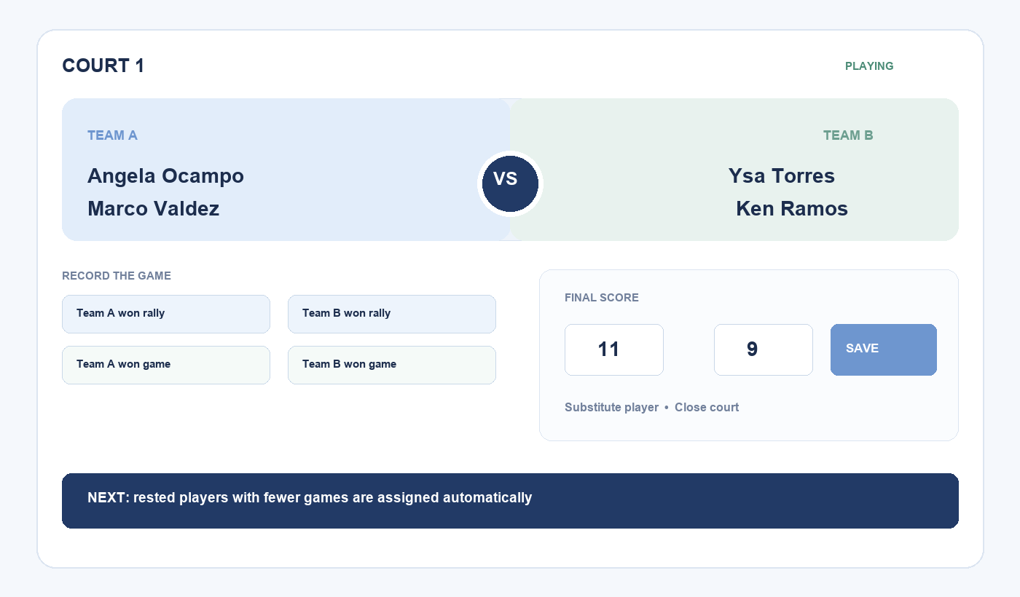
Figure 2. Live court controls and side-by-side matchup.
- Fill open courts assigns rested players with fewer games first.
- The announcer reads the court and player names when enabled.
- Rally buttons follow the selected side-out or rally-scoring rules.
- Winner-only entry is the fastest result option.
- Final-score entry supplies better point-margin skill data.
- Substitute a player replaces someone who leaves early without resetting the score.
- Close court removes a court from automatic assignments until it is reopened.

4. Scoring Rules and Validation
Traditional side-out scoring starts doubles at 0-0-2, awards points only to the serving team, and tracks server one, server two, and side-outs.
Example — Play To 11, Win By 2: 11-9 and 12-10 are valid. 11-10 and 12-9 are rejected. Scores above 11 are allowed only after deuce.
The final point margin updates skill strength. A close win changes ratings gently; a dominant win makes a larger adjustment.

5. Rotation and Matchmaking
Winner vs Winner: Winning partners stay together and wait for another winning team.
Balanced Remix: Partners may change. The app balances the selected players using current skill results.
Pure Random: Eligible players are reshuffled after every game.
Rest fairness: Players who just finished wait behind rested players with fewer completed games.

6. Team Tournament
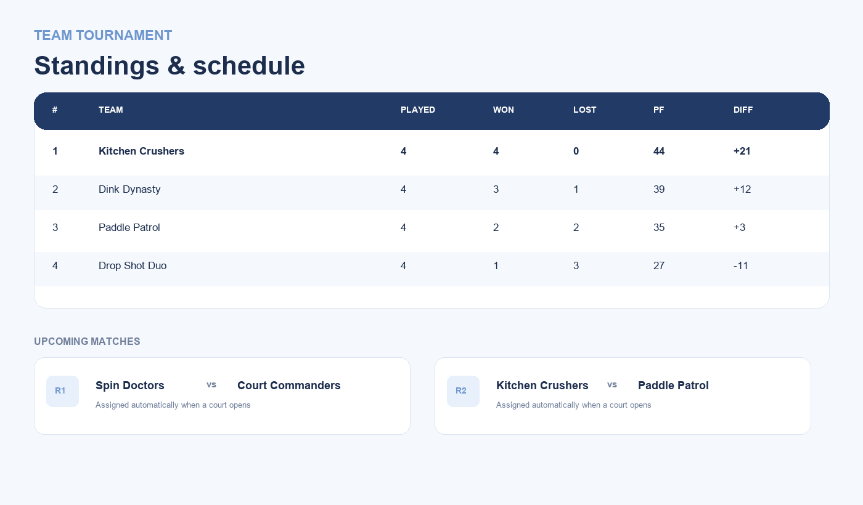
Figure 3. Round-robin standings and upcoming matches.
Generate tournament schedule creates every team-versus-team round-robin fixture. The assignment engine prevents one team from playing on two courts simultaneously.
Standings rank teams by wins, then point difference. Entering final scores produces more useful standings than winner-only entry.

7. Session Data and Offline Use
- The browser saves every change automatically.
- No account or central database is required.
- The app keeps working offline after it has been installed or cached.
- Export creates a JSON backup; Import restores that backup.
- Sessions do not automatically sync between devices.
- Clearing browser site data removes the local session.

Organizer Checklist
☐ Confirm court count and event mode before player check-in.
☐ Test the announcer volume before assigning the first court.
☐ Keep the organizer device charged.
☐ Use final scores when practical; use winner-only entry when courts are moving quickly.
☐ Close courts as reserved time expires.
☐ Export the session before clearing browser data or moving devices.

About the Application
King of Open Play was conceived and directed by Developer King, an engineer in the airline industry who loves data and builds AI-powered applications on the side. AI was used as a development tool for planning, programming, testing, and interface iteration.
The application is designed for free public access as a static Progressive Web App.

