Code Review
1)
The first thing I want to improve is the BGM part. I want to hide it and use an icon to represent it, but this cannot be achieved with only HTML.

Code snippet:
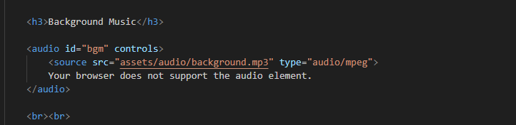
Current outcome:
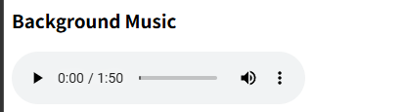
Desired outcome:

Instead of the default audio control bar, a speaker icon is used to control the background music (BGM) and appears on the navigation bar. A left click on the speaker icon toggles the music between play and pause.

Fix solution:
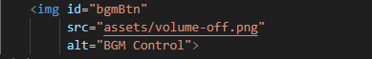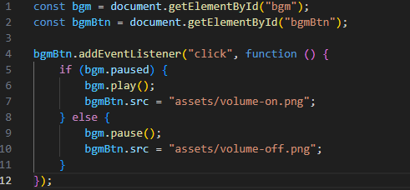
New outcome:
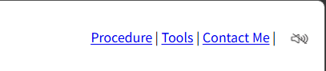
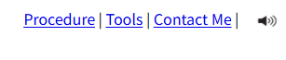

2)
Code snippet:
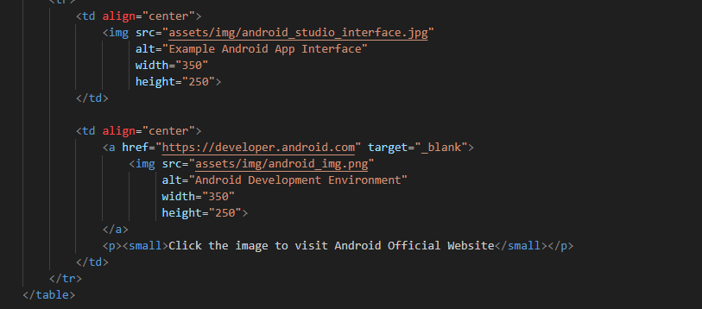
Current Outcome:
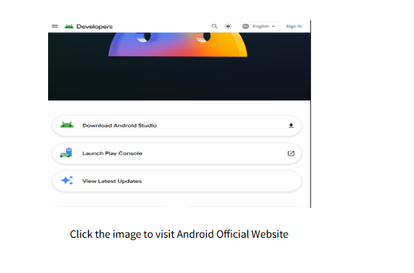
Desired Outcome:
The goal is to develop an interactive image feature that improves user experience.
When a user clicks on an image, a modal overlay appears, dimming the background and showing a larger version of the image in the center of the screen.
A close button is in the top-right corner, enabling the user to exit the view.
If the user clicks on the enlarged image, they are redirected to a related external website.
This interaction is implemented in a reusable way using a shared class and data attributes, allowing multiple images to use the same functionality.
Fix solution:
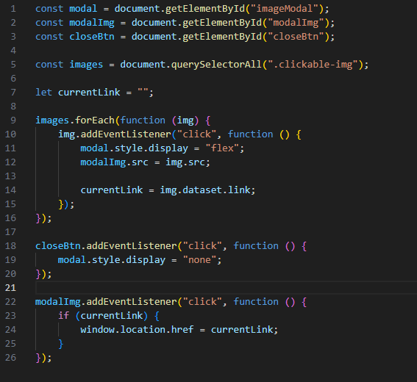
New outcome:
