Auto Pan-Tilt V1.0 EX1
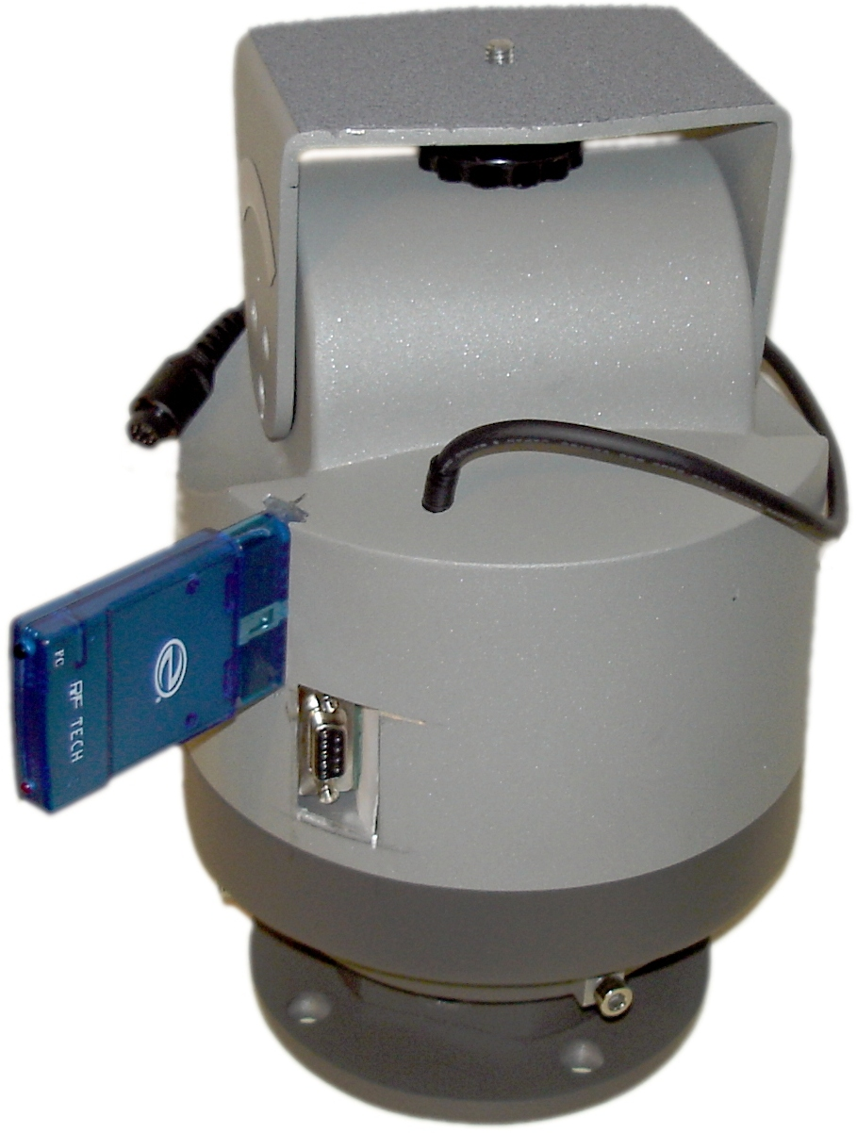

Features:
- 24VDC operation
- Wireless range up to 100' (LOS)
- High accuracy
- Pan Angle: 350°
- Pan step size: 0.03°
- Tilt Angle: +/-50°
- Tilt step size: 0.01°
- Pan Speed: 0.04 to 6°/sec
- Tilt Speed: 0.02 to 3°/sec
- Ergonomic hand held controller
- Serial port control
- Open source Firmware
- Full Zoom, Focus, Record, shot review for the Sony EX-1 HD camcorder.
- Fully proportional controls
- Maximum load 6kg
- Weight 6.2kg
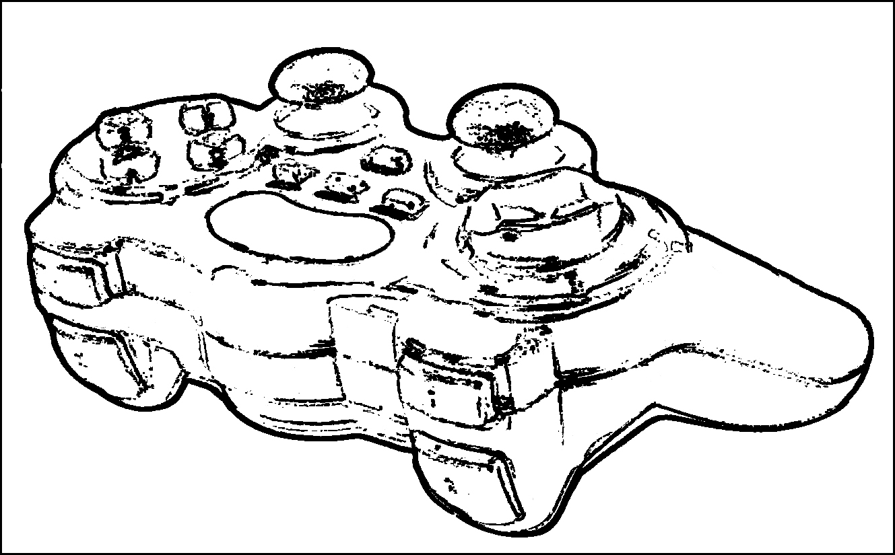

Table of Contents
Auto Pan-Tilt V1.0 EX1 1
Features: 1
Overview 3
Installation: 3
Mounting: 3
Clearance: 3
Power: 3
Controller 4
Functions 4
Pan and Tilt: 4
Zoom and Focus 4
Focus (with optional accessory kit) 4
Record/Shot recall 4
Storing preset positions 5
Recalling preset positions 5
Calibration 5
Setting Zoom zero point 5
Reversing the Pan tilt joystick 5
Permanently storing presets, joystick settings and zoom zero point 5
Remote Head 6
Serial Port 6
Power Connector 6
Lens Connector 6
Focus/Aux Connector 6
Wireless Receiver Connector 6
Serial Communication 7
Connection information 7
Boot up status information 7
Serial Command Structure 7
Software Licensing 8
Modifications 8
GPL license 8

Overview
The auto pan tilt with camera control wireless pan tilt head is designed for advanced motion control for the next generation of HD cameras. Incorporating 2.4GHZ hand held wireless controls, the common 24VDC power and a serial port allow this head to incorporate into almost any solution to provide high accuracy camera control at unparalleled cost. Designed for demanding environments where high precision and accuracy are a must. It also can also be used for remote sensor platform control, robotics, and range finding with its built in computer interface.
Custom configurations can be interfaced with almost any camera solution at additional cost. Other control solutions such as blue-tooth control, Zig bee based mesh networking interfaces, or integration with existing control solutions are also possible.

Installation:

Mounting:
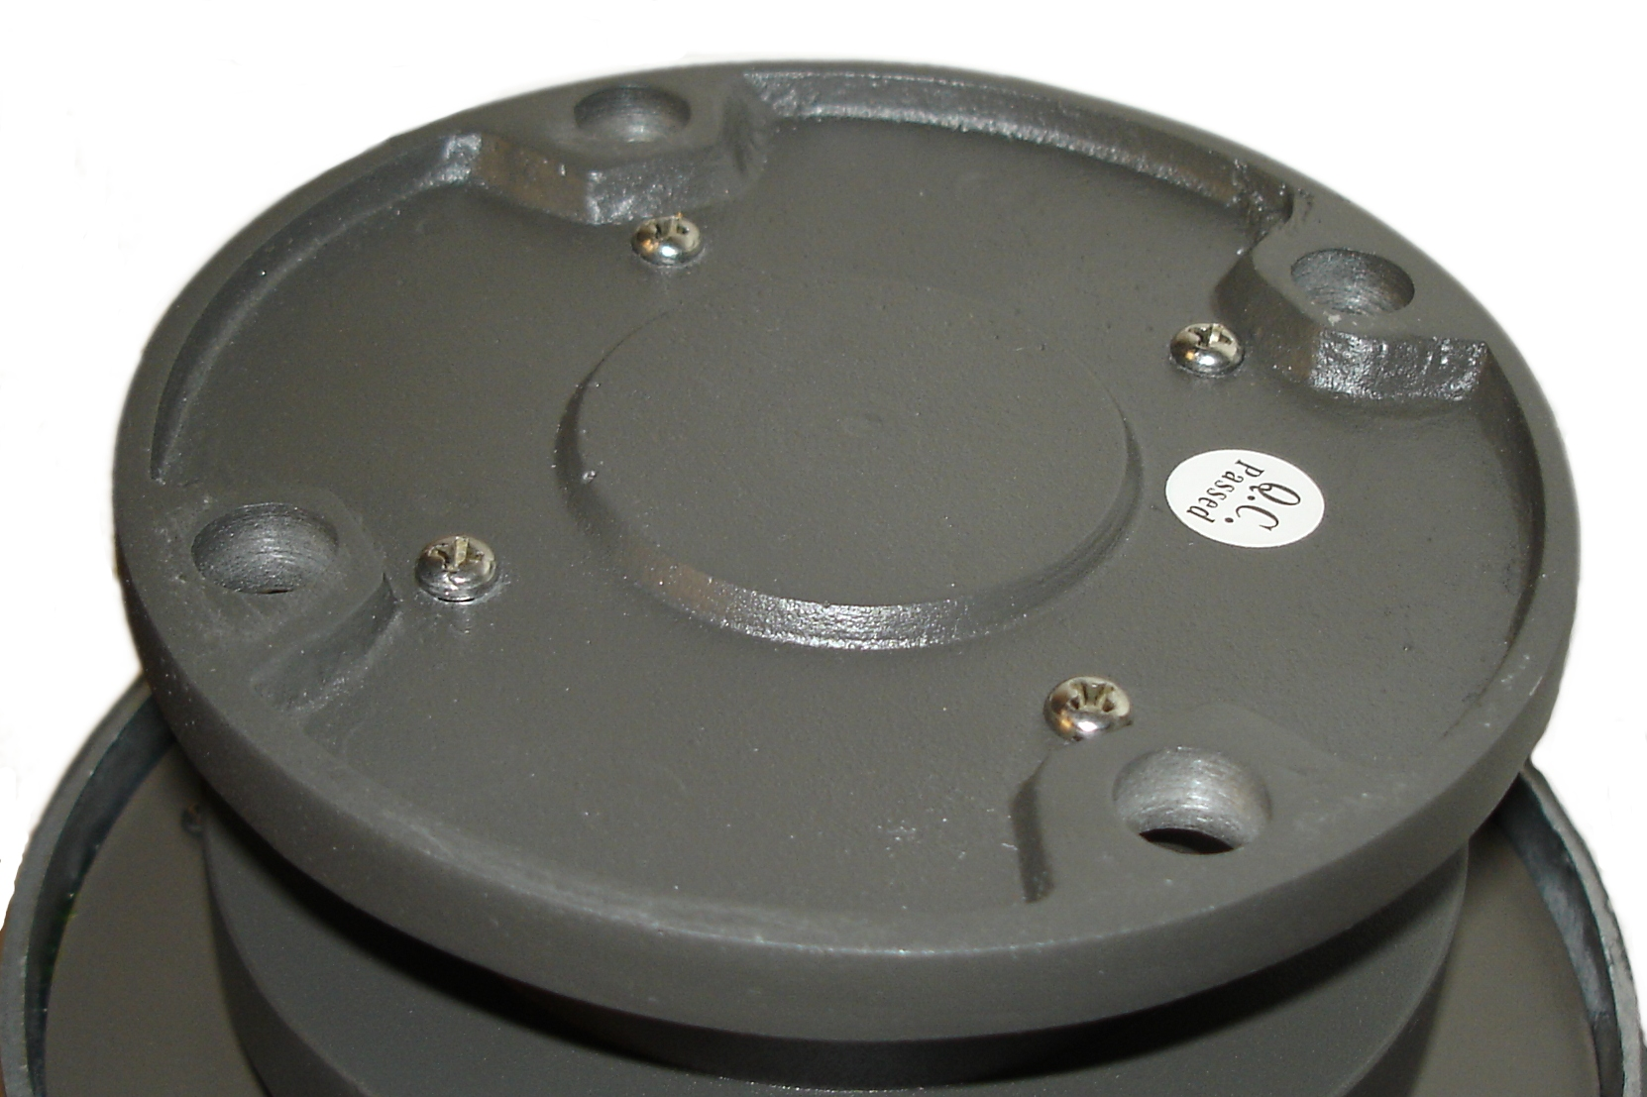
The Pan tilt head must be bolted using 4 bolts to a sturdy base. There is also a standard tripod mount in the middle of the base if a tripod mount is required. However for permanent operation 4 bolts to a sturdy base is preferred.

Clearance:
Make sure that there is adequate clearance all around the camera head – whenever power is turned on the head must zero itself which means it will automatically rotate and tilt to the lower left maximum. Any equipment mounted on the head with attached cabling must have enough slack to allow this to occur otherwise damage to equipment or cabling may occur.

Power:
The head needs 24VDC regulated power to function which is supplied through a standard center positive 2.5mm concentric barrel connector. This head should be used with the included power supply or a supply rated at least 1A at 24VDC. If using a wireless controller 4 AAA batteries are needed for the remote controller

Controller
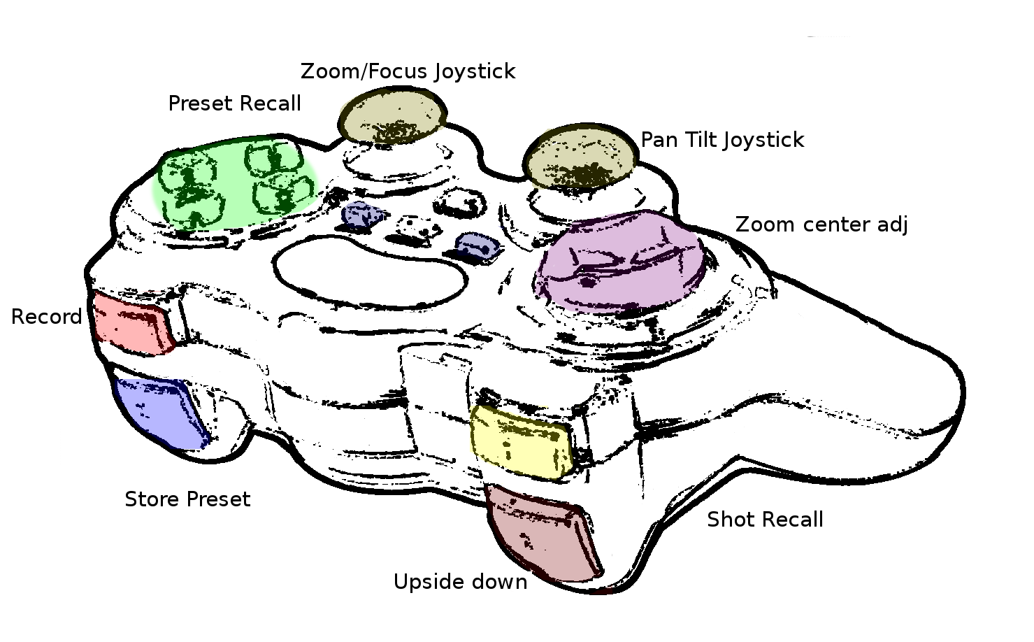

Functions

Pan and Tilt:
Using the pan tilt joystick fully proportional control of the head is assumed by the operator. A small movement of the joystick away from its center position will result in a slow pan or tilt. 8 levels of speed control are available for each direction of the pan and tilt. The Unit can be programmed to operate at very slow speeds. Using this method suitable for special filming requirements such as time-laps photography.

Zoom and Focus
Moving the Zoom joystick forward and back will cause the zoom of the camera to zoom in and out proportionally. Currently the zoom cannot be recalled for specific presets.

Focus (with optional accessory kit)
Moving the Zoom/Focus joystick left and right operates the focus control. This operates the special focus servo mounted under the camera allowing precision focus control.

Record/Shot recall
The L1 and R1 buttons are used for record, and shot recall on the camera. Pressing the button will result in toggling the record/pause, and shot recall.

Storing preset positions
To store a preset hold down the Store Preset button while selecting any one of the four preset recall buttons to overwrite the current position preset that is stored in that particular slot. These will only be stored until power loss unless the presets are stored to nonvolatile memory feature.

Recalling preset positions
To recall a preset position press the corresponding preset recall position. If during the middle of the movement to a preset position the user requires to change the direction moving the joystick will cause the preset recall to abort and normal joystick control to resume.

Calibration

Setting Zoom zero point
At first use the controller will initialize to default values, this may be different from the camera's zero point. If you experience zoom creep ( a slow zooming in or out when the zoom joystick is centered) you can calibrate the zoom using the wireless controller. Hold the select button while pressing the zoom center adjust control up or down to adjust the center point. Continue this until the zoom no longer creeps in or out. This calibration will not be permanently stored through power loss until the store presets command is executed.

Reversing the Pan tilt joystick
If reverse operation of the pan tilt joystick is required for mounting the camera backwards or upside down the joystick control can be reversed so the operator will not be confused. Hold down the select button and momentarily press the Upside down button to reverse control of the pan tilt joystick.

Permanently storing presets, joystick settings and zoom zero point
To permanently store the zoom zero point, the pan tilt joystick reverse and all current position presets hold down the Select button and press Start. This saves all current settings into nonvolatile memory which will be saved through power loss.

Remote Head

Serial Port

Power Connector

Lens Connector

Focus/Aux Connector

Wireless Receiver Connector

Physical Dimensions

Serial Communication

Connection information
The serial port should be connected using a straight through cable to a computer to allow serial communication. The serial port on the controller operates at 9600 baud with 8N1 format. Asserting the DTR line will cause the controller to reset.

Boot up status information
When turning on the controller it will display via serial the firmware version as well initialization information regarding several subsystems inside the controller.

Serial Command Structure
Serial commands are only enabled when the wireless joystick receiver is unplugged. Serial communication is entirely using human readable information. All commands will respond “OK” when received correctly.
Command | Space 0x20 | Variable 1 | Space (0X20) | Variable 2 | Linefeed 0x10
Move to pos | Space (0X20) | X position (0 to 11000) | Space (0X20) | Y position (0 to 9000) | Linefeed 0x10
M | Space (0X20) | 100 | Space (0X20) | 6438 | Linefeed 0x10
Set velocity | Space (0X20) | 1 or -1 are fastest | Linefeed 0x10
X | Space (0X20) | 1 | Linefeed 0x10
Y | Space (0X20) | -4 | Linefeed 0x10
Return current position | Returns coordinates in the form “X Y”
C | Linefeed 0x10
Run pan tilt head (enables pan – tilt unit)
G | Linefeed 0x10
Stop pan tilt head (Disables pan – tilt unit)
S | Linefeed 0x10
Toggle camera record
R | Linefeed 0x10
Set Zoom (relative speed, 0 to 255) values around 127 are approximately center
Z | Space (0X20) | 128 | Linefeed 0x10
Set Focus (relative focus, Number from 500 to 1500)
F | Space (0X20) | 900 | Linefeed 0x10

Software Licensing

Modifications
Modifications to the provided software or the use of other software with this unit which causes destruction or damage to the unit is will void all existing warranties. Any modifications to the unit (including software modifications are done entirely at the users risk, the manufacture provides no warranty, expressly or implied.

GPL license
The firmware on this device is Licensed under GPL V3 by Kieran Levin. All source code is available for download at www.kieranlevin.com in compliance with the following license.
Copyright (C)2009 Kieran Levin

This program is free software: you can redistribute it and/or modify
it under the terms of the GNU General Public License as published by
the Free Software Foundation, either version 3 of the License, or
(at your option) any later version.

This program is distributed in the hope that it will be useful,
but WITHOUT ANY WARRANTY; without even the implied warranty of
MERCHANTABILITY or FITNESS FOR A PARTICULAR PURPOSE. See the
GNU General Public License for more details.

You should have received a copy of the GNU General Public License
along with this program. If not, see <http://www.gnu.org/licenses/>.

