**Smart Canteen Management System using Naïve Bayes Algorithm**

**P.Praneetha1, Dr.K.Srinivasa Rao2, G.S.Prabhu Kiran3, P.Vasantha4,P.Vasu5,N.Charles Bunny6**

1CST, Sri Vasavi Engineering College(A), Pedatadepalli, Tadepalligudem-534101

2Ass Professor, Department of AIML, Sri Vasavi Engineering College(A),Pedatadepalli, Tadepalligudem-534101

3CST, Sri Vasavi Engineering College(A), Pedatadepalli, Tadepalligudem-534101

4CST, Sri Vasavi Engineering College(A), Pedatadepalli, Tadepalligudem-534101

5CST, Sri Vasavi Engineering College(A), Pedatadepalli, Tadepalligudem-534101

6CST, Sri Vasavi Engineering College(A), Pedatadepalli, Tadepalligudem-534101

---------------------------------------------------------------------***---------------------------------------------------------------------

**Abstract -** The "Smart Canteen Management System" project aims to revolutionize the traditional canteen experience in educational institutions by leveraging modern technologies and automation. This system offers an efficient and convenient approach to managing canteen operations, enabling seamless transactions,improved resource utilization, and enhanced user experience for both faculty members and students .It will bring numerous benefits, including reduced waiting times, increased efficiency, improved inventory management, and enhanced user satisfaction .Here we use Naïve bayes algorithm for classification used for classifier tasks. Every person eats at least twice or three times daily, therefore during that time it can aid them without delaying their schedule. This solution is made to be adaptable and may be customized to meet the particular needs of various educational institutions. It aims to provide a modern and technologically advanced dining experience in the school or college cafeteria, making it more convenient and adaptable to the specific needs of each institution.

***Keywords— Canteen management , Naïve Bayes , Educational Institutions , Web Technologies ,Django framework.***

**1.INTRODUCTION**

We're all searching for creative methods to streamline our daily routines in the hectic world of education today, where every second counts. We need efficiency and convenience, whether we're racing to lectures, balancing assignments, or attempting to fit in extracurricular activities. The "Smart Canteen Management System" is ready to change how we perceive school and college canteens at this point.Consider the issues that are all-too-common in traditional canteens: the never-ending lineups, the paper-based processes, and the ongoing battle to keep things moving efficiently. These problems affect not just the

personnel and students, but also the general effectiveness of our institutions and universities. The "Smart Canteen Management System" is on a mission, and that's the thrilling part. This groundbreaking initiative isn't just about advancing technology; it's focused on enhancing the lives of students on campus. Picture a time when your canteen visits are all about efficiency and technology. Imagine a situation that enables us to say goodbye to those frustratingly long lines, and welcome an effortless, enjoyable dining experience.

With the "Smart Canteen Management System," it's all about putting your needs first, ensuring that your time in the canteen is not just effective but also filled with satisfaction. This marks a step towards making dining on campus more enjoyable and efficient, guaranteeing that every moment spent in the cafeteria is time well invested. So, brace yourself for a future of campus dining where convenience and efficiency reign supreme .

**1.1.Objective**

A smart canteen management system streamlines operations, optimizing order processing and inventory control for heightened efficiency. By offering a seamless user experience through personalized menus and quick transactions, it enhances overall satisfaction. Informed decision- making is facilitated through advanced analytics, ensuring adaptability and resource optimization for sustained operational excellence.

**1.2.Scope**

1.User-Friendly Ordering: Streamline canteen operations with an intuitive online ordering system for users, enabling convenient customization and quick transactions.

2.Efficient POS Integration: Seamlessly integrate with point-of-sale systems, facilitating smooth in-person transactions and supporting diverse payment methods.

3.Smart Inventory Management: Optimize stock levels with automated alerts for low inventory, supplier management,

and real-time tracking for efficient supply chain management.

4.Insightful Analytics: Gain valuable insights into sales, popular items, and customer preferences through robust reporting and analytics tools.

5. Enhanced User Experience: Elevate the canteen experience with mobile accessibility, user feedback mechanisms, and secure authentication, ensuring a positive and efficient dining environment.:

**2.LITERATURE SURVEY**

The most important step in the software development process is the literature review. This will describe some preliminary research that was carried out by several authors on this appropriate work and we are going to take some important articles into consideration and further extend our work.

**M. Ambika, Saravana Kumar R, Sandhya S Nair, and Ranjith Kumar S**, published in the International Journal of Innovative Technology and Exploring Engineering (IJITEE) under Blue Eyes Intelligence Engineering & Sciences Publication, a notable topic of exploration is the "Cashless Canteen System." This system presents a considerable advantage in that its effectiveness is not confined by the scale or size of the business. Unlike traditional models, this innovative platform proves adaptable to both small-scale and large-scale enterprises. However, it's worth noting that this system has a limitation - the absence of a liquid cash payment option

**Suman Chatterjee and Manish Kumar Thakur present the "Smart Collage Management System (IJERT)**.” This Android-based application offers a more user-friendly and efficient way for college administrators, faculty, and students to handle various tasks. One of its key advantages is reducing the need for extensive paperwork. While this excerpt doesn't delve into specific details, it emphasizes the system's commitment to enhancing the college experience by simplifying various academic and administrative processes.

**Ketan Bhekare, Chinmay Karandikar, Ganesh Kamble, and Varsha Wangikar**, in their research paper titled "Smart Canteen System," published in the Journal of Emerging Technologies and Innovative Research (JETIR) in April 2019, have highlighted the system's efficiency compared to manual processes. Their study reveals that the online-based system not only saves time but also enhances the overall convenience for customers who regularly order food from the canteen. Although this excerpt provides a concise overview, it emphasizes the significance of the system's efficiency and customer satisfaction.

**B. Kale, Ruchika K. Balwade, and Vipin B. Gawai** from All India Shri Shivaji Memorial Society’s College of Engineering, Pune, India, and published in the SAMRIDDHI Volume 12, Special Issue 2 in 2020, they present an "Online Food Ordering System for College Canteen." Their main goal is to create an Android app that addresses the common issue of students having to wait in long queues to place their food orders and then wait again for their deliveries. This system aims to enhance the overall efficiency and convenience of the food ordering process for college students, making their dining experience more pleasant and time-saving.

**Mr. Ram Krishna Singh, Km. Anjali, Madhavi Tripathi, Ashi Sachan, and Antima Gupta**, in their paper featured in the May 2023 issue of the International Journal for Research in Applied Science & Engineering Technology (IJRASET), introduce the "E-Canteen System." This innovative system is designed to benefit both customers and administrators. It aims to provide excellent service to customers while also boosting sales and attracting more business for administrators. While this summary provides a concise overview, it underscores the system's dual focus on enhancing customer experience and fostering business growth within the canteen context.

**Dr. C. Mahiba, Rajashekar V, S Dhanush, Santosh Kumar, and Sharath Chandra BR,** in their paper published in the June 2023 issue of the International Journal of Research Publication and Reviews, introduce the "College E-Canteen Management System." This innovative system brings valuable benefits to the canteen management team, including a reduction in paper usage and the elimination of the need for additional personnel at the billing counter.

**3.EXISTING SYSTEM**

The current canteen management systems are falling short in keeping up with the changing needs of students and faculty members. They often lead to frustratingly long waiting times, relying heavily on manual processes. This not only results in inefficient use of resources but also provides a less than ideal user experience. Students and faculty members, who require meals several times a day, find themselves hampered by the time-consuming procedures for ordering, making payments, and waiting for their food. This inconvenience doesn't just affect individual productivity; it also has a negative impact on the overall quality of the campus experience.

**3.1.Manual Hassles:** The way canteens are managed right now involves a lot of manual work. This leads to delays and inefficiencies in serving students and faculty.

**3.2.Never-Ending Wait:** Ordering food, making payments, and waiting for the meal often takes too long. This can disrupt the schedules of both students and faculty, causing frustration.

**3.3.User-Friendly Shortage:** The existing systems don't offer a great user experience. They fail to reach the necessities of those who rely on the canteen multiple times a day, affecting their satisfaction.

**3.4.Resource Mismanagement:** Resources like food and staff are often not used effectively. The current systems struggle to allocate these resources efficiently, leading to waste and extra costs.

**3.5.Campus Vibe Disrupted:** All these inconveniences not only influence singles but also affect the overall campus experience, making it less enjoyable for everyone.

**3.6.Flexibility Gap:** The present systems are not very flexible. Campuses find it hard to adapt the canteen operations to their unique needs, leading to less-than-optimal service

**3.7.Service Not Up to the Mark:** Due to this lack of adaptability, the quality of service often falls short, making the dining experience for students and faculty less enjoyable

**4.PROPOSED SYSTEM**

The proposed "Smart Canteen Management System" is a comprehensive and innovative solution designed to address the shortcomings of traditional canteen management in educational institutions. By leveraging modern technologies and automation, this system aims to transform the canteen experience into a seamless, efficient, and user-centric process. The core components of the proposed system include:

•Digital Ordering and Menu Display

•Efficient Order Processing and Payment

•Real-time Transaction Tracking

•Time Slot Reservation and Management

•Feedback and Ratings System

Advantages of Proposed system:

A Smart Canteen Management System offers efficiency with streamlined ordering, reduced queues, and enhanced customer experience. It ensures safety with contactless options, personalization based on preferences, and efficient inventory management. The system employs data analytics, secure payments, and allergen management, while promoting sustainability and simplifying staff management. It complies with regulations, optimizes resource allocation, and encourages loyalty programs, making it a comprehensive solution for modernizing and improving canteen operations.

**5.METHODS**

5.1.**RegisterCustomer:**This function lets new customers sign up, storing their details and indicating whether the registration was successful.

5.2.**SearchForFoodItems**: Registered customers can find food items they like by providing their preferences, receiving recommendations based on those preferences.

5.3.**PlaceOrder:** Customers can place orders for specific food items, notifying the kitchen about their choice.

5.4.**CreateFoodItem:** This function helps in adding new food items to the menu and reports success or failure.

5.5.**GetEstimatedDeliveryTime:** It estimates the time required for delivery and provides this information to customers.

5.6**.TrackOrderStatus:**Customers can check the status of their orders, whether they're being prepared, out for delivery, or already delivered.

5.7.**UpdateOrderStatus:**This function is used to update the status of orders as they progress, reporting success or failure in the process.

def RegisterCustomer(details):

StoreCustomerDetails(details)

Return success or failure

def SearchForFoodItems(customerID):

customerPreferences = RetrieveFoodPreferences(customerID)

matchingFoodItems = NaiveBayesFoodRecommendation(customerPrefer)

Return list of matching food items

def PlaceOrder(customerID, foodItemID):

AddFoodItemToOrder(customerID, foodItemID)

NotifyKitchen(foodItemID, customerID)

def CreateFoodItem(foodItemDetails):

StoreFoodItemInMenu(foodItemDetails)

Return success or failure

def GetEstimatedDeliveryTime(orderID):

estimatedTime = CalculateDeliveryTime(orderID)

Return estimatedTime

def TrackOrderStatus(orderID):

orderStatus = RetrieveOrderStatus(orderID)

Return orderStatus

def UpdateOrderStatus(orderID, newStatus):

UpdateStatusInDatabase(orderID, newStatus)

Return success or failure

**System architecture:**

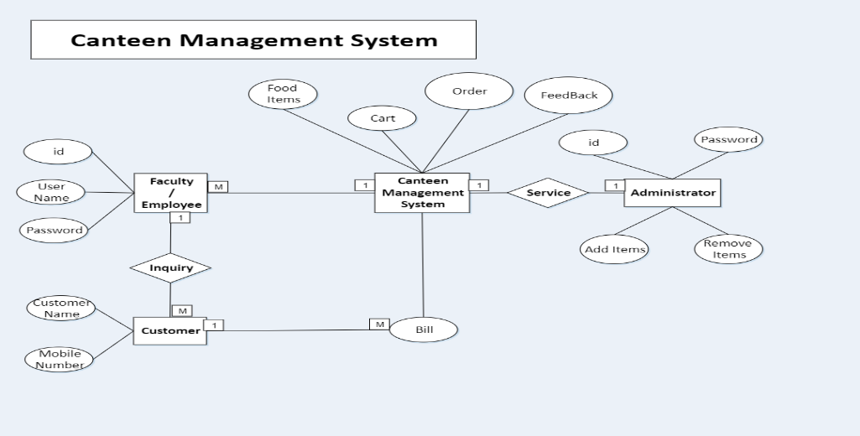

**6.RESULTS**

**6.1 Index view**

"The index view in the Smart Canteen Management System serves as the central hub for users to explore and interact with the menu. Displaying a well-organized list of menu items with real-time availability, the index view offers a user-friendly interface, supporting features like categorization, filtering, and search. Its responsiveness, dynamic updates, and integration with the ordering system ensure a seamless and efficient experience for customers, allowing them to quickly browse, select, and order items with ease."

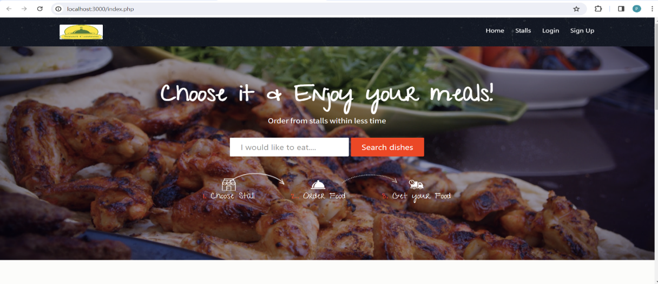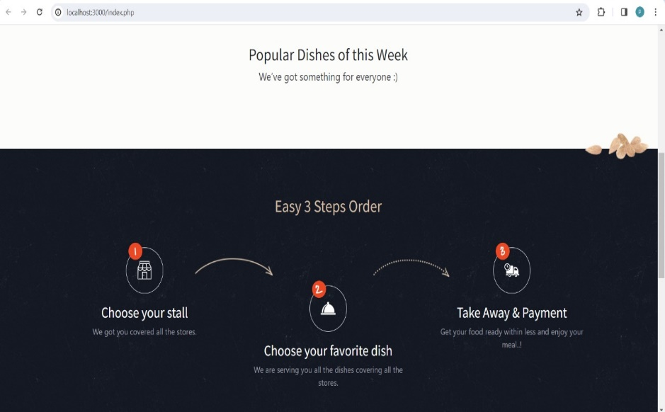

**6.2 NGO’s dashboard**

In the context of a Smart Canteen Management System project, a login form plays a crucial role in ensuring secure access to the system.The login form is the gateway to the Smart Canteen Management System, providing a secure means for authorized users to access the platform. Users, including both customers and staff, input their unique credentials such as username and password to gain entry. The form incorporates essential security measures, including encryption, to safeguard sensitive information. Upon successful authentication, users are granted access to personalized features, ensuring a secure and seamless experience within the Canteen Management System.

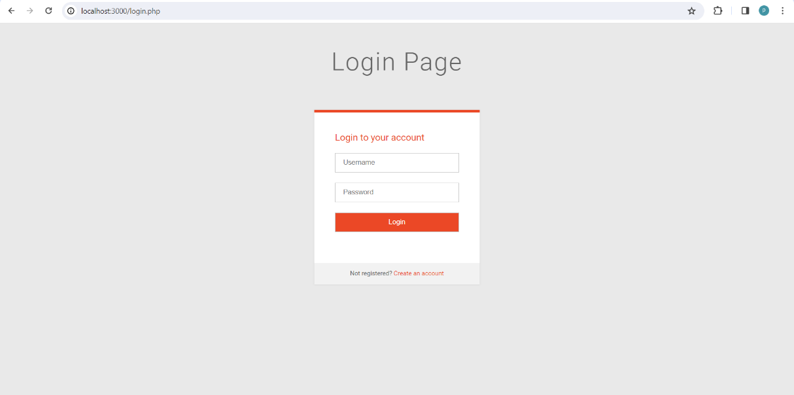

**6.3 Admin side view**

The admin side view in the Smart Canteen Management System is the interface designed for administrators to efficiently oversee and control canteen operations. It includes features like user management for adding or modifying accounts, menu management for updating items and prices, order tracking for real-time monitoring,

reporting for data-driven decisions, inventory control for stock management, system configuration for adjusting settings, security management for permissions, communication tools for announcements, and a dashboard for a quick overview of key metrics. This interface empowers administrators to streamline tasks and ensure the smooth functioning of the canteen system..

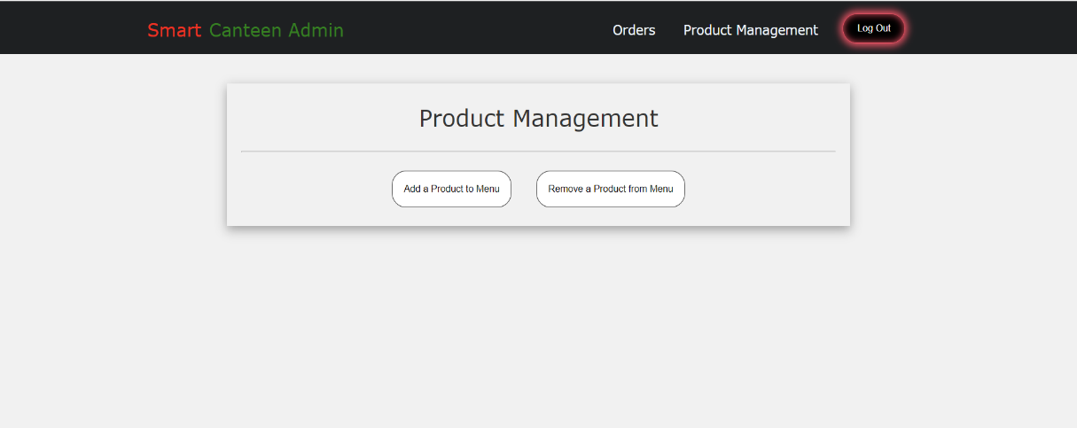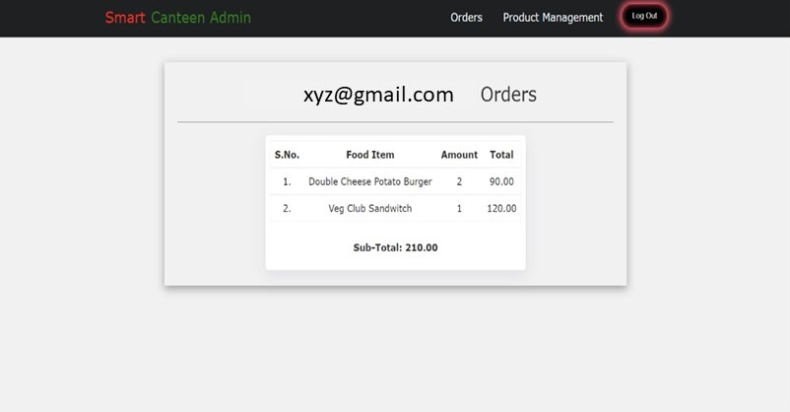

**6.4 Registration form:**

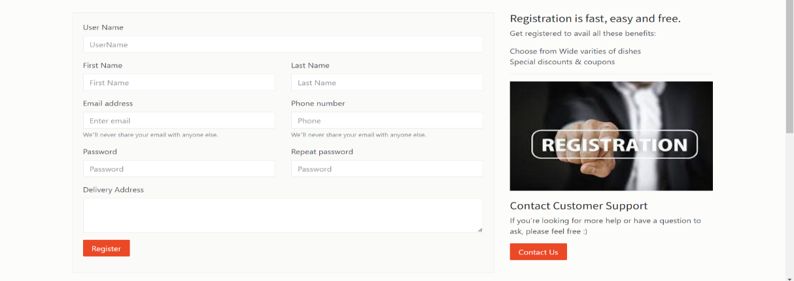

**6.5 Client side view:**

The client-side view in the Smart Canteen Management System is tailored for customers, offering a user-friendly interface. It includes features such as easy menu exploration, simple order placement, account management, search options, cart management, secure payment methods, real-time order tracking, promotions display, and a feedback platform. This ensures a seamless and engaging experience for customers as they browse, order, and interact with the canteen system.

.

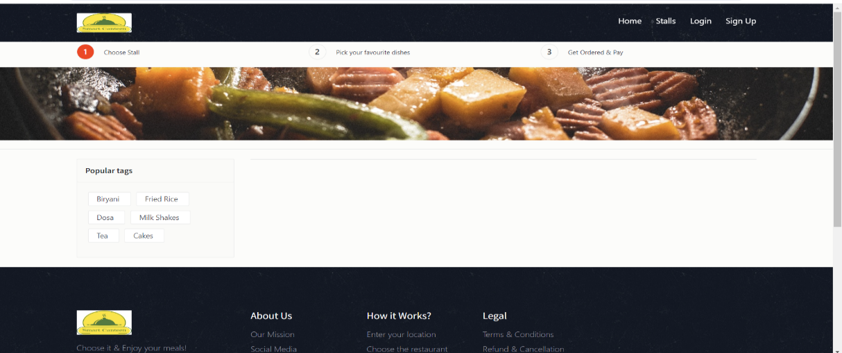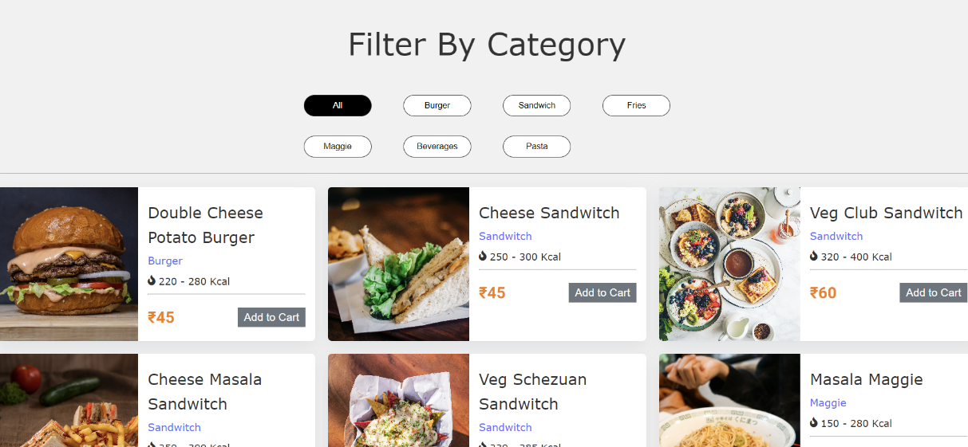

**6.6 Discussion:**

Waiting times were effectively decreased, order accuracy was improved, resources were optimally allocated, and customer happiness was increased with the "Smart Canteen System" for educational institutions. The incorporation of time slot bookings and feedback mechanisms boosted the canteen's operations' efficiency and convenience

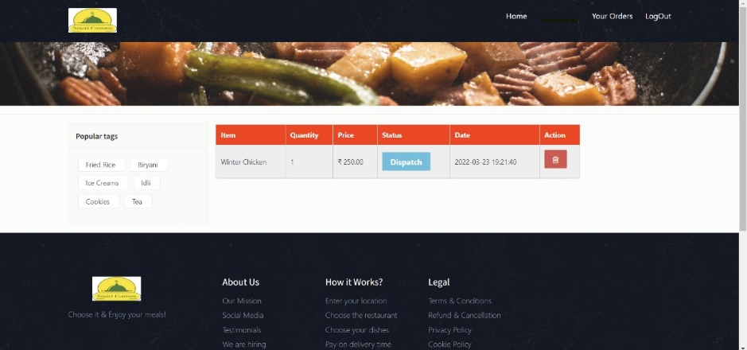

From the above window, we can find the result is declared and giving assurance for a better smart canteen system in institutions.

**7.CONCLUSION**

Finally, the "Smart Canteen Management System" project seeks to usher in a new era of canteen management in educational institutions by utilizing the strength of contemporary technology and automation. By streamlining transactions, optimizing resource allocation, and boosting the overall experience for both staff members and students, this ground-breaking solution presents a practical and user-friendly approach to managing cafeteria operations. Several advantages, including shorter wait times, increased effectiveness, simplified inventory management, and higher user satisfaction, are promised as a result of its implementation. Every person needs many meals a day, thus this method becomes a vital resource for preventing schedule disruptions caused by lengthy lines and delays. Additionally, it provides a flexible and scalable system that enables customization to meet the specific needs of many academic institutions. By doing this, it prepares everyone for a contemporary, cutting-edge, and enjoyable canteen experience.

It can also be expanded as:

The "Smart Canteen Management System" could be expanded to include meal customization, dietary tracking, feedback and ratings, mobile payment integration, allergen alerts, real-time inventory management, integration with kitchen equipment, discounts and loyalty programs, multilingual support, and a food donation feature. The user experience, efficiency, and social responsibility would all be improved by these additions.

**8.ACKNOWLEDGEMENT**

We would like to express our deepest gratitude to Dr .K. Srinivasa Rao ,Department of Artificial Intelligence and Machine Learning, for his invaluable guidance, persistent support, and profound expertise throughout the development of this project. His meticulous critiques, profound insights, and unwavering encouragement have been instrumental in shaping our research and driving it to fruition. His dedication towards fostering an environment of academic rigor and innovative thinking has not only

facilitated our project's success but has also instilled in us a passion for continuous learning and exploration. We sincerely thank him for his patience, wisdom, and commitment, which have been the cornerstone of our journey.

**REFERENCES**

[1] Ms. S.A.Patil 1, Janhavi. B. Sutar 2 , Sakshi. Y(2021) “AUTOMATED CANTEEN MANAGEMENT SYSTEM”- , IRJ of Modernization in Engineering Technology and Science , Volume:03.

[2] Ms.Minu, Kowshik reddy, Sumanth Ashik Teja (2018) “ONLINE CANTEEN SYSTEM” CSE ,SRM Institute of Science and Technology, Ramapuram, Chennai, India , JETIR October 2018, Volume 5 of 10th Issue.

[3] Tazeen Khan and Daniel Yunus published a paper titled "Cloud-Based Canteen Management System" in the International Journal for Research in Engineering Application & Management (IJREAM) in November 2016.

[4] Rupali B. Kale , K. Balwade, Vipin B. Gawai(2020) “Online Food Ordering System for Canteen in College”, RESEARCH ARTICLE SAMRIDDHI Volume 12, Issue 2.

[5] Shourya Pradhan, Shubham Jain ,Shubhanshu Pratap Singh, Yash Gupta (2019)“Canteen Management App”,International Journal of Information Sciences and

Application (IJISA). ISSN 0974-2255, Vol.11, No.1, 2019.

[6] Arfa Hassan, Salma Rashid, Raheela Khan, and Shazia Saqib authored the paper titled "Automated Food

Ordering System," which was published in the LGU Research Journal for Computer Sciences & IT (Volume 2, Issue 4) in October-December 2018.

[7] N. Durga Swathi & T. Durga “ONLINE CANTEEN FOOD ORDERING SYSTEM”, VSM College of Engineering, East Godavari District, AP, India, AEGAEUM JOURNAL Volume 8, Issue 8, 2020 ISSN NO: 0776-3808.

[8] B. Muniraja and J. Rajanikanth's research paper on "In-Time Billing Process for Canteen Management System" was featured in the IJETER, Volume 3, Issue 6, with pages spanning from 200 to 203 in 2015.

[9] Ashwini J, Ayisha Shetty, Chaithra, Lasya K Rao,Asst. Prof. Ramya D Shetty(2018) “Automated Food Ordering System”, International Journal of Scientific &

Engineering Research Volume 9.

[10] Suman Chatterjee,Manish Kumar Thakur's "Smart College Management System" is featured in the IJERT . This Android-based app simplifies college tasks for administrators, faculty, and students, reducing paperwork and enhancing the college experience.