KIRAN.N
GREAT LEARNING

time Series forecasting project Report

Table of Contents
List Of Tables 3
List Of Figures 4
Problem 5
Q1 Read the data as an appropriate Time Series data and plot the data. 5
Q2. Perform appropriate Exploratory Data Analysis to understand the data and also perform decomposition. 6
Size Of Dataset 6
Data Type & Null Check 7
Descriptive Statistics 7
Univariate Analysis 8
Q3 Split the data into training and test. The test data should start in 1991. 11
Q4 Build all the exponential smoothing models on the training data and evaluate the model using RMSE on the test data. Other models such as regression, naïve forecast models and simple average models. should also be built on the training data and check the performance on the test data using RMSE. 12
Basic Forecast 12
Moving Average Forecast 13
Exponential Smoothening Forecast 14
Q5. Check for the stationarity of the data on which the model is being built on using appropriate statistical tests and also mention the hypothesis for the statistical test. If the data is found to be non-stationary, take appropriate steps to make it stationary. Check the new data for stationarity and comment. Note: Stationarity should be checked at alpha = 0.05. 16
Q6. Build an automated version of the ARIMA/SARIMA model in which the parameters are selected using the lowest Akaike Information Criteria (AIC) on the training data and evaluate this model on the test data using RMSE. 17
Sparkling Data 19
Rose Data 20
Q7 Build ARIMA/SARIMA models based on the cut-off points of ACF and PACF on the training data and evaluate this model on the test data using RMSE. 22
Sparkling data 22
Rose Data 25
Q8 Build a table with all the models built along with their corresponding parameters and the respective RMSE values on the test data. 28
Sparkling Data 28
Rose Data 29
Q9 Based on the model-building exercise, build the most optimum model(s) on the complete data and predict 12 months into the future with appropriate confidence intervals/bands 29
Sparkling Data 29
Rose Data 30
Q10 Comment on the model thus built and report your findings and suggest the measures that the company should be taking for future sales. 30
Suggestions: 31
Thank You 31

List Of Tables
Table 1: Sparking Data Set Sample 5
Table 2: Rose Data Set Sample 5
Table 3: Descriptive Statistics of Sparkling Dataset 7
Table 4: Descriptive Statistics of Rose Dataset 8
Table 5: RMSE Values of Sparkling Data 12
Table 6: RMSE Values of Rose Data 13
Table 7: Moving Average RMSE Values of Sparkling Data 13
Table 8: Moving Average RMSE Values of Rose Data 14
Table 9: Exponential Smoothening RMSE values of Sparkling Data 14
Table 10: Exponential Smoothening RMSE values of Rose Data 15
Table 11: Exponential Smoothening Parameters for Sparkling Data 16
Table 12: Exponential Smoothening Parameters for Rose Data 16
Table 13: Summarising ARIMA - SARIMA Optimal Values 18
Table 14: Auto ARIMA Model Result Summary of Sparkling Data 19
Table 15: Auto SARIMA Model Result Summary of Sparkling Data 19
Table 16: Auto ARIMA - SARIMA RMSE values of Sparkling Data 20
Table 17: Auto ARIMA Model Result Summary of Rose Data 20
Table 18: Auto SARIMA Model Result Summary of Rose Data 21
Table 19: ARIMA - SARIMA RMSE values of Rose Data 21
Table 20: Manual ARIMA Model Result Summary of Sparkling Data 23
Table 21: Manual SARIMA Model Result Summary of Sparkling Data 24
Table 22: Manual ARIMA - SARIMA RMSE values of Sparkling Data 24
Table 23: Manual ARIMA Model Result Summary of Rose Data 26
Table 24: Manual SARIMA Model Result Summary of Rose Data 27
Table 25: Manual ARIMA - SARIMA RMSE values of Rose Data 28
Table 26: Sparkling Data RMSE Values on the Test Data 28
Table 27: Rose Data RMSE Values on the Test Data 29

List Of Figures
Figure 1: Time Series Data Plot of Sparkling Data 6
Figure 2: Time Series Data Plot of Rose Data 6
Figure 3: Sparkling Sales Yearly Boxplot 8
Figure 4: Rose Sales Yearly Boxplot 8
Figure 5: Sparkling Sales Monthly Boxplot 9
Figure 6: Rose Sales Monthly Boxplot 9
Figure 7: Additive Decomposition of Sparkling Data 9
Figure 8: Multiplicative Decomposition of Sparkling Data 10
Figure 9: Additive Decomposition of Rose Data 10
Figure 10: Multiplicative Decomposition of Rose Data 11
Figure 11: Sparkling Dataset After Train and Test Split 12
Figure 12: Rose Dataset After Train and Test Split 12
Figure 13: Sparkling Data Forecast Plot 13
Figure 14: Rose Data Forecast Plot 13
Figure 15: Moving Average Sparkling Data Forecast Plot 14
Figure 16: Moving Average Rose Data Forecast Plot 14
Figure 17: Exponential Smoothening Sparkling Data Forecast Plot 15
Figure 18: Exponential Smoothening Rose Data Forecast Plot 15
Figure 19: Rolling Statistics plot of Sparkling Data with one level of differencing 17
Figure 20: Rolling Statistics plot of Rose Data with one level of differencing 17
Figure 21: ACF Plot of Sparkling Data 18
Figure 22: ACF Plot of Rose Data 18
Figure 23: Auto SARIMA Model Diagnostic Plot of Sparkling Data 20
Figure 24: SARIMA Model Diagnostic Plot of Rose Data 21
Figure 25: ACF Plot of Sparkling Training Data with 1 Level Differencing 22
Figure 26: PACF Plot of Sparkling Training Data with 1 Level Differencing 22
Figure 27: ACF Plot of Sparkling Training Data with 12 Level Differencing 23
Figure 28: PACF Plot of Sparkling Training Data with 12 Level Differencing 23
Figure 29: Manual SARIMA Model Diagnostic Plot of Sparkling Data 24
Figure 30: ACF Plot of Rose Training Data with 1 Level Differencing 25
Figure 31: PACF Plot of Rose Training Data with 1 Level Differencing 25
Figure 32: ACF Plot of Rose Training Data with 12 Level Differencing 26
Figure 33: PACF Plot of Rose Training Data with 12 Level Differencing 27
Figure 34: Manual SARIMA Model Diagnostic Plot of Rose Data 28
Figure 35: Sparkling Data Forecast Using Optimal Model 30
Figure 36: Rose Data Forecast Using Optimal Model 30
Figure 37: Optimal Model with Optimal Values 30

Problem
For this particular assignment, the data of different types of wine sales in the 20th century is to be analysed. Both of these data are from the same company but of different wines. As an analyst in the ABC Estate Wines, you are tasked to analyse and forecast Wine Sales in the 20th century.

Q1 Read the data as an appropriate Time Series data and plot the data.
Time Series data present in csv file is read into a pandas Data Frame using read_csv() function. This normally loads data into a dataframe. To inform pandas that current data is a time series data we pass a parameter ‘parse_dates’ with the time series column YearMonth as a value. Also, we make our time series reference as the index.
The current Time series data, Sparkling.csv has the sales information of Sparkling wines from January 1980 to July 1995 total 187 rows.
The current Time series data, Rose.csv has the sales information of Sparkling wines from January 1980 to July 1995 total 187 rows.
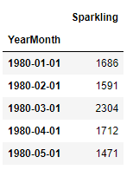
Table 1: Sparking Data Set Sample
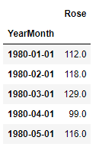
Table 2: Rose Data Set Sample

Following figures show the Time series plot of Sparkling and Rose wine sales information.

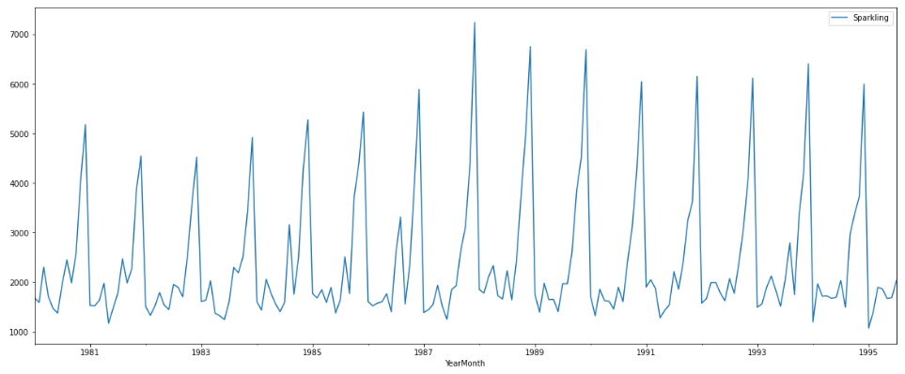
Figure 1: Time Series Data Plot of Sparkling Data

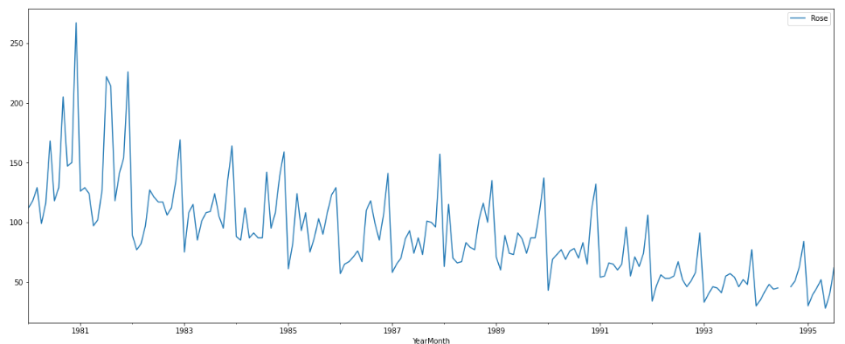
Figure 2: Time Series Data Plot of Rose Data

Q2. Perform appropriate Exploratory Data Analysis to understand the data and also perform decomposition.

Size Of Dataset
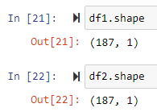
From the above output we observe there are total 187 rows of data in each dataset.

Data Type & Null Check
- Sparkling Dataset

<class 'pandas.core.frame.DataFrame'>
DatetimeIndex: 187 entries, 1980-01-01 to 1995-07-01
Data columns (total 1 columns):
# Column Non-Null Count Dtype
--- ------ -------------- -----
0 Sparkling 187 non-null int64
dtypes: int64(1)

The Sparkling column present in data set is of integer type and there are no null values present in the dataset.

- Rose dataset
<class 'pandas.core.frame.DataFrame'>
DatetimeIndex: 187 entries, 1980-01-01 to 1995-07-01
Data columns (total 1 columns):
# Column Non-Null Count Dtype
--- ------ -------------- -----
0 Rose 185 non-null float64
dtypes: float64(1)
memory usage: 2.9 KB
The Rose column present in data set is of integer type and there are 2 null values present in the dataset. Using bfill() we are replacing null values present in the dataset.

Descriptive Statistics
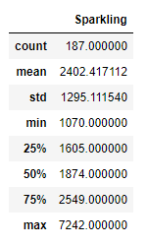
Table 3: Descriptive Statistics of Sparkling Dataset
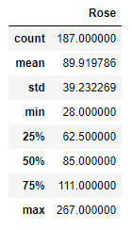
Table 4: Descriptive Statistics of Rose Dataset

Univariate Analysis

Box Plots by Year
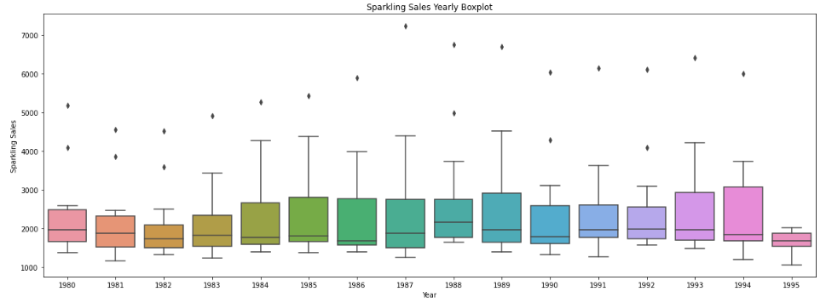
Figure 3: Sparkling Sales Yearly Boxplot
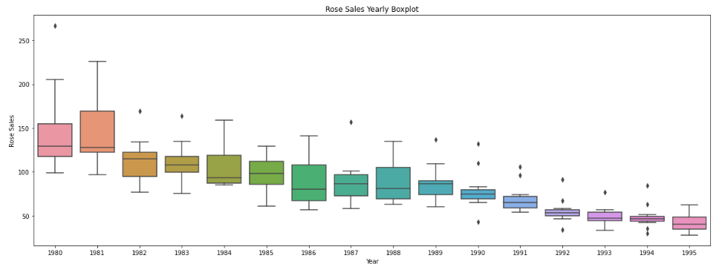
Figure 4: Rose Sales Yearly Boxplot

Box Plots by Month
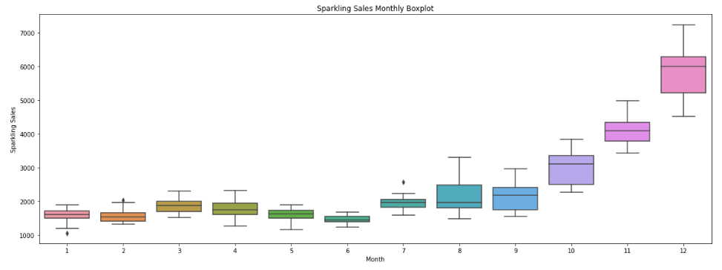
Figure 5: Sparkling Sales Monthly Boxplot
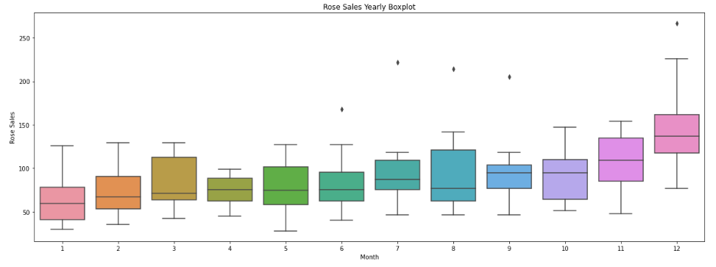
Figure 6: Rose Sales Monthly Boxplot
From the above monthly plots, we observe sales during December month are high compared to other months.
Also, sale of Rose wine is decreasing on year-on-year basis.

Time Series Decomposition
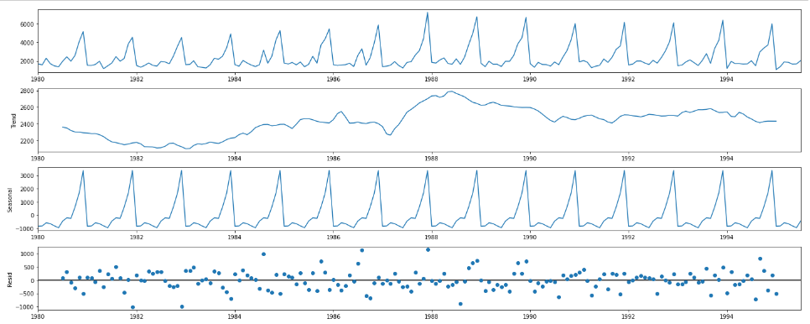
Figure 7: Additive Decomposition of Sparkling Data
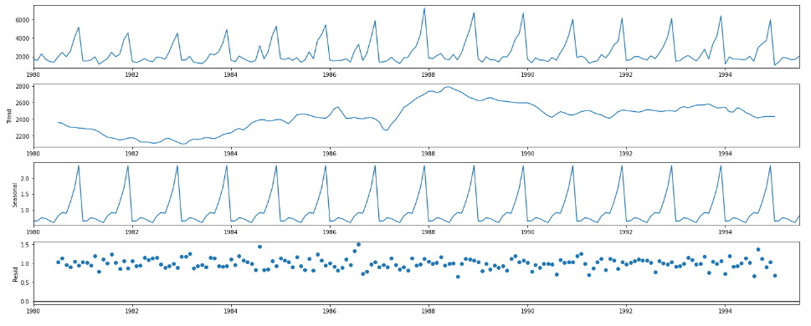
Figure 8: Multiplicative Decomposition of Sparkling Data
We have decomposed the Time series data in Additive and Multiplicative decomposition in Fig 7 and Fig 8 respectively. Observing both the decomposition patterns, Residual component in Additive decomposition still shows some kind of pattern and data points are spread across while Residual component in Multiplicative decomposition does not show any pattern and data points are spread evenly.
Hence Multiplicative decomposition is the right way of decomposition for Sparkling dataset.
Individual Components output is present in IPYNB file.
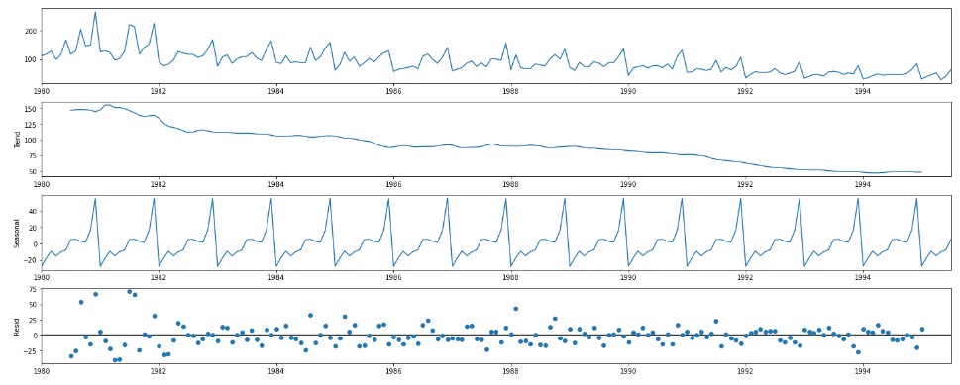
Figure 9: Additive Decomposition of Rose Data
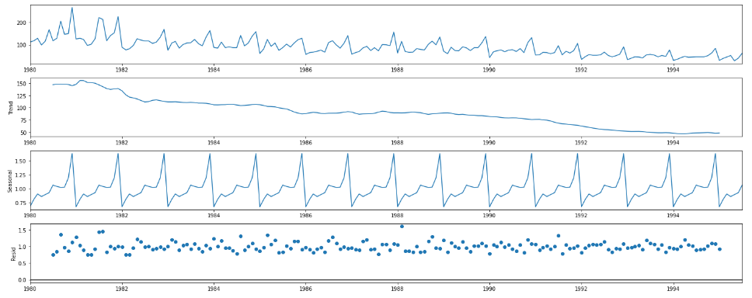
Figure 10: Multiplicative Decomposition of Rose Data
We have decomposed the Time series data in Additive and Multiplicative decomposition in Fig 9 and Fig 10 respectively. Observing both the decomposition patterns, Residual component in Additive decomposition still shows some kind of pattern and data points are spread across while Residual component in Multiplicative decomposition does not show any pattern and data points are spread evenly.
Hence Multiplicative decomposition is the right way of decomposition for Sparkling dataset.
Individual Components output is present in IPYNB file.

Q3 Split the data into training and test. The test data should start in 1991.
The regular approach to split the data into Train and Test dataset was to use TrainTestSplit which randomly splits the data train and test dataset. Currently we are dealing with Timeseries data which cannot be split randomly, here we split the data into train and test dataset based on a date. In the current problem all timeseries data before 1991 is taken as train data and test data starts from 1991.

After splitting the data into train and test data in both Sparkling and Rose dataset, Train dataset has 132 rows and test data set has 55 rows.
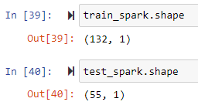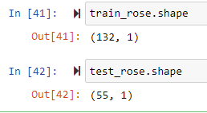

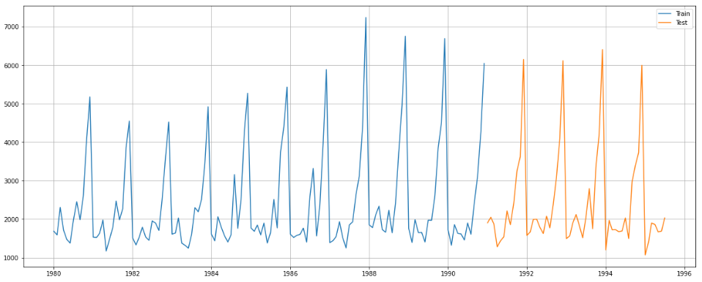
Figure 11: Sparkling Dataset After Train and Test Split
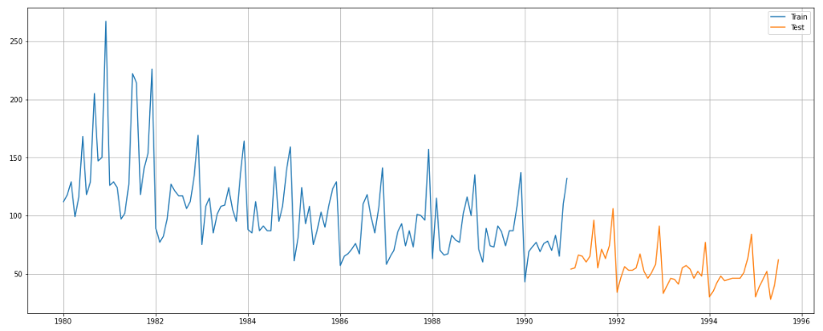
Figure 12: Rose Dataset After Train and Test Split

Q4 Build all the exponential smoothing models on the training data and evaluate the model using RMSE on the test data. Other models such as regression, naïve forecast models and simple average models. should also be built on the training data and check the performance on the test data using RMSE.
After splitting the given dataset into test and train dataset, we have built Linear Regression Model, Naïve Forecast Model and Simple average model for Forecasting purpose.

Basic Forecast
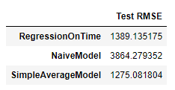
Table 5: RMSE Values of Sparkling Data
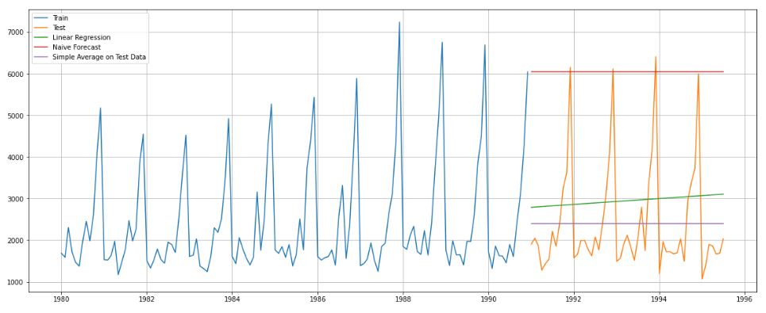
Figure 13: Sparkling Data Forecast Plot
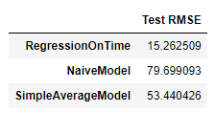
Table 6: RMSE Values of Rose Data
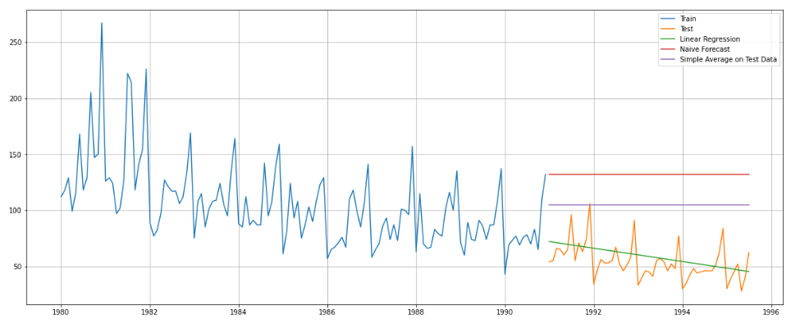
Figure 14: Rose Data Forecast Plot

Moving Average Forecast
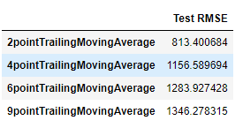
Table 7: Moving Average RMSE Values of Sparkling Data
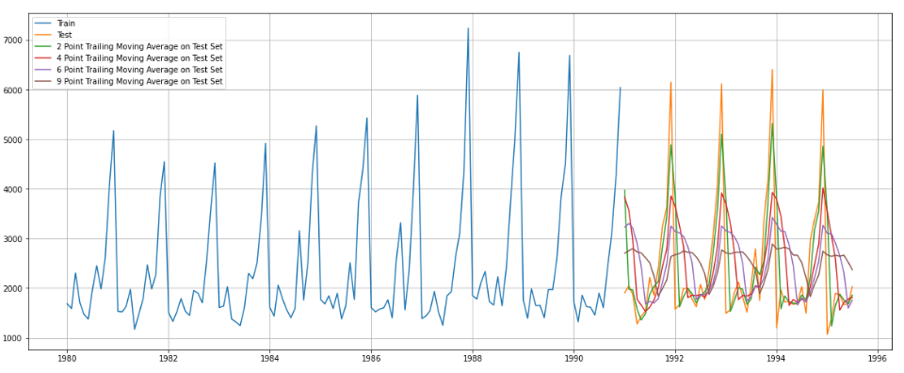
Figure 15: Moving Average Sparkling Data Forecast Plot
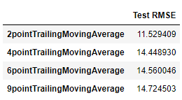
Table 8: Moving Average RMSE Values of Rose Data
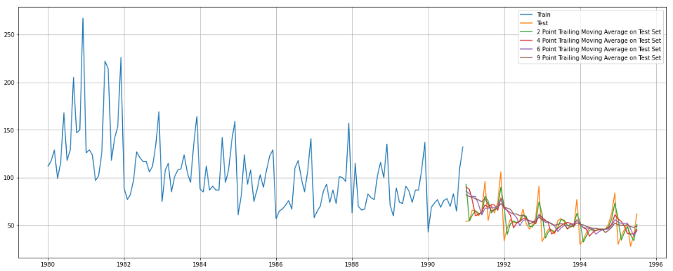
Figure 16: Moving Average Rose Data Forecast Plot

Exponential Smoothening Forecast
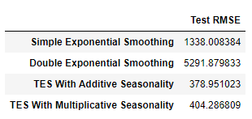
Table 9: Exponential Smoothening RMSE values of Sparkling Data
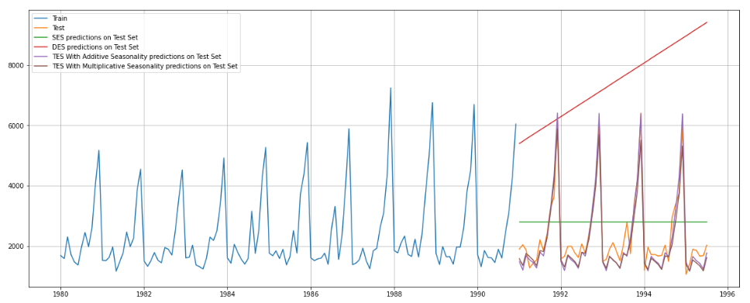
Figure 17: Exponential Smoothening Sparkling Data Forecast Plot
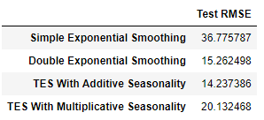
Table 10: Exponential Smoothening RMSE values of Rose Data
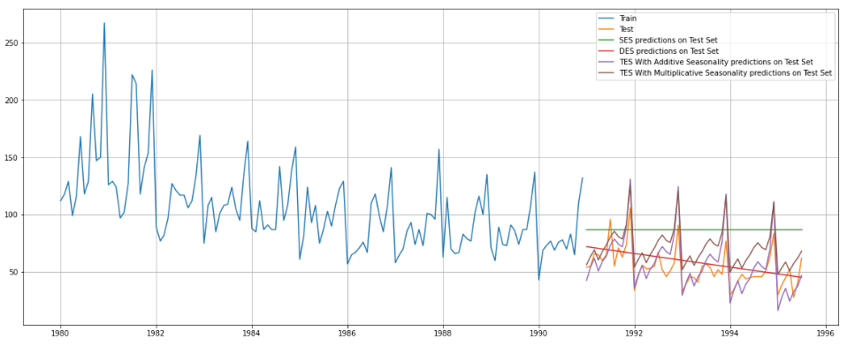
Figure 18: Exponential Smoothening Rose Data Forecast Plot
From the above forecasts,
- Sparkling data has highest RMSE for Double Exponential Smoothening Model and lowest RMSE for Triple Exponential Smoothening Model with Additive Seasonality. So Triple Exponential Smoothening Model with Additive Seasonality is better for the given Sparkling data.
- Rose data has highest RMSE for Naïve Forecast Model and lowest RMSE for 2-point Trailing Moving Average Model. So, 2-point Trailing Moving Average Model is better for the given Rose data.
Following table gives the Exponential smoothening parameters for each of the models.
 | Alpha | Beta | Gama
Single Exponential Smoothening | 0.07 | - | -
Double Exponential Smoothening | 0.67 | 0.0001 | -
Triple Exponential Smoothening (Add) | 0.11 | 0.01 | 0.46
Triple Exponential Smoothening (Mul) | 0.11 | 0.04 | 0.36

Table 11: Exponential Smoothening Parameters for Sparkling Data
 | Alpha | Beta | Gama
Single Exponential Smoothening | 0.098 | - | -
Double Exponential Smoothening | 0 | 0.16 | -
Triple Exponential Smoothening (Add) | 0.08 | 0.0002 | 0.003
Triple Exponential Smoothening (Mul) | 0.07 | 0.04 | 0.00007

Table 12: Exponential Smoothening Parameters for Rose Data

Q5. Check for the stationarity of the data on which the model is being built on using appropriate statistical tests and also mention the hypothesis for the statistical test. If the data is found to be non-stationary, take appropriate steps to make it stationary. Check the new data for stationarity and comment. Note: Stationarity should be checked at alpha = 0.05.
The Augmented Dickey-Fuller test is a unit root test which determines whether there is a unit root and subsequently whether the series is non-stationary.
The hypothesis in a simple form for the ADF test is:
H0: The Time Series has a unit root and is thus non-stationary.
H1: The Time Series does not have a unit root and is thus stationary.

We would want the series to be stationary for building ARIMA models and thus we would want the p-value of this test to be less than the alpha value where alpha = 0.05.
- We see that at 5% significant level the Sparkling Time Series data is non-stationary. (p-value = 0.567)
- We see that at 5% significant level the Rose Time Series data is non-stationary.
(p-value = 0.756)
Let us take one level of differencing to see whether the series becomes stationary.
- We see that at α = 0.05 the Sparkling Time Series with one level of differencing is indeed stationary. (p-value = 8.47 e-11)
- We see that at α = 0.05 the Sparkling Time Series with one level of differencing is indeed stationary. (p-value = 3.89 e-08)
Above we have considered training data, also complete dataset is not stationary for both Sparkling and Rose but with one level of differencing they are stationary.
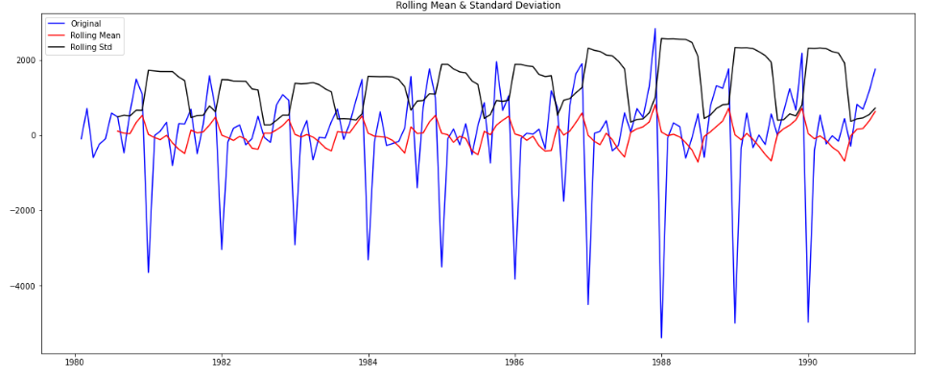Figure 19: Rolling Statistics plot of Sparkling Data with one level of differencing
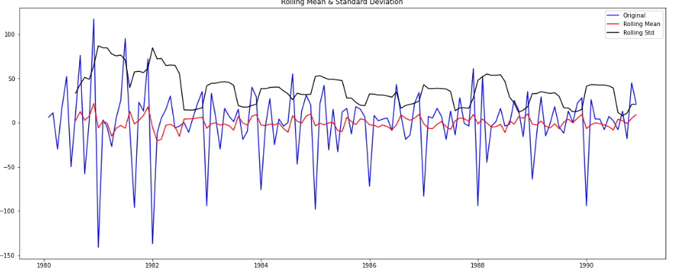
Figure 20: Rolling Statistics plot of Rose Data with one level of differencing

Q6. Build an automated version of the ARIMA/SARIMA model in which the parameters are selected using the lowest Akaike Information Criteria (AIC) on the training data and evaluate this model on the test data using RMSE.
ARIMA models can be built keeping the Akaike Information Criterion (AIC) in mind as well. In this case, we choose the ‘p’ and ‘q’ values to determine the AR and MA orders respectively which gives us the lowest AIC value. Lower the AIC better is the model.
After building the ARIMA mode, optimal values for p, d, q with lowest AIC is:
- Sparkling data -> (2,1,2) with AIC of 2210.61
- Rose data -> (0,1,2) with AIC of 1276.83

We will Plot PACF plot to find the seasonality factor before proceeding with SARIMA model.
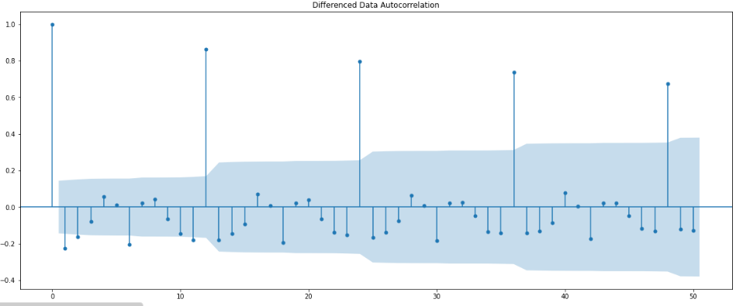
Figure 21: ACF Plot of Sparkling Data
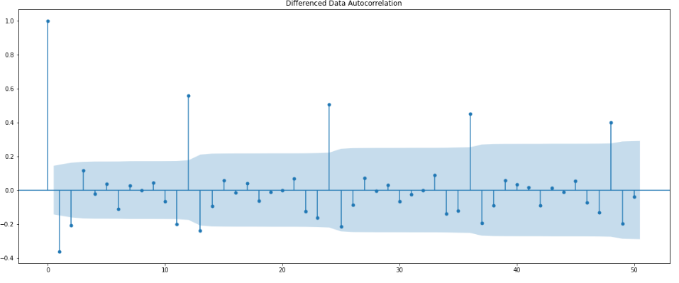
Figure 22: ACF Plot of Rose Data

From the above 2 plots we observe the seasonality of 6 as well as 12 for both Sparkling and Rose Data. We will proceed with 6.
Since the Sparkling data and Rose data with difference level equal to seasonal factor (6) is stationary we take D as 0.
After building the ARIMA mode, optimal values for (p, d, q) and (P, D, Q, seasonal factor) with lowest AIC is:
- Sparkling data -> (0,1,2) (2, 0, 2, 6) with AIC of 1727.88
- Rose data -> (1,1,2) (2, 0, 2, 6) with AIC of 1041.65
 |  | ARIMA (p, d, q) | SARIMA (p, d, q) (P, D, Q, Seasonal Factor)
Sparkling Data | (2, 1, 2) |  | (0,1,2) (2, 0, 2, 6)
Rose Data | (0, 1, 2) |  | (1,1,2) (2, 0, 2, 6)

Table 13: Summarising ARIMA - SARIMA Optimal Values

Sparkling Data
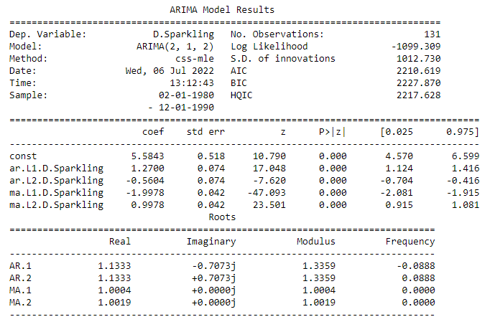
Table 14: Auto ARIMA Model Result Summary of Sparkling Data
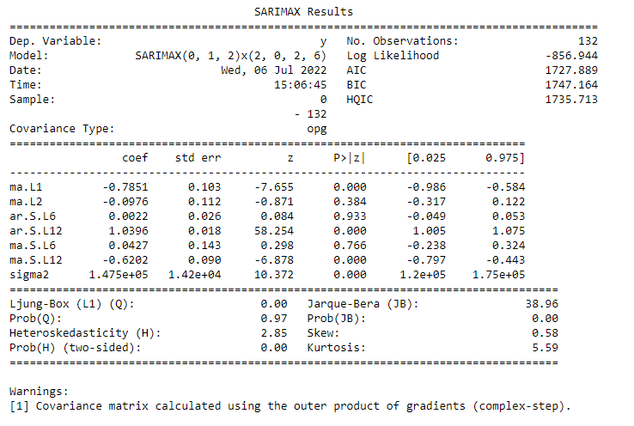
Table 15: Auto SARIMA Model Result Summary of Sparkling Data

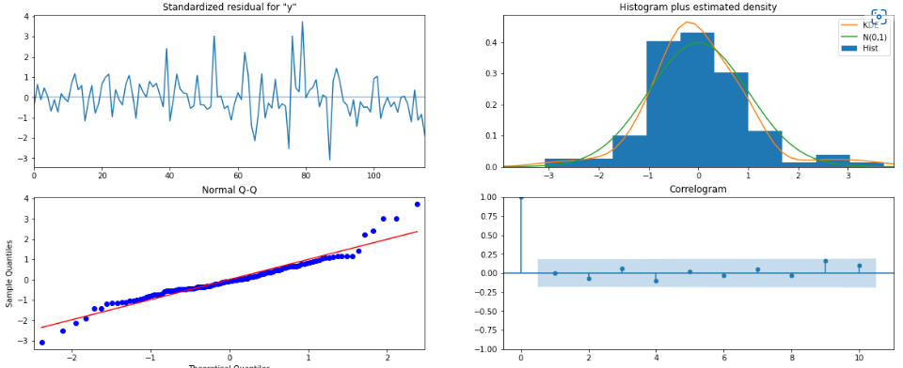
Figure 23: Auto SARIMA Model Diagnostic Plot of Sparkling Data
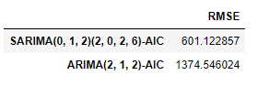
Table 16: Auto ARIMA - SARIMA RMSE values of Sparkling Data

Rose Data
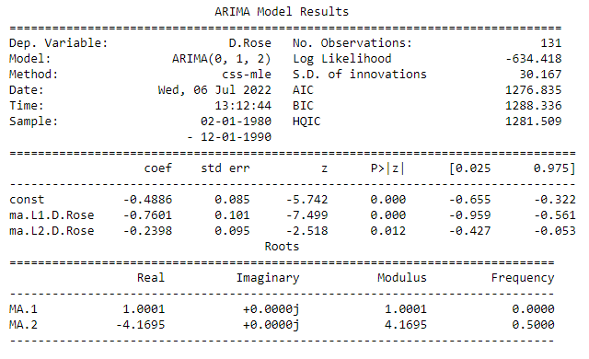
Table 17: Auto ARIMA Model Result Summary of Rose Data
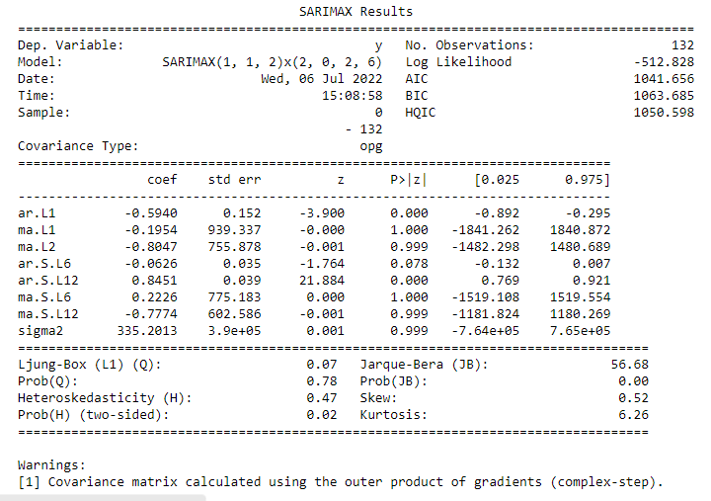
Table 18: Auto SARIMA Model Result Summary of Rose Data
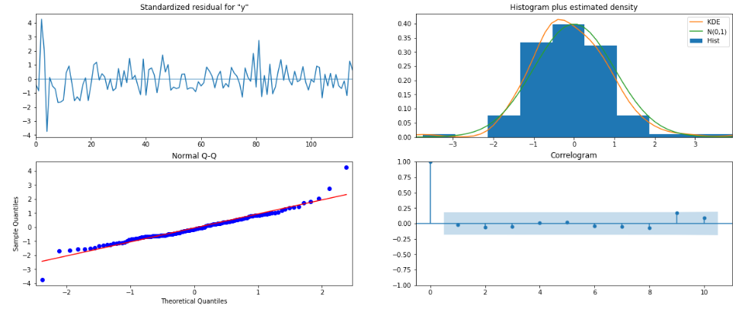
Figure 24: SARIMA Model Diagnostic Plot of Rose Data
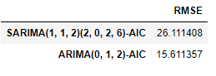
Table 19: ARIMA - SARIMA RMSE values of Rose Data

Q7 Build ARIMA/SARIMA models based on the cut-off points of ACF and PACF on the training data and evaluate this model on the test data using RMSE.
For both Sparkling and Rose data, data as it is was not stationary but data with 1 level of differencing is stationary so d = 1.

Sparkling data
Let us plot ACF and PACF plot and find the values for p and q based on the cut off
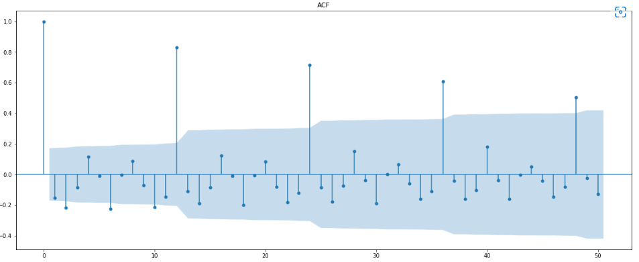
Figure 25: ACF Plot of Sparkling Training Data with 1 Level Differencing
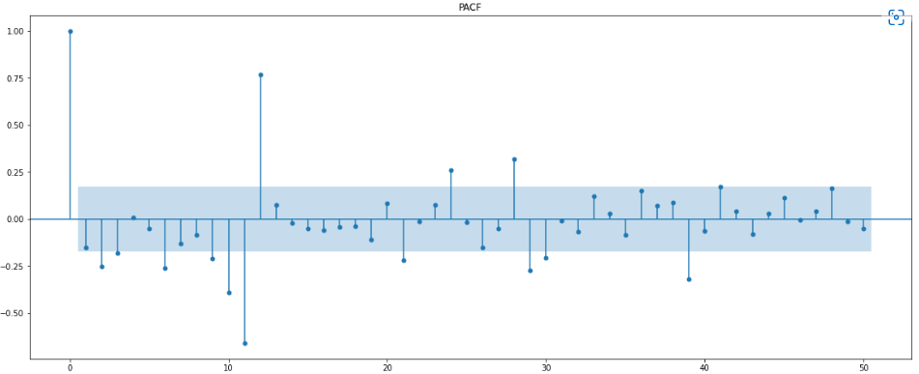
Figure 26: PACF Plot of Sparkling Training Data with 1 Level Differencing
- The Auto-Regressive parameter in an ARIMA model is 'p' which comes from the significant lag before which the PACF plot cuts-off to 0.
- The Moving-Average parameter in an ARIMA model is 'q' which comes from the significant lag before the ACF plot cuts-off to 0.

So, for ARIMA model (p, d, q) is (0, 1, 0)
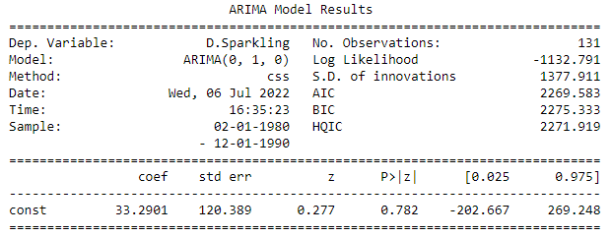
Table 20: Manual ARIMA Model Result Summary of Sparkling Data
Since we observe a seasonality of 12 we plot a ACF and PACF plot for Data with level of difference equal to 12 to find P and Q based on the cut off.
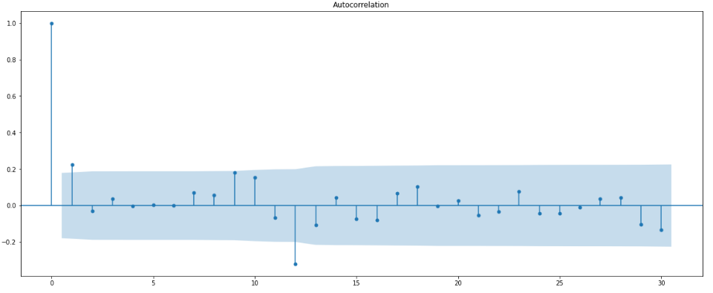
Figure 27: ACF Plot of Sparkling Training Data with 12 Level Differencing
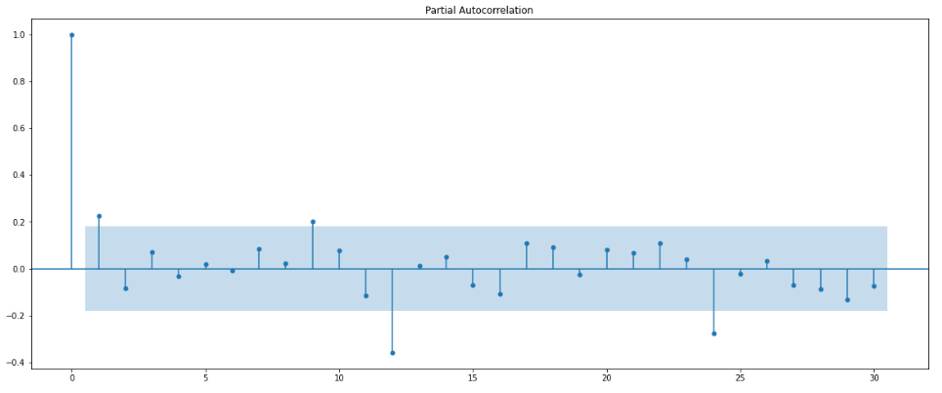
Figure 28: PACF Plot of Sparkling Training Data with 12 Level Differencing

- The Auto-Regressive parameter in a SARIMA model is 'P' which comes from the significant lag before which the PACF plot cuts-off to 1.
- The Moving-Average parameter in a SARIMA model is 'Q' which comes from the significant lag before the ACF plot cuts-off to 1.
So, for SARIMA model (p, d, q) (P, D, Q, seasonal Factor) is (0, 1, 0) (1, 0, 1, 12)
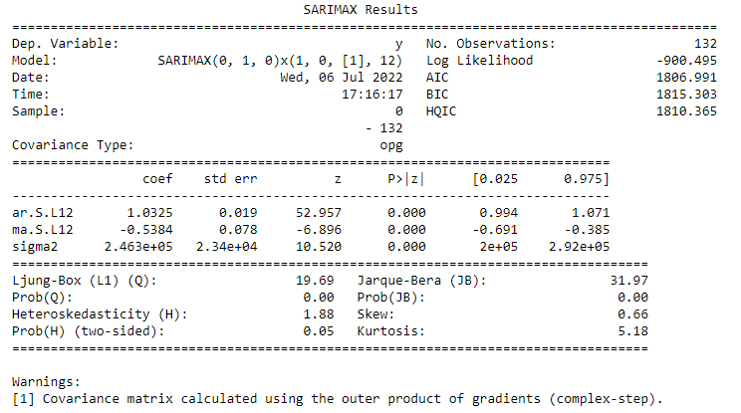
Table 21: Manual SARIMA Model Result Summary of Sparkling Data
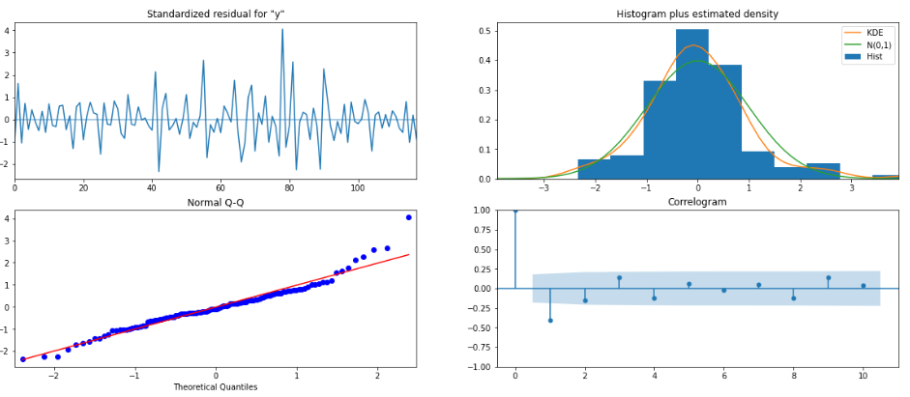
Figure 29: Manual SARIMA Model Diagnostic Plot of Sparkling Data
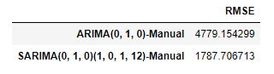
Table 22: Manual ARIMA - SARIMA RMSE values of Sparkling Data

Rose Data
Let us plot ACF and PACF plot and find the values for p and q based on the cut off
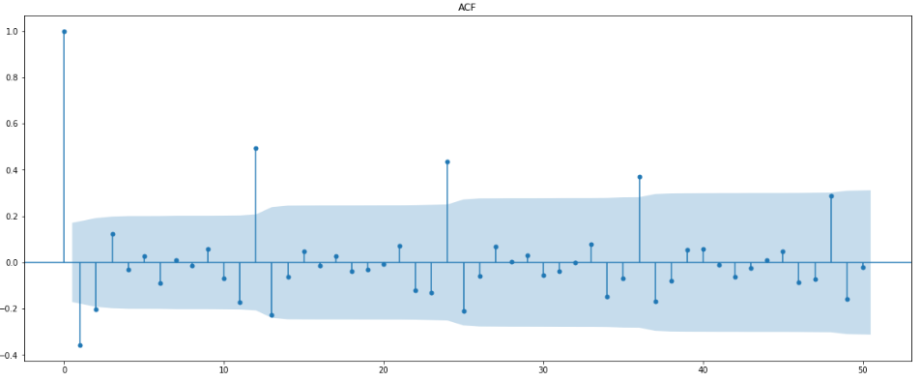
Figure 30: ACF Plot of Rose Training Data with 1 Level Differencing
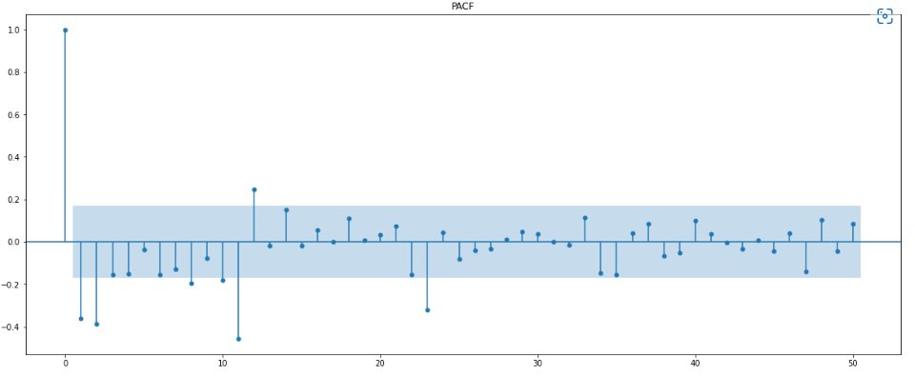
Figure 31: PACF Plot of Rose Training Data with 1 Level Differencing
- The Auto-Regressive parameter in an ARIMA model is 'p' which comes from the significant lag before which the PACF plot cuts-off to 2.
- The Moving-Average parameter in an ARIMA model is 'q' which comes from the significant lag before the ACF plot cuts-off to 2.

So, for ARIMA model (p, d, q) is (2, 1, 2)
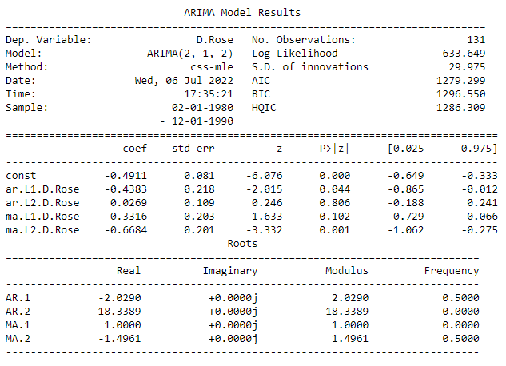
Table 23: Manual ARIMA Model Result Summary of Rose Data
Since we observe a seasonality of 12 we plot a ACF and PACF plot for Data with level of difference equal to 12 to find P and Q based on the cut off.
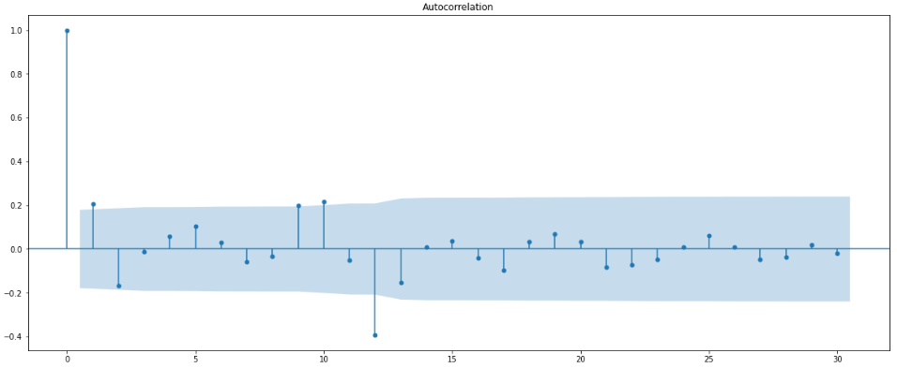
Figure 32: ACF Plot of Rose Training Data with 12 Level Differencing

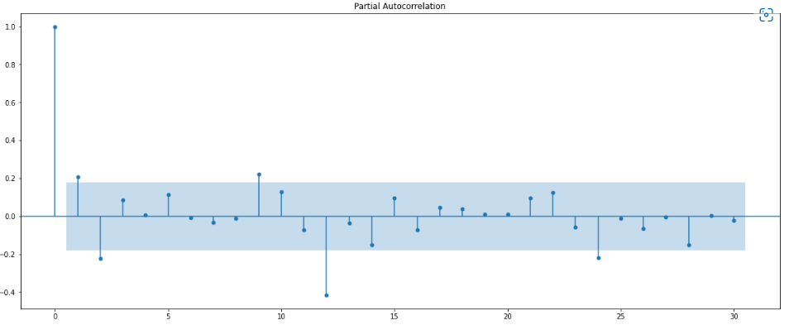
Figure 33: PACF Plot of Rose Training Data with 12 Level Differencing
- The Auto-Regressive parameter in a SARIMA model is 'P' which comes from the significant lag before which the PACF plot cuts-off to 2.
- The Moving-Average parameter in a SARIMA model is 'Q' which comes from the significant lag before the ACF plot cuts-off to 1.
So, for SARIMA model (p, d, q) (P, D, Q, seasonal Factor) is (2, 1, 2) (2, 0, 1, 12)
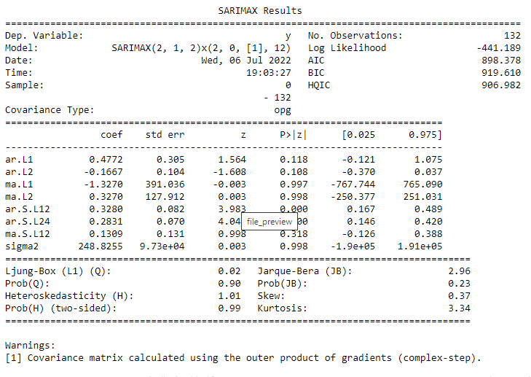
Table 24: Manual SARIMA Model Result Summary of Rose Data
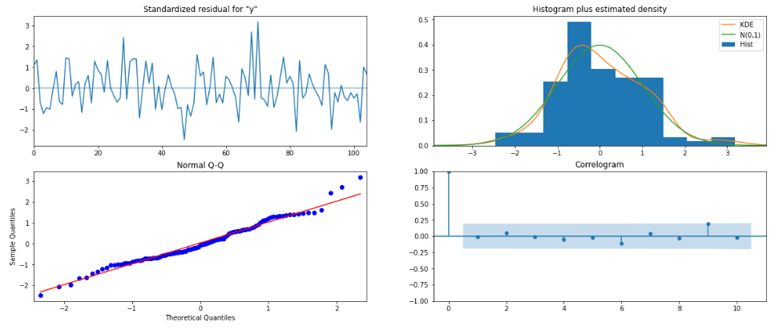
Figure 34: Manual SARIMA Model Diagnostic Plot of Rose Data
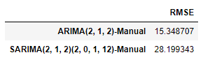
Table 25: Manual ARIMA - SARIMA RMSE values of Rose Data

Q8 Build a table with all the models built along with their corresponding parameters and the respective RMSE values on the test data.

Sparkling Data
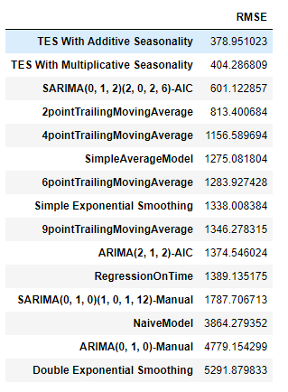
Table 26: Sparkling Data RMSE Values on the Test Data

Rose Data
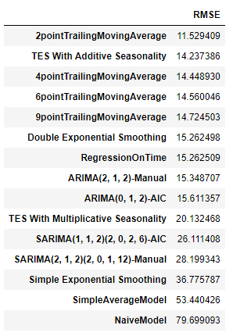
Table 27: Rose Data RMSE Values on the Test Data

Q9 Based on the model-building exercise, build the most optimum model(s) on the complete data and predict 12 months into the future with appropriate confidence intervals/bands

Sparkling Data
From the Table 27 we observe Triple Exponential Smoothing with additive seasonality is the optimal model for given Sparkling dataset which has least RMSE value compared to other models built.
So, using this model we will forecast the data for next 12 months.
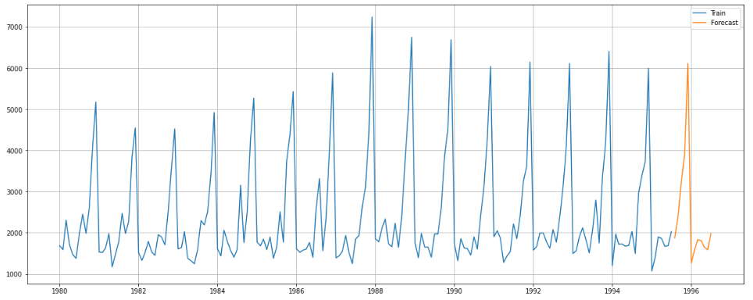
Figure 35: Sparkling Data Forecast Using Optimal Model

Rose Data
From the Table 28 we observe Triple Exponential Smoothing with additive seasonality is the 2nd optimal model for given Rose dataset which has least RMSE value compared to other models built.
2 Point Trailing Moving average was one with least RMSE.
Here using Triple Exponential Smoothing with additive seasonality model we will forecast the data for next 12 months.
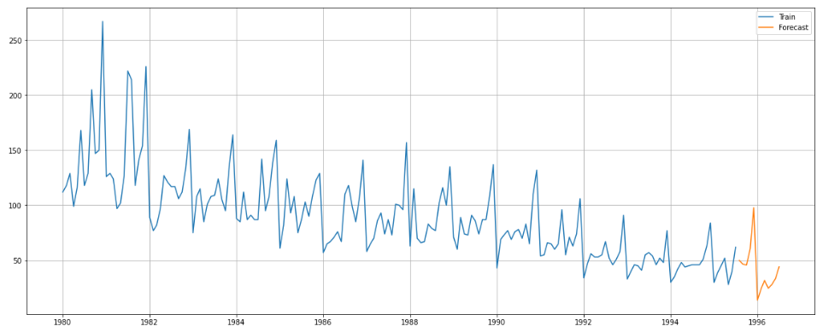
Figure 36: Rose Data Forecast Using Optimal Model

Q10 Comment on the model thus built and report your findings and suggest the measures that the company should be taking for future sales.
Here Triple Exponential Smoothing with additive seasonality model has been selected as optimal Model.
 | Alpha | Beta | Gama
Triple Exponential Smoothening (Add) – Sparkling Data | 0.11 | 0.01 | 0.46
Triple Exponential Smoothening (Mul) – Rose Data | 0.07 | 0.04 | 0.00007
Figure 37: Optimal Model with Optimal Values
Triple Exponential Smoothing with additive seasonality had RMSE of 404.28 and 14.23 for Sparkling and Rose data respectively.

Suggestions:
- From Figure 4 we observe Sales of Rose is decreasing year by year, so company can give more offers on Rose wines and market about the product so that sales increase.
- From Figure 5 and Figure 6 we observe sales of Sparkling and Rose are more in December month Compared to other moths. So, they can increase their production in December month and give more offers and attract customers in other months.
- Market about the products to increase visibility.
- Promote the products by promoting health benefits of wine

Thank You

