KIRAN.N
GREAT LEARNING

Machine learning project Report

Contents
List of Figures 3
List of Tables 4
Problem 1 5
Data Dictionary 5
Q 1.1 Read the dataset. Do the descriptive statistics and do the null value condition check. Write an inference on it. 5
Sample of the Dataset 5
Data Types 6
Null Check 6
Duplicate Check 6
Descriptive Statistics 6
Skewness 7
Q 1.2 Perform Univariate and Bivariate Analysis. Do exploratory data analysis. Check for Outliers. 7
Outliers Check 7
Uni-Variate Analysis 8
Bi-Variate Analysis 8
Multi-Variate Analysis 9
Q 1.3 Encode the data (having string values) for Modelling. Is Scaling necessary here or not? Data Split: Split the data into train and test (70:30). 11
Scaling 11
Encoding String Values 11
Data Split 11
Q 1.4 Apply Logistic Regression and LDA (linear discriminant analysis). 11
Q 1.5 Apply KNN Model and Naïve Bayes Model. Interpret the results. 12
Q 1.6 Model Tuning, Bagging (Random Forest should be applied for Bagging), and Boosting. 12
Random Forest 12
Grid Search 13
Q 1.7 Performance Metrics: Check the performance of Predictions on Train and Test sets using Accuracy, Confusion Matrix, Plot ROC curve and get ROC_AUC score for each model. Final Model: Compare the models and write inference which model is best/optimized. 14
Confusion Metrices 14
Classification Report 15
Accuracy Scores 16
AUC & ROC Curves 17
Q 1.8 Based on these predictions, what are the insights? 19
Problem – 2 20
Q 2.1 Find the number of characters, words, and sentences for the mentioned documents. 20
Q 2.2 Remove all the stopwords from the three speeches 21
Q 2.3 Which word occurs the most number of times in his inaugural address for each president? Mention the top three words. (after removing the stopwords) 21
Q 2.4 Plot the word cloud of each of the speeches of the variable. (after removing the stopwords) 22

List of Figures
Figure 1: Box Plot of Numeric Columns 7
Figure 2: Histogram of Numeric Columns 8
Figure 3: Count Plot of Object Columns 8
Figure 4: Bivariate Analysis Vote Verses All Numeric Columns 8
Figure 5: Bivariate Analysis Gender Verses All Numeric Columns 9
Figure 6: Bi-Variate Analysis of Vote verses Gender 9
Figure 7: Pair Plot 10
Figure 8: Correlation Plot 10
Figure 9: Random Forest ROC Curve for Training Data 17
Figure 10: Random Forest ROC Curve for Testing Data 17
Figure 11: Random Forest with Bagging ROC Curve for Training Data 17
Figure 12: Random Forest with Bagging ROC Curve for Testing Data 18
Figure 13: Random Forest with Ada Boosting ROC Curve for Training Data 18
Figure 14: Random Forest with Ada Boosting ROC Curve for Testing Data 18
Figure 15: Random Forest with Gradient Boosting ROC Curve for Training Data 19
Figure 16: Random Forest with Gradient Boosting ROC Curve for Testing Data 19
Figure 17: Word Cloud Roosevelt Speech 22
Figure 18: Word Cloud Kennedy Speech 22
Figure 19: Word Cloud Nixon Speech 22

List of Tables
Table 1: Sample Dataset 5
Table 2: Descriptive Statistics of Numeric Columns 6
Table 3 :Descriptive Statistics of Object Columns 7
Table 4: Skewness Matrix 7
Table 5:LR and LDA Model Scores of Test & Train data 11
Table 6: KNN and GNB Model Scores of Test & Train data 12
Table 7: Model Scores of Different Model Tuning Techniques 13
Table 8: Comparison of all 4 models 20
Table 9: Table of Word, Character And Sentences Count 20
Table 10: Difference in Count Before and After Removing Stop words 21

Problem 1
You are hired by one of the leading news channels CNBE who wants to analyse recent elections. This survey was conducted on 1525 voters with 9 variables. You have to build a model, to predict which party a voter will vote for on the basis of the given information, to create an exit poll that will help in predicting overall win and seats covered by a particular party.

Data Dictionary
- vote: Party choice: Conservative or Labour
- age: In years
- economic.cond.national: Assessment of current national economic conditions, 1 to 5.
- economic.cond.household: Assessment of current household economic conditions, 1 to 5.
- Blair: Assessment of the Labour leader, 1 to 5.
- Hague: Assessment of the Conservative leader, 1 to 5.
- Europe: an 11-point scale that measures respondents' attitudes toward European integration. High scores represent ‘Eurosceptic’ sentiment.
- political.knowledge: Knowledge of parties' positions on European integration, 0 to 3.
- gender: female or male.

Q 1.1 Read the dataset. Do the descriptive statistics and do the null value condition check. Write an inference on it.

Sample of the Dataset
After removing the redundant ‘Unnamed’ and renaming the columns, by replacing ‘.’ with ‘_’ the sample data appears as follows.
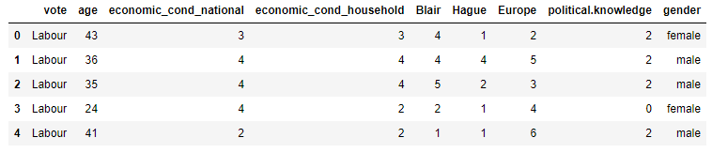
Table 1: Sample Dataset

There are total 1525 rows and 9 columns present in the given dataset. Each row in the dataset represents an individual voters vote along with other information.

Data Types
vote object
age int64
economic_cond_national int64
economic_cond_household int64
Blair int64
Hague int64
Europe int64
political.knowledge int64
gender object

Out of nine columns two are of object type and remaining seven are of integer type.

Null Check
<class 'pandas.core.frame.DataFrame'>
RangeIndex: 1525 entries, 0 to 1524
Data columns (total 9 columns):
# Column Non-Null Count Dtype
--- ------ -------------- -----
0 vote 1525 non-null object
1 age 1525 non-null int64
2 economic_cond_national 1525 non-null int64
3 economic_cond_household 1525 non-null int64
4 Blair 1525 non-null int64
5 Hague 1525 non-null int64
6 Europe 1525 non-null int64
7 political.knowledge 1525 non-null int64
8 gender 1525 non-null object

From the above result we observe there are no null values present in the given dataset.

Duplicate Check
There are total 8 duplicate rows in the given dataset. We will drop duplicates and proceed further.

Descriptive Statistics
Following table shows the descriptive statistics of all numeric columns present in data set.
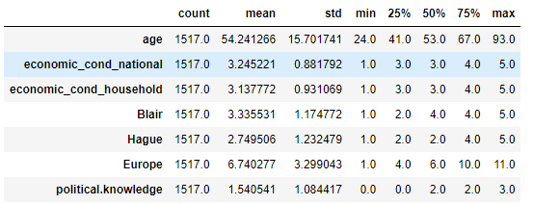
Table 2: Descriptive Statistics of Numeric Columns
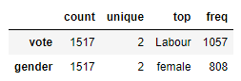
Table 3 :Descriptive Statistics of Object Columns
- From the above table, in the given dataset highest voles are for Labour Party.
- Females are higher in number compared to men in the given data set.

Skewness
It is a measure of the asymmetry of distribution of data about its mean. The skewness value can be positive, zero, negative.
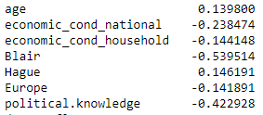
Table 4: Skewness Matrix
From the above table we infer the following:
- Data in age, Europe, economic_cond_household and Hauge column is almost normally distributed.
- Data in other columns are left skewed.

Q 1.2 Perform Univariate and Bivariate Analysis. Do exploratory data analysis. Check for Outliers.

Outliers Check
Let us plot box plot for all numeric columns in the dataset.
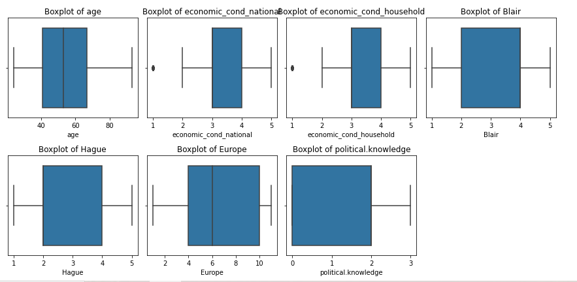
Figure 1: Box Plot of Numeric Columns
- From the above figure we observe few outliers are present in economic_cond_national and economic_cond_household column.
- There are 65 outliers in economic_cond_household column and 37 outliers in economic_cond_national column.
- Column economic_cond_household has 4.2% of outliers and column economic_cond_national has 2.4% of outliers.

Uni-Variate Analysis
Let us plot the histogram for all the numeric columns of the dataset.
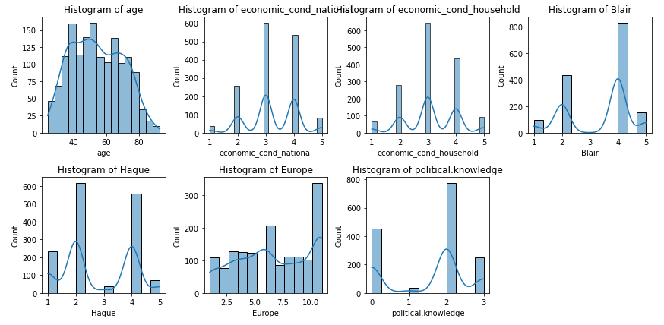
Figure 2: Histogram of Numeric Columns
Let us plot the Count Plot for all object columns of the dataset.
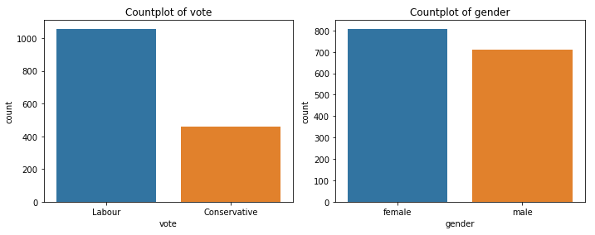
Figure 3: Count Plot of Object Columns

Bi-Variate Analysis
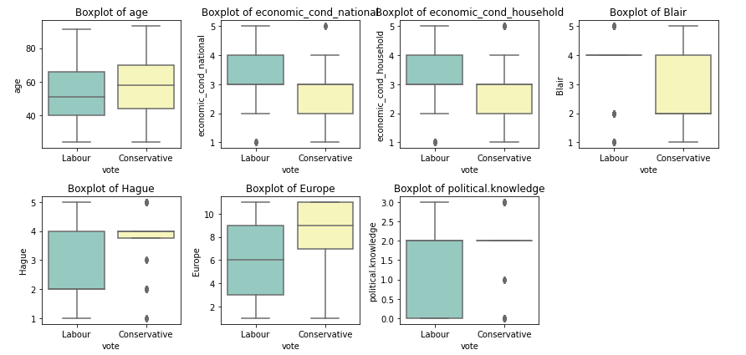
Figure 4: Bivariate Analysis Vote Verses All Numeric Columns
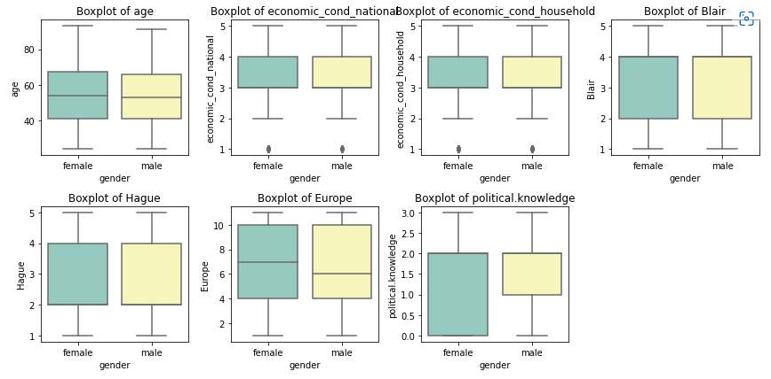
Figure 5: Bivariate Analysis Gender Verses All Numeric Columns
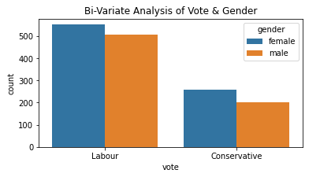
Figure 6: Bi-Variate Analysis of Vote verses Gender
Here we have plotted Categorical verses categorical and Categorical verses Continuous variables. Continuous verses continuous will be present in pair plot.

Multi-Variate Analysis
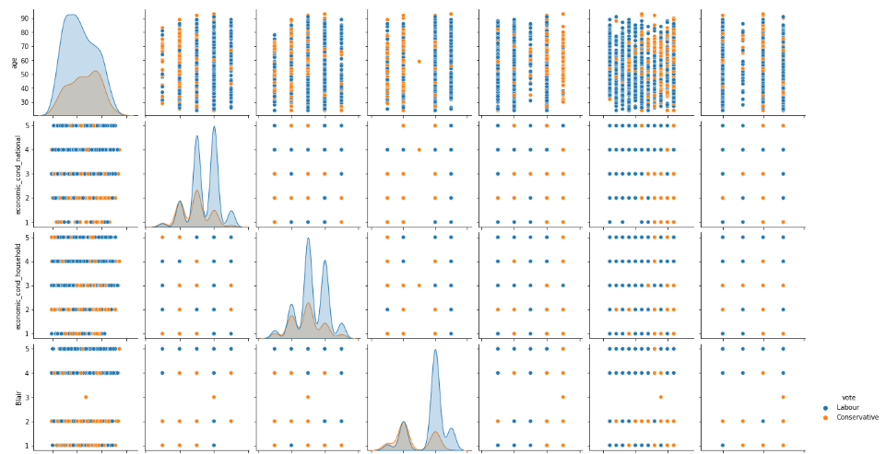
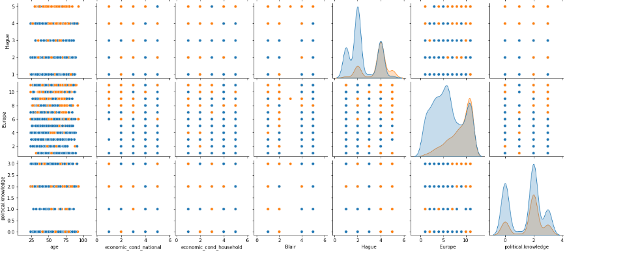
Figure 7: Pair Plot

Correlation Plot
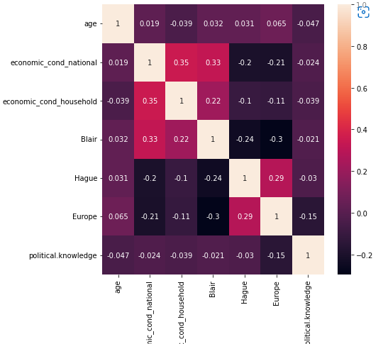
Figure 8: Correlation Plot
From the above correlation plot we observe there is very less correlation among the different columns of data.
Correlation values near to 1 or -1 are highly positively correlated and highly negatively correlated respectively. Correlation values near to 0 are not correlated to each other.

Q 1.3 Encode the data (having string values) for Modelling. Is Scaling necessary here or not? Data Split: Split the data into train and test (70:30).

Scaling
Referring to table Table:2 descriptive statistics we observe different columns in the dataset are in different scales, also variance of each column differs drastically so scaling is required.
From scipy.stats module we use zscore functionality to scale the data.
Scaled data will have mean value near to ‘0’ and standard deviation near to ‘1’.

Encoding String Values
We have 2 columns vote and gender which are of object type. Before we proceed with Model building activity, we need to convert these string values to numeric type. We use encoding technique to assign integer value to each unique categorical value.
Column: vote
['Labour', 'Conservative']
Categories (2, object): ['Conservative', 'Labour']
[1 0]

Column: gender
['female', 'male']
Categories (2, object): ['female', 'male']
[0 1]

Data Split
Segregate the dependent variables and independent variable separately.
From train_test_split functionality available in sklearn.model_selection module we split the data into train and test data in required ratio.

Q 1.4 Apply Logistic Regression and LDA (linear discriminant analysis).
We build Logistic Regression Model using LogisticRegression present in sklearn.linear_model module.
We build the Linear Discriminant Analysis model using LinearDiscriminantAnalysis present in sklearn.discriminant_analysis module.
Following Table summarises the Model scores of Train & Test data for Logistic Regression and LDA models built.
 | Train Data | Test Data
Logistic Regression | 83.12% | 83.33%
Linear Discriminant Analysis | 83.4% | 83.33%

Table 5:LR and LDA Model Scores of Test & Train data
From the Above table for both LR and LDA models, model score of Train & test data are close enough so we can conclude both LR & LDA models are neither overfit nor under fit.
Scores are slightly better for LDA compared to LR model. So for current dataset we can prefer LDS model over LR model.

Q 1.5 Apply KNN Model and Naïve Bayes Model. Interpret the results.
We build KNN Model using KNeighborsClassifier present in sklearn.neighbors module. Here ‘weights’ parameter is set to distance which tells model to use distance as a weight to find nearest neighbour and ‘n_neighbors’ parameter is set to 5 which tells model to consider 5 nearest neighbours.
We build KNN Model using GaussianNB present in sklearn. naive_bayes module.
Following Table summarises the Model scores of Train & Test data for GNB and KNN models built.

 | Train Data | Test Data
K Nearest Neighbours | 100% | 82.4%
Gaussian Naïve Basyes | 83.5% | 82.23%

Table 6: KNN and GNB Model Scores of Test & Train data
From the above table, KNN model has accuracy of 100% for training data while the testing data has 82.4% accuracy. So, the model built here is an overfit model.
From the above table, GNB model has accuracy of 83.5% for training data while the testing data has 82.23% accuracy. Here there is slight difference between the accuracies for Test and Train data. So, this is neither overfit nor underfit model.
Comparing both the models built for given dataset we can prefer GNB model since it is not overfit.

Q 1.6 Model Tuning, Bagging (Random Forest should be applied for Bagging), and Boosting.

Random Forest
While building the random forest model, the tree building activity continues until we get all terminal nodes as pure nodes. This will cause an overfitting of model. To avoid this overfitting, we can prune the tree by passing few parameters. Different Trees built in this way collectively form a Random Forest. Parameters used for pruning are like
- max_depth - indicates max levels up to which trees can extend
- min_samples_leaf - indicate minimum number of samples to be present on each leaf.
- min_samples_split -indicate minimum number of samples to be required for splitting current node.
- n_estimators - Number of Decision Trees to be constructed
- max_features - Number of columns randomly selected for decision making at each stage

Grid Search
When we are not sure with the optimal value for each of the parameters, we can pass a list of values to each parameter. We create a dictionary with each parameter as a key and list of values to each key. Using the GridSearchCV functinality available in sklearn.model_selection module we pass the above dictionary and build the model.
The resultant model will select the optimal values for each parameter and build the model. The optimal values set for each parameter will be stored in grid_search.best_params_ variable.
Out of the different values passed in a list to each parameter we have got best values to each parameter as:
{'criterion': 'gini',
'max_depth': 6,
'max_features': 3,
'min_samples_leaf': 10,
'min_samples_split': 5,
'n_estimators': 50}

Using same Random Forest classifier we have proceed building different models with Boosting and Bagging technques.
Following Table summarises the Model scores of Train & Test data.

 | Train Data | Test Data
Random Forest | 85.86% | 82.45%
Random Forest with Bagging | 85.67% | 82.23%
Random Forest with Ada Boosting | 100% | 81.3%
Random Forest with Gradient Boosting | 88.03% | 82.89%

Table 7: Model Scores of Different Model Tuning Techniques
Inference From above Table:
- For the given data Random Forest with Ada Boosting is an overfit model.
- For Random Forest, Random Forest with Bagging and Random Forest with Gradient Boosting the difference between model scores for train and test data is less. These models are neither overfit nor under fit models.
- Among the different Model tuning techniques Random Forest with Gradient Boosting has better model scores compared to others.
So Random Forest with Gradient Boosting is the best model for given data set out of different Model tuning techniques.

Q 1.7 Performance Metrics: Check the performance of Predictions on Train and Test sets using Accuracy, Confusion Matrix, Plot ROC curve and get ROC_AUC score for each model. Final Model: Compare the models and write inference which model is best/optimized.

Confusion Metrices
- Decision Tree Model Training Set

array([[210, 97],
[ 53, 701]], dtype=int64)

- Decision Tree Model Testing Set

array([[101, 52],
[ 28, 275]], dtype=int64)

- Decision Tree Model with Bagging Training Set

array([[207, 100],
[ 52, 702]], dtype=int64)

- Decision Tree Model with Bagging Testing Set

array([[ 99, 54],
[ 27, 276]], dtype=int64)

- Decision Tree Model with Ada Boosting Training Set

array([[307, 0],
[ 0, 754]], dtype=int64)

- Decision Tree Model with Ada Boosting Testing Set

array([[105, 48],
[ 37, 266]], dtype=int64)

- Decision Tree Model with Gradient Boosting Training Set

array([[226, 81],
[ 46, 708]], dtype=int64)

- Decision Tree Model with Gradient Boosting Testing Set

array([[103, 50],
[ 28, 275]], dtype=int64)

Classification Report

- Decision Tree Model Training Set

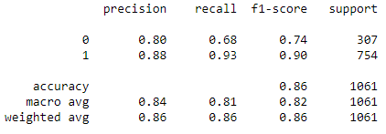

- Decision Tree Model Testing Set

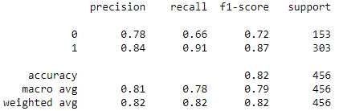

- Decision Tree Model with Bagging Training Set

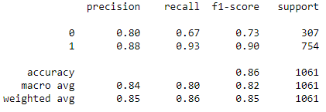

- Decision Tree Model with Bagging Testing Set

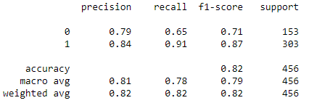
- Decision Tree Model with Ada Boosting Training Set

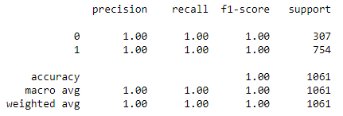

- Decision Tree Model with Ada Boosting Testing Set

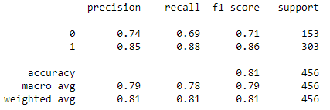

- Decision Tree Model with Gradient Boosting Training Set

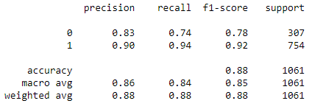

- Decision Tree Model with Gradient Boosting Testing Set

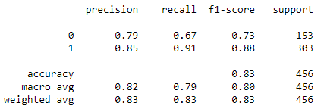

Accuracy Scores
Accuracy scores are captured under Table7

AUC & ROC Curves
- Decision Tree Model Training Set
AUC – 0.926
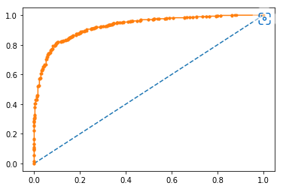
Figure 9: Random Forest ROC Curve for Training Data

- Decision Tree Model Testing Set
AUC – 0.89
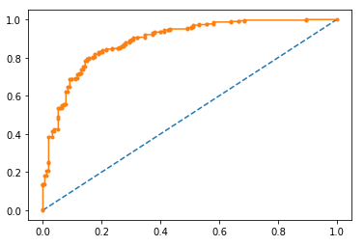
Figure 10: Random Forest ROC Curve for Testing Data

- Decision Tree Model with Bagging Training Set
AUC – 0.916
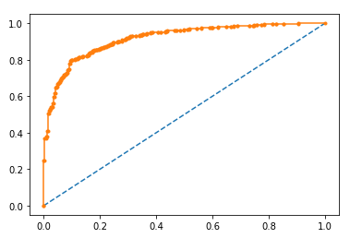
Figure 11: Random Forest with Bagging ROC Curve for Training Data

- Decision Tree Model with Bagging Testing Set
AUC – 0.891
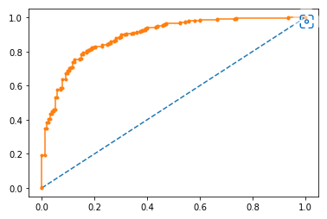
Figure 12: Random Forest with Bagging ROC Curve for Testing Data

- Decision Tree Model with Ada Boosting Training Set
AUC – 1.0
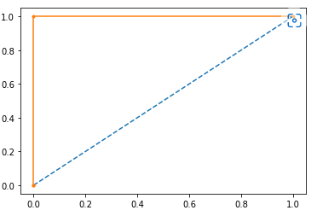
Figure 13: Random Forest with Ada Boosting ROC Curve for Training Data

- Decision Tree Model with Ada Boosting Testing Set
AUC – 0.892
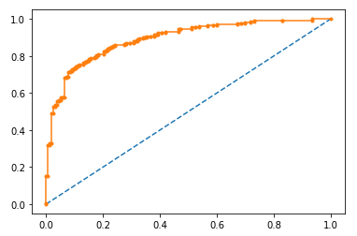
Figure 14: Random Forest with Ada Boosting ROC Curve for Testing Data
- Decision Tree Model with Gradient Boosting Training Set
AUC – 0.935
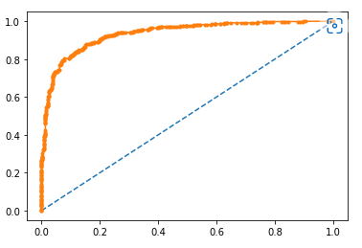
Figure 15: Random Forest with Gradient Boosting ROC Curve for Training Data

- Decision Tree Model with Gradient Boosting Testing Set
AUC – 0.897
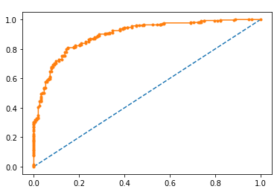
Figure 16: Random Forest with Gradient Boosting ROC Curve for Testing Data

Comments on analysing above data:
- In RF with Ada Boosting Accuracy score, AUC, f1-score, recall, precision for training data is overfit.
- Accuracy score, AUC, f1-score, recall, precision for both training and testing data is almost similar for other 3 models.
- Compared to all 4 models Random Forest with Gradient Boosting model has good accuracy.

Q 1.8 Based on these predictions, what are the insights?
Comparing all the stats of all 4 models in following table.
Here f1-score values corresponding to ‘1’ (Vote to Conservative ) are tabulated.
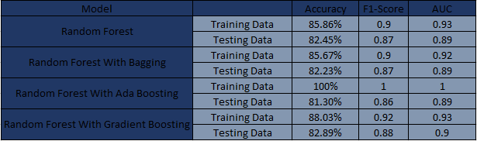
Table 8: Comparison of all 4 models
All the stats are similar for training and testing data except for Random Forest with Ada Boosting. Random Forest with Ada Boosting is overfitted model for given dataset. Based on accuracy, f1-score and AUC Random Forest with Gradient Boosting model is having better values compared to other 3 models for given dataset.

The given data set has 69.67% data with vote to Conservative Party and 30.32% data with vote to Labour Party.
- Data is not equally Distributed in the given dataset.
- A dataset with equally distributed dataset would be better for model building activity.
- For the current dataset Bagging Technique didn’t improve the model performance.
- For the given training dataset Ada Boosting was a Overfit Model.
- For the given dataset Gradient boosting has improved the model performance compared to Regularised Random Forest model.
- Data imbalance can be solved by oversampling or under sampling technique.

Problem – 2
In this particular project, we are going to work on the inaugural corpora from the nltk in Python. We will be looking at the following speeches of the Presidents of the United States of America:
- President Franklin D. Roosevelt in 1941
- President John F. Kennedy in 1961
- President Richard Nixon in 1973

Q 2.1 Find the number of characters, words, and sentences for the mentioned documents.
Following Table gives the required counts for mentioned Documents from the corpus.
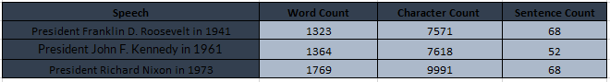
Table 9: Table of Word, Character And Sentences Count

Q 2.2 Remove all the stopwords from the three speeches
Stopwords are the words in any language which does not add much meaning to a sentence. They can safely be ignored without sacrificing the meaning of the sentence.
Stopwords are present for each language in nltk corpus. We can download them and use them.

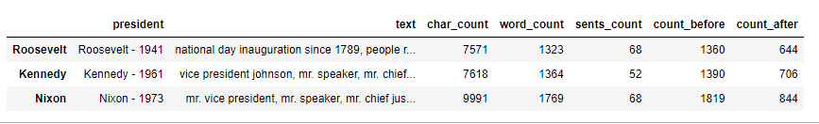
Table 10: Difference in Count Before and After Removing Stop words

Q 2.3 Which word occurs the most number of times in his inaugural address for each president? Mention the top three words. (after removing the stopwords)
For Roosevelt – 1941 Speech Top 3 words occurring most number of times
know 9
us 8
life 6
dtype: int64

For Kennedy – 1961 Speech Top 3 words occurring most number of times
let 16
us 11
new 7
dtype: int64

For Nixon – 1973 Speech Top 3 words occurring most number of times
us 25
let 22
new 15
dtype: int64

Q 2.4 Plot the word cloud of each of the speeches of the variable. (after removing the stopwords)

Figure 17: Word Cloud Roosevelt Speech

Figure 18: Word Cloud Kennedy Speech

Figure 19: Word Cloud Nixon Speech

