Finance and Risk analysis

KIRAN.N - GREAT LEARNING
  - Milestone-1

Table of Contents
Table Of Figures 2
List Of Tables 3
Sample Of Dataset 4
Exploratory Analysis 4
Descriptive Statistics 5
Q 1.1 Outlier Treatment 5
Q 1.2 Missing Value Treatment 6
Q 1.3 Transform Target variable into 0 and 1 6
Q 1.5 Train Test Split 6
Q 1.6 Build Logistic Regression Model (using statsmodel library) on most important variables on Train Dataset and choose the optimum cutoff. Also showcase your model building approach 7
Q1.7 Validate the Model on Test Dataset and state the performance matrices. Also state interpretation from the model 8
Q 1.4 Univariate & Bivariate analysis with proper interpretation. 8

Table Of Figures
Figure 1: Box Plot of 65 Numeric Columns 5
Figure 2: Box Plot of 65 Numeric Columns After Outlier Treatment 6
Figure 3: Histogram & Boxplot of Equity Paid Up 8
Figure 4: Histogram & Boxplot of Total Debt 9
Figure 5: Histogram & Boxplot of Book_Value_Adj_Unit_Curr 9
Figure 6: Histogram & Boxplot of CEPS 9
Figure 7: Histogram & Boxplot of Current Ratio 10
Figure 8: Histogram & Boxplot of PBITM 10
Figure 9: Histogram & Boxplot of Value_of_Output_Gross_Block 10
Figure 10: Histogram & Boxplot of Debtors Velocity 11
Figure 11: Pair Plot of Important Columns 11
Figure 12: Correlation Heat Map of Important Columns 12

List Of Tables
Table 1: Sample Dataset 4
Table 2: Descriptive Statistics of Data 5
Table 3: Train Data Classification Report For 0.5 Threshold 7
Table 4: Train Data Classification Report For 0.203 Threshold 7
Table 5: Test Data Classification Report For 0.203 Threshold 8

Problem Statement
Businesses or companies can fall prey to default if they are not able to keep up their debt obligations. Defaults will lead to a lower credit rating for the company which in turn reduces its chances of getting credit in the future and may have to pay higher interests on existing debts as well as any new obligations. From an investor's point of view, he would want to invest in a company if it is capable of handling its financial obligations, can grow quickly, and is able to manage the growth scale.

A balance sheet is a financial statement of a company that provides a snapshot of what a company owns, owes, and the amount invested by the shareholders. Thus, it is an important tool that helps evaluate the performance of a business.

Data that is available includes information from the financial statement of the companies for the previous year (2015). Also, information about the Networth of the company in the following year (2016) is provided which can be used to drive the labeled field.

Sample Of Dataset
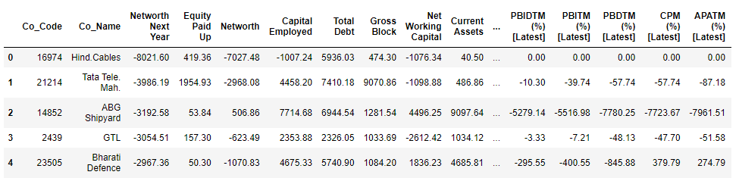
Table 1: Sample Dataset
Dataset has 67 columns with 3586 rows. Each row in the dataset corresponds to one individual with their financial statement details.

Exploratory Analysis
There are total 3586 rows and 67 columns in the dataset. Out of 67, 1 column is of object type, 3 columns are of integer type and rest 63 is of float data type.
There are total 118 null values are missing values resent in given dataset.
We are using ‘ffill’ method to impute null values in dataframe. This method replaces the NULL values with the value from the previous row.

Descriptive Statistics
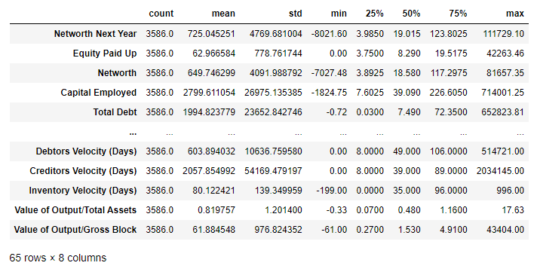
Table 2: Descriptive Statistics of Data

Q 1.1 Outlier Treatment
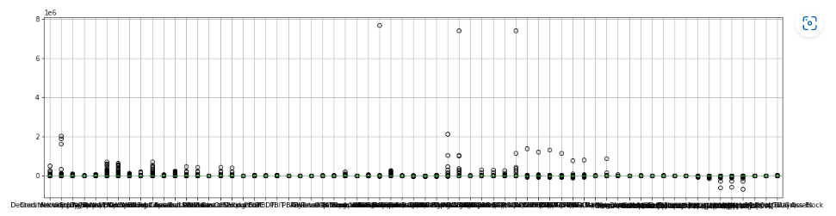
Figure 1: Box Plot of 65 Numeric Columns

Out of 66 numeric columns in dataframe ‘Co_Code’ column is a kind of Identifier; it has nothing to do with numeric calculations.
From the above figure it is evident that outliers are present all 65 numeric columns.
Outliers are data points in a dataset that are considered to be extreme, false, or not representative of what the data is describing. These outliers can be caused by either incorrect data collection or genuine outlying observations. Removing these outliers will often help your model to generalize better as these long tail observations could skew the learning.
Any data point below than Q1 – 1.5 times Inter Quartile Range and above Q3 + 1.5 times Inter Quartile Range is considered as outlier.
As part of Outlier treatment, values less than (Q1 – 1.5 * IQR) is set to lower boundary i.e (Q1 – 1.5 * IQR) and values more than (Q3 + 1.5 * IQR) is set to upper boundary i.e (Q3 + 1.5 * IQR).

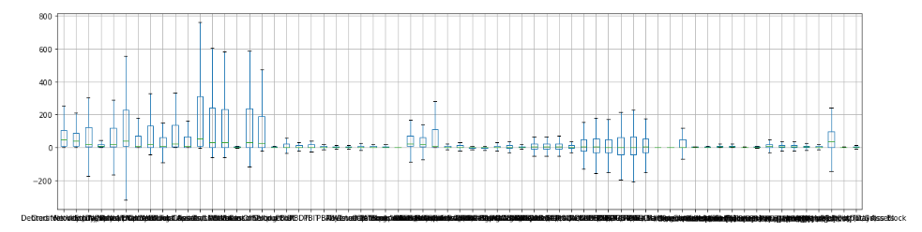
Figure 2: Box Plot of 65 Numeric Columns After Outlier Treatment

Q 1.2 Missing Value Treatment
There were total 118 null values are missing values resent in given dataset.
We are using ‘ffill’ method to impute null values in dataframe. This method replaces the NULL values with the value from the previous row.

Q 1.3 Transform Target variable into 0 and 1
We create a new column ‘default’ in dataframe. This column will be a dependent column. It takes the value of 1 when net worth next year is negative & 0 when net worth next year is positive.
There is total 3199 rows with value as ‘0’ and 387 rows with value as ‘1’.
Nearly 11% of rows have value as ‘1’. The given dataset is not balanced dataset.

Q 1.5 Train Test Split
We use train_test_split functionality to split the given data into Test and Train split in required proportion randomly.
After splitting the data in 67:33 ratio:
- Test Split has 2402 rows of data.
- Train split has 1184 rows of data.

Q 1.6 Build Logistic Regression Model (using statsmodel library) on most important variables on Train Dataset and choose the optimum cutoff. Also showcase your model building approach
Correlation heatmap is added in the IPYNB file. (Due to size constraint it is not added here.)
From the Correlation Heatmap we observe there is strong correlation among the variable(columns).
Using Variance Inflation Factor (VIF), we remove a column with highest VIF value and again calculate
VIF for remaining columns and remove the one with highest value. We continue this process until we have columns with VIF values less than ‘5’.
In this way we have eliminated 30+ columns from our given dataset.
Then we build a Logistic regression model. By going through the model summary we again remove all the columns whose ‘p-value is greater than 0.05.
By following this procedure, we finally arrived at a model which was built using most important 8 independent columns which are Equity_Paid_Up, Total_Debt, Book_Value_Adj_Unit_Curr, CEPS, Current_Ratio, PBITM, Value_of_Output_Gross_Block, Debtors_Velocity.
Following is the Classification Report with default threshold of 0.5
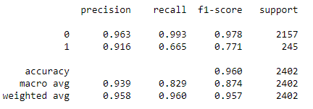
Table 3: Train Data Classification Report For 0.5 Threshold
Using ROC we found optimal threshold as 0.203
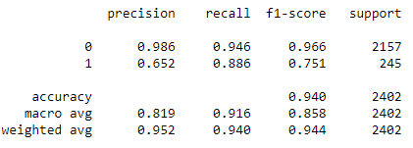
Table 4: Train Data Classification Report For 0.203 Threshold
With the optimal Threshold value we observe there is a better Recall value compared to previous one.

Q1.7 Validate the Model on Test Dataset and state the performance matrices. Also state interpretation from the model
To validate the model built, we will use the model to predict the ‘default’ values of test set with the same optimul threshold of 0.203.
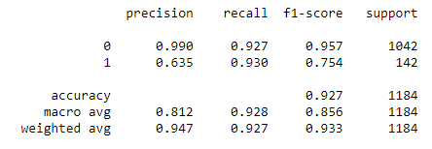
Table 5: Test Data Classification Report For 0.203 Threshold

By comparing Table 4 and 5 we infer the following:
- Accuracy is 90+ so the model built is a good model.
- Precision & Recall values of both tables are quite similar, so the model is neither over fit nor under fit.
- Precision value is quite good so model returns more relevant results than irrelevant ones.

Q 1.4 Univariate & Bivariate analysis with proper interpretation.
Univariate Analysis
- Equity_Paid_Up

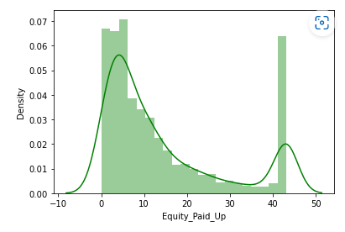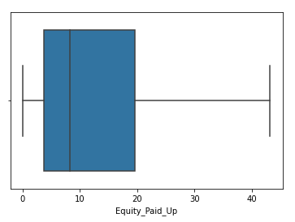
Figure 3: Histogram & Boxplot of Equity Paid Up
Here Data is Rightly skewed.

- Total_Debt
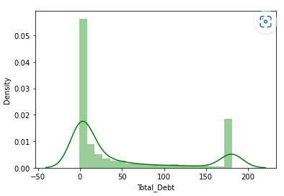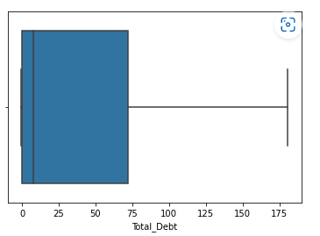
Figure 4: Histogram & Boxplot of Total Debt
Here Data is Rightly skewed.
- Book_Value_Adj_Unit_Curr
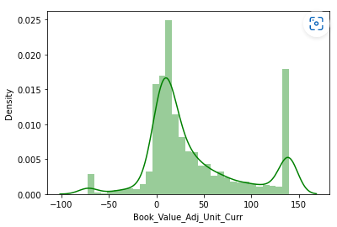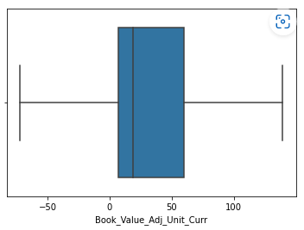
Figure 5: Histogram & Boxplot of Book_Value_Adj_Unit_Curr
Data is normally Distributed.
- CEPS
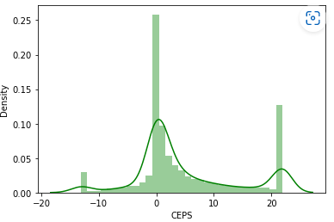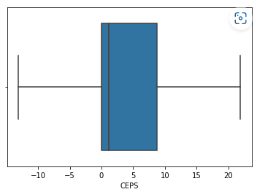
Figure 6: Histogram & Boxplot of CEPS
Data is Normally Distributed.
- Current_Ratio
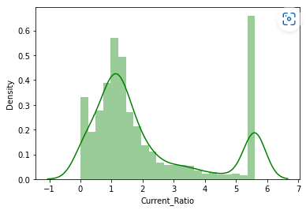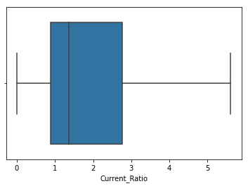
Figure 7: Histogram & Boxplot of Current Ratio
Here Data is Rightly skewed.
- PBITM
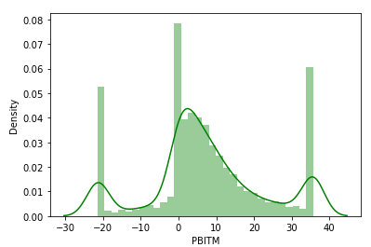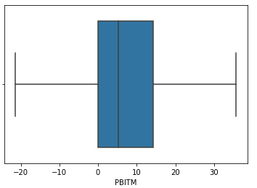
Figure 8: Histogram & Boxplot of PBITM
Data is Normally Distributed.
- Value_of_Output_Gross_Block
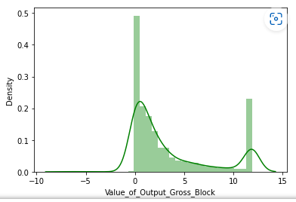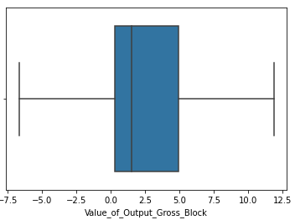
Figure 9: Histogram & Boxplot of Value_of_Output_Gross_Block
Here data is slightly Right Skewed.
- Debtors_Velocity

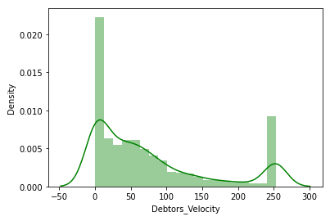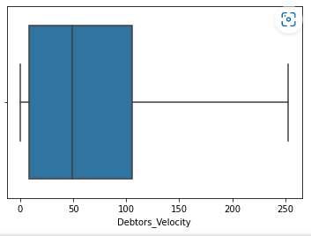
Figure 10: Histogram & Boxplot of Debtors Velocity
Here Data is Rightly skewed.
Bi-Variate Analysis
Pairplot shows the relationship between the variables in the form of scatterplot and the distribution of the variable in the form of histogram.
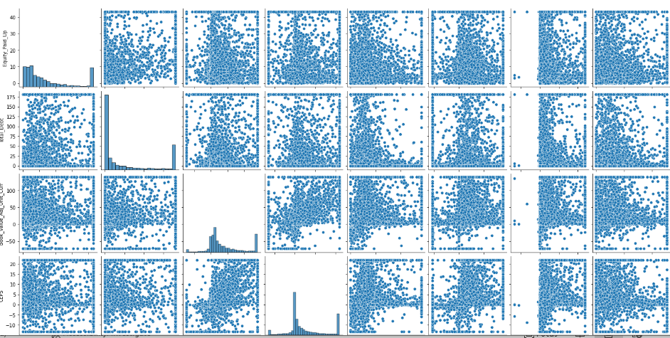
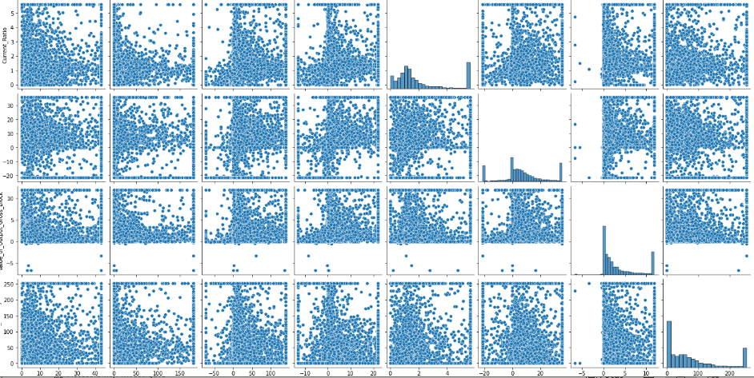
Figure 11: Pair Plot of Important Columns
In Pair plot we can analyse how 1 variable varies w.r.t other variable.
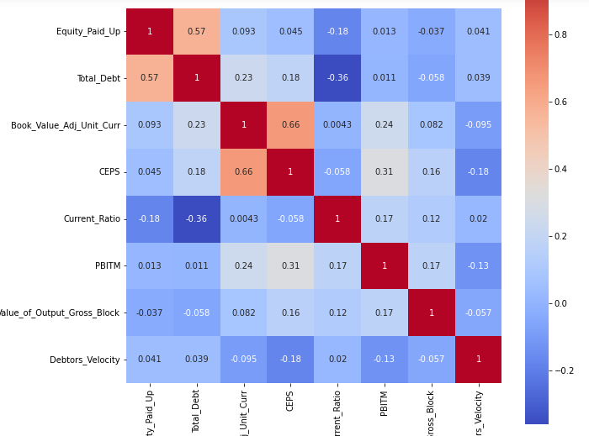
Figure 12: Correlation Heat Map of Important Columns

