Test cases for Alza.cz

1. As an end-user, I am able to navigate through all the menu items on the page. (I have written the Data-driven technique to validate the links, URLs, and titles.)

2.  As an end-user, I am able to search for a product. (I have written the scripts to validate the empty string in the search option, product not available on the website, able to search the product with a proper name.)

3. As an end-user, I can add the product to the cart section. (I have written the scripts to validate the empty cart, after going to the cart return to the shopping, search for a product, and select a product from the search list, add it the cart, and the cart button will provide feedback to the customer.)

4. As an end-user, I am able to navigate through all the utility items on the page. (I have written the Data-driven technique to validate the links and URLs.)

5. As an end-user, I am able to log in to the alza website. (I have written the scripts to validate the error messages without user name and password,  creating a new user link, and forgot password link.

Defect Format:

Title: There is no email validation for forgot password link.

Steps to recreate:

1. Open <https://www.Alza.cz/EN> web page.
2. Click on the login utility and login popup will appear.
3. Click on the forgot password link on the popup.
4. Just click on the “Sent” button.
5. There is no email validation for forgotpassword popup.
6. Though you have not entered any email and the message is showing some reset password link is sent it to email.(which is wrong functionality).

Suggested Solution: “make it as a mandatory field”

Severity: 3

Priority: 3

Attached/shared all the required logs to the ticket.

Snapshot is attached.

Automation report

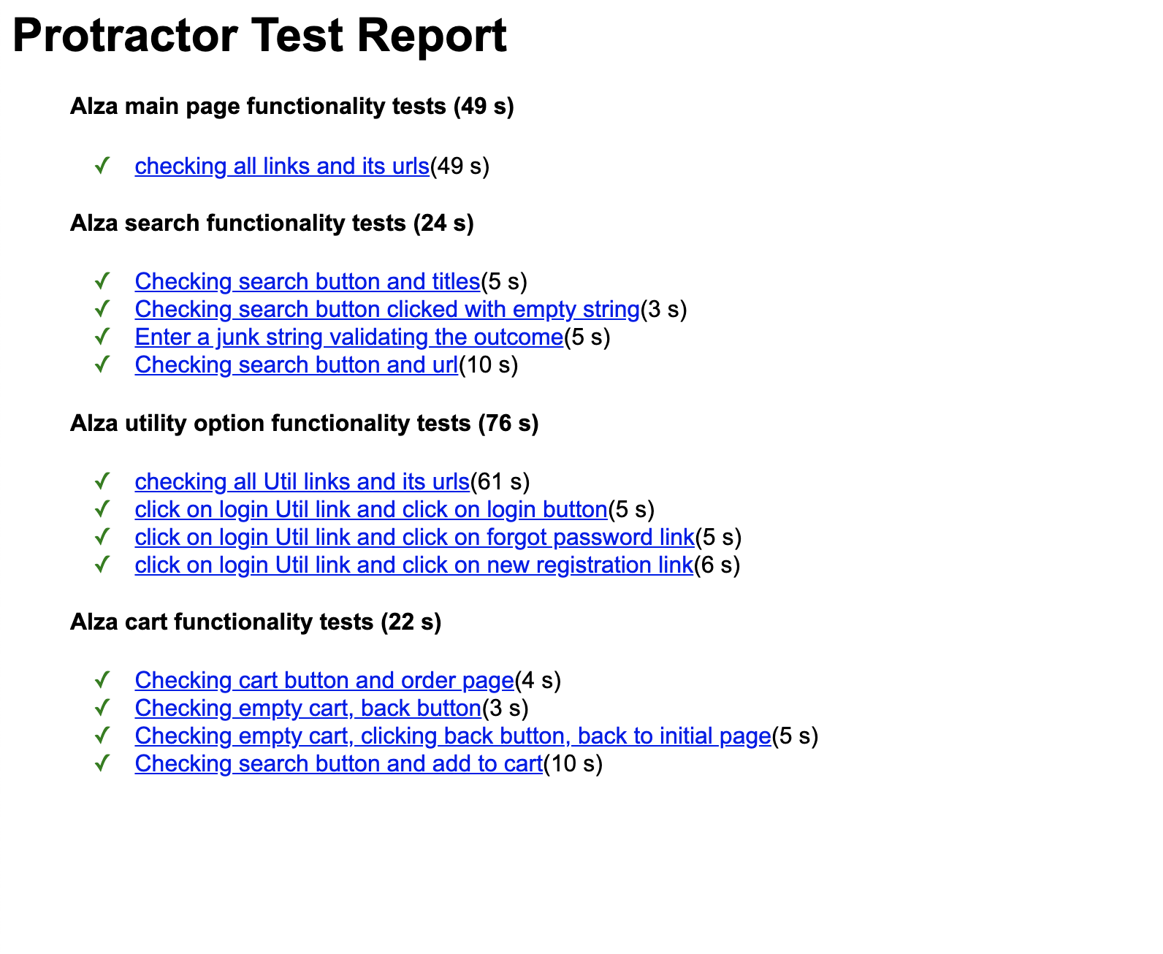

Project structure

