**Section Cheat Sheet (PPT)**

Kestrel and Other Servers

**Application Servers**

* Kestrel

**Reverse Proxy Servers**

* IIS
* Nginx
* Apache

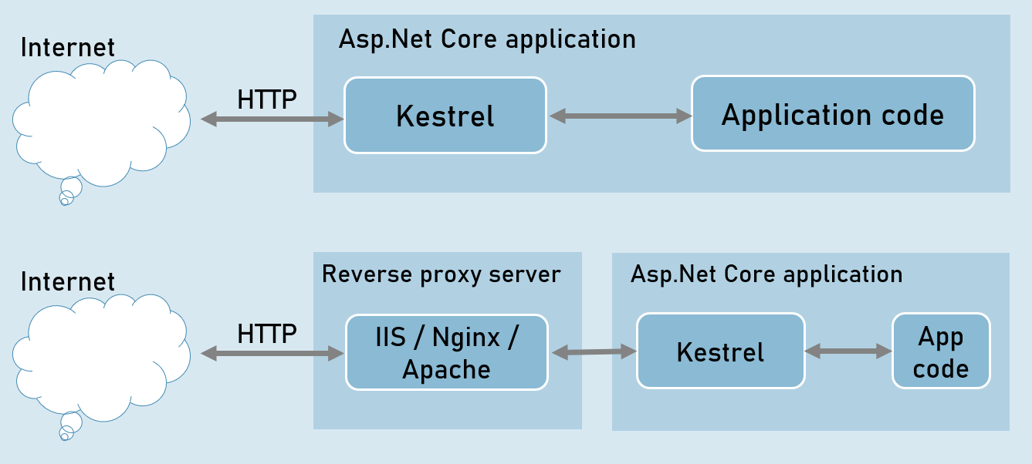

**Benefits of Reverse Proxy Servers**

* Load Balancing
* Caching
* URL Rewriting
* Decompressing the requests
* Authentication
* Decryption of SSL Certificates

**IIS express**

* HTTP access logs
* Port sharing
* Windows authentication
* Management console
* Process activation
* Configuration API
* Request filters
* HTTP redirect rules