**Section Cheat Sheet (PPT)**

Introduction to Routing

Routing is a process of matching incoming HTTP requests by checking the HTTP method and url; and then invoking corresponding endpoints.

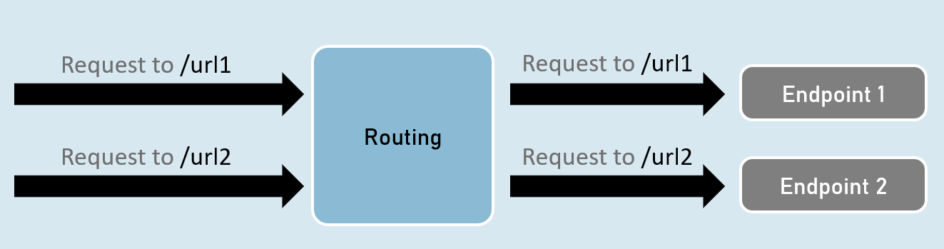

Routing - UseRouting and UseEndPoints

**UseRouting( )**

app.UseRouting();

Enables routing and selects an appropriate end point based on the url path and HTTP method.

**UseEndPoints( )**

1. app.UseEndPoints(endpoints =>
2. {
3. endpoints.Map(…);
4. endpoints.MapGet(…);
5. endpoints.MapPost(…);
6. );

Executes the appropriate endpoint based on the endpoint selected by the above UseRouting() method.

Map, MapGet, MapPost

**endpoints.Map( )**

1. endpoints.Map("path", async (HttpContext context) =>
2. {
3. //code
4. });

Executes the endpoint when a HTTP request's url path begins with the specified path.

**endpoints.MapGet( )**

1. endpoints.MapGet("path", async (HttpContext context) =>
2. {
3. //code
4. });

Executes the endpoint when a HTTP GET request's url path begins with the specified path.

**endpoints.MapPost( )**

1. endpoints.MapPost("path", async (HttpContext context) =>
2. {
3. //code
4. });

Executes the endpoint when a HTTP POST request's url path begins with the specified path.

GetEndpoint( )

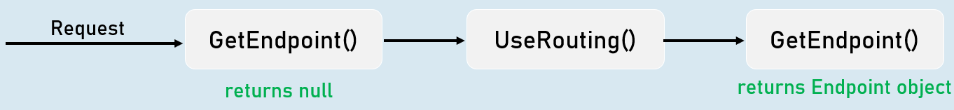

context.GetEndpoint();

Returns an instance of Microsoft.AspNetCore.Http.Endpoint type, which represents an endpoint.

That instance contains two important properties: DisplayName, RequestDelegate.

Route Parameters

**"{parameter}"**

A route parameter can match with any value.

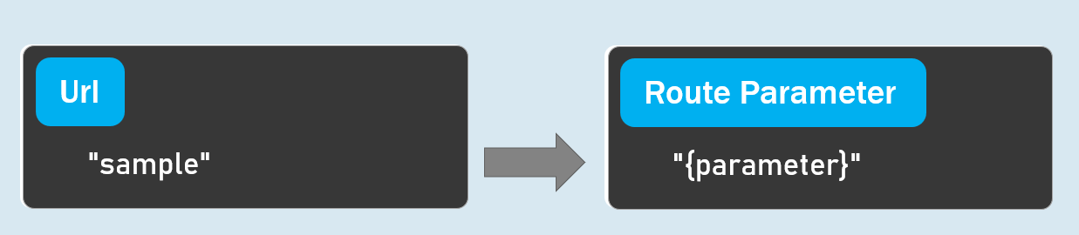

**Default Route Parameters**

"{parameter=default_value}"

A route parameter with default value matches with any value.

It also matches with empty value. In this case, the default value will be considered into the parameter.

**Optional Route Parameters**

"{parameter?}"

"?" indicates an optional parameter.

That means, it matches with a value or empty value also.

Route Constraints

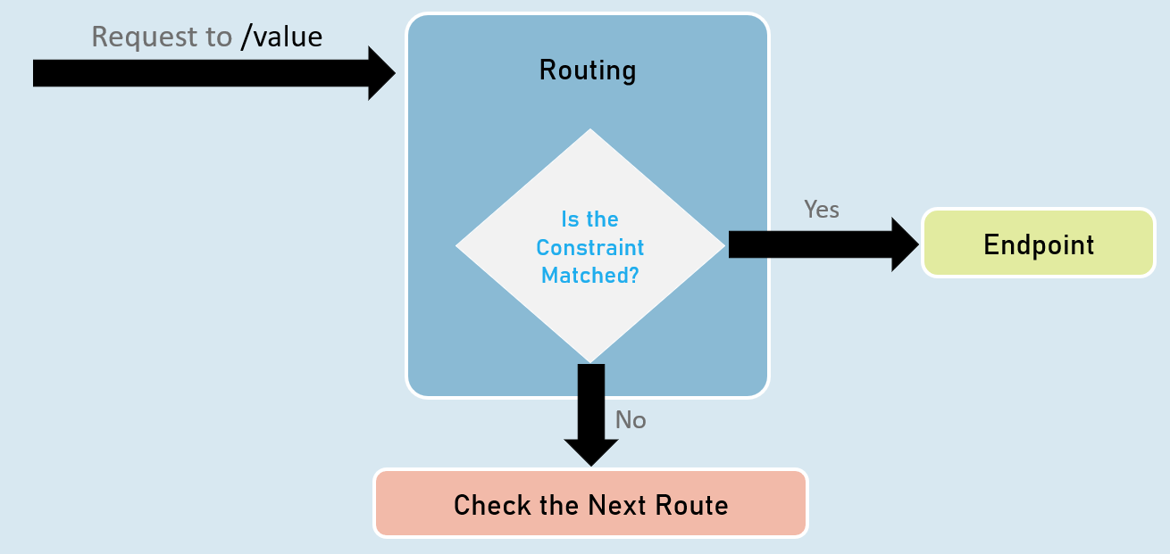

**Route Parameter with Constraint:**

"{parameter:constraint}"

A route parameter that has a constraint can match with a value that satisfies the given constraint.

**Multiple Constraints**

"{parameter:constraint1:constraint2}"

A route parameter can have more than one constraint, separated with colon ( : ).

**int**

Matches with any integer.

Eg: {id:int} matches with 123456789, -123456789

**bool**

Matches with true or false. Case-insensitive.

Eg: {active:bool} matches with true, false, TRUE, FALSE

**datetime**

Matches a valid DateTime value with formats "yyyy-MM-dd hh:mm:ss tt" and "MM/dd/yyyy hh:mm:ss tt".

Eg: {id:datetime} matches with 2030-01-01%2011:59%20pm

Note: '%20' is equal to space.

**decimal**

Matches with a valid decimal value.

Eg: {price:decimal} matches with 49.99, -1, 0.01

**long**

Matches a valid long value.

Eg: {id:long} matches with 123456789, -123456789

**guid**

Matches with a valid Guid value (Globally Unique Identifier - A hexadecimal number that is universally unique).

Eg: {id:guid} matches with 123E4567-E89B-12D3-A456-426652340000

**minlength(value)**

Matches with a string that has at least specified number of characters.

Eg: {username:minlength(4)} matches with John, Allen, William

**maxlength(value)**

Matches with a string that has less than or equal to the specified number of characters.

Eg: {username:maxlength(7)} matches with John, Allen, William

**length(min,max)**

Matches with a string that has number of characters between given minimum and maximum length (both numbers including).

Eg: {username:length(4, 7)} matches with John, Allen, William

**length(value)**

Matches with a string that has exactly specified number of characters.

Eg: {tin:length(9)} matches with 987654321

**min(value)**

Matches with an integer value greater than or equal to the specified value.

Eg: {age:min(18)} matches with 18, 19, 100

**max(value)**

Matches with an integer value less than or equal to the specified value.

Eg: {age:max(100)} matches with -1, 1, 18, 100

**range(min,max)**

Matches with an integer value between the specified minimum and maximum values (both numbers including).

Eg: {age:range(18,100)} matches with 18, 19, 99, 100

**alpha**

Matches with a string that contains only alphabets (A-Z) and (a-z).

Eg: {username:alpha} matches with rick, william

**regex(expression)**

Matches with a string that matches with the specified regular expression.

Eg 1: {age:regex(^[0-9]{2}$)} matches with any two-digit number, such as 10, 11, 98, 99

Eg 2: {age:regex(^\d{3}-\d{3}$)} matches with any three-digit number, then hyphen, and then three-digit number, such as 123-456

Custom Route Constraint Classes

Custom Route Constraint Class

1. public class ClassName : IRouteConstraint
2. {
3. public bool Match(HttpContext? HttpContext, IRouter? route, string routeKey, RouteValueDictionary values, RouteDirection routeDirection)
4. {
5. //return true or false
6. }
7. }
8. builder.Services.AddRouting(options =>
9. {
10. options.ConstraintMap.Add("name", typeof(ClassName));
11. }); //adding the custom constraint to routing

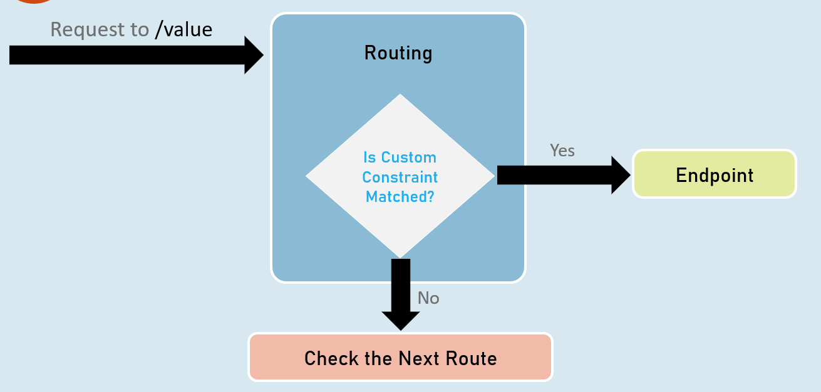

Endpoint Selection Order

Top is highest precedence (will be evaluated first)

**1:**URL template with more segments.

Eg: "a/b/c/d" is higher than "a/b/c".

**2:**URL template with literal text has more precedence than a parameter segment.

Eg: "a/b" is higher than "a/{parameter}".

**3:**URL template that has a parameter segment with constraints has more precedence than a parameter segment without constraints.

Eg: "a/b:int" is higher than "a/b".

**4:**Catch-all parameters (**).

Eg: "a/{b}" is higher than "a/**".

WebRoot

