**Section Cheat Sheet (PPT)**

Model Binding

Model Binding is a feature of asp.net core that reads values from http requests and pass them as arguments to the action method.

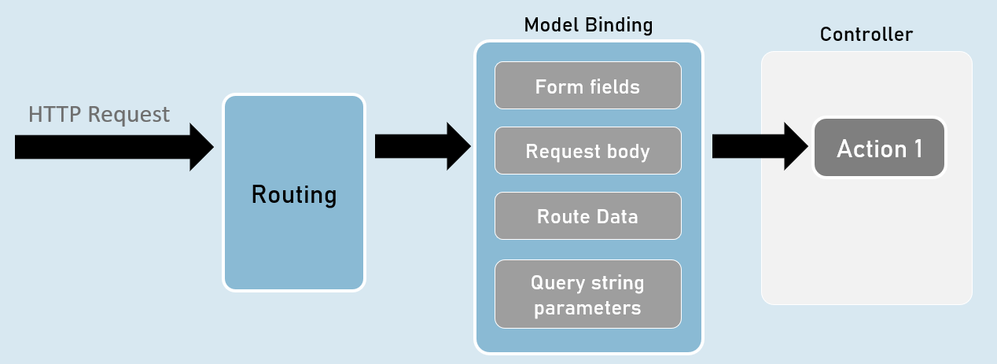

QueryString vs RouteData

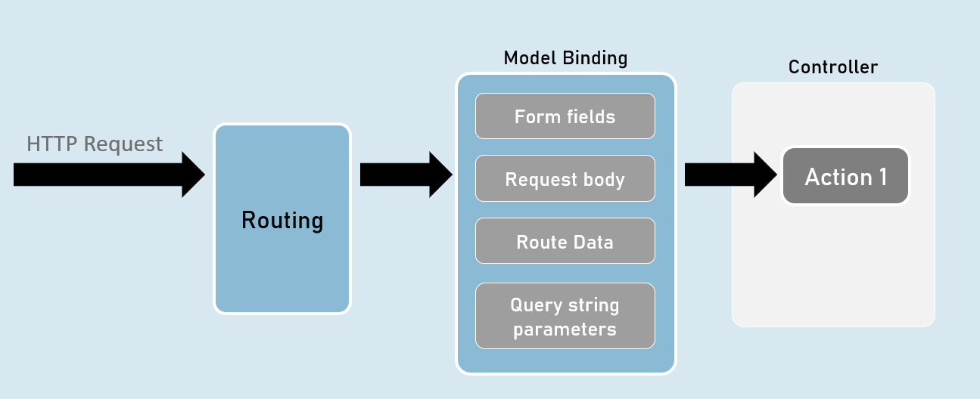

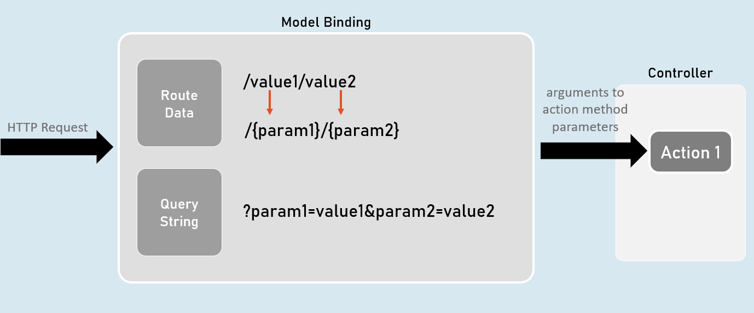

[FromQuery] and [FromRoute]

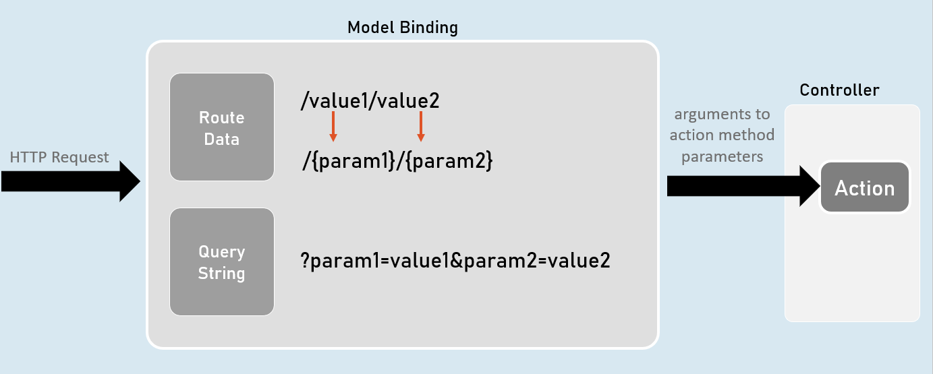

[FromQuery]

1. //gets the value from query string only
2. public IActionResult ActionMethodName( [FromQuery] type parameter)
3. {
4. }

[FromRoute]

1. //gets the value from route parameters only
2. public IActionResult ActionMethodName( [FromRoute] type parameter)
3. {
4. }

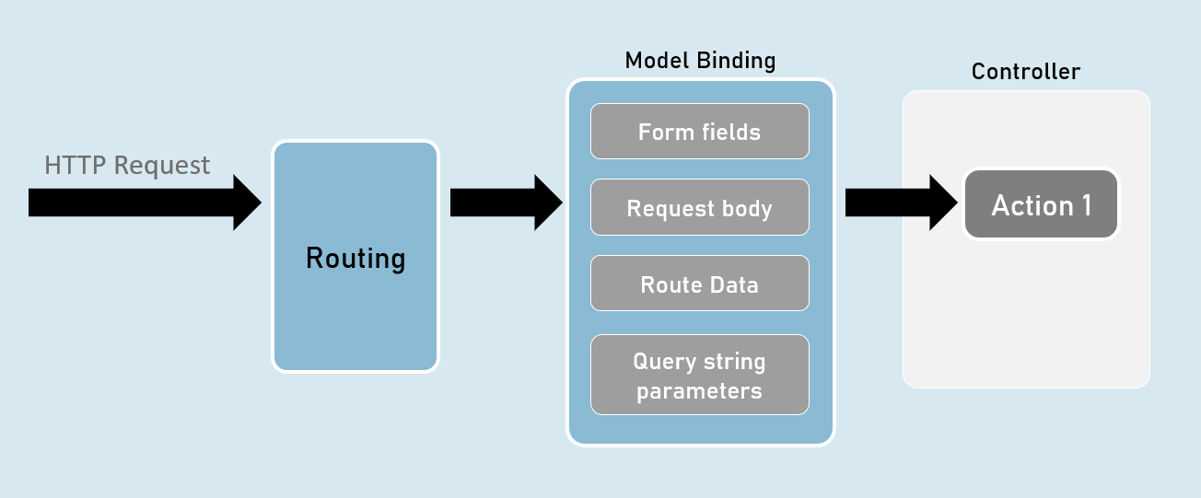

Models

Model is a class that represents structure of data (as properties) that you would like to receive from the request and/or send to the response.

Also known as POCO (Plain Old CLR Objects).

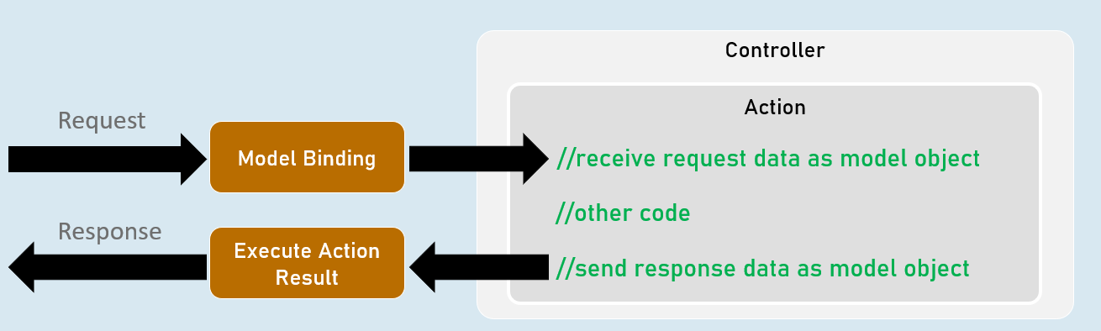

Model

1. class ClassName
2. {
3. public type PropertyName { get; set; }
4. }

form-urlencoded and form-data

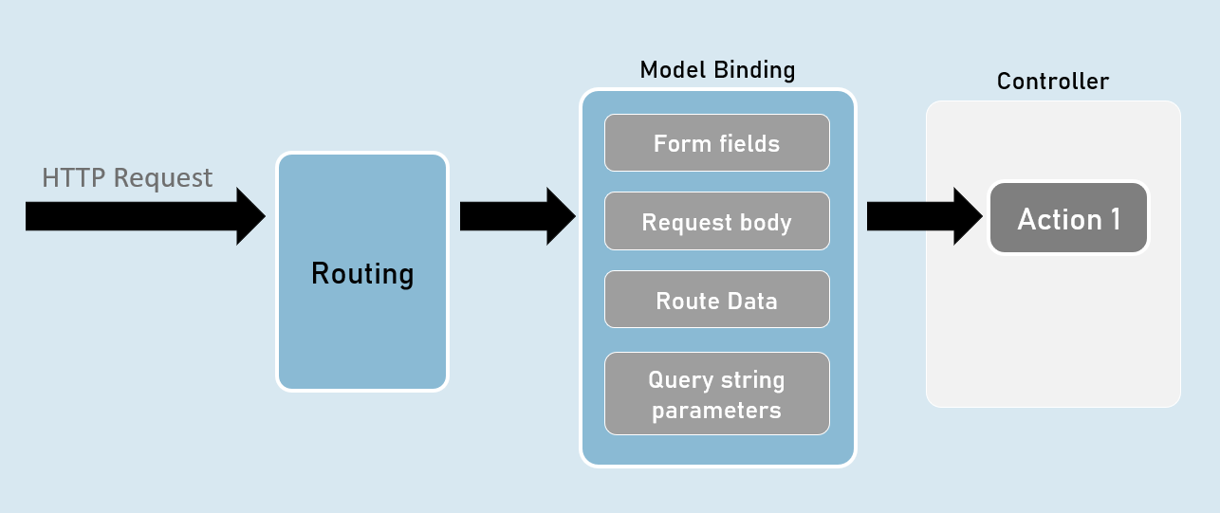

form-urlencoded (default)

**Request Headers**

Content-Type: application/x-www-form-urlencoded

**Request Body**

param1=value1&param2=value2

form-data

**Request Headers**

Content-Type: multipart/form-data

**Request Body**

--------------------------d74496d66958873e

Content-Disposition: form-data; name="param1"

value1

--------------------------d74496d66958873e

Content-Disposition: form-data; name="param2"

value2

Model Validation

1. class ClassName
2. {
3. [Attribute] //applies validation rule on this property
4. public type PropertyName { get; set; }
5. }

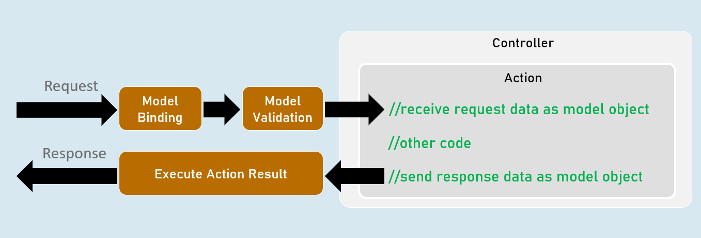

ModelState

**IsValid**

Specifies whether there is at least one validation error or not (true or false).

**Values**

Contains each model property value with corresponding "Errors" property that contains list of validation errors of that model property.

**ErrorCount**

Returns number of errors.

Model Validation

**[Required(ErrorMessage = "value")]**

Specifies that the property value is required (can't be blank or empty).

**[StringLength(int maximumLength, MinimumLength = value, ErrorMessage = "value")]**

Specifies minimum and maximum length (number of characters) allowed in the string.

**[Range(int minimum, int maximum, ErrorMessage = "value")]**

Specifies minimum and maximum numerical value allowed.

**[RegularExpression(string pattern, ErrorMessage = "value")]**

Specifies the valid pattern (regular expression).

**[EmailAddress(ErrorMessage = "value")]**

Specifies that the value should be a valid email address.

**[Phone(ErrorMessage = "value")]**

Specifies that the value should be a valid phone number).

Eg: (999)-999-9999 or 9876543210

**[Compare(string otherProperty, ErrorMessage = "value")]**

Specifies that the values of current property and other property should be same.

**[Url(ErrorMessage = "value")]**

Specifies that the value should be a valid url (website address).

Eg: http://www.example.com

**[ValidateNever]**

Specifies that the property should not be validated (excludes the property from model validation).

Custom Validations

1. class ClassName : ValidationAttribute
2. {
3. public override ValidationResult? IsValid(object? value, ValidationContext validationContext)
4. {
5. //return ValidationResult.Success;
6. //[or] return new ValidationResult("error message");
7. }
8. }

**ValidationAttribute**

* Base class for all validation attributes such as RequiredAttribute, RegularExpressionAttribute, RangeAttribute, StringLengthAttribute, CompareAttribute etc.
* Provides properties such as ErrorMessage & methods such as Validate(), IsValid() etc.

**ValidationContext**

* Acts as a parameter for "IsValid()" method of custom validation attribute classes.
* Provides properties such as ObjectType, ObjectInstance.

Custom Validations with Multiple Properties

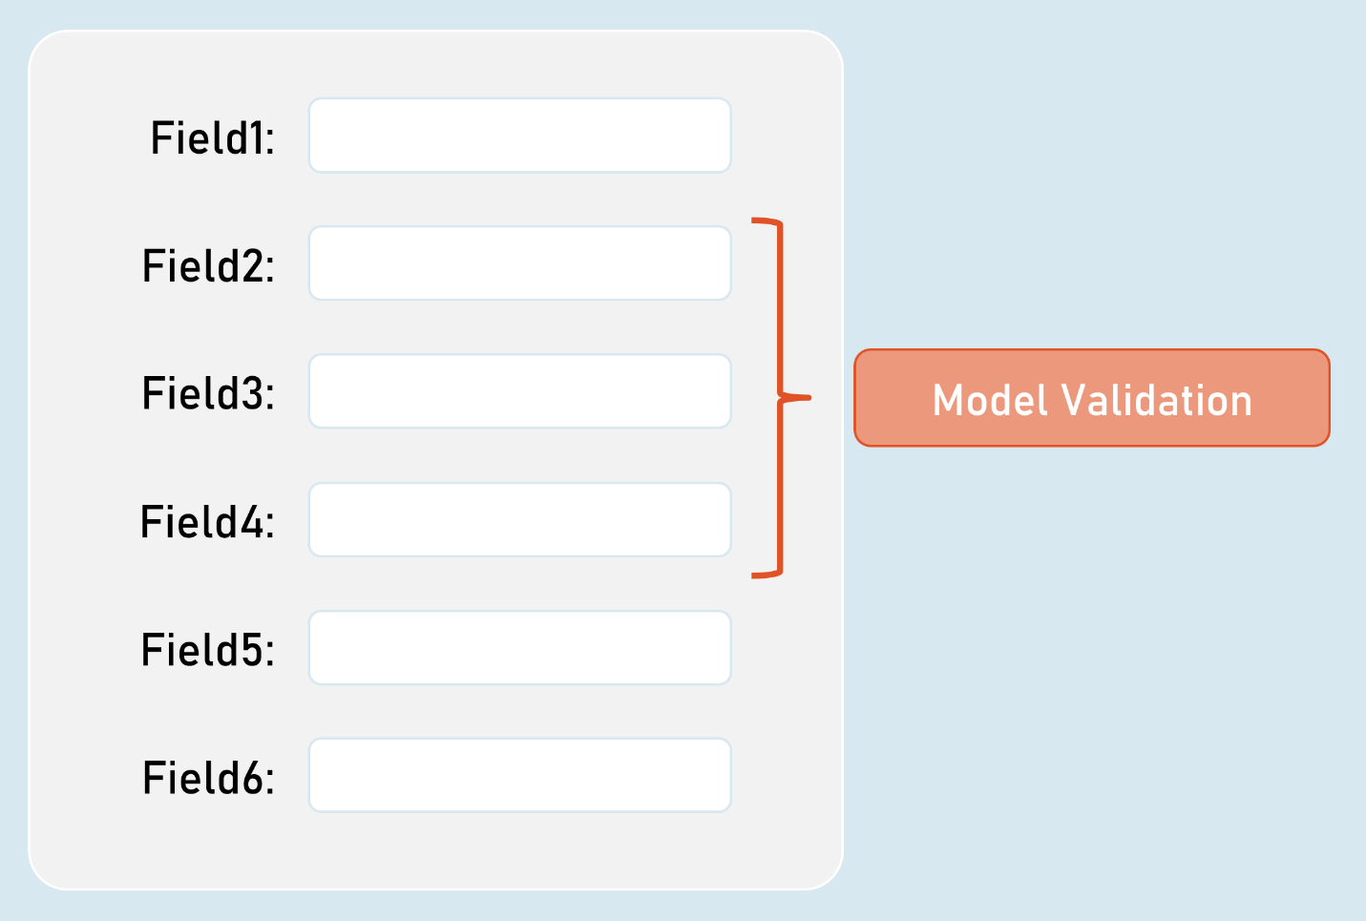

IValidatableObject

1. class ClassName : IValidatableObject
2. {
3. //model properties here
5. public IEnumerable<ValidationResult> Validate(ValidationContext validationContext)
6. {
7. if (condition)
8. {
9. yield return new ValidationResult("error message");
10. }
11. }
12. }

* Base class for model classes with validation.
* Provides a method called Validate() to define class level validation logic.
* The Validate() method executes after validating all property-level validations are executed; but doesn't execute if at least one property-level validations result error.

**ValidationContext**

* Acts as a parameter for "Validate()" method of model classes with IValidatableObject.
* Provides properties such as ObjectType, ObjectInstance.

[Bind] and [BindNever]

**[Bind]**

1. class ClassNameController
2. {
3. public IActionResult ActionMethodName( [Bind(nameof(ClassName.PropertyName), nameof(ClassName.PropertyName) )] ClassName parameterName)
4. {
5. }
6. }

* [Bind] attribute specifies that only the specified properties should be included in model binding.
* Prevents over-posting (post values into unexpected properties) especially in 'Create' scenarios.

**[BindNever]**

1. class ModelClassName
2. {
3. [BindNever]
4. public type PropertyName { get; set; }
5. }

* [BindNever] attribute specifies that the specified property should NOT be included in model binding.
* Useful when you have fewer properties to eliminate from model binding.

[FromBody]

1. //enables the input formatters to read data from request body (as JSON or XML or custom) only
2. public IActionResult ActionMethodName( [FromBody] type parameter)
3. {
4. }

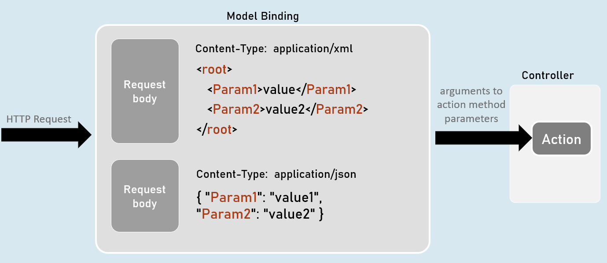

Input Formatters

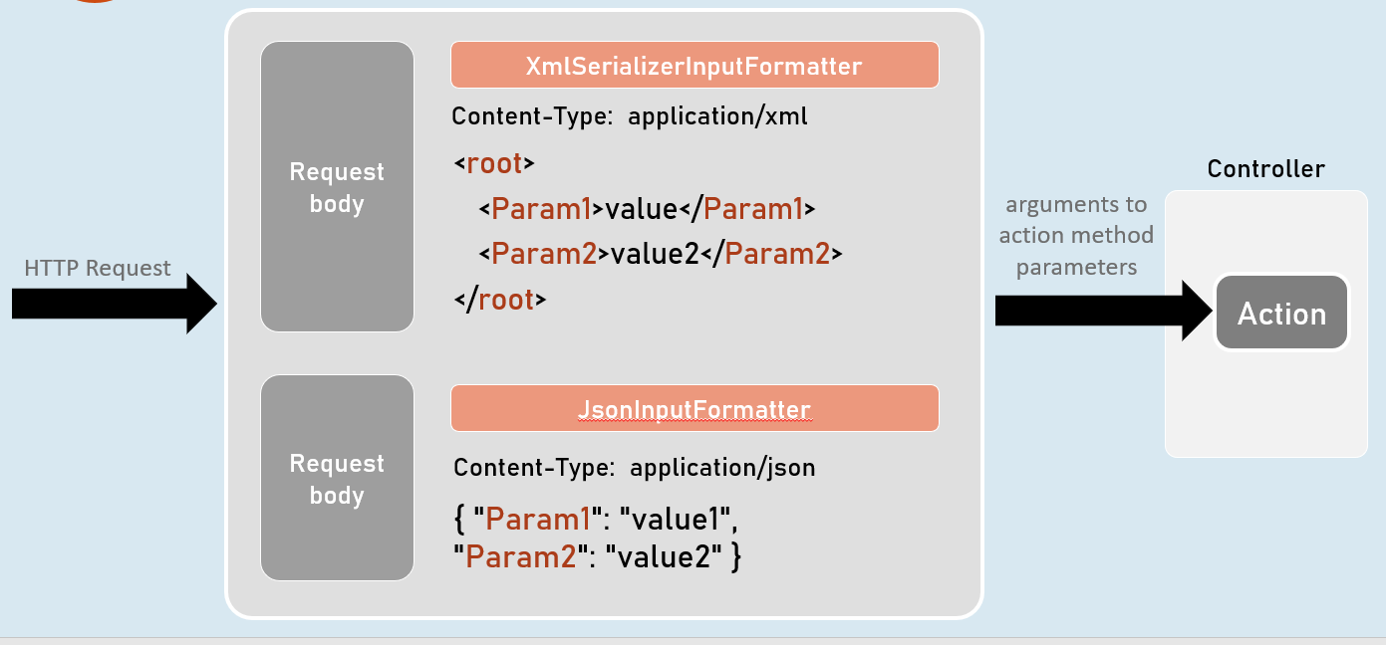

Custom Model Binders

**Custom Model Binder**

1. class ClassName : IModelBinder
2. {
3. public Task BindModelAsync(ModelBindingContext bindingContext)
4. {
5. //gets value from request
6. bindingContext.ValueProvider.GetValue("FirstName");
8. //returns model object after reading data from the request
9. bindingContext.Result = ModelBindingResult.Success(your_object);
10. }
11. }

**IModelBinder**

* Base interface for all custom model binders.
* Provides a method called BindModelAsync, to define logic for binding (reading) data from the request and creating a model object that has be received as parameter in the action method.

**ModelBindingContext**

* Acts as a parameter for "BindModelAsync()" method of custom model binder classes.
* Provides properties such as HttpContext, ModelState, ValueProvider, Result etc..

Custom Model Binder Providers

1. class ClassName : IModelBinderProvider
2. {
3. public IModelBinder GetBinder(ModelBinderProviderContext providerContext)
4. {
5. //returns type of custom model binder class to be invoked
6. return new BinderTypeModelBinder(typeof(YourModelBinderClassName));
7. }
8. }

**IModelBinderProvider**

* Base interface for all custom model binder providers.
* Provides a method called GetBinder, to return the type of custom model binder class.

**ModelBinderProviderContext**

* Acts as a parameter for "GetBinder()" method of custom model binder provider classes.
* Provides properties such as BindingInfo, Services etc.