**ection Cheat Sheet (PPT)**

Layout Views

Layout View is a web page (.cshtml) that is responsible for containing presentation logic template (commonly the html template with header, sidebar, footer etc.)

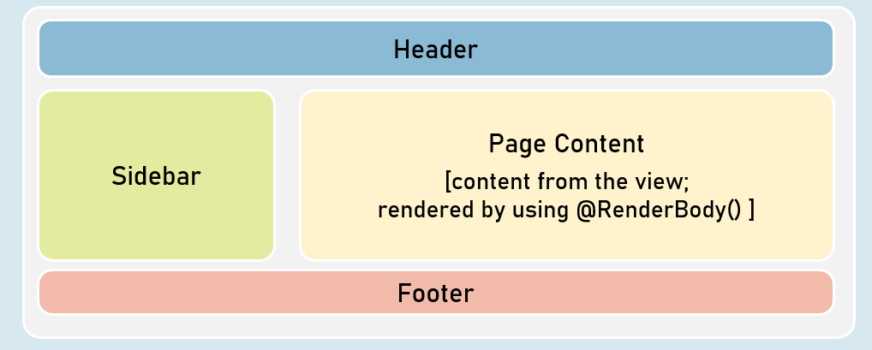

Order of Views Execution

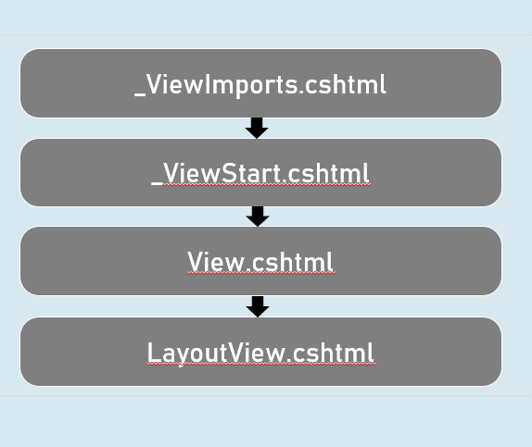

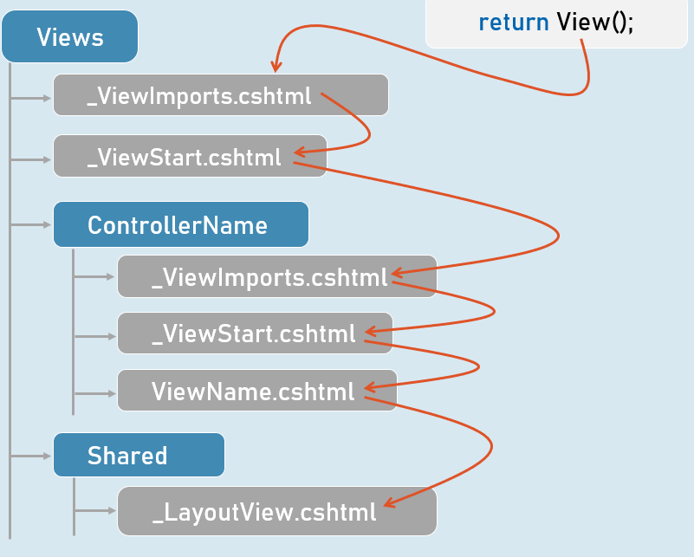

Layout Views

* The @RenderBody() method presents only in layout view to represent the place where exactly the content from the view has to be rendered.
* The "Layout" property of the view specifies path of the layout view.
* It can be dynamically set in the view.
* Both View and Layout View shares the same ViewData object.
* So it is possible to send data from view to layout, since the view executes first.
* The css files / js files imported in layout view will be applicable to view also, because the content of view will be merged into the layout view at run time.