**Section Cheat Sheet (PPT)**

Partial Views

Partial view is a razor markup file (.cshtml) that can't be invoked individually from the controller; but can be invoked from any view within the same web application.

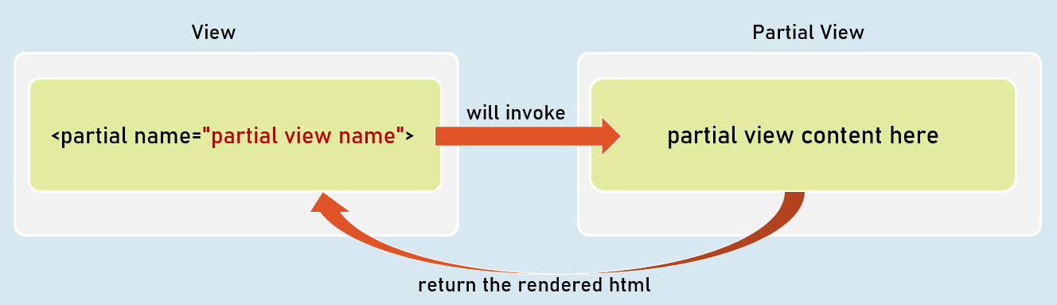

Invoking Partial Views

<partial name="partial view name" />

Returns the content to the parent view.

@await Html.PartialAsync("partial view name")

Returns the content to the parent view.

@{ await Html.RenderPartialAsync("partial view name"); }

Streams the content to the browser.

Partial Views with ViewData

When partial view is invoked, it receives a *copy* of the parent view's ViewData object.

So, any changes made in the ViewData in the partial view, do NOT effect the ViewData of the parent view.

Optionally, you can supply a custom ViewData object to the partial view, if you don't want the partial view to access the entire ViewData of the parent view.

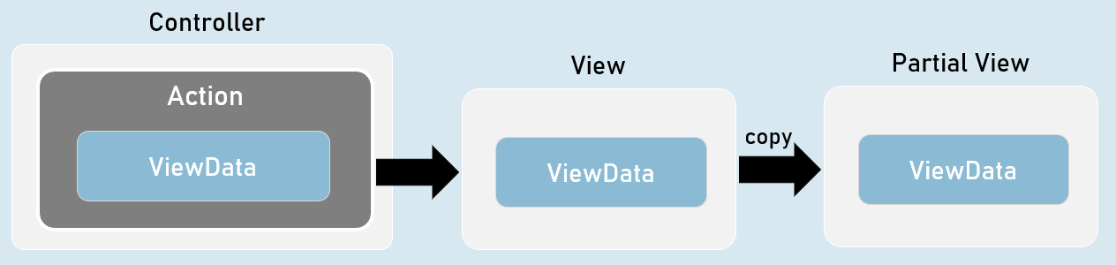

**Invoking Partial Views with View Data**

@{ await Html.RenderPartialAsync("partial view name", ViewData); }

-- or --

<partial name="partial view name" view-data="ViewData" />

Strongly Typed Partial Views

Strongly Typed Partial View is a partial view that is bound to a specified model class.

So, it gets all the benefits of a strongly typed view.

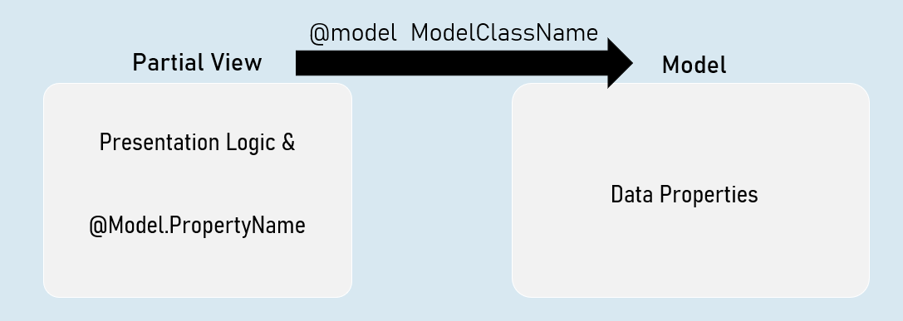

**Invoking Strongly-Typed Partial View**

@{ await Html.RenderPartialAsync("partial view name", Model); }

-- or --

<partial name="partial view name" model="Model" />

PartialViewResult

PartialViewResult can represent the content of a partial .

Generally useful to fetch partial view's content into the browser, by making an asynchronous request (XMLHttpRequest / fetch request) from the browser.

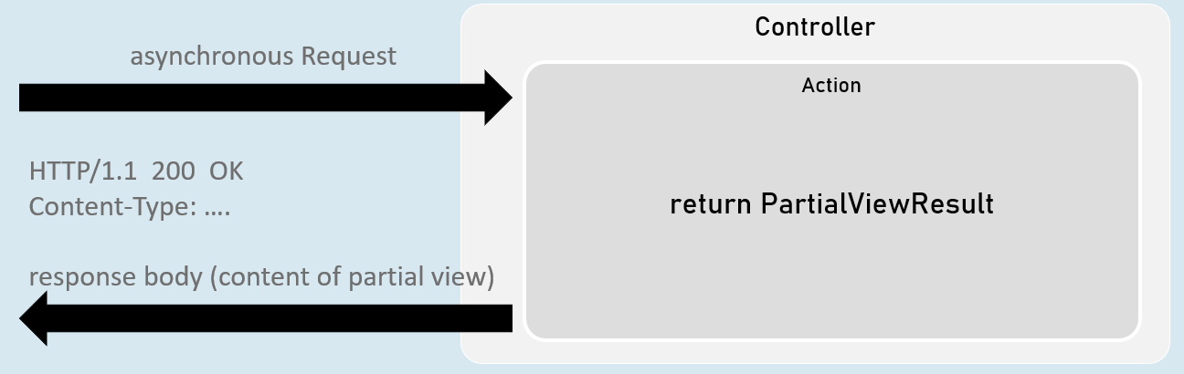

return new PartialViewResult() { ViewName = "partial view name", Model = model };

[or]

return PartialView("partial view name", model);