**Section Cheat Sheet (PPT)**

Introduction to Environments

An environment represents is a system in which the application is deployed and executed.

**Development**

The environment, where the developer makes changes in the code, commits code to the source control.

**Staging**

The environment, where the application runs on a server, from which other developers and quality controllers access the application.

**Production**

The environment, where the real end-users access the application.

Shortly, it's where the application "live" to the audience.

Environment Setting

**Set Environment in launchSettings.json**

in launchSettings.json

1. {
2. "profiles":
3. {
4. "profileName":
5. {
6. "environmentVariables":
7. {
8. "DOTNET_ENVIRONMENT": "EnvironmentNameHere",
9. "ASPNETCORE_ENVIRONMENT": "EnvironmentNameHere"
10. }
11. }
12. }
13. }

**Access Environment in Program.cs**

app.Environment

IWebHostEnvironment

**EnvironmentName**

Gets or sets name of the environment.

By default it reads the value from either DOTNET_ENVIRONMENT or ASPNETCORE_ENVIRONMENT.

**ContentRootPath**

Gets or sets absolute path of the application folder.

**IsDevelopment()**

Returns Boolean true, if the current environment name is "Development".

**IsStaging()**

Returns Boolean true, if the current environment name is "Staging".

**IsProduction()**

Returns Boolean true, if the current environment name is "Production".

**IsEnvironment(string environmentName)**

Returns Boolean true, if the current environment name matches with the specified environment.

Access Environment in Controller and other classes

1. using Microsoft.AspNetCore.Mvc;
2. using Microsoft.AspNetCore.Hosting;
4. public class ControllerName : Controller
5. {
6. private readonly IWebHostEnvironment _webHost;
8. public ControllerName(IWebHostEnvironment webHost)
9. {
10. _webHost = webHost;
11. }
12. }

Developer Exception Page

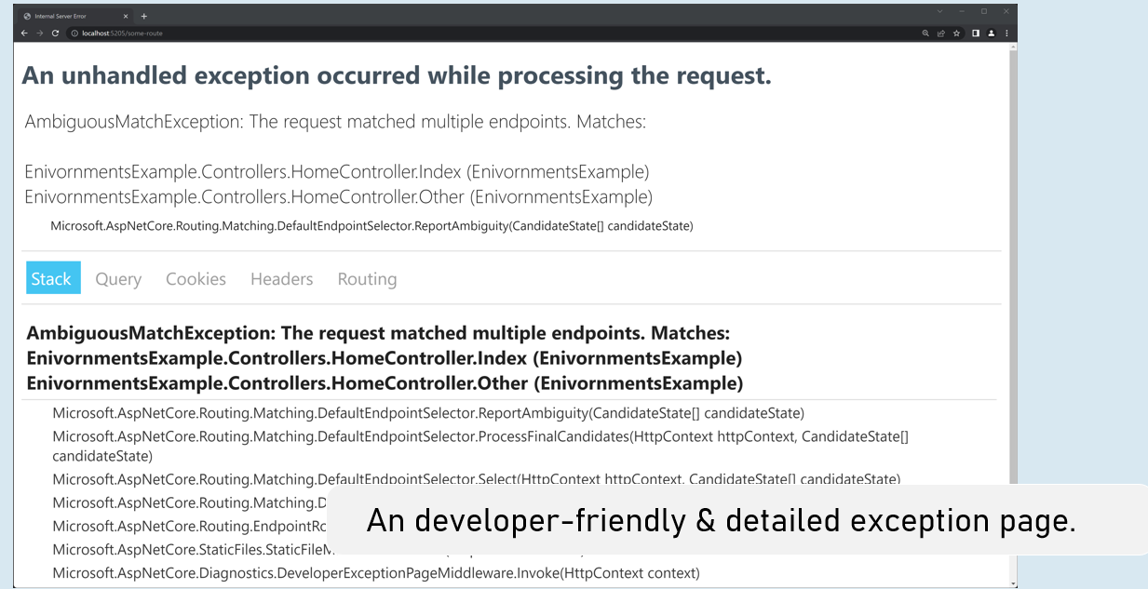

Enable developer exception page

in Program.cs

1. if (app.Environment.IsDevelopment()
2. {
3. app.UseDeveloperExceptionPage();
4. }

Process-Level Environment

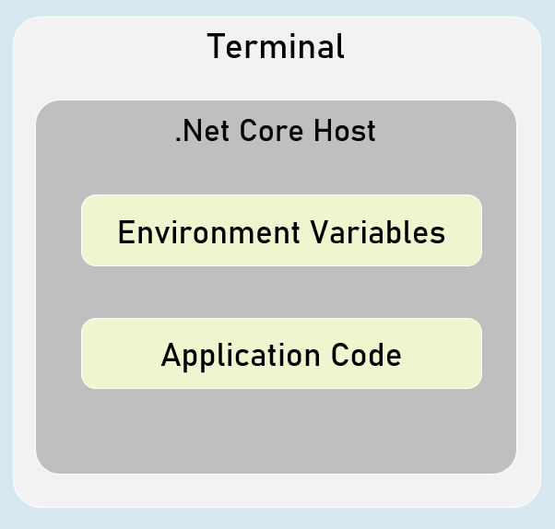

The environment variables are stored & accessible within the same process only.

Setting Environment Variables in Process

in "Windows PowerShell" / "Developer PowerShell in VS"

$Env:Environment="EnvironmentName"

dotnet run --no-launch-profile

<environment> tag helper

**include**

1. <environment include="Environment1,Environment2">
2. html content here
3. </environment>

It renders the content only when the current environment name matches with either of the specified environment names in the "include" property.

**exclude**

1. <environment exclude="Environment1,Environment2">
2. html content here
3. </environment>

It renders the content only when the current environment name doesn't match with either of the specified environment names in the "exclude" property.