**Section Cheat Sheet (PPT)**

Introduction to xUnit

xUnit is the free, open source unit testing tool for .NET Framework.

* Easy and extensible.
* Best to use with a mocking framework called "Moq".

Add Country - xUnit Test

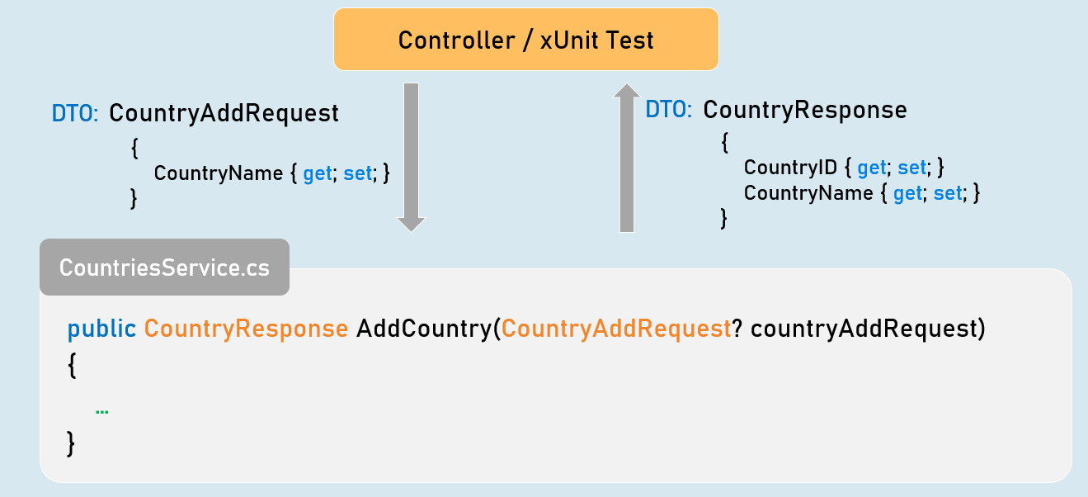

1. public CountryResponse AddCountry(CountryAddRequest? countryAddRequest)
2. {
3. //Check if "countryAddRequest" is not null.
4. //Validate all properties of "countryAddRequest"
5. //Convert "countryAddRequest" from "CountryAddRequest" type to "Country".
6. //Generate a new CountryID
7. //Then add it into List<Country>
8. //Return CountryResponse object with generated CountryID
9. }

Get All Countries - xUnit Test

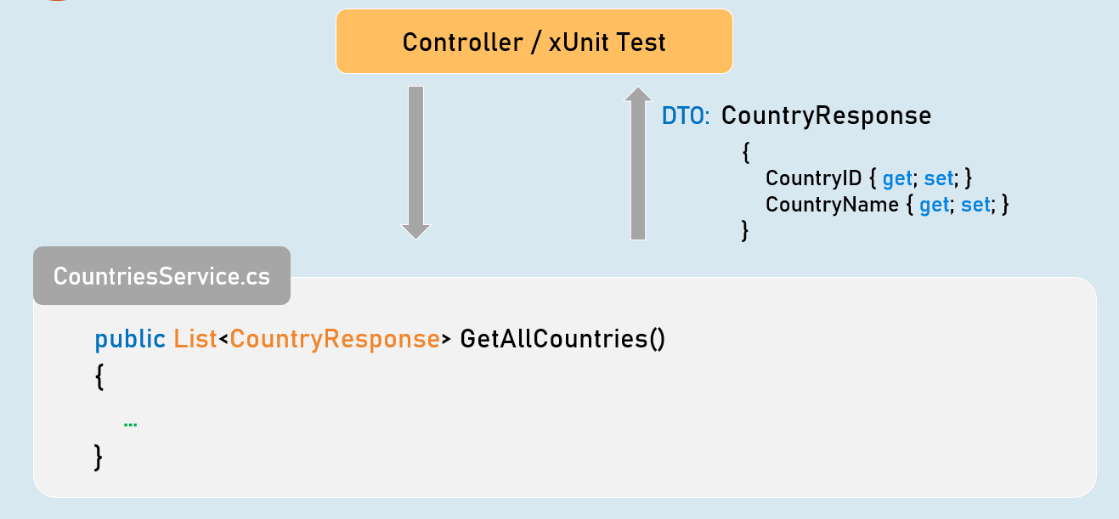

1. public List<CountryResponse> GetAllCountries()
2. {
3. //Convert all countries from "Country" type to "CountryResponse" type.
4. //Return all CountryResponse objects
5. }

Get Country by Country ID - xUnit Test

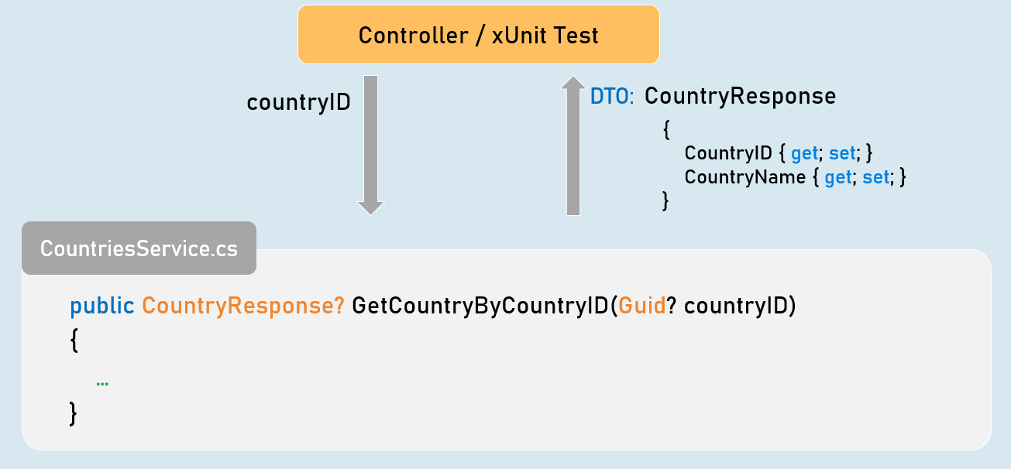

1. public CountryResponse? GetCountryByCountryID(Guid? countryID)
2. {
3. //Check if "countryID" is not null.
4. //Get matching country from List<Country> based countryID.
5. //Convert matching country object from "Country" to "CountryResponse" type.
6. //Return CountryResponse object
7. }

Add Person - xUnit Test

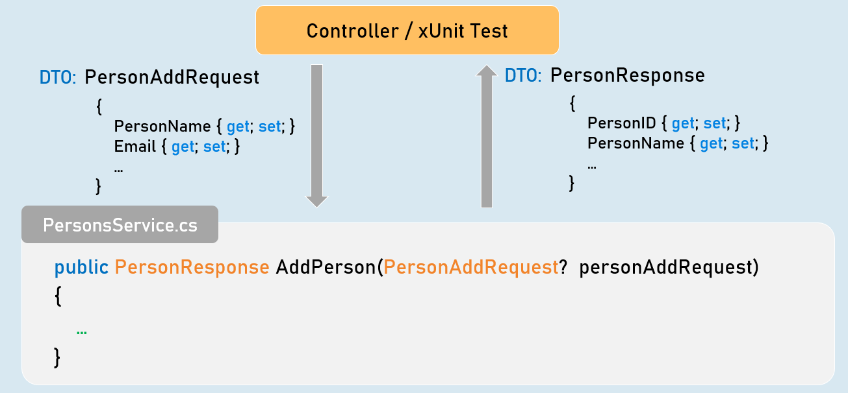

1. public PersonResponse AddPerson(PersonAddRequest? personAddRequest)
2. {
3. //Check if "personAddRequest" is not null.
4. //Validate all properties of "personAddRequest".
5. //Convert "personAddRequest" from "PersonAddRequest" type to "Person".
6. //Generate a new PersonID.
7. //Then add it into List<Person>.
8. //Return PersonResponse object with generated PersonID.
9. }

Get Person by Person ID - xUnit Test

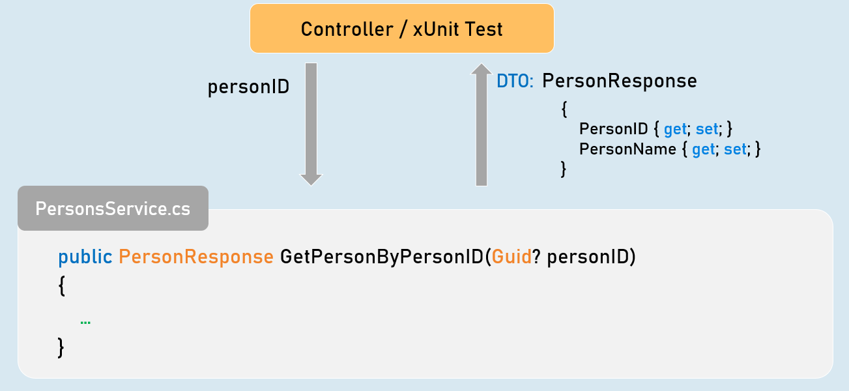

1. public PersonResponse GetPersonByPersonID(Guid? personID)
2. {
3. //Check if "personID" is not null.
4. //Get matching person from List<Person> based personID.
5. //Convert matching person object from "Person" to "PersonResponse" type.
6. //Return PersonResponse object
7. }

Get All Persons - xUnit Test

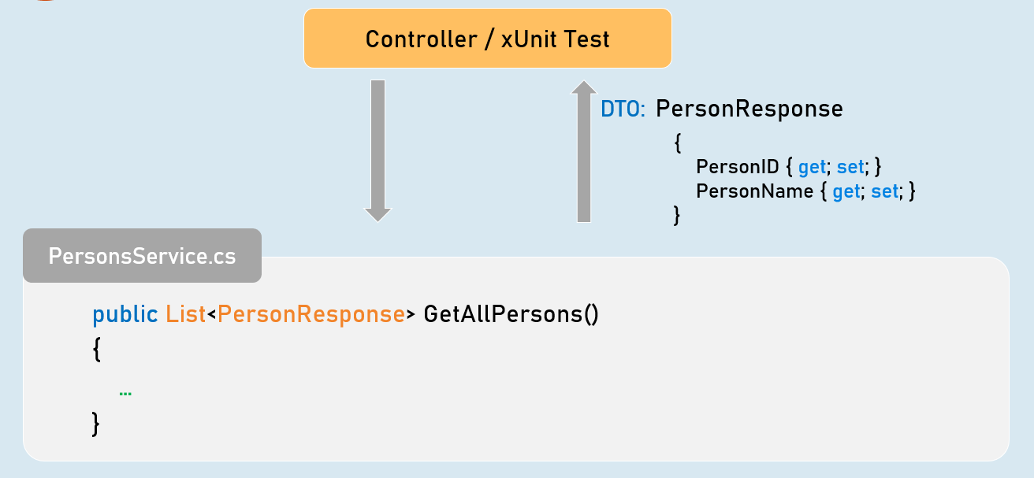

1. public List<PersonResponse> GetAllPersons()
2. {
3. //Convert all persons from "Person" type to "PersonResponse" type.
4. //Return all PersonResponse objects
5. }

Get Filtered Persons - xUnit Test

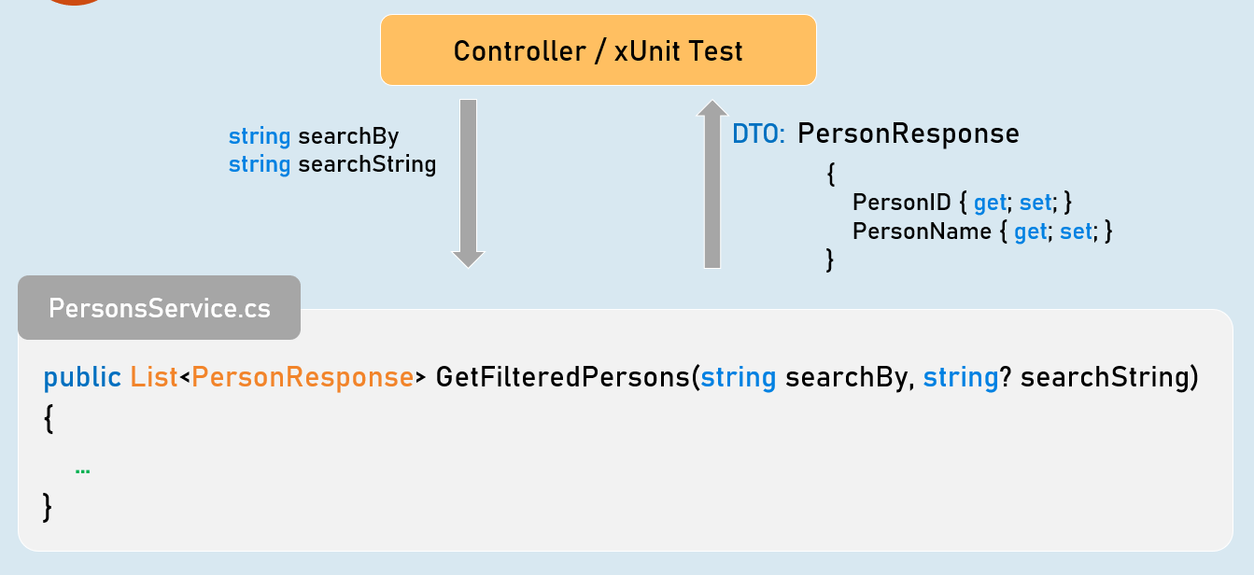

1. public List<PersonResponse> GetFilteredPersons(string searchBy, string? searchString)
2. {
3. //Check if "searchBy" is not null.
4. //Get matching persons from List<Person> based on given searchBy and searchString.
5. //Convert the matching persons from "Person" type to "PersonResponse" type.
6. //Return all matching PersonResponse objects
7. }

Get Sorted Persons - xUnit Test

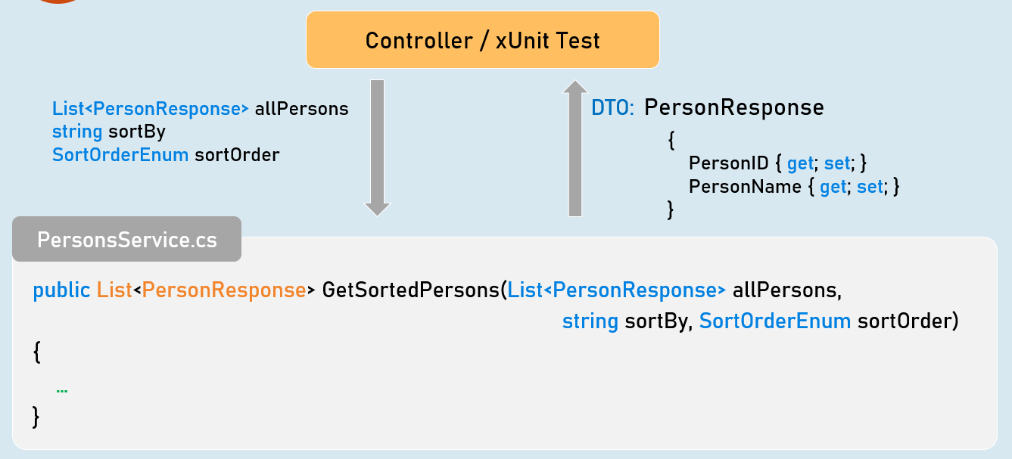

1. public List<PersonResponse> GetSortedPersons(List<PersonResponse> allPersons,
2. string sortBy, SortOrderEnum sortOrder)
3. {
4. //Check if "sortBy" is not null.
5. //Get sorted persons from "allPersons" based on given "sortBy" and "sortOrder".
6. //Convert the sorted persons from "Person" type to "PersonResponse" type.
7. //Return all sorted PersonResponse objects
8. }

Update Person - xUnit Test

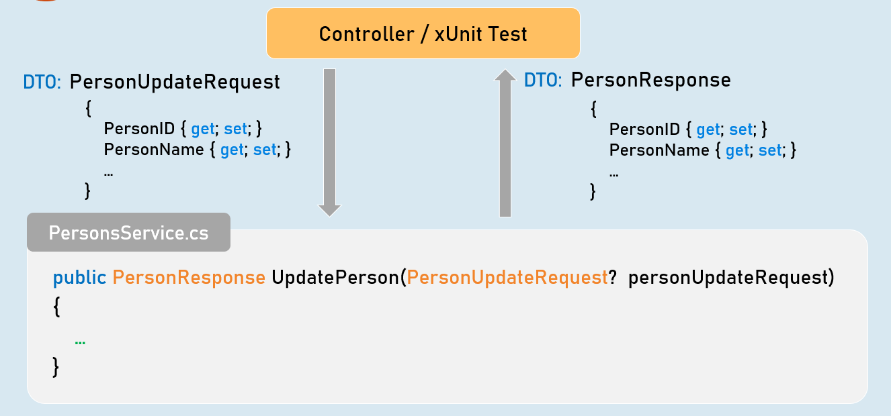

1. public PersonResponse UpdatePerson(PersonUpdateRequest? personUpdateRequest)
2. {
3. //Check if "personUpdateRequest" is not null.
4. //Validate all properties of "personUpdateRequest"
5. //Get the matching "Person" object from List<Person> based on PersonID.
6. //Check if matching "Person" object is not null
7. //Update all details from "PersonUpdateRequest" object to "Person" object
8. //Convert the person object from "Person" to "PersonResponse" type
9. //Return PersonResponse object with updated details
10. }

Delete Person - xUnit Test

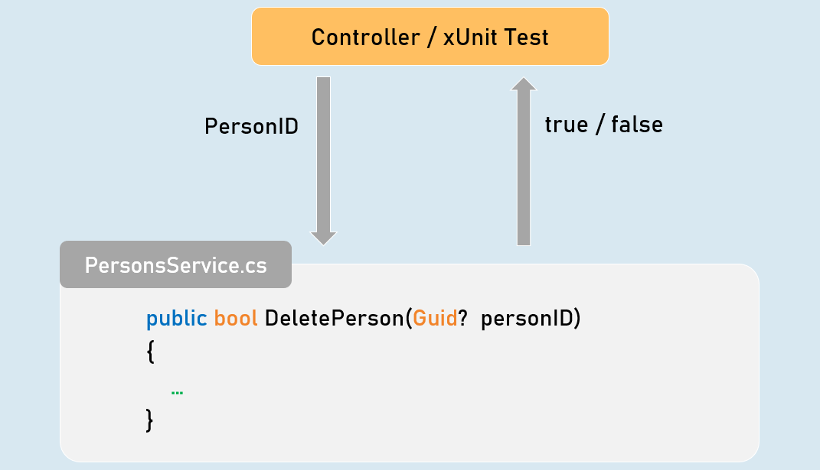

1. public bool DeletePerson(Guid? personID)
2. {
3. //Check if "personID" is not null.
4. //Get the matching "Person" object from List<Person> based on PersonID.
5. //Check if matching "Person" object is not null
6. //Delete the matching "Person" object from List<Person>
7. //Return Boolean value indicating whether person object was deleted or not
8. }