**Section Cheat Sheet (PPT)**

Logging

Logging is the process of recording run-time actions as they happen in real-time.

Helps us to understand the failures and performance bottlenecks of the application.

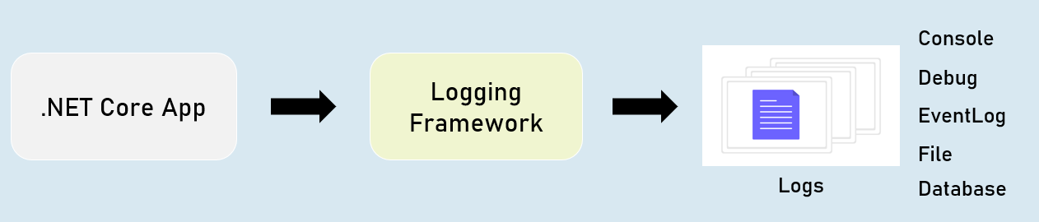

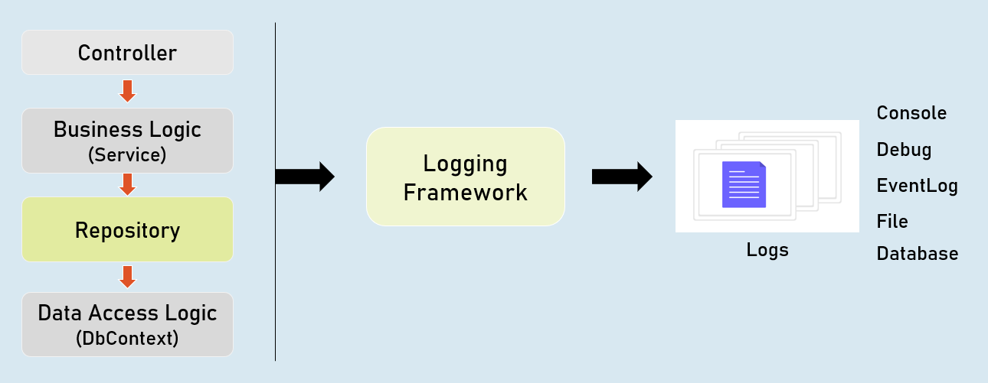

ILogger

**Debug**

ILogger.LogDebug("log_message");

Logs that provide details & values of variables for debugging purpose.

**Information**

ILogger.LogInformation("log_message");

Logs that track the general flow of the application execution.

**Warning**

ILogger.LogWarning("log_message");

Logs that highlight an abnormal or unexpected event.

**Error**

ILogger.LogError("log_message");

Logs to indicate that flow of execution is stopped due to a failure.

**Critical**

ILogger.LogCritical("log_message");

Logs to indicate an unrecoverable application crash.

Logging Configuration

**appsettings.json**

1. {
2. "Logging": {
3. "LogLevel": {
4. "Default": "Debug | Information | Warning | Error| Critical"
5. "Microsoft.AspNetCore": "Debug | Information | Warning | Error | Critical"
6. }
7. }
8. }

**Controller and other classes**

1. using Microsoft.AspNetCore.Mvc;
2. using Microsoft.Extensions.Logging;
4. public class ControllerName : Controller
5. {
6. private readonly ILogger<ClassName> _logger;
8. public ControllerName(ILogger<ClassName> logger)
9. {
10. _logger = logger;
11. }
12. }

Logging Providers

Logging provider specifies where to store / display logs.

The built-in logging providers in asp.net core doesn't support file / database logging providers.

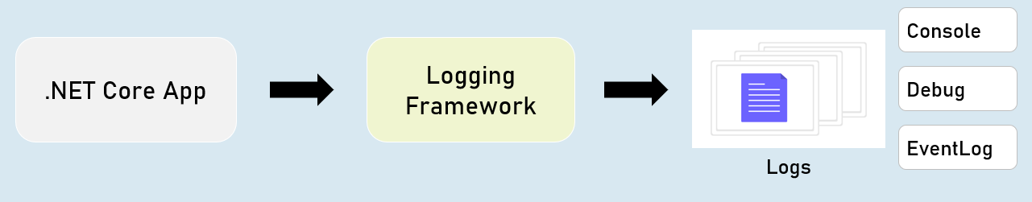

in **Program.cs:**

1. builder.Host.ConfigureLogging(logging =>
2. {
3. logging.ClearProviders();
4. logging.AddConsole();
5. logging.AddDebug();
6. logging.AddEventLog();
7. });

HTTP Logging

Logs details all HTTP requests and responses.

You need to set a value of "HttpLoggingFields" enum to set specify desired details.

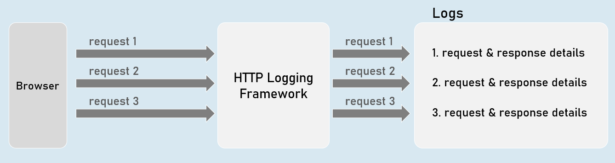

HTTP Logging Options

**"HttpLoggingFields" enum:**

**RequestMethod**

Method of request. Eg: GET

**RequestPath**

Path of request. Eg: /home/index

**RequestProtocol**

Protocol of request. Eg: HTTP/1.1

**RequestScheme**

Protocol Scheme of request. Eg: http

**RequestQuery**

Query string Scheme of request. Eg: ?id=1

**RequestHeaders**

Headers of request. Eg: Connection: keep-alive

**RequestPropertiesAndHeaders**

Includes all of above (default)

**RequestBody**

Entire request body. [has performance drawbacks; not recommended]

**Request**

Includes all of above

**"HttpLoggingFields" enum**

**ResponseStatusCode**

Status code of response. Eg: 200

**ResponseHeaders**

Headers of response. Eg: Content-Length: 20

**ResponsePropertiesAndHeaders**

Includes all of above (default)

**ResponseBody**

Entire response body. [has performance drawbacks; not recommended]

**Response**

Includes all of above

**All**

Includes all from request and response

**HTTP Logging Options**

Program.cs:

1. builder.Serices.AddHttpLogging(options =>
2. {
3. options.LoggingFields = Microsoft.AspNetCore.HttpLogging.HttpLoggingFields.YourOption;
4. });

Serilog

Serilog is a structured logging library for Asp.Net Core.

Supports variety of logging destinations, referred as "Sinks" - starts with Console, Azure, DataDog, ElasticSearch, Amazon CloudWatch, Email and Seq.

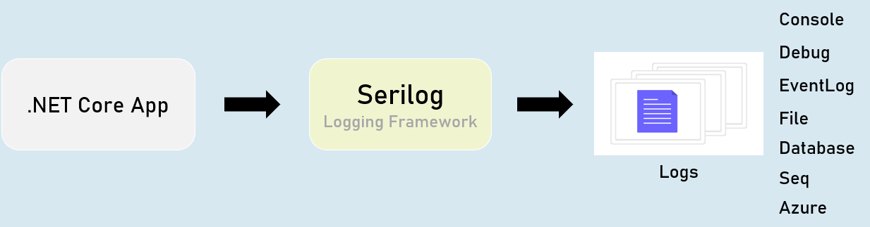

**Serilog - Configuration**

**appsettings.json**

1. {
2. "Serilog": {
3. "Using": [
4. "Serilog.Sinks.YourSinkHere"
5. ],
6. "MinimumLevel": "Debug | Information | Warning | Error | Critical",
7. "WriteTo": [
8. {
9. "Name": "YourSinkHere",
10. "Args": "YourArguments"
11. }
12. ]
13. }
14. }

Serilog - Options

**Program.cs:**

1. builder.Host.UseSerilog(HostBuilderContext context,
2. IServiceProvider services, LoggerConfiguration configuration) =>
3. {
4. configuration
5. .ReadFrom.Configuration(context.Configuration) //read configuration settings from built-in IConfiguration
6. .ReadFrom.Services(services); //read services from built-in IServiceProvider
7. });

Serilog - File Sink

The "Serilog.Sinks.File" logs into a specified file.

You can configure the filename, rolling interval, file size limit etc., using configuration settings.

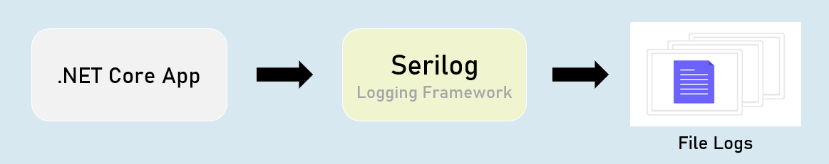

**Serilog - "File Sink" Configuration**

**appsettings.json**

1. {
2. "Serilog": {
3. "Using": [ "Serilog.Sinks.File" ],
4. "MinimumLevel": "Debug | Information | Warning | Error | Critical",
5. "WriteTo": [
6. {
7. "Name": "File",
8. "Args": [
9. "path": "folder/filename.ext",
10. "rollingInterval": "Minute | Hour | Day | Month | Year | Infinite",
11. ]
12. }
13. ]
14. }
15. }

Serilog - Database Sink

The "Serilog.Sinks.MSSqlServer" logs into a specified SQL Server database.

You can configure the connection string using configuration settings.

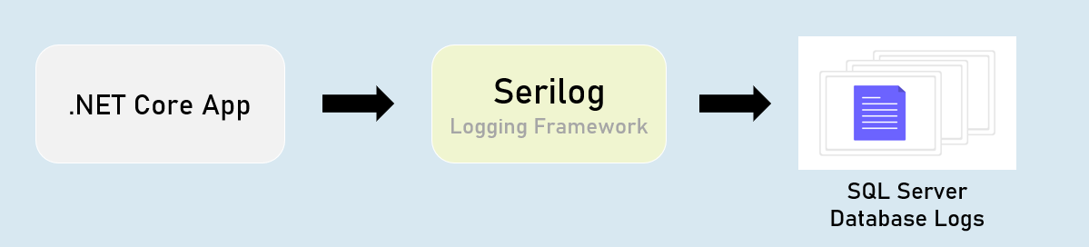

**Serilog - 'MSSqlServer' Sink Configuration**

**appsettings.json**

1. {
2. "Serilog": {
3. "Using": [ "Serilog.Sinks.MSSqlServer" ],
4. "MinimumLevel": "Debug | Information | Warning | Error | Critical",
5. "WriteTo": [
6. {
7. "Name": "MSSqlServer",
8. "Args": [
9. "connectionString": "your_connection_string_here",
10. "tableName": "table_name",
11. ]
12. }
13. ]
14. }
15. }

Serilog - Seq Sink

The "Serilog.Sinks.Seq" is a real-time search and analysis server for structured application log data.

Seq server can run on Windows, Linux or Docker.

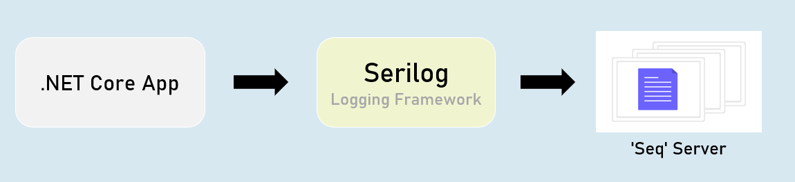

**Serilog - 'Seq' Sink - Configuration**

**appsettings.json**

1. {
2. "Serilog": {
3. "Using": [ "Serilog.Sinks.Seq" ],
4. "MinimumLevel": "Debug | Information | Warning | Error | Critical",
5. "WriteTo": [
6. {
7. "Name": "Seq",
8. "Args": [
9. "serverUrl": "http://localhost:5341"
10. ]
11. }
12. ]
13. }
14. }

Serilog - RequestId

"RequestId" is the unique number (guid) of each individual requests, used to identify to which request the log belongs to.

RequestId is "TraceIdentifier" internally, that is generated by Asp.Net Core.

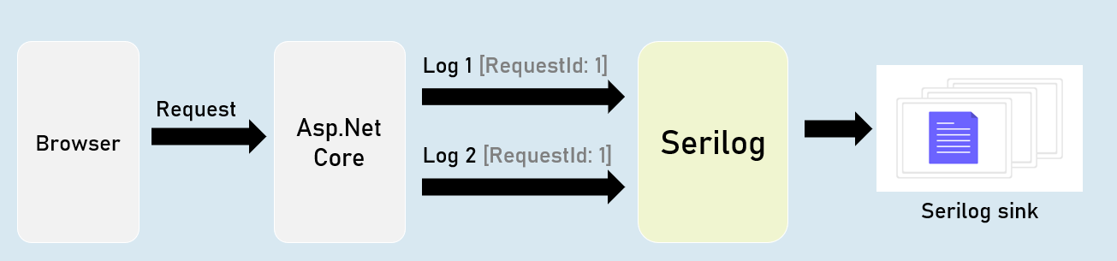

Serilog - Enrichers

Enrichers are additional details that are added to LogContext; so they're stored in logs.

Eg: MachineName[or]Custom Properties.

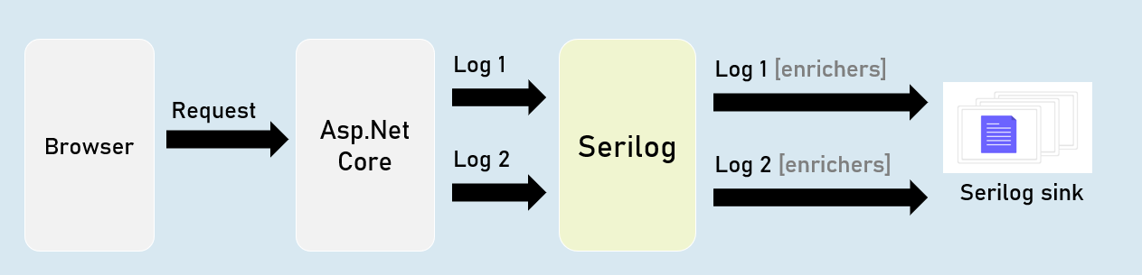

Serilog - IDiagnosticContext

Diagnostic context allows you to add additional enrichment properties to the context; and all those properties are logged at once in the final "log completion event" of the request.

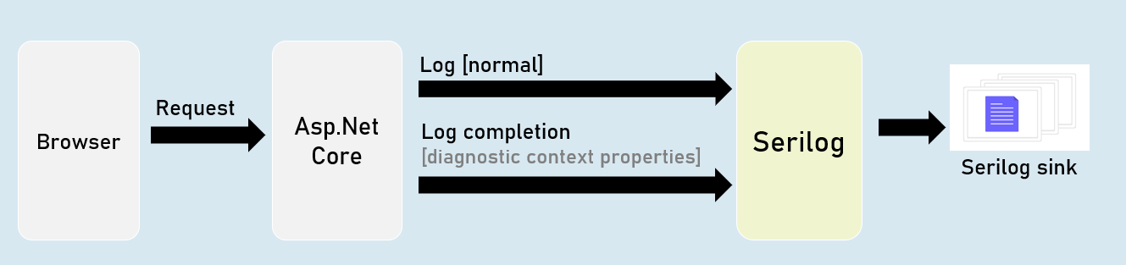

Serilog Timings

"SerilogTimings" package records timing of a piece of your soure code, indicating how much time taken for executing it.

