**Section Cheat Sheet (PPT)**

Introduction to Web API

ASP.NET Core Web API is a component (part) of ASP.NET Core, which is used create HTTP-based RESTful services (also known as HTTP services) that can be consumed (invoked) by wide range of client applications such as single-page web applications, mobile applications etc.

**Asp.Net Core:**

* Asp.Net Core MVC
* Asp.Net Core Web API
* Asp.Net Core Blazor
* Asp.Net Core Razor Pages

RESTful / Web API Services

RESTful services (Representational State Transfer) is an architecture style that defines to create HTTP services that receives HTTP GET, POST, PUT, DELETE requests; perform CRUD operations on the appropriate data source; and returns JSON / XML data as response to the client.

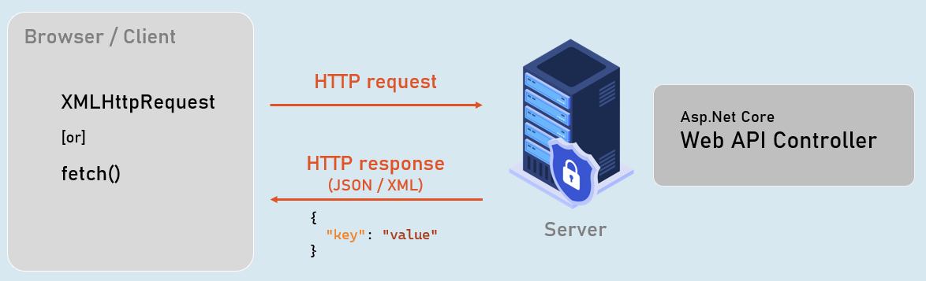

Web API Controllers

**Should be either or both:**

* The class name should be suffixed with "Controller". Eg: ProductsController
* The [ApiController] attribute is applied to the same class or to its base class.

**Controller**

1. [ApiController]
2. class ClassNameController
3. {
4. //action methods here
5. }

**Optional:**

* Is a public class.
* Inherited from Microsoft.AspNetCore.Mvc.ControllerBase.

Introduction to EntityFrameworkCore

EntityFrameworkCore is light-weight, extensible and cross-platform framework for accessing databases in .NET applications.

It is the most-used database framework for Asp.Net Core Apps.

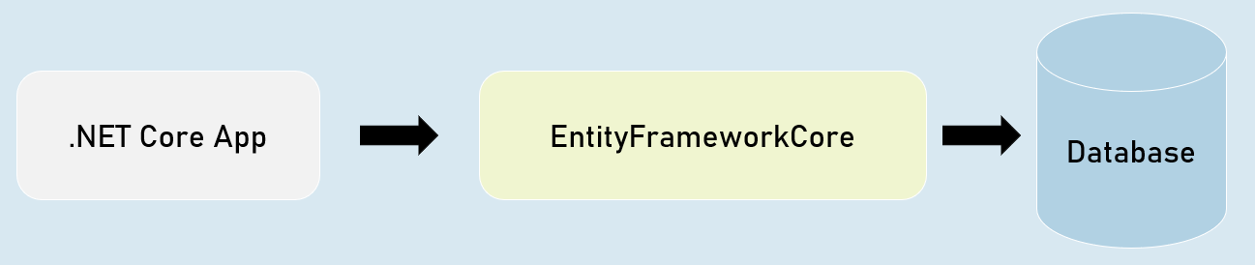

**EFCore Models**

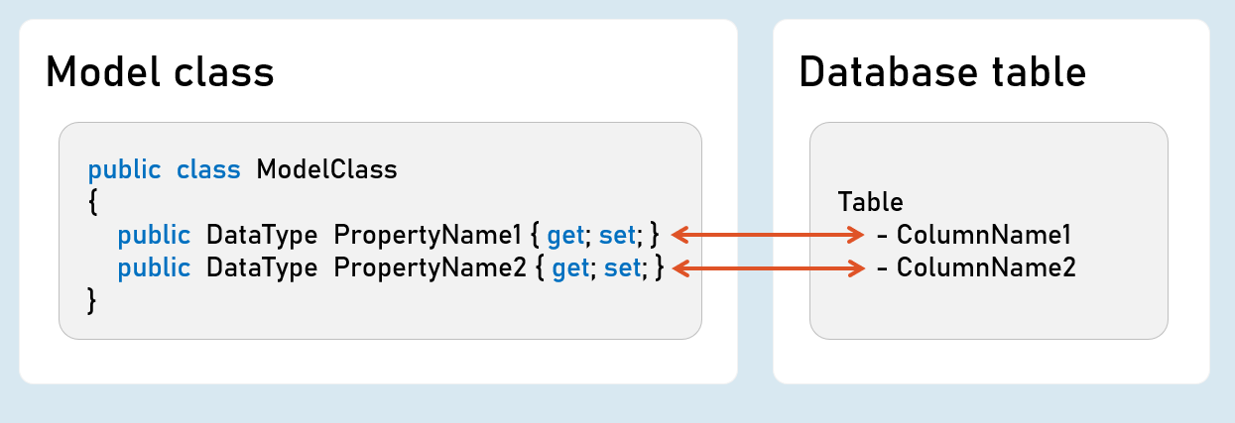

Pros & Cons of EntityFrameworkCore

**1. Shorter Code**

The CRUD operations / calling stored procedures are done with shorter amount of code than ADO.NET.

**2. Performance**

EFCore performs slower than ADO.NET.

So ADO.NET or its alternatives (such as Dapper) are recommended for larger & high-traffic applications.

**3. Strongly-Typed**

The columns as created as properties in model class.

So the Intellisense offers columns of the table as properties, while writing the code.

Plus, the developer need not convert data types of values; it's automatically done by EFCore itself.

ProblemDetails

**ProblemDetails**

1. public class ProblemDetails
2. {
3. string? Type { get; set; } //URI references that identifies the problem type
4. string? Title { get; set; } //Summary of the problem type
5. int? Status { get; set; } //HTTP response status code
6. string? Detail { get; set; } //Explanation of the problem
7. }

**ValidationProblemDetails**

1. public class ValidationProblemDetails : ProblemDetails
2. {
3. string? Type { get; set; } //URI references that identifies the problem type
4. string? Title { get; set; } //Summary of the problem type
5. int? Status { get; set; } //HTTP response status code
6. string? Detail { get; set; } //Explanation of the problem
7. IDictionary<string, string[]> Errors { get; set; } //List of validation errors
8. }

IActionResult [vs] ActionResult

**IActionResult**

1. public interface IActionResult
2. {
3. Task ExecuteResultAsync(ActionContext context); //converts an object into response
4. }

**ActionResult<T>**

1. public sealed class ActionResult<T>
2. {
3. IActionResult Convert(); //converts the object into ObjectResult
4. }

IActionResult

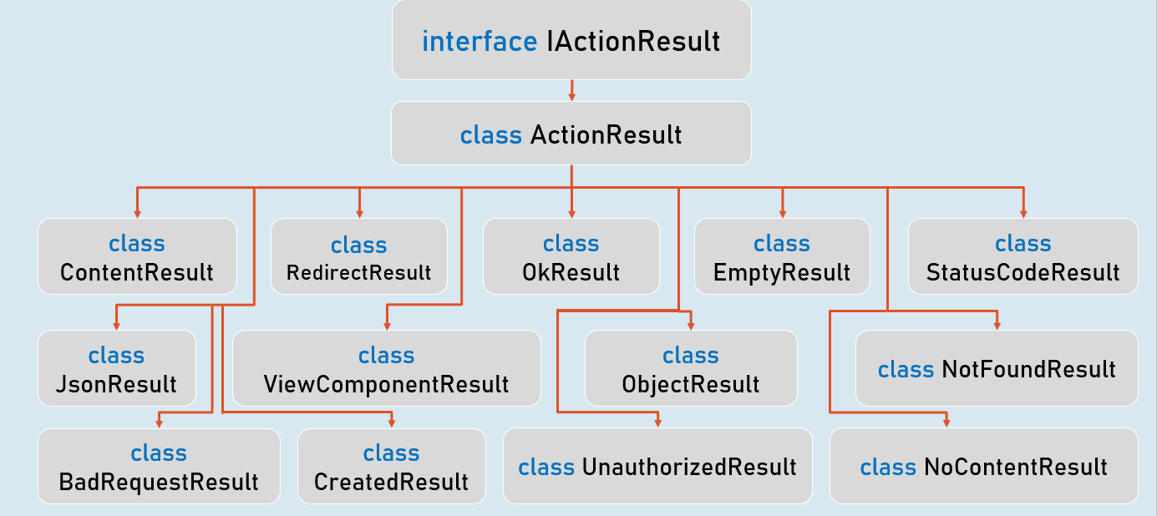

ObjectResult

