**Section Cheat Sheet (PPT)**

Introduction to Swagger

Swagger is a set of open-source tools that help developers to generate interactive UI to document, test RESTful services.

Swagger is a set of tools to implement Open API.

**1. Swasbuckle.AspNetCore**

Framework that makes it easy to use swagger in asp.net core.

**2. Swagger**

Set of tools to generate UI to document & test RESTful services.

**3. Open API**

Specification that defines how to write API specifications in JSON).

API Versions

API Versioning is the practice of transparently managing changes to your API, where the client requests a specific version of API; and the server executes the same version of the API code.

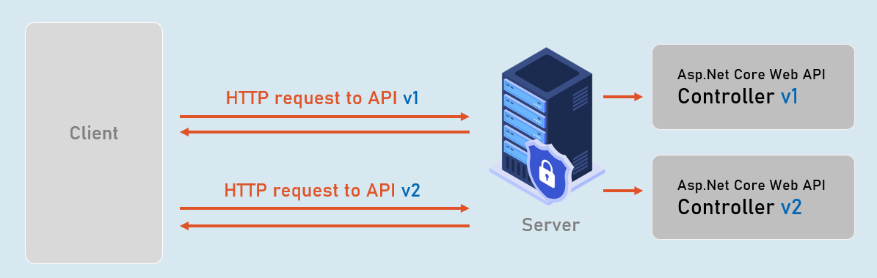

Content Negotiation

Content negotiation is the process of selecting the appropriate format or language of the content to be exchanged between the client (browser) and Web API.

