**Section Cheat Sheet (PPT)**

Angular

Angular is a TypeScript-based, free and open-source web application framework that is used to create dynamic, single-page web applications that run on the browser.

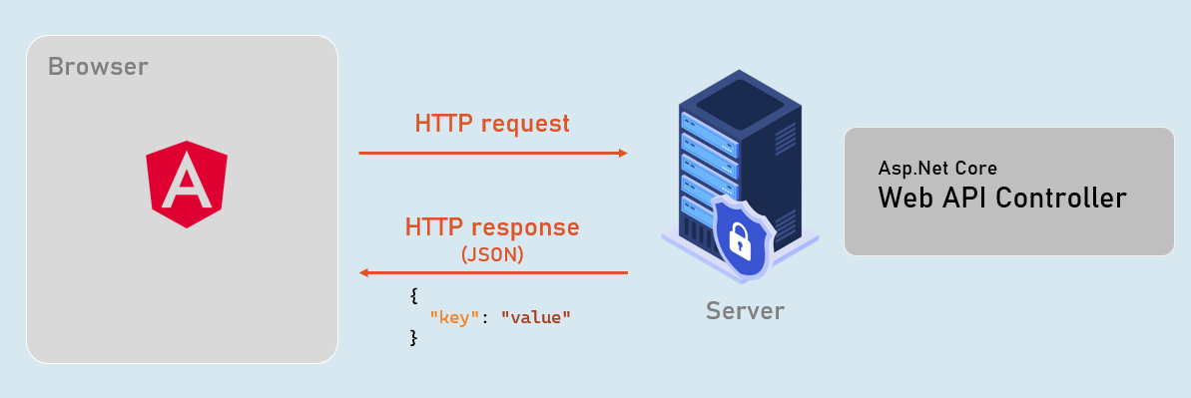

CORS

CORS (Cross-Origin Resource Sharing) is a security feature implemented by web browsers to allow or deny a web page from making requests to a different domain than the one that served the web page.

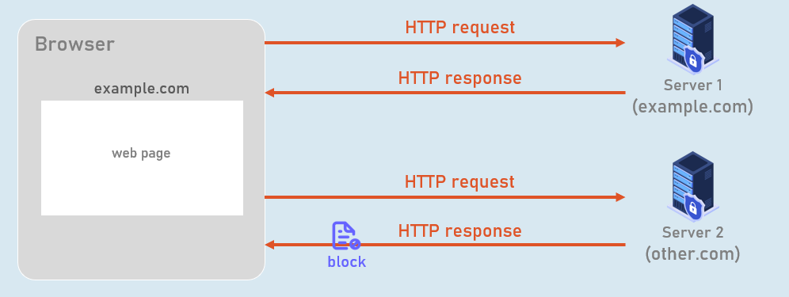

How CORS works?

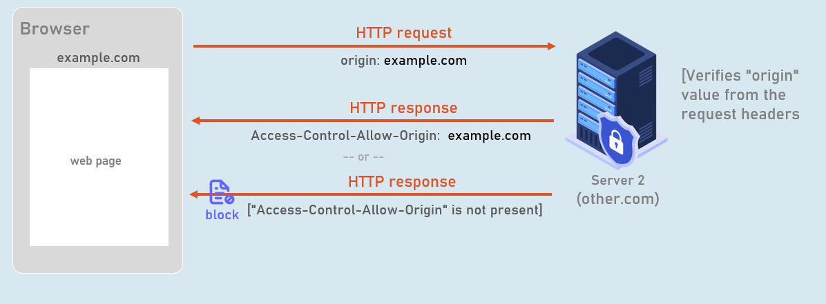

Preflight Request

It is an HTTP OPTIONS request that is sent by the browser to the Web API server before the actual request is made.

The preflight request is used to determine whether the Web API server is willing to accept the actual request.

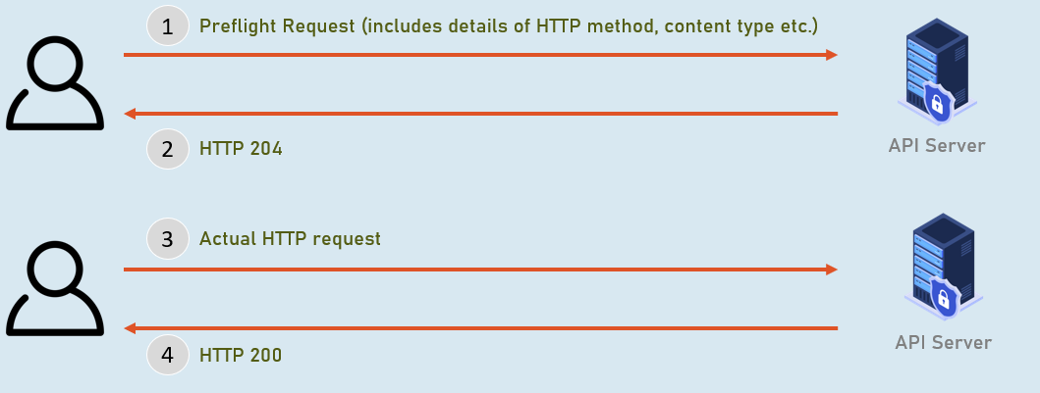

Clean Architecture

