**Section Cheat Sheet (PPT)**

Understanding .NET Framework

**What is .NET?**

* Application Development Platform, to build Desktop, Web and Mobile Apps.
* Developed by Microsoft, in 2002.
* Provides fully managed, secured application execution environment.
* Supports multiple languages such as C#, VB, VC++ etc.

Modules & Apps

**ASP.Net**

WebSites

Web Applications

WebServices

**C#.Net**

Windows GUI Applications

Windows Services

Console Applications

Common Language Infrastructure (CLI)

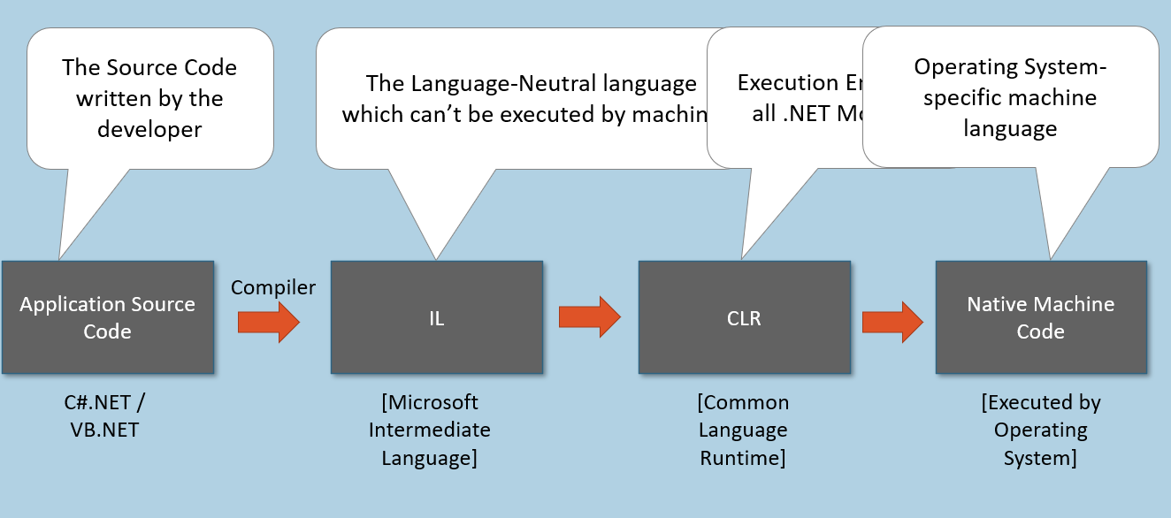

Common Language Runtime (CLR)

1. "Execution Engine" for all .net languages.
2. Code-Execution Environment that executes all types of .net applications.
3. Applications developed in any .net language runs based on "CLR" only.
4. CLR is a part of .NET Framework; pre-installed in Windows.

**CLR Components:**

* Class Loader
* Memory Manager
* Garbage Collector
* JIT Compiler
* Exception Manager
* Thread Manager
* Security Manager

Components of CLR

**Class Loader:**

Loading classes from compiled source code to memory.

Loads a class, when it is needed (before creating object).

**Memory Manager:**

Allocating necessary memory for objects.

When an object is created in the code, certain amount of memory will be allocated for the object in application's "heap".

**Garbage Collector:**

Freeing (deleting) memory of objects.

Identifies all unreferenced objects and delete them in memory (RAM).

**JIT (Just-In-Time) Compiler:**

Convert the MSIL Code into Native Machine Language.

Compiles the code of a class, when it is needed (before executing that particular class).

**Exception Manager:**

Raise notifications while run-time errors.

Creates exception logs.

**Thread Manager:**

Create threads (background process) to execute the code.

The entire program is treated as "Main thread".

Developer can create sub threads (child threads) to do background processes.

**Security Manager:**

Verifies whether the application has permission to access system resources or not.

Before executing the application, it verifies whether the application has not attacked by malicious programs & has necessary permissions to access files / folders and hardware resources.

.NET Framework

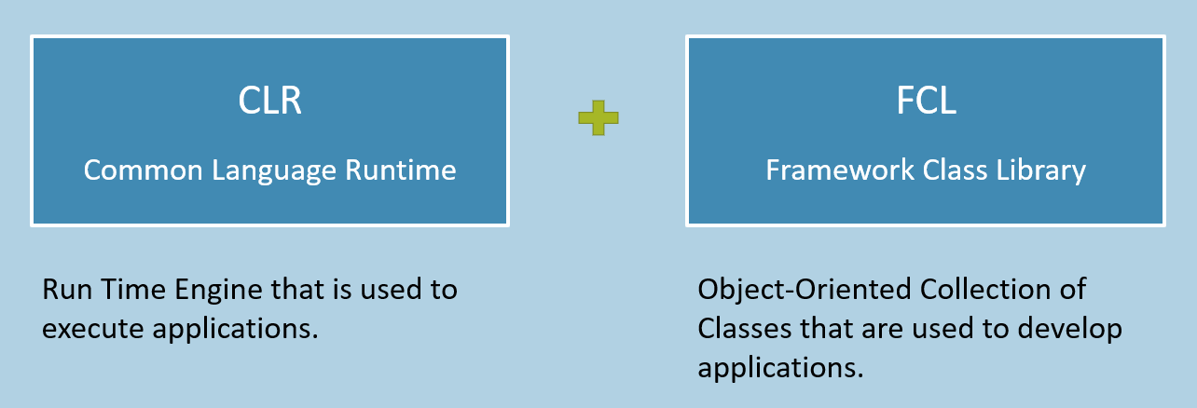

**.NET Framework Architecture**

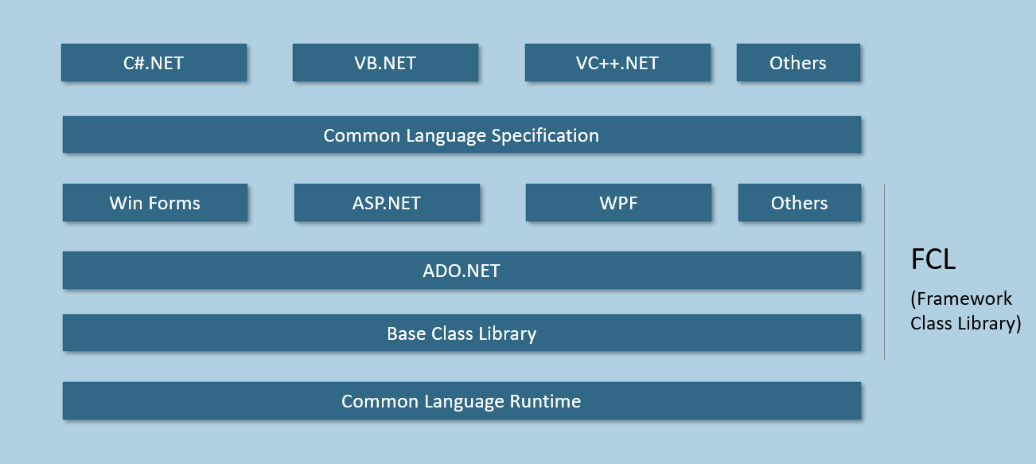

**Base Class Library (BCL)**

Contains a set of pre-defined classes that can be used in all types of .net applications & languages for general I/O operations, type conversion, creation of threads etc.

Eg:

* Console
* String
* StringBuilder
* Convert
* Thread
* Task

etc.

**ADO.NET**

Contains a set of pre-defined classes that can be used in all types of .net applications & languages for connecting to databases, retrieving data from databases, inserting, updating, deleting rows etc.

Eg:

* SqlConnection
* SqlCommand
* SqlDataAdapter
* SqlDataReader

etc.

**WinForms**

Contains a set of pre-defined classes that can be used in Windows GUI applications for development of GUI elements such as form, textbox, button, checkbox, radio button, dropdownlist etc.

Eg:

* Form
* Label
* Button
* Text Box

etc.

**Windows Presentation Foundation (WPF)**

Contains a set of pre-defined classes that can be used in Rich Windows GUI applications for development of GUI elements such as window, textbox, button, checkbox, radio button, dropdownlist etc.

Eg:

* Window
* Label
* Button
* Text Box

etc.

**Active Server Pages (ASP.NET)**

Contains a set of pre-defined classes that can be used in Web Applications for development of GUI elements such as page, textbox, button, checkbox, radio button, dropdownlist etc.

Eg:

* Page
* Label
* Button
* Text Box

etc.

**Common Language Specification (CLS)**

Contains a set of rules (concepts) that are common to all .net languages such as C#.NET, VB.NET etc.

**Common rules of CLS:**

* CTS (Common Type System): Contains data types such as Int32, Int64, Single, Double etc.
* Classes & Objects
* Reference Variables
* Method Parameters
* Generics

etc.

Versions of .NET Framework

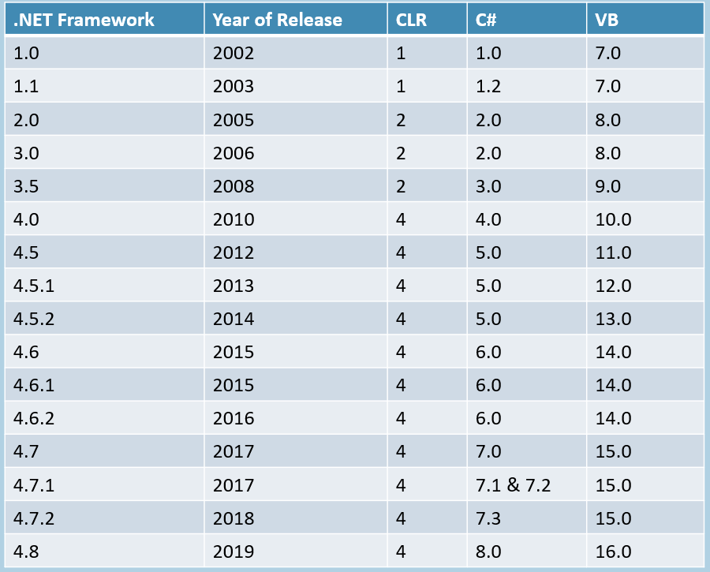

**.NET 1.0 New Features**

1. Data Types
2. Classes
3. Objects
4. Arrays
5. Collections
6. All other basic language features.

**.NET 1.1 New Features**

1. Code Access Security in ASP.NET applications
2. ODBC (Open Database Connection)
3. .NET Compact Framework to run .net apps on small devices

**.NET 2.0 New Features**

1. 64-bit system execution support
2. Themes, Skins, MasterPages and WebParts, Membership in ASP.NET
3. Partial Classes, Nullable Types, Anonymous Methods, Iterators, Generics in C#
4. CLR 2.0

**.NET 3.0 New Features**

1. WPF (Windows Presentation Foundation): Framework to develop rich Windows GUI Apps.
2. WCF (Windows Communication Foundation): Framework to develop Service Oriented Applications (SOA).
3. WWF (Windows Workflow Foundation): Framework to develop task automation and transactions using workflows.

**.NET 3.5 New Features**

1. Data Annotations
2. Entity Framework

**.NET 4.0 New Features**

1. Task Parallel Library (Tasks)
2. Named Parameters in C#
3. CLR 4.0

**.NET 4.5 New Features**

1. Windows Store Apps
2. Async and Await in C#
3. New input types, Bundling & Minification, Web Sockets, Anti-XSS in ASP.NET

**.NET 4.6 New Features**

1. SHA-2, Elliptic Curve Cryptography API
2. 64-bit JIT compiler for Managed Code
3. Introduction of .NET Core (Provides multi-platform support for Windows, LINUX, Mac, Android, iOS).

**.NET 4.7 New Features**

1. Print-API and Stylus support for WPF
2. Introduction of ASP.NET Core (Provides multi-platform support for Windows, LINUX, Mac as Web Servers).

**.NET 4.8 New Features**

1. Performance & security updates.
2. Support for high-resolution displays.

.NET Core

* Introduced in 2016.
* Microsoft's Application Development Platform to develop any desktop, web, mobile and embedded (IoT) applications.
* Supports Windows, LINUX, Mac, Android, iOS, Windows Phone devices.
* Versions: 1.0, 1.1, 2.0, 2.1, 2.2, 3.0, 3.1
* Mainly used in Xamarin and ASP.NET Core.
* Open Source (via MIT license)
* Contains the class library, which is a subset of .NET Framework.
* Doesn't contain any Windows-specific classes / run time services.
* C# / VB.NET can used for writing code of .NET Core.

Introducing Visual Studio

IDE / Code editor for all types of .net applications & languages.

Should be installed on 'Developer-machine'.

**Features:**

* Intelli-sense (code completion)
* Syntax highlighting
* Debugger
* GUI Designer

**Versions of Visual Studio**

