Inheritance

* This allows classes to be arranged in a hierarchy that represents "is-a-type-of" relationships.
* The "parent class" acts as a "base type" of "one or more child classes".
* Child classes are derived from parent class.

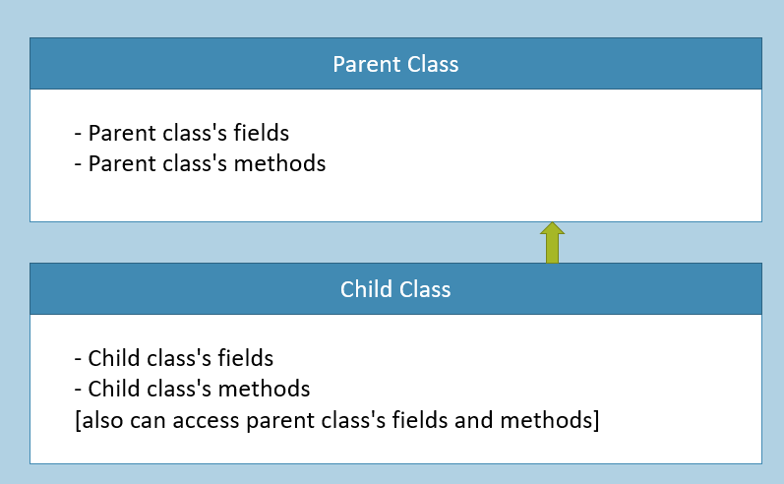

* Concept of extending the parent class, by creating child class.
* "Child class" extends "parent class".
* The child class's object stores members of both child class and parent class.

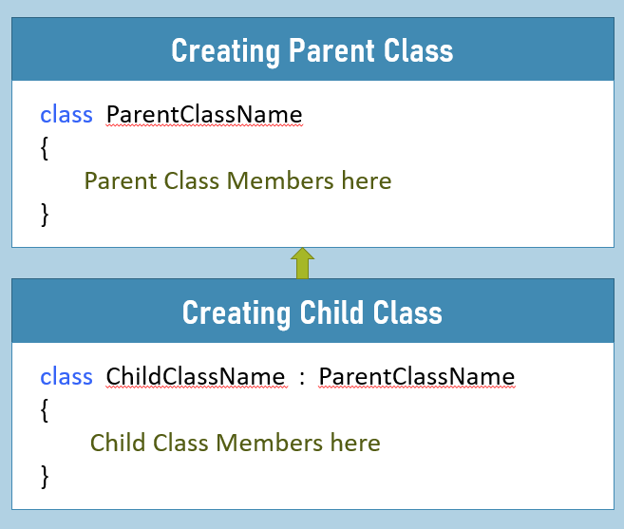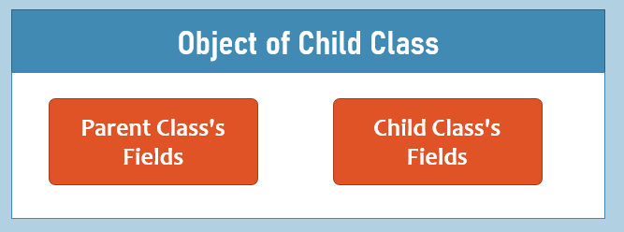

Types of Inheritance

**1. Single Inheritance**

1. class ParentClassName
2. {
3. }
5. class ChildClassName : ParentClassName
6. {
7. }

One Parent Class, One Child Class.

**2. Multi-Level Inheritance**

1. class ParentClassName
2. {
3. }
5. class ChildClass1 : ParentClassName
6. {
7. }
9. class ChildClass2 : ChildClass1
10. {
11. }

One Parent Class, One Child Class; and the Child class has another Child class.

**3. Hierarchical Inheritance**

1. class ParentClassName
2. {
3. }
5. class ChildClass1 : ParentClassName
6. {
7. }
9. class ChildClass2 : ParentClassName
10. {
11. }

One Parent Class, Multiple Child Classes.

**4. Multiple Inheritance**

1. class ParentClass1
2. {
3. }
5. class ParentClass2
6. {
7. }
9. class ChildClass : ParentClass1, ParentClass2
10. {
11. }

Multiple Parent Classes, One Child class.

**5. Hybrid Inheritance**

1. class ParentClassName
2. {
3. }
5. class ChildClass1 : ParentClassName
6. {
7. }
9. class ChildClass2 : ChildClass1
10. {
11. }
13. class ChildClass3 : ChildClass1
14. {
15. }

Hierarchical Inheritance + Multi Level Inheritance

'base' keyword

The "base" keyword represents parent class's members in the child class.

It is optional to use, by default.

It is must to use, when there is "name ambiguity" between parent class's member and child class's member.

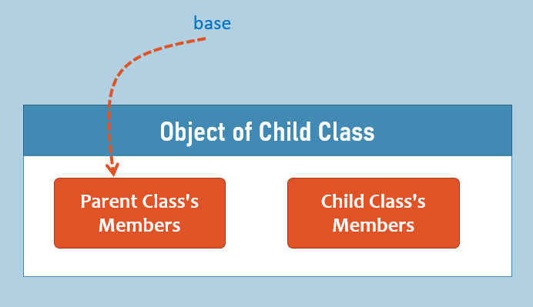

Parent Class's Constructor

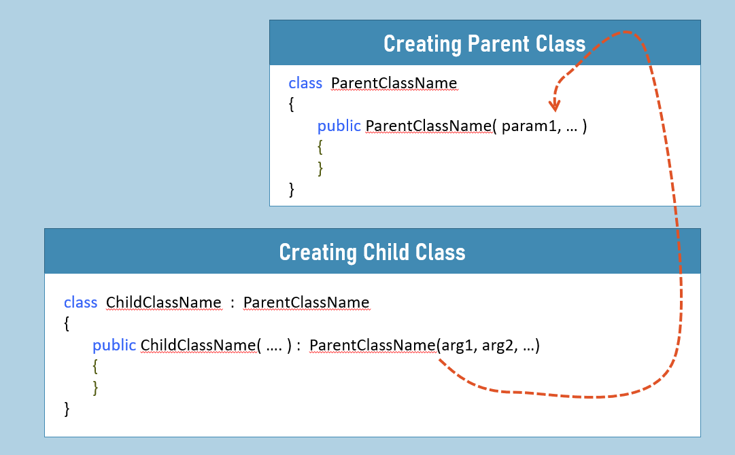

It is OPTIONAL to call "Parent Class's Parameter-less Constructor" from "Child Class".

It is MUST to call "Parent Class's Parameterized Constructor" from "Child Class" and pass necessary arguments.

Method Hiding

It is a concept, which is used to hide (overwrite) the parent class's method, by creating another method in the child class with same name and same parameters.

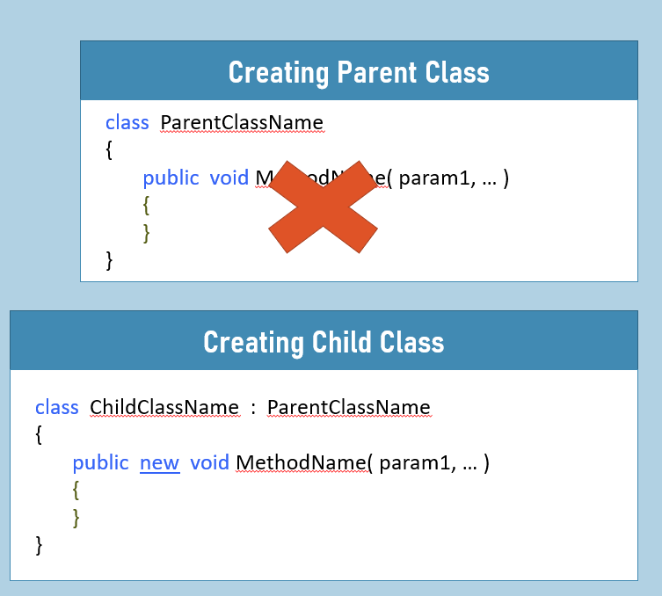

When method hiding is done, if the method is called using child class's object; the child class's method only executes; parent class's method will not be executed.

Method hiding is done automatically; but is recommended to use "new" keyword (but not must).

Method Overriding

It is a concept, which is used to extend the parent class's method, by creating another method in the child class with same name and same parameters.

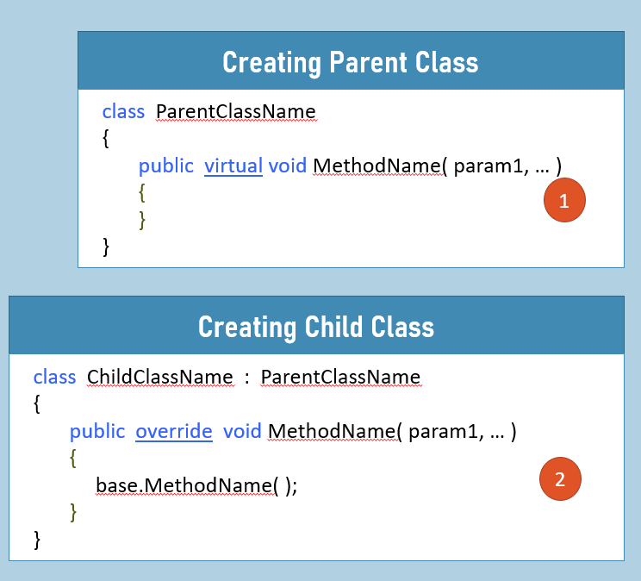

When method overriding is done, if the method is called using child class's object; the parent class's method first and child's method executed next.

Method Overriding is done with "virtual" keyword at parent class; and "override" keyword at child class's method.

The parent class's method invoked using "base" keyword.

Without 'virtual' keyword are parent class's method; the child class's method can't be 'override'.

Key Points to Remember

* The "parent class" acts as a "base type" of "one or more child classes".
* The 'base' keyword inside the child class, can access the members of parent class.
* The child class's object stores parent class's fields also, automatically; however they are accessible in child class if they are not 'private'.
* Method hiding is a concept of 'overwriting' the parent class's method, by creating another method in child class, with same signature.
* Method overriding is a concept of 'extending' the parent class's method, by creating another method in child class, with same signature.
* C# doesn't support multiple inheritance (with multiple parent classes). That means, a child class can have ONLY ONE parent class; however, a child class can have MULTIPLE parent interfaces; so in this way, C# supports multiple inheritance.

Sealed Classes

Sealed class is a class, which is instantiable; but not inheritable.

Use sealed class, whenever you don't want to let other developers to create child classes for the specific class.

1. sealed class Class1
2. {
3. }
5. class Class2 : Class1 //not possible
6. {
7. }

Comparison Table: Class [vs] Sealed Class

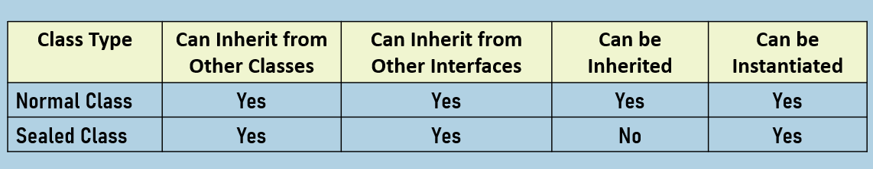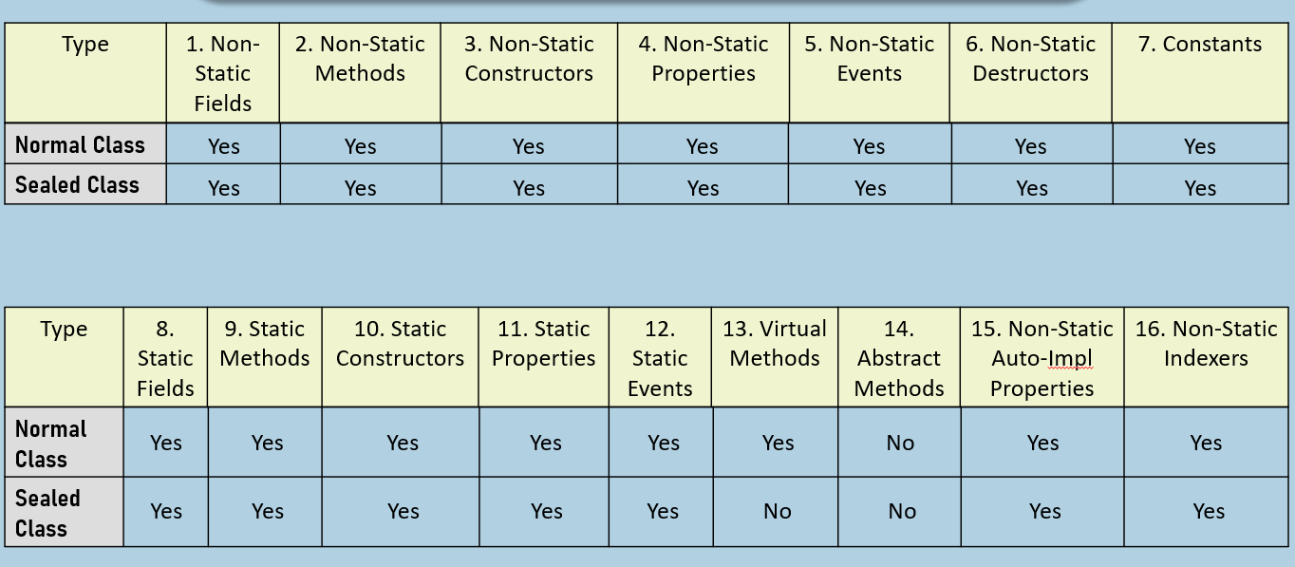

Sealed Methods

Sealed Methods must be "override methods"; which can't be overridden in the corresponding child classes.

Use sealed methods to prevent overriding that particular methods in the corresponding child classes.

