Abstraction

Abstraction is a concept of representing objects in a simplified way by focusing only on the essential features and ignoring the irrelevant details.

It provides a blueprint or a contract for derived classes to follow, ensuring consistency in your code.

**Benefit:**

Makes the program loosely coupled (makes the classes less dependent on the other).

**Implemented using:**

* Abstract classes [or]
* Interfaces

Abstract Classes

Abstract class is a parent class, for which, we can't create object; but we can create child classes.

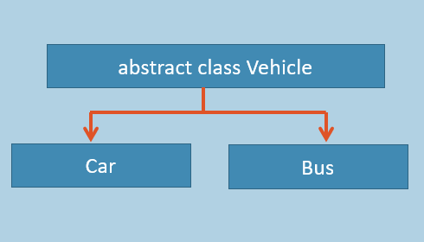

**Parent Class [Abstract Class]**

1. abstract class AbstractClassName
2. {
3. //Abstract Class Members here
4. }

**Child Class of Abstract Class**

1. class ChildClassName : AbstractClassName
2. {
3. Child Class Members here
4. }

The main intention of abstract class is to provide common set of fields and methods to all of its child classes of a specific group.

Abstract class can contain all types of members (fields, properties, methods, constructors etc.).

We can't create object for abstract class; but we can access its members through child class's object.

So 'creating child class of abstract class' is the only-way to utilize abstract classes.

Use Abstract class concept, for the classes, for which, you feel creating object is not meaningful.

Comparison Table: Class (vs) Abstract Class

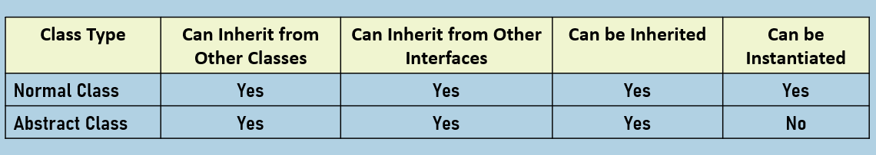

**Based on members:**

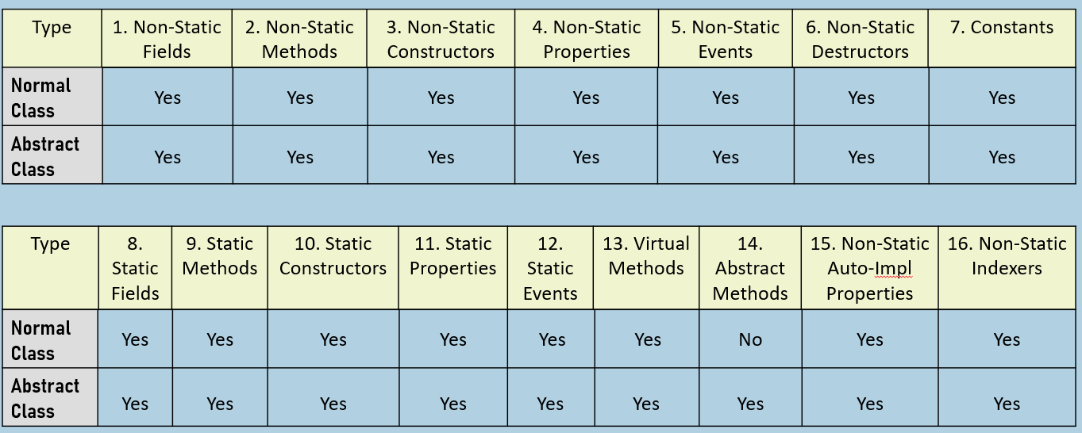

Abstract Methods

Abstract methods are declared in parent class, with "abstract" keyword; implemented in child classes, with "override" keyword.

When the parent class don't want to provide the definition of a method;it wants to let child classes to implement the method.

**Parent Class [Abstract Class]**

1. abstract class AbstractClassName
2. {
3. AccessModifier abstract ReturnDataType MethodName(param1, …);
4. }

**Child Class of Abstract Class**

1. class ChildClassName : AbstractClassName
2. {
3. AccessModifier override ReturnDataType MethodName(param1, …)
4. {
5. }
6. }

Abstract Methods contain "method declaration" only; but not "method body".

Child class  must provide method body for abstract methods.

Eg:

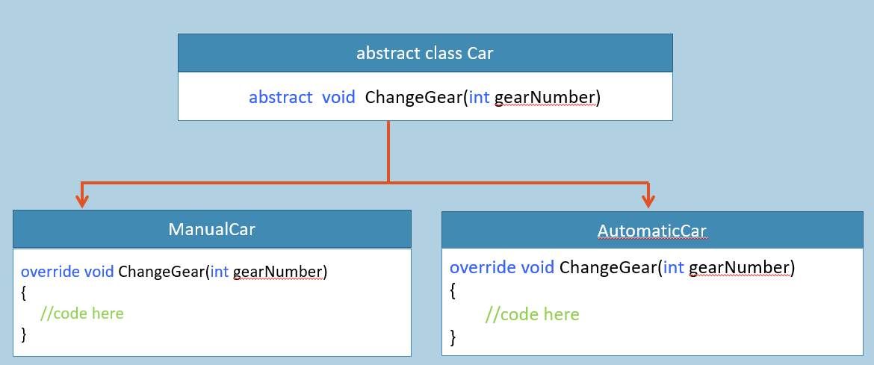

Interfaces

Interface is a set of abstract methods, that must be implemented by the child classes.

Eg:

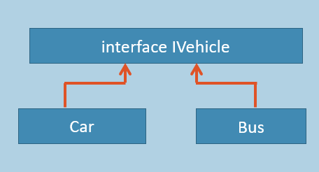

**Interface**

1. interface InterfaceName
2. {
3. ReturnDataType MethodName(param1, …);
4. }

**Child Class of Interface**

1. class ChildClassName : InterfaceName
2. {
3. public ReturnDataType MethodName(param1, …)
4. {
5. }
6. }

* The child class that implements the interface, MUST implement ALL METHODS of the interface.
* Interface methods are by default "public" and "abstract".
* The child class must implement all interface methods, with same signature.
* You can't create object for interface.
* You can create reference variable for the interface.
* The reference variable of interface type can only store the address of objects of any one of the corresponding child classes.
* You can implement multiple interfaces in the same child class [Multiple Inheritance].
* An interface can be child of another interface.

Comparison Table: Abstract Class (vs) Interface

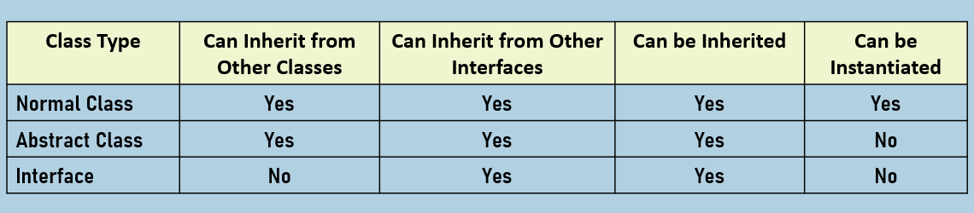

**Based on members:**

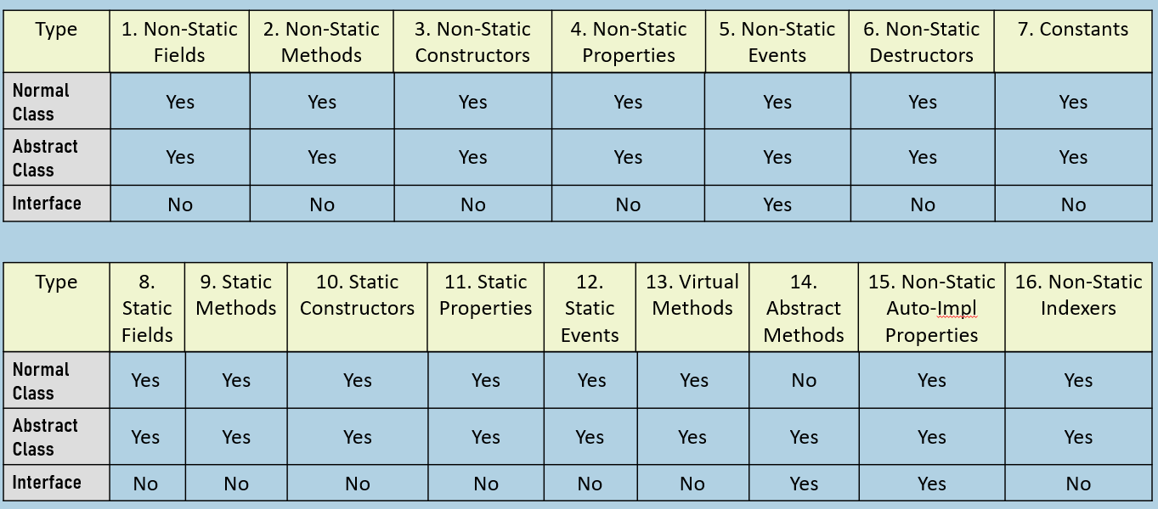

Polymorphism

Polymorphism provides the ability to the developer, to define different implements for the same method in the same class or different classes.

**Compile-time polymorphism:**

* Eg: Method Overloading
* Decission will be taken at compilation time.
* Also known as "Early binding" / "Static polymorphism".

**Run-time polymorphism:**

* Eg: Method Overriding
* Decission will be taken at run time.
* Also known as "Late binding" / "Dynamic polymorphism".

**Implementation of different types of Polymorphism**

1. public void Add(int a, int b);
2. public void Add(int a, int b, int c);

**Run-Time Polymorphism Example - Method Overriding:**

1. abstract class ParentClass
2. {
3. public abstract void Add(int a, int b);
4. }
6. class ChildClass1 : ParentClass
7. {
8. public override void Add(int a, int b)
9. {
10. //Implementation for ChildClass1.Add
11. }
12. }
14. class ChildClass1 : ParentClass
15. {
16. public override void Add(int a, int b)
17. {
18. //Implementation for ChildClass2.Add
19. }
20. }

23. ParentClass c1;
24. c1 = new ChildClass1();
25. c1.Add(10, 20); //calls ChildClass1.Add
27. c1 = new ChildClass2();
28. c1.Add(10, 20); //calls ChildClass2.Add

**Run-Time Polymorphism Example - With Interfaces:**

1. interface InterfaceName
2. {
3. void Add(int a, int b);
4. }
6. class ChildClass1 : InterfaceName
7. {
8. public void Add(int a, int b)
9. {
10. //Implementation for ChildClass1.Add
11. }
12. }
14. class ChildClass2 : InterfaceName
15. {
16. public void Add(int a, int b)
17. {
18. //Implementation for ChildClass2.Add
19. }
20. }

23. InterfaceName c1;
24. c1 = new ChildClass1();
25. c1.Add(10, 20); //calls ChildClass1.Add
27. c1 = new ChildClass2();
28. c1.Add(10, 20); //calls ChildClass2.Add

Multiple Inheritance

In C#, "multiple inheritance" IS POSSIBLE with INTERFACES; that means a child class can have multiple parent interfaces.

Eg:

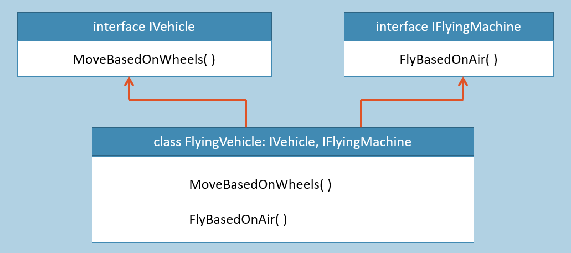

1. interface Interface1
2. {
3. void Method1(param1, param2, ...);
4. }
6. interface Interface2
7. {
8. void Method2(param1, param2, ...);
9. }
11. class ChildClass : Interface1, Interface2
12. {
13. public void Method1(param1, param2, ...)
14. {
15. //implementation for ChildClass.Method1
16. }
18. public void Method1(param1, param2, ...)
19. {
20. //implementation for ChildClass.Method2
21. }
22. }
24. Interface1 c1 = new ChildClass();
25. c1.Method1(...); //calls ChildClass.Method1
27. Interface2 c2 = new ChildClass();
28. c2.Method2(...); //calls ChildClass.Method2

"One Child - Multiple Parent Classes / Parent Interfaces" is called as "Multiple Inheritance".

In C#.NET, "multiple inheritance" IS NOT POSSIBLE with CLASSES; that means you can't specify multiple parent classes.

The child class MUST IMPLEMENT all methods of all the interfaces, that are inherited from.

Interface Inheritance

If an interface inherits from another interface, we call it as "Interface Inheritance".

The child class that implements the child interface must implement all the members of both parent interface and child interface too.

Eg:

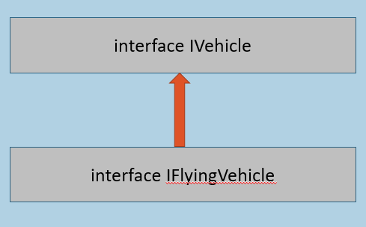

1. interface Interface1
2. {
3. public void Method1(param1, param2, ...);
4. }
6. interface Interface2 : Interface1
7. {
8. public void Method2(param1, param2, ...);
9. }
11. class ChildClass : Interface2
12. {
13. public void Method1(param1, param2, ...)
14. {
15. //Implementation for ChildClass.Method1
16. }
18. public void Method2(param1, param2, ...)
19. {
20. //Implementation for ChildClass.Method2
21. }
22. }
24. Interface1 c1 = new ChildClass();
25. c1.Method1(...); //calls ChildClass.Method1
27. Interface2 c2 = new ChildClass();
28. c2.Method1(...); //calls ChildClass.Method1
29. c2.Method2(...); //calls ChildClass.Method2

Explicit Interface Implementation

"Explicit Interface Implementation" is used to implement an interface method privately; that means the interface method becomes as "private member" to the child class.

Eg:

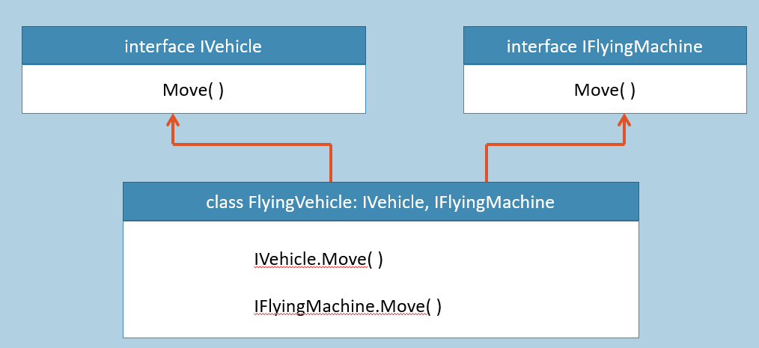

1. interface Interface1
2. {
3. void Method1(param1, param2, ...);
4. }
6. interface Interface2
7. {
8. void Method1(param1, param2, ...);
9. }
11. class ChildClass : Interface1, Interface2
12. {
13. void Interface1.Method1(param1, param2, ...)
14. {
15. }
17. void Interface2.Method1(param1, param2, ...)
18. {
19. }
20. }
22. Interface1 c1 = new ChildClass();
23. c1.Method1(...); //calls Interface1.Method1 at ChildClass
25. Interface2 c2 = new ChildClass();
26. c2.Method1(...); //calls Interface2.Method1 at ChildClass

If a child class inherits from two or more interfaces, and there is a duplicate method (having same name and parameters) among those interfaces; then use "Explicit Interface Implementation", to provide different implementations for different interface methods respectively.

You can use "Explicit Interface Implementation" to create private implementation of interface method; so that you can create abstraction for those methods.