Tuples

The System.Tuple class represents a set of values of any data type.

Introduced in C# 4.0.

Useful to return multiple values from a method (or) to pass multiple values to a method.

Represents a set of values quickly without creating a separate class.

Alternative to anonymous objects (to be used as parameter types / return types).

**Step 1: Object of Tuple class**

var referenceVariable = new Tuple<type1, type2, …>( ) { value1, value2, … };

**Step 2: Accessing Elements**

1. referenceVariable.Item1 //returns value1
2. referenceVariable.Item2 //returns value2
3. …

**Tuple**

1. Item1 = value1
2. Item2 = value2

Tuple stores only a set of values (of any data type); but doesn't store property names. So you should access them as Item1, Item2 etc.; which doesn't make sense some times.

Tuple supports up to 8 elements only by default. You can store more than 8 values by using nested tuples (tuple inside tuple).

Tuples are mainly used to pass multiple values to a method as parameter; and also return multiple values from a method.

Value Tuples

'Value Tuples' are advancement to 'Tuple' class with simplified syntax.

Introduced in C# 7.1.

Supports unlimited values.

You will access elements with real field names; instead of Item1, Item2 etc.

Can be used as method parameters / return value; much like Tuple class.

**Step 1: Creating Value Tuple**

(type fieldName1, type fieldName2, …) referenceVariable = (value1, value2, … );

**Step 2: Accessing Elements**

1. referenceVariable.fieldName1 //returns value1
2. referenceVariable.fieldName2 //returns value2
3. …

**Value Tuple**

1. field1 = value1
2. field2 = value2

Deconstruction

Deconstruction allows you to assign elements of value tuple into individual local variables.

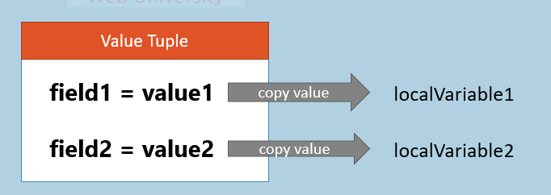

**Step 1: Create Value Tuple**

(type fieldName1, type fieldName2, …) referenceVariable = (value1, value2, … );

**Step 2: Deconstruction**

(type variableName1, type variableName2, …) = referenceVariable;

Discards

Discard allows you to skip a value which you don't require, by using underscore ( _ ).

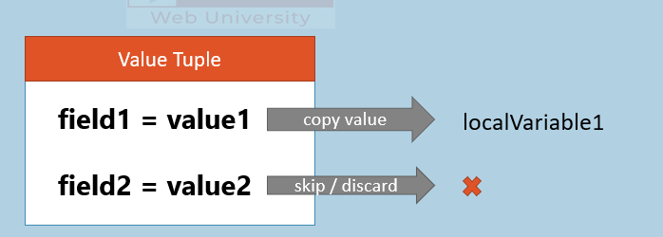

**Step 1: Create Value Tuple**

(type fieldName1, type fieldName2) referenceVariable = (value1, value2);

**Step 2: Deconstruction with Discard**

(type variableName1, _ ) = referenceVariable;