LINQ

LINQ is a 'uniform query syntax' that allows you to retrieve data from various data sources such as arrays, collections, databases, XML files.

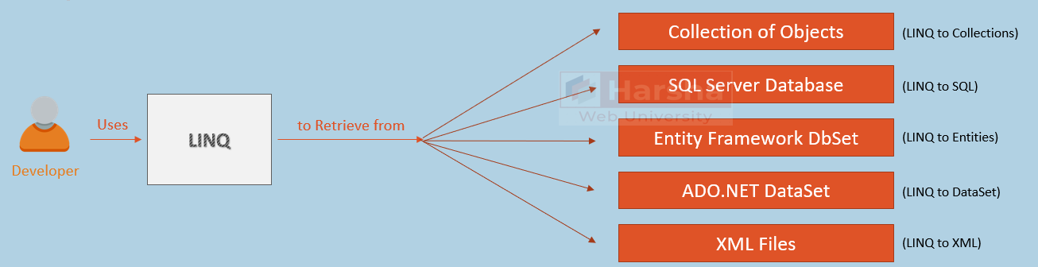

**LINQ Query - Example**

1. var result = Customers.Where(temp => temp.Location == "New York").ToList( );
2. //returns a list of customers from New York location.

Advantages of LINQ

**Single Syntax - To Query Multiple Data Sources**

Developer uses the same LINQ syntax to retrieve information from various data sources such as collections, SQL Server database, Entity Framework DbSet's, ADO.NET DataSet etc.

**Compile-Time Checking of Query Errors**

Errors in the LINQ query will be identified while compilation time / while writing the code in Visual Studio.

**IntelliSence Support**

The list of properties of types are shown in VS IntelliSence while writing the LINQ queries.

LINQ Extension Methods

**Filtering:**Where, OfType

**Sorting:**OrderBy, OrderByDescending, ThenBy, ThenByDescending, Reverse

**Grouping:**GroupBy

**Join:**Join

**Project:**Select, SelectMany

**Aggregation:**Average, Count, Max, Min, Sum

**Quantifiers:**All, Any, Contains

**Elements:**ElementAt, ElementAtOrDefault, First, FirstOrDefault, Last, LastOrDefault, Single, SingleOrDefault

**Set Operations:**Distinct, Except, Intersect, Union

**Partitioning:**Skip, SkipWhile, Take, TakeWhile

**Concatenation:**Concat

**Equality:**SequenceEqual

**Generation:**DefaultEmpty, Empty, Range, Repeat

**Conversion:**AsEnumerable, AsQueryable, Cast, ToArray, ToDictionary, ToList

Where

Where() method filters collection based on given lambda expression and returns a new collection with matching element.

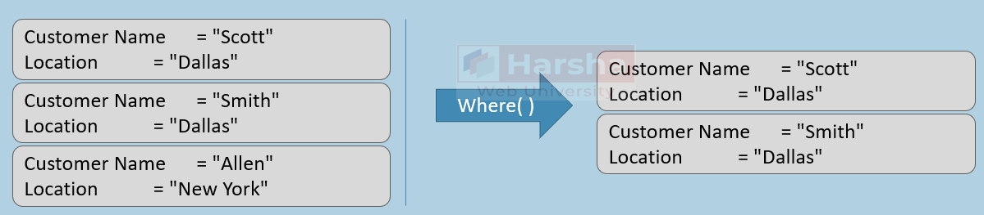

**Where Extension Method - Declaration**

Where(Func<TSource, bool> predicate)

**Where Extension Method - Usage**

1. var result = Customers.Where(temp => temp.Location == "Dallas").ToList( );
2. //returns a list of customers from Hyderabad location.

OrderBy

OrderBy() method sorts collection based on given lambda expression (property) and returns a new collection with sorted elements.

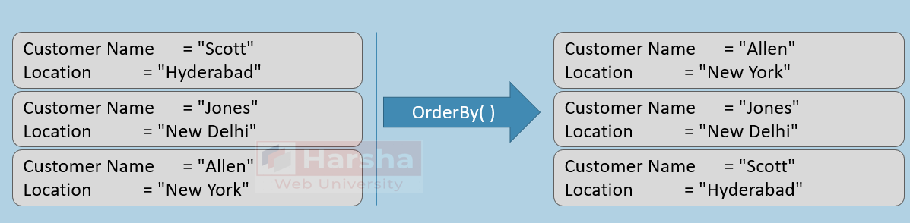

**OrderBy Extension Method - Declaration**

1. OrderBy(Func<TSource, TKey> keySelector)

**OrderBy Extension Method - Usage**

1. var result = Customers.OrderBy(temp => temp.CustomerName).ToList( );
2. //returns a list of customers sorted based on customer name.

**OrderByDescending Extension Method - Declaration**

1. OrderByDescending(Func<TSource, TKey> keySelector)

**OrderByDescending Extension Method - Usage**

1. var result = Customers.OrderByDescending(temp => temp.CustomerName).ToList( );
2. //returns a list of customers sorted based on customer name in descending order.

**ThenBy Extension Method - Declaration**

1. ThenBy(Func<TSource, TKey> keySelector)

**ThenBy Extension Method - Usage**

1. var result = Customers.OrderBy(temp => temp.Location)
2. .ThenBy(temp => temp.CustomerName).ToList( );
3. //returns a list of customers sorted based on location and customer name.

**ThenByDescending Extension Method - Declaration**

ThenByDescending(Func<TSource, TKey> keySelector)

**ThenByDescending Extension Method - Usage**

1. var result = Customers.OrderBy(temp => temp.Location)
2. .ThenByDescending(temp => temp.CustomerName).ToList( );
3. //returns a list of customers sorted based on location (ascending) and customer name (descending).

First

First() method returns first element in the collection that matches with the collection.

It throws exception if no element matches with the condition.

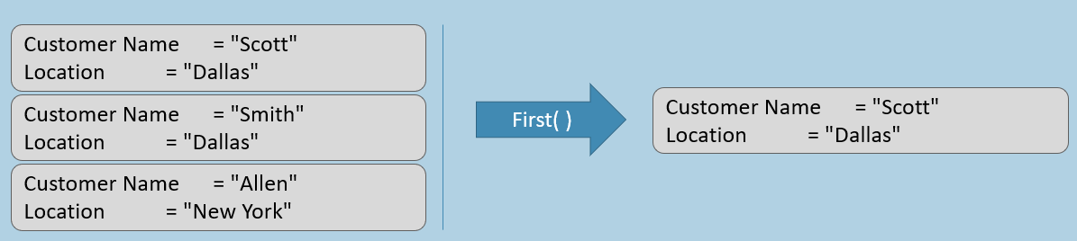

**First Extension Method - Declaration**

1. First(Func<TSource, bool> predicate)

**First Extension Method - Usage**

1. var result = Customers.First(temp => temp.Location == "Dallas");
2. //returns the first customer from Dallas location.

FirstOrDefault

FirstOrDefault() method returns first element that matches with the condition.

It returns null if no element matches with the condition.

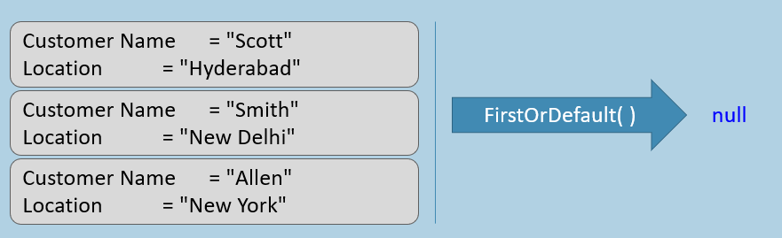

**FirstOrDefault Extension Method - Declaration**

FirstOrDefault(Func<TSource, bool> predicate)

**FirstOrDefault Extension Method - Usage**

1. var result = Customers.FirstOrDefault(temp => temp.Location == "London");
2. //returns the first customer from London location (or) returns null if not exists.

Last

Last() method returns last element in the collection that matches with the collection.

It throws exception if no element matches with the condition.

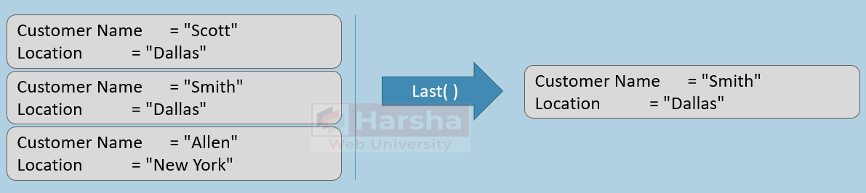

**Last Extension Method - Declaration**

Last(Func<TSource, bool> predicate)

**Last Extension Method - Usage**

1. var result = Customers.Last(temp => temp.Location == "Dallas");
2. //returns the last customer from Dallas location.

LastOrDefault

LastOrDefault() method returns last element that matches with the condition.

It returns null if no element matches with the condition.

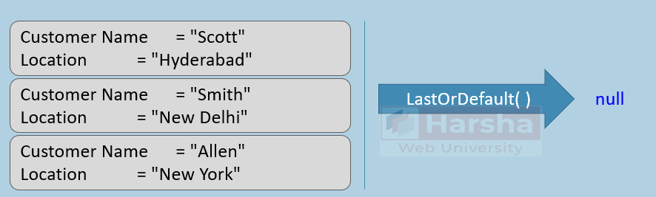

**LastOrDefault Extension Method - Declaration**

LastOrDefault(Func<TSource, bool> predicate)

**LastOrDefault Extension Method - Usage**

1. var result = Customers.LastOrDefault(temp => temp.Location == "London");
2. //returns the last customer from London location (or) returns null if not exists.

ElementAt

Element() method returns an element in the collection at specified index.

It throws exception if no element exists at the specified index; to get 'null' instead, use ElementOrDefault().

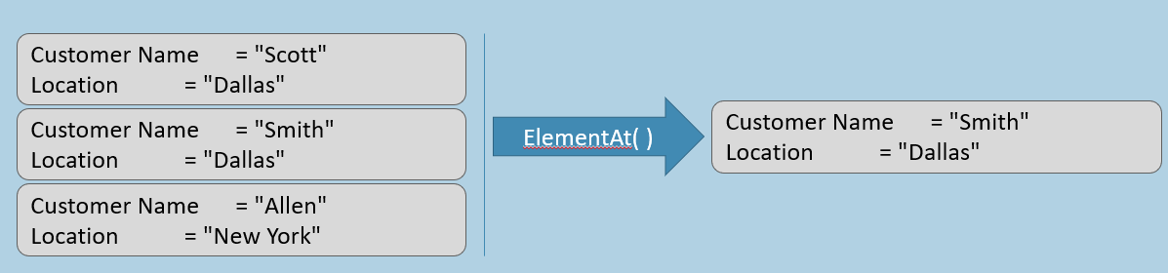

**ElementAt Extension Method - Declaration**

ElementAt(int index)

**ElementAt Extension Method - Usage**

var result = Customers.ElementAt(1); //returns the customer at index 1

Single

It returns first element (only one element) that matches with the collection.

It throws exception if no element or multiple elements match with the condition.

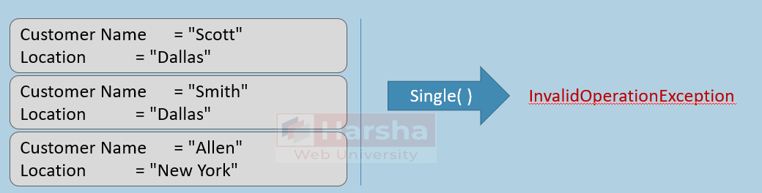

**Single Extension Method - Declaration**

Single(Func<TSource, bool> predicate)

**Single Extension Method - Usage**

1. var result = Customers.Single(temp => temp.Location == "Dallas");
2. //returns the first (only one customer) from Dallas location.
3. but it throws exception if none / multiple elements matches with the condition.

SingleOrDefault

It returns first element (only one element) that matches with the collection.

It returns null if no element matches with the condition; but it throws exception if multiple elements match with the condition.

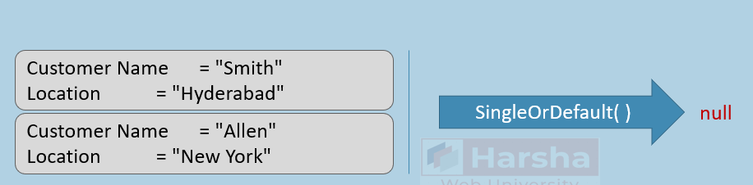

**SingleOrDefault Extension Method - Declaration**

SingleOrDefault(Func<TSource, bool> predicate)

**SingleOrDefault Extension Method - Usage**

1. var result = Customers.SingleOrDefault(temp => temp.Location == "London");
2. //returns the first (only one customer) from London location.
3. it throws exception if multiple elements matches with the condition; but null in case of no match.

Select

It returns collection by converting each element into another type, based on the conversion expression.

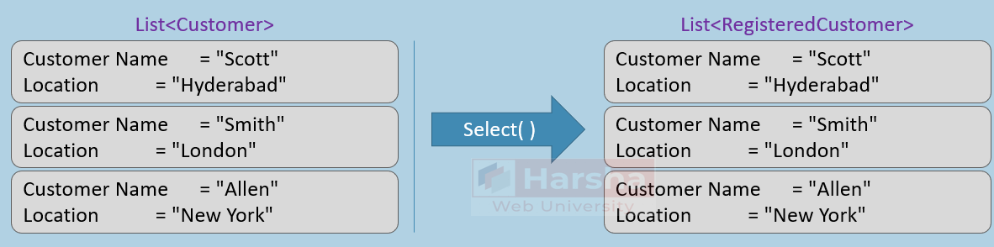

**Select Extension Method - Declaration**

Select(Func<TSource, TResult> selector)

**Select Extension Method - Usage**

1. var result = Customers.Select(temp => new RegisteredCustomer()
2. { CustomerName = temp.CustomerName, Location = temp.Location } );
3. //converts all customers into a collection of RegisteredCustomer class.

Reverse

It reverses the collection.

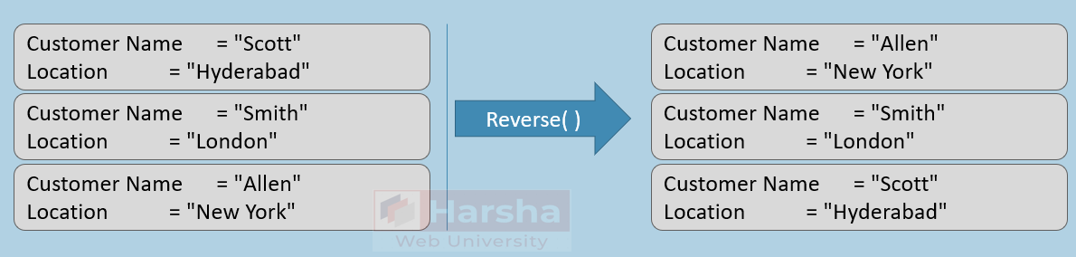

Reverse Extension Method - Declaration

Reverse( )

**Reverse Extension Method - Usage**

var result = Customers.Reverse( ); //reverses the customers collection

Min, Max, Count, Sum, Average

It performs aggregate operations such as finding minimum value of specific property of all elements of a collection.

**Min, Max, Count, Sum, Average - Example**

1. var result1 = Students.Min( temp => temp.Marks ); //minimum value of Marks property
2. var result2 = Students.Max( temp => temp.Marks ); //maximum value of Marks property
3. var result3 = Students.Count( ); //count of elements
4. var result4 = Students.Sum( temp => temp.Marks); //sum value of Marks property
5. var result5 = Students.Average( temp => temp.Marks); //average value of Marks property