Methods

Method is a function (group of statements), to do some process based on fields.

Methods are parts of the class.

Methods can receive one or more input values as "parameters" and return a value as "return".

Eg:

1. class Car
2. {
3. int calculateEmi( int carPrice, int noOfMonths, int interestRate )
4. {
5. //do calculation here
6. return (emi);
7. }
8. }

**Syntax of Method**

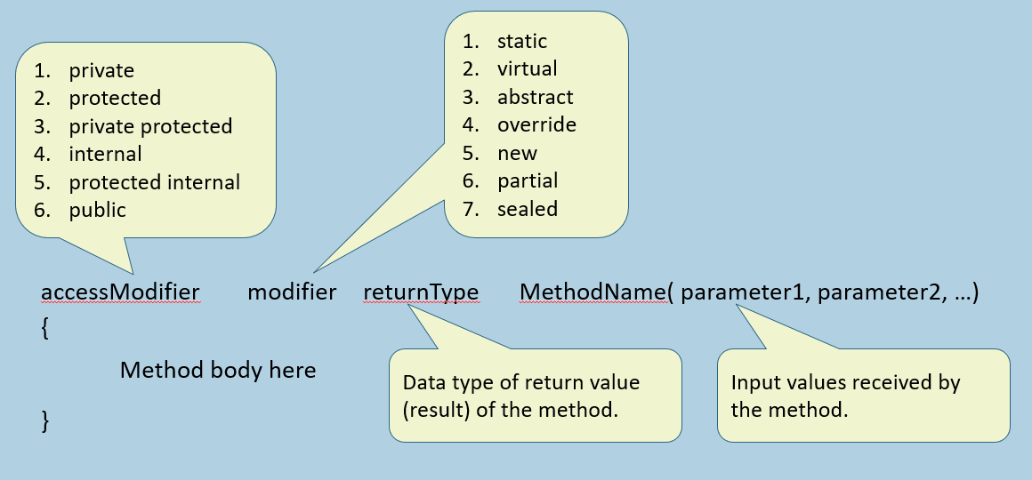

Access Modifiers of Methods

Access Modifiers (a.k.a. "Access Specifier" or "Visibility Modifier) of methods, are same as access modifiers of fields.

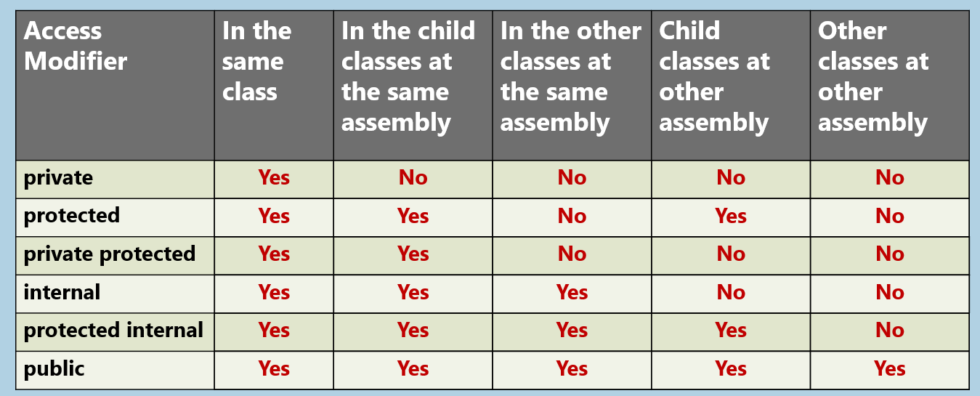

Encapsulation

Encapsulation is a concept of:

* Bundling the data (fields) and operations (methods) that manipulate the data together.
* ides internal implementation details of an object and provide a essential members to interacting with them.

Benefits:

1. Modularity
2. Hiding implementation details
3. Data Integrity

Implemented using:

1. Private fields &
2. Public properties or public methods

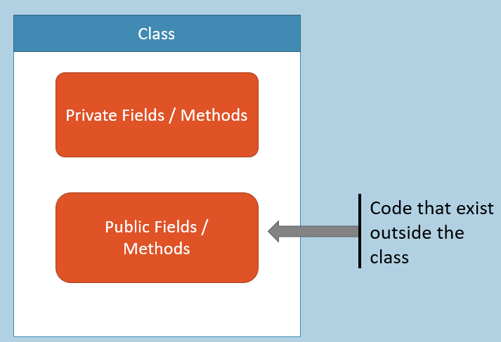

Local Variables and Parameters

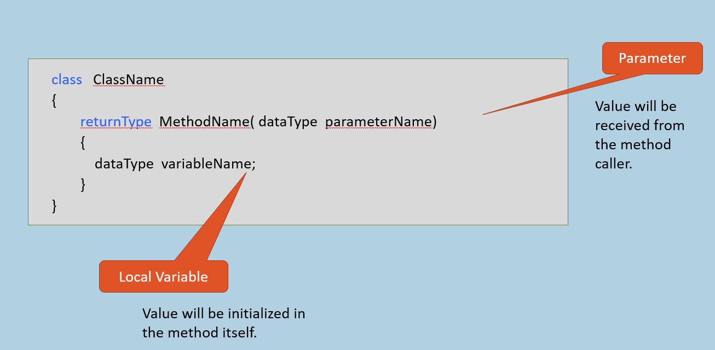

**Parameters:**

The variables that are being received from the "method caller" are called as "parameters".

The parameters are stored in the Stack of the method.

For every method call, a new stack will be created.

**Local Variables:**

The variables that are declared inside the method are called as "Local variables". Local variables can be used only within the same method.

Local variables are stored in the same stack, just like parameters.

The stack will be deleted at the end of method execution. So all local variables and parameters will be deleted.

"this" keyword

The "this" keyword refers to "current object", which method has invoked the method.

The "this" keyword is available only within the "instance methods".

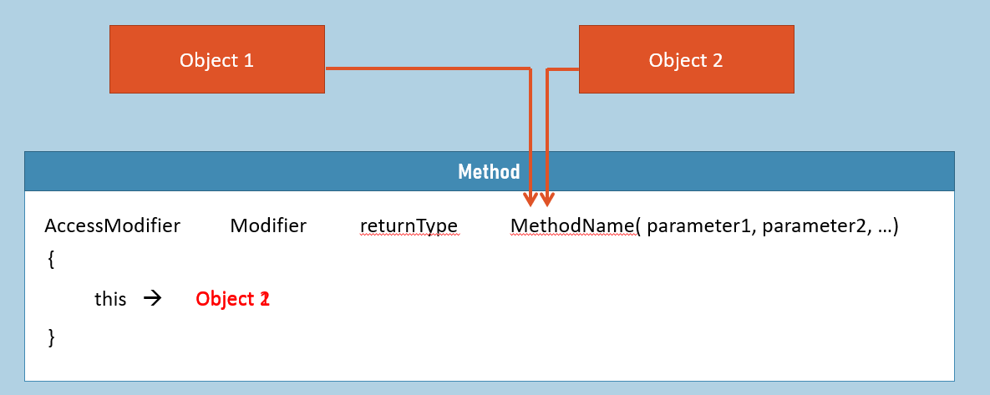

Instance Methods (vs) Static Methods

**Association:**

**Instance Methods:**Associated with Objects

**Static Methods:**Associated with class.

**Manipulates:**

**Instance Methods:**Manipulates instance fields.

**Static Methods:**Manipulates static fields.

**Declaration:**

**Instance Methods:**Declared without "static" keyword. Syntax: returnType methodName( ) { }

**Static Methods:**Declared with "static" keyword. Syntax: static returnType methodName( ) {  }

**Accessible with:**

**Instance Methods:**Accessible with object (through reference variable).

**Static Methods:**Accessible with class name only (not with object).

**Can access (fields)**

**Instance Methods:**Can access both instance fields and static fields

**Static Methods:**Can't access instance fields; but can access static fields only.

**Can access (methods)**

**Instance Methods:**Can access both instance methods and static methods.

**Static Methods:**Can't access instance methods; but can access static methods only.

**"this" keyword:**

**Instance Methods:**Can use "this" keyword, as there must be "current object" to call instance method.

**Static Methods:**Can't use "this" keyword, as there is NO "current object" while calling instance methods.

Reference Variables as Arguments

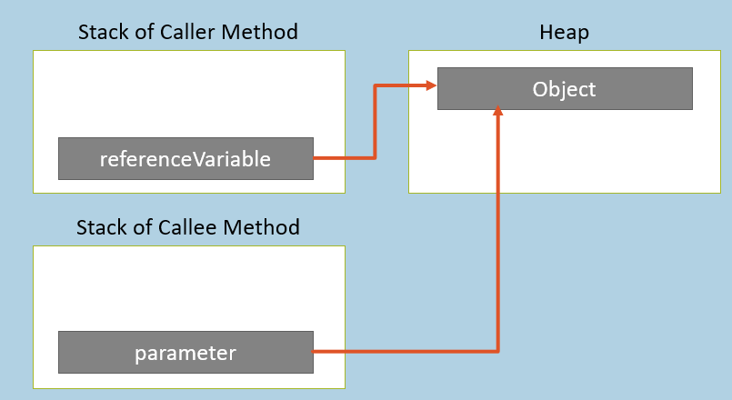

If you pass "reference variable" as argument, the reference (address) of object will be passed to the method.

The parameter's data type will be the class name.

If you make any changes to object in the method, the same will be affected automatically in the caller method, as you are accessing the same object.

Default Arguments

Default value of the parameter of a method.

If you don’t pass value to the parameter, the default value gets assigned to the parameter.

To void bothering to pass value to the parameter; instead, take some default value into the parameter automatically, if the method caller has not supplied value to the parameter.

1. accessModifier   modifier    returnType  MethodName( parameter1 )
2. {
3. Method body here
4. }

Named Arguments

Supply value to the parameter, based on parameter name.

Syntax: parametername: value

You can change order of parameters, while passing arguments.

Parameter names are expressive (understandable) at method-calling time.

Calling a method: MethodName(ParameterName : value, ParameterName : value);

Method Overloading

Writing multiple methods with same name in the same class, with different parameters.

Caller would have several options, while calling a method.

Difference between parameters of all the methods that have same name, is MUST.

1. MethodName( )
2. MethodName( int )
3. MethodName( string )
4. MethodName( int, string )
5. MethodName( string , int)
6. MethodName( string , string, int)
7. etc.

Parameter Modifiers

Specifies how the parameter receives a value.

* Default [No keyword]
* ref
* out
* in
* params

Parameter Modifiers (default)

The "Argument" will be assigned into the "Parameter" but not reverse.

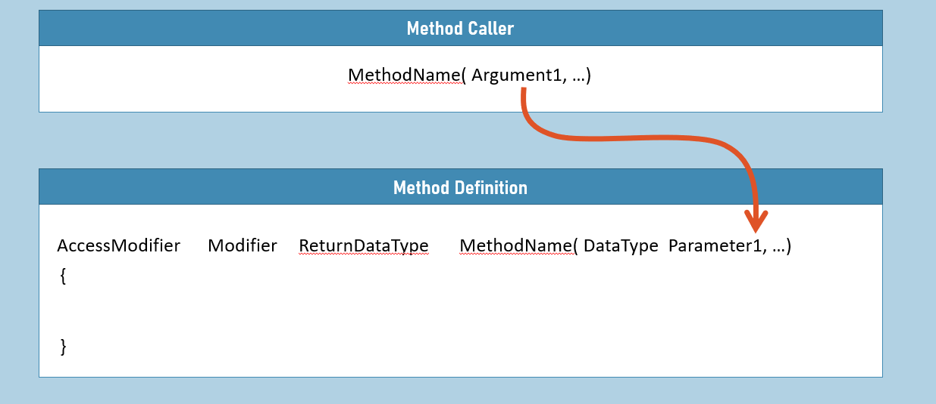

Parameter Modifiers (ref)

The "Argument" will be assigned into the "Parameter" and vice versa.

The Argument must be a variable and must be pre-initialized.

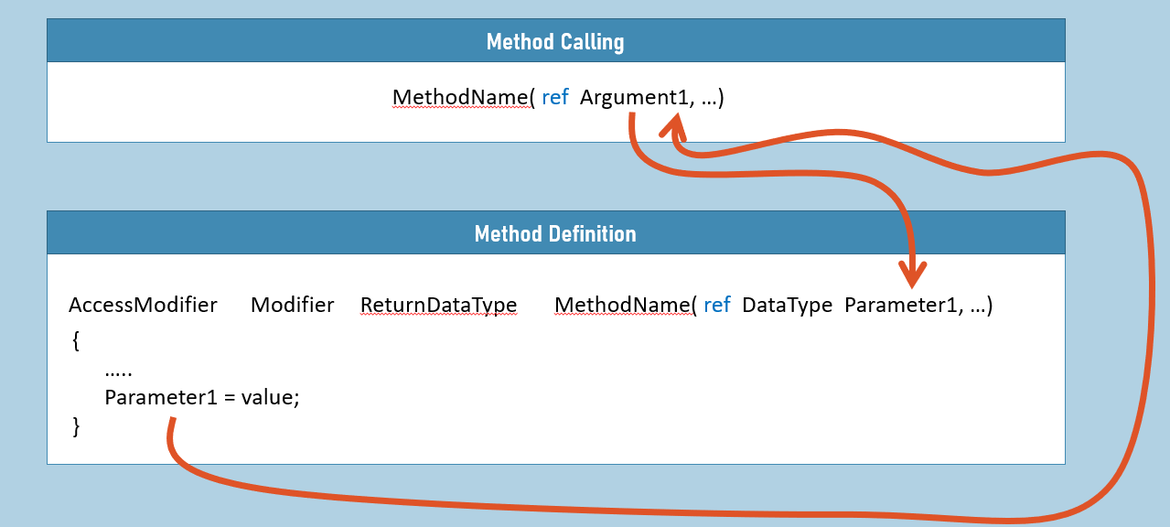

Parameter Modifiers (out)

The "Argument" will not be assigned into the "Parameter" but only reverse.

The Argument must be a variable; The Argument can be un-initialized.

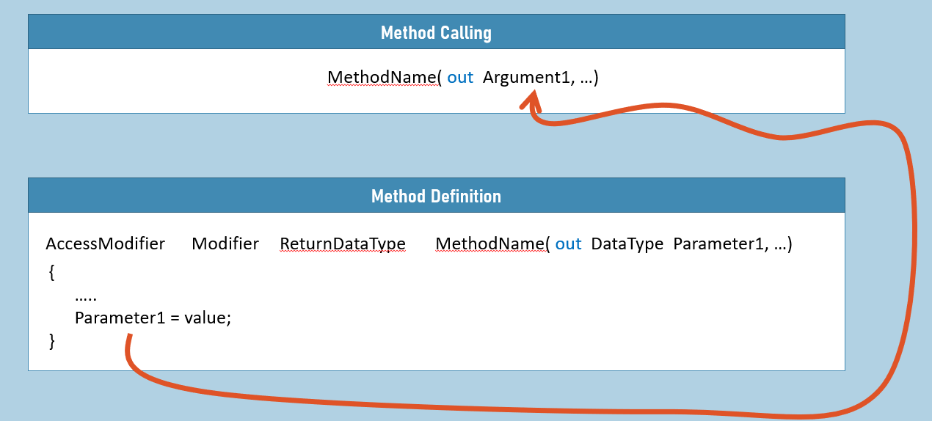

'out' variable declaration

You can declare out variable directly while calling the method with 'out' parameter.

New feature in C# 7.0.

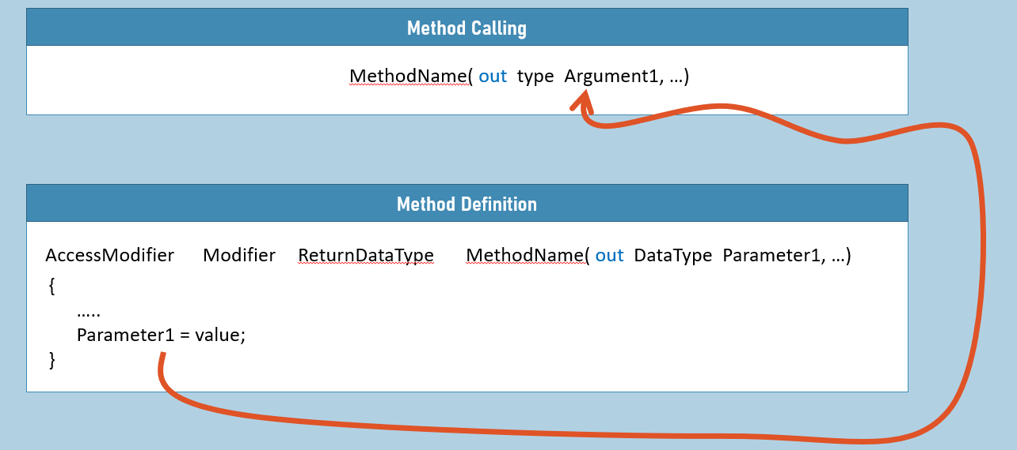

Parameter Modifiers (in)

The "Argument" will be assigned into the "Parameter", but the parameter becomes read-only.

We can't modify the value of parameter in the method; if you try to change, compile-time error will be shown.

New feature of C# 7.2.

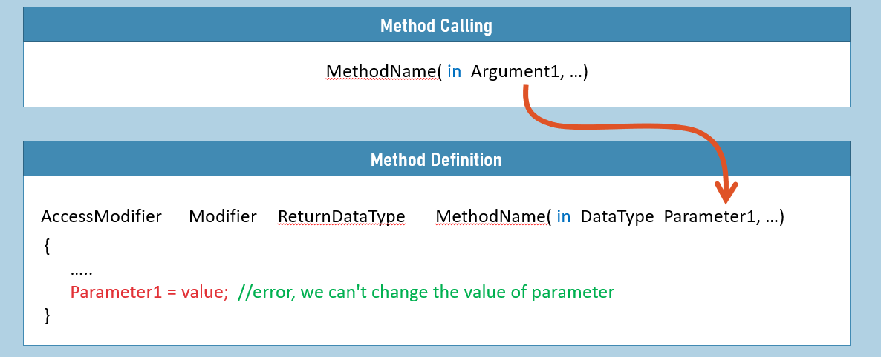

ref returns

The reference of return variable will be assigned to receiving variable.

New feature in C# 7.3.

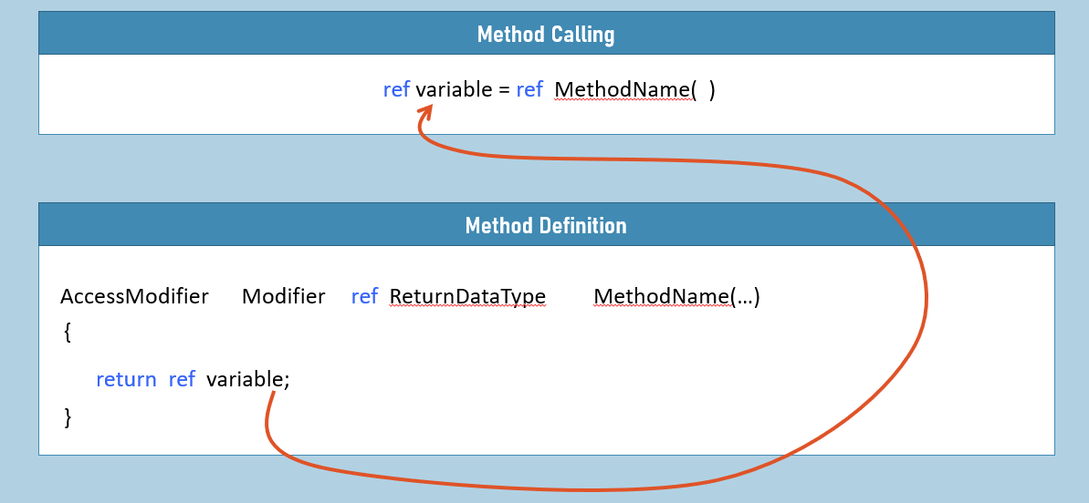

Parameter Modifiers (params)

All the set of arguments will be at-a-time received as an array into the parameter.

The "params" parameter modifier can be used only for the last parameter of the method; and can be used only once for one method.

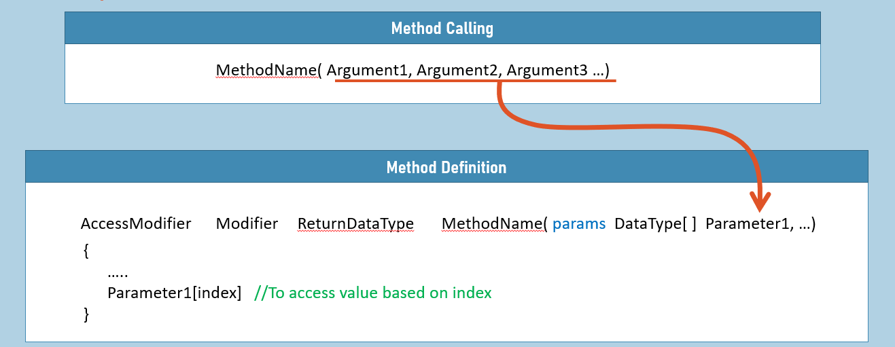

Local Functions

"Local functions" are functions, to do some small process, which is written inside a method.

Local functions are not part of the class; they can't be called directly through reference variable.

Local functions don't support "access modifiers" and "modifiers".

Local functions support parameters, return.

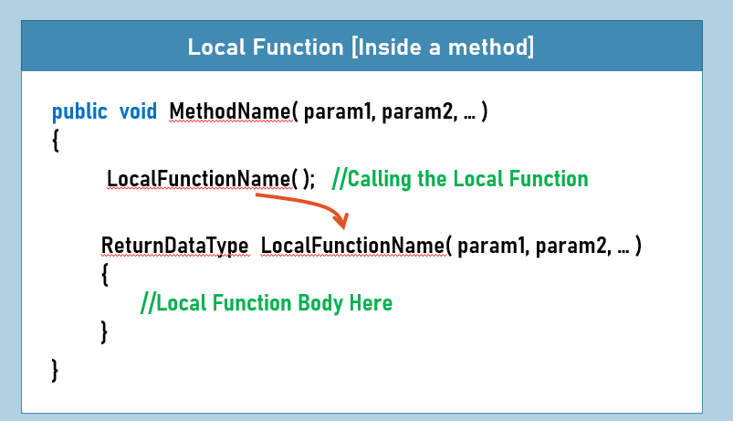

Static Local Functions

"Static Local functions" are functions, same as normal "Local Functions".

Only the difference is, static local functions can't access local variables or parameters of containing method.

This is to avoid accidental access of local variables or parameters of containing method, inside the local function.

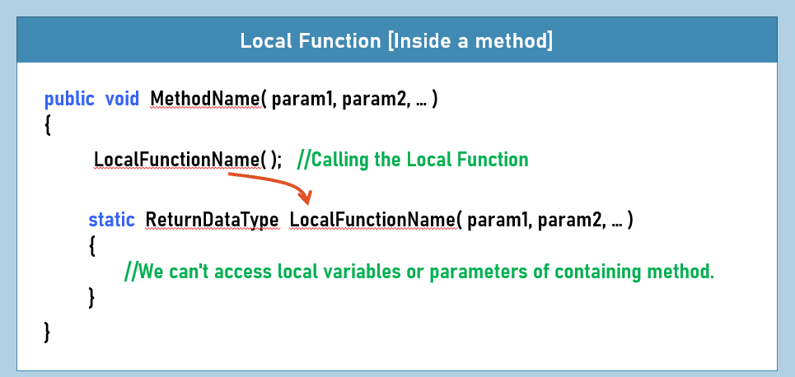

Recursion

A method calls itself.

Useful in mathematic computations, such as finding factorial of a number.

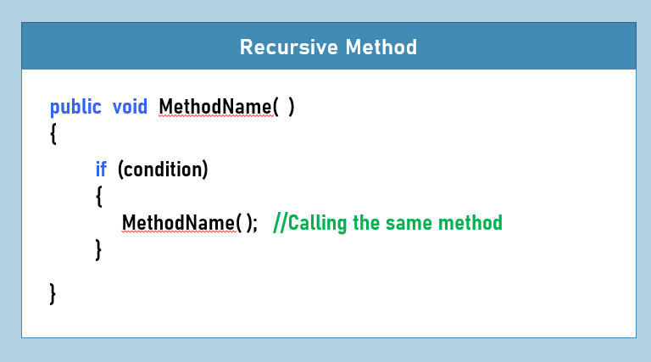

**Key Points to Remember**

* Method is a part of class, that contains collection of statements to do some process.
* Access modifiers of Methods: private, protected, private protected, internal, protected internal, public.
* Modifiers of Methods: static, virtual, abstract, override, new, partial, sealed
* For each method call, a new stack will be created; all local variables and parameters of the method will be stored in that stack; will be deleted automatically at the end of method execution.
* In instance methods, the 'this' keyword refers to 'current object, based on which the method is called'.
* Instance methods can access & manipulate instance fields & static fields; Static methods can access only static fields.
* But static method can create an object for the class; then access instance fields through that object.
* Using named arguments , you can change order of parameters while calling the method.
* Method Overloading is 'writing multiple methods with same name in the same class with different set of parameters'.
* The 'ref' parameter is used to receive value into the method and also return some value back to the method caller; The 'out' parameter is only used to return value back to the method caller; but not for receiving value into the method.