Type Conversion

'Type Conversion' is a process of convert a value from one type (source type) to another type (destination type).

Eg: int -> long

1. Implicit Casting

(from lower-numerical-type to higher-numerical-type)

2. Explicit Casting

(from higher-numerical-type to lower-numerical-type)

3. Parsing / TryParse

(from string to numerical-type)

4. Conversion Methods

(from any-primitive-type to any-primitive-type and also string along with other types such as DateTime, Base64 etc.)

Implicit Casting

The 'lower-numerical type' can be automatically (implicitly) converted into 'higher-numerical type'.

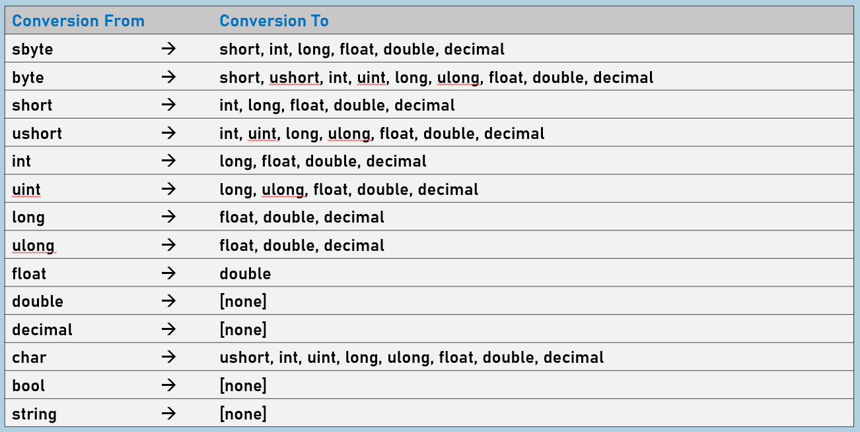

Explicit Casting

We can manually convert a value from one data type to another data type, by specifying the destination data type within brackets, at left-hand-side of the source value.

**Loosy conversion:** If the destination type is not sufficient-enough to store the converted value, the value may loose.

**Syntax:** (DestinationDataType)SourceValue

1. At all cases in the table of implicit casting.

2. At the case in the following table of explicit casting.

3. Child class to Parent class.

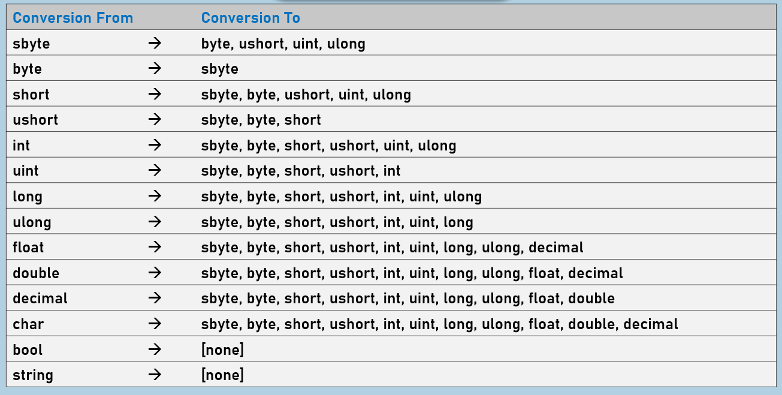

Parse

The string value can be converted into any numerical data type, by using "Parsing" technique.

Eg:  string à int

The source value must contain digits only; shouldn't contain spaces, alphabets or special characters.

If the source value is invalid, it raises FormatException.

**Syntax:** DestinationDataType.Parse(SourceValue)

TryParse

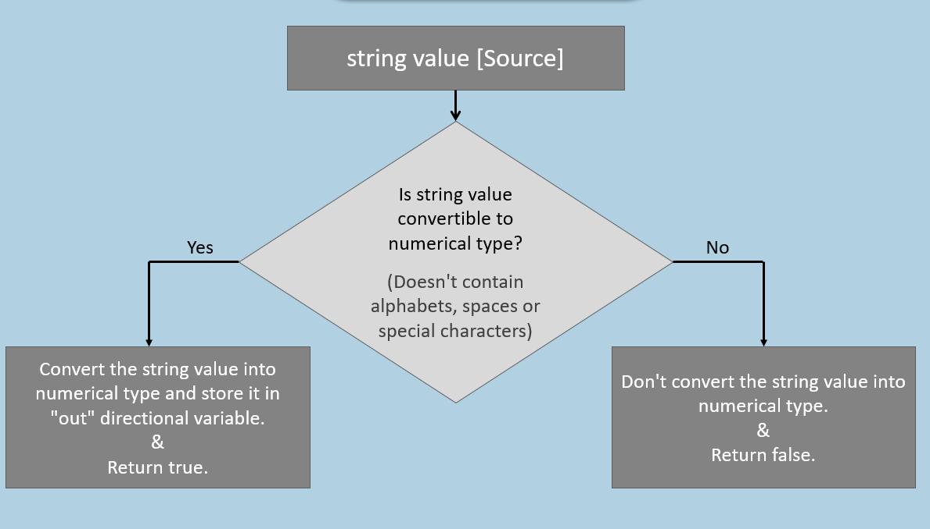

The string value can be converted into any numerical data type, by using "TryParse" technique (same as "parse"); but it checks the source value before attempting to parse.

Eg:  string -> int

If the source value is invalid, it returns false; It doesn't raise any exception in this case.

If the source value is valid, it returns true [indicates conversion is successful]

It avoids FormatException.

bool variable = *DestinationType*.TryParse(*SourceValue*, out *DestinationVariable*)

Conversion Methods

Conversion method is a pre-defined method, which converts any primitive type (and also 'string') to any other primitive type (and also 'string').

Eg: string  ->  int      and      int  ->  string

The System.Convert is a class, which contains a set of pre-defined methods.

It raises FormatException, if the source value is invalid.

For each data type, we have a conversion method.

All conversion methods are static methods.

**Syntax:**

type destinationVariable = Convert.*ConversionMethod*(*SourceValue*)

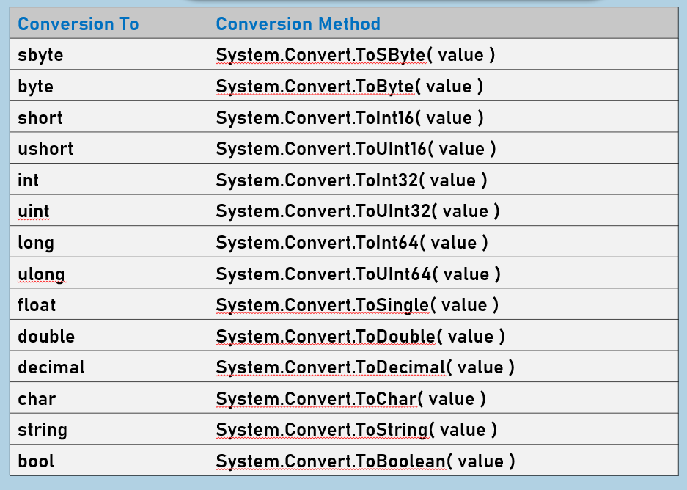

**Key Points to Remember**

* For all the possible cases of 'implicit casting' and 'explicit casting', it is preferred to use 'explicit casting' or 'conversion methods' always.
* For conversion from 'string' to 'numerical type', use TryParse, instead of 'Parse'; as 'TryParse' avoids exceptions.
* For conversion of value from any-type to any-type, use conversion method.