Properties

Receive the incoming value; validate the value; assign value into field.

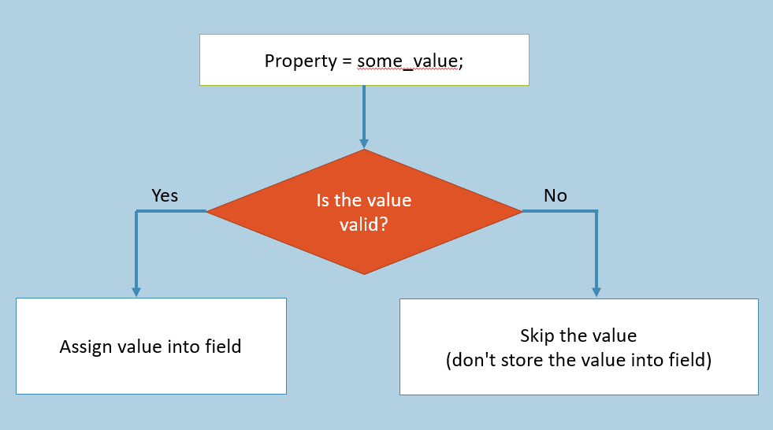

Property is a collection of two accessors (get-accessor and set-accessor).

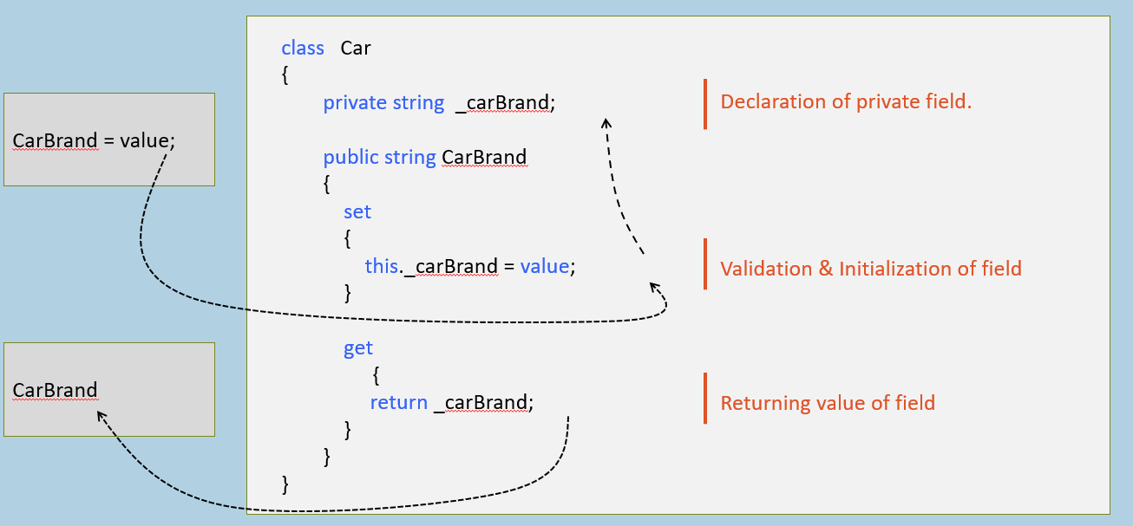

**Syntax of Property**

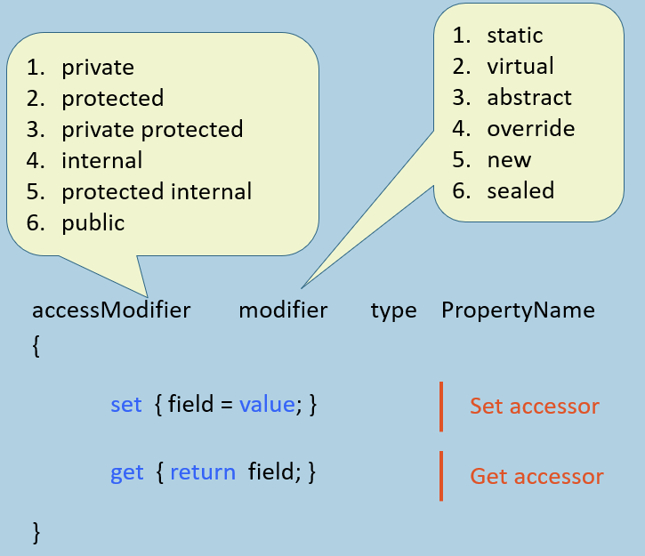

Set Accessor [vs] Get Accessor

**Set Accessor**

1. set
2. {
3. field = value;
4. }
5. Used to validate the incoming value and assign the same into field.
6. Executes automatically when some value is assigned into the property.
7. Has a default (implicit) parameter called "value", which represents current value i.e. assigned to the property.
8. Can't have any additional parameters.
9. But can't return any value.

**Get Accessor**

1. get
2. {
3. return field;
4. }
5. Used to calculate value and return the same (or) return the value of field as-it-is.
6. Executes automatically when the property is retrieved.
7. Has no implicit parameters.
8. Can't have parameters.
9. Should return value of field.

Features and Advantages of Properties

Properties create a protection layer around fields, preventing assignment of invalid values into properties & also do some calculation automatically when someone has invoked the property.

No memory will be allocated for the property.

**Access modifier of accessors:**

Access modifier is applicable for the property, set accessor and get accessor individually. But access modifiers of accessors must be more restrictive than access modifier of property.

Eg:

1. internal modifier data_type PropertyName
2. {
3. private set { property = value; }
4. protected get { return property; }
5. }

Read-Only [vs] Write-Only Properties

**Readonly Property**

1. accessModifier type PropertyName
2. {
3. get
4. {
5. return field;
6. }
7. }
8. Contains ONLY 'get' accessor
9. Reads & returns the value of field; but not modifies the value of field.

**Write-only Property**

1. accessModifier type PropertyName
2. {
3. set
4. {
5. field = value;
6. }
7. }
8. Contains ONLY 'set' accessor.
9. Validates & assigns incoming value into field; but doesn't return the value.

**Auto-Implemented Properties**

Property with no definition for set-accessor and get-accessor.

Used to create property easily (with shorter syntax).

Creates a private field (with name as _propertyName) automatically, while compilation-time.

Auto-Implemented property can be Read-only (only 'get' accessor) property; but it can't be Write-only (only 'set' accessor).

1. accessModifier modifier data_type PropertyName
2. {
3. accessModifier set;
4. accessModifier get;
5. }

Useful only when you don't want to write any validation or calculation logic.

**Auto-Implemented Property Initializer**

New feature in C# 6.0

You can initialize value into auto-implemented property.



Properties: Key Points to Remember

It is recommended to use Properties always in real-time projects.

You can also use 'Auto-implemented properties' to simplify the code.

Properties doesn't occupy any memory (will not be stored).

Properties forms a protection layer surrounding the private field that validates the incoming value before assigning into field.

Read-only property has only 'get' accessor; Write-only property has only 'set' accessor.

Properties can't have additional parameters.

**Indexers**

Receive a number / string. Search for the particular item among a group of items; set or get value into the group of items.

It provides shorter syntax to access a group of items.

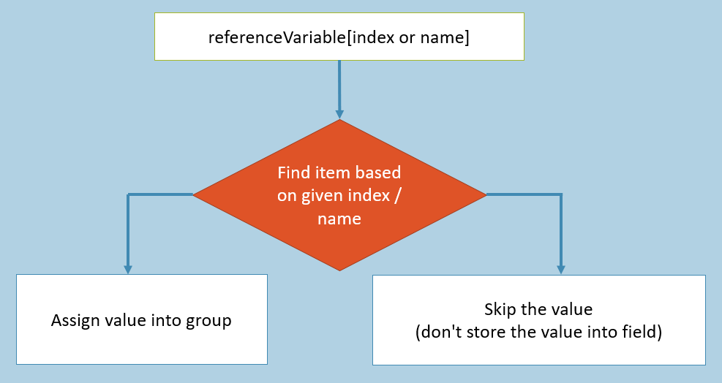

Indexer is a special member of class, which contains set-accessor and get-accessor to access a group of items / elements.

Eg:

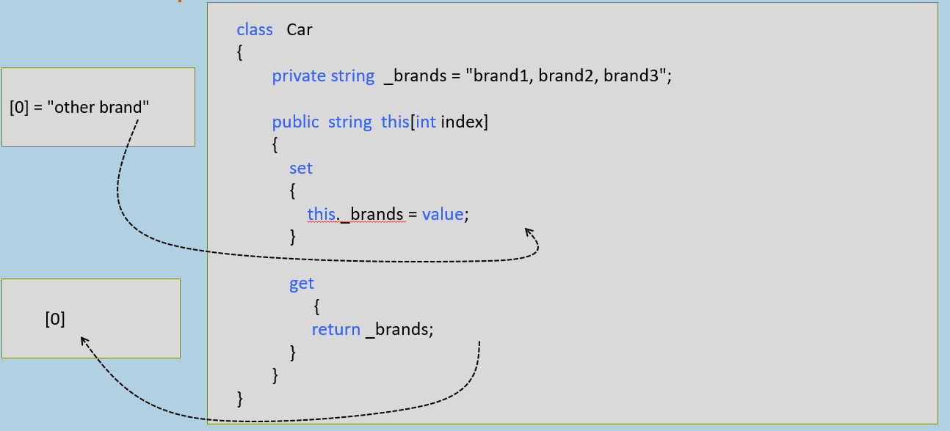

**Syntax of Indexer**

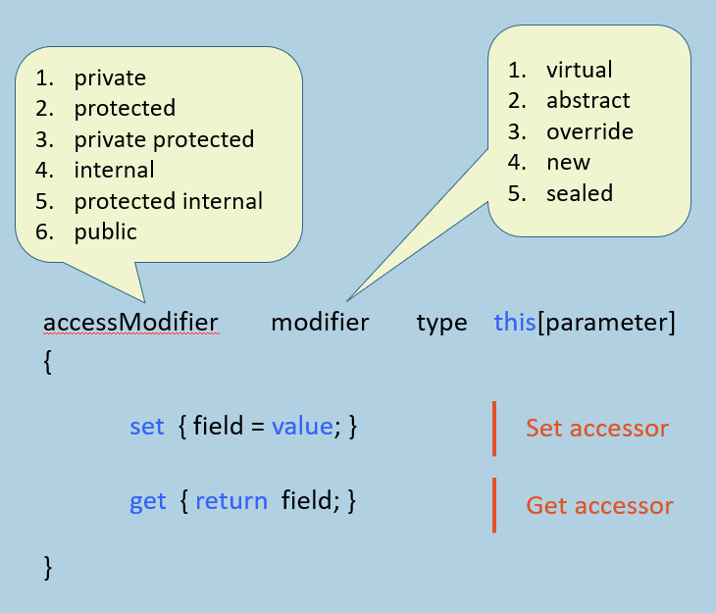

Indexers: Key Points to Remember

* Indexers are always created with 'this' keyword.
* Indexers are generally used to access group of elements (items).
* Parameterized properties are called indexer.
* Indexers are implemented through get and set accessors along with the [ ] operator.
* Indexer must have one or more parameters.
* ref and out parameter modifiers are not permitted in indexer.
* Indexer can't be static.
* Indexer is identified by its signature (syntax of calling); where as a property is identified it's name.
* Indexer can be overloaded.