Interaction
- The sticky accordion text is no longer fully visible when scrolling

- The screen hops up/down – side to side when scrolling on the iPad
- The tapping the X does not close the flight profile

Visual clean up
- Reduce the size of the expand and collapse icons (Style guide pending)

- Remove the boarder on the bottom of the accordion
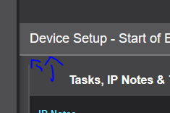
Prototype

- Remove the space on the left and right of the 3 column layout tables (was not present in ILP 1.O so could look at that)
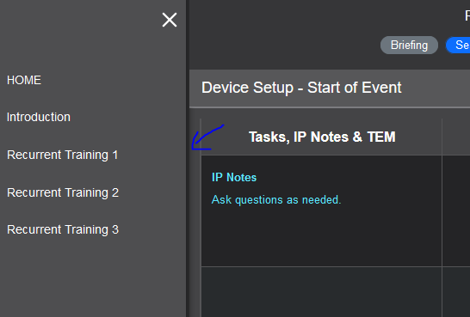

Prototype
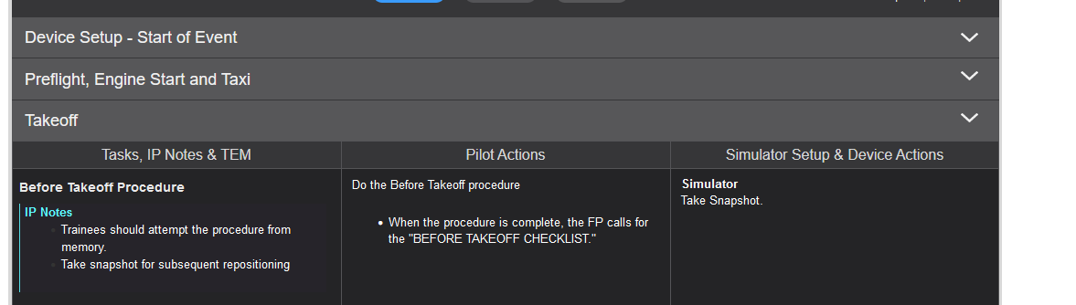
The main navigation appears when the Flight profile is open
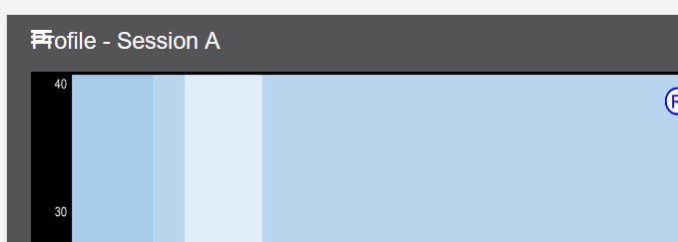

Alignment
Right justify the ellipses, expand all and the expand accordions (pending style guide updates)

Prototype
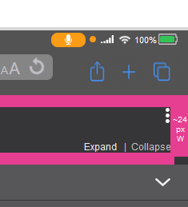

Left justify the main menu with the accordion text – Still working on this one

Questions
Is there an example of a nested topic?

