Work Item ID: 5324206
Work Item Assignee: Manohar, Thulasi, Hina
Name of Work Item: [SPIKE] TD: TIDES: Curriculum Management
Design Document Version 1.0

Work Item Description
The purpose of this story is to research and document how CACTUS can display curriculum data from TIDES and use that data to automatically build a book map with the associated elements and attributes

Acceptance Criteria/Problem Statement
CACTUS will have a TIDES menu that will display the following:
- The user will be able to access a TIDES Inbox that shows approved curriculum
- The user will be able to open and view the curriculum structure from the Inbox
- The user will be able to view if CACTUS already has existing topic files containing the learning objective attributes listed in the curriculum
- The user will be able to initiate the curriculum workflow
- When the user initiates the curriculum workflow CACTUS will automatically create the necessary map and topic files needed to complete the outline structure of the book
- The user will be able to check out files that are not associated to another workflow
- The user will be able to check in files to the workflow
- The user will be able to perform mini assembles and book assembles from the curriculum outline
- The user will be able to check out multiple files to share with other stakeholders via Content Fusion
- The user will be able to move curriculum workflow to the next step
- The user will be able to manually add a topic/map file to the curriculum outline
Prerequisites/Assumptions:

- Connection authorized token or certificate, url, username, password, port etc will be given by TIDES
- JSON of course list and course outline from TIDES as per given format metadata
- Receive notification from TIDES if any new course has been added accordingly we need to update our inbox in CACTUS

Primary Analysis/ Case Study
Break down problem statement (can consider as a stories):

- The user will be able to access a TIDES Inbox that shows approved curriculum
  - Frontend design of CACTUS for TIDES Inbox
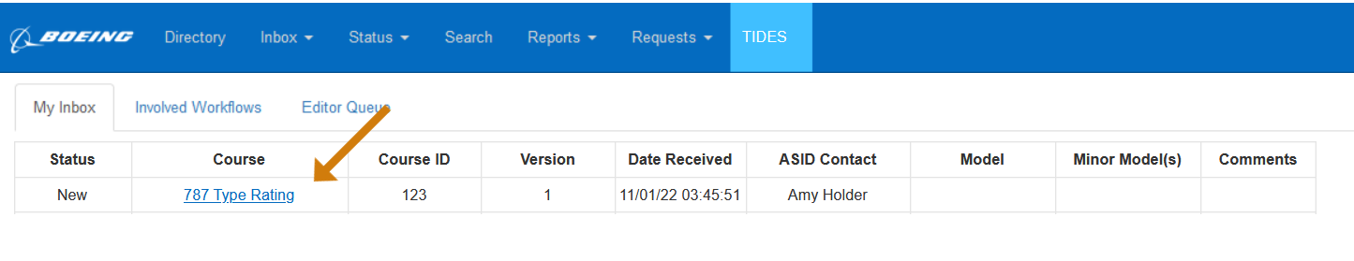
  - On click of TIDES establish connection between CATUS and TIDES/ASID using certificate or authorized token
Rest, service and Dao implementation, send req payload and get response from TIDES
  - On success connection fetch course data from TIDES in JSON format and display in Inbox tab
CourseListJSON
  - Receive notification from TIDES if any new course added.
(follow above step 3)
Approaches:
1: When CACTUS user gets notification, page will be refreshed and get latest data from TIDES
2: Create a cron job on specific time interval to get latest data from TIDES
3: Add refresh button in CATUS inbox so user can refresh and fetch latest data whenever needed
- The user will be able to open and view the curriculum structure from the Inbox
  - On click of any row/course fetch outline data of that book from TIDES using course id in JSON format.
CourseOutlineJSON
  - Display outline into course outline view popup
- The user will be able to view if CACTUS already has existing topic files containing the learning objective attributes listed in the curriculum
auto_Id | TNA_TaskId | title | topicType | Phase | taskDesc | Model | Associated Book/Map Id | localization
1 | task_lc_737_T_EASA__en-GB_00002 | Approach | Task | test | Test | 737 | 10897456 | En-US
2
  - Identify Tasks which are not exist in CATUS and we have received from TIDES, use different styling to display those in view
How to identify?
Should have a SQL table to store all topic metadata along with TNAId
match TNAIds received from TIDES if it doesn’t match then Topic is not available and need to create new one
  - What about the CATUS existing Topics, how to create/update existing and convert it to Task?
Create new Topic in CACTUS: Add in topic type dropdown while creating topic, if user selects Task then generate unique TNAId and associate it with Topic, create alfresco field
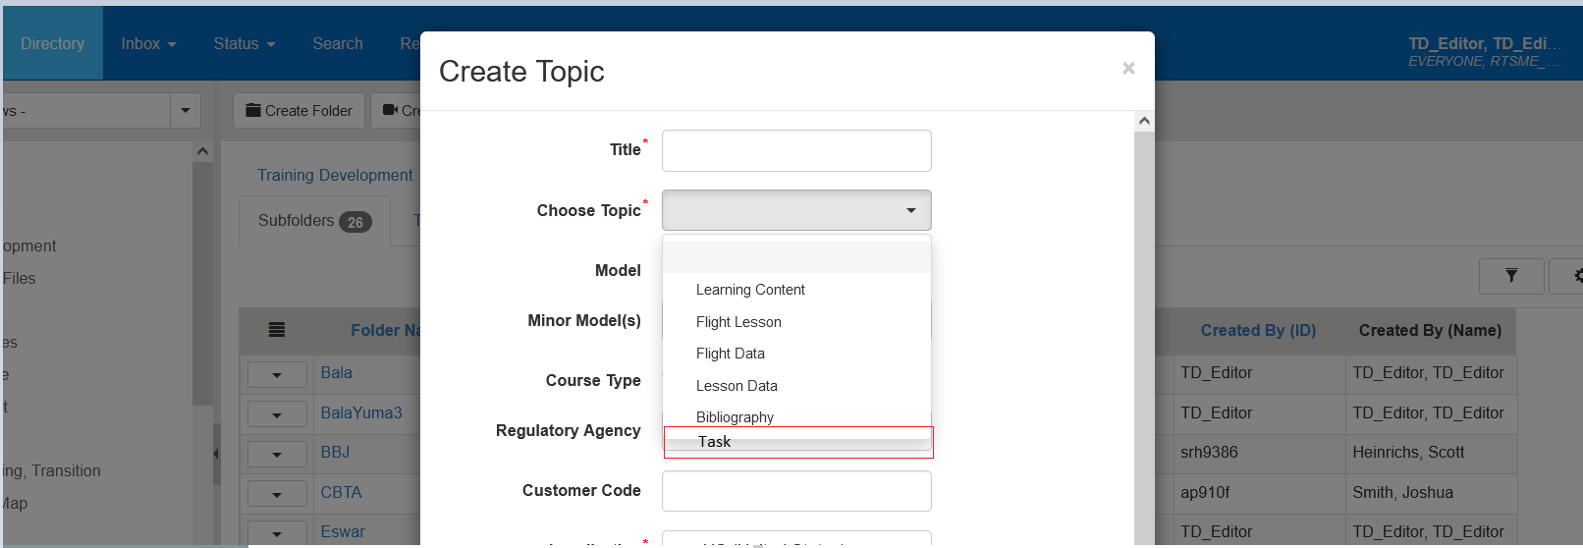
We can have separate template as well to create and maintain task. similar to bookmap, map and topic, will we have task folder as well in TD?
  - User should get option to convert Topic to TNA Topic/Task while doing check in, if user choose to convert it to Task then generate unique TNAId
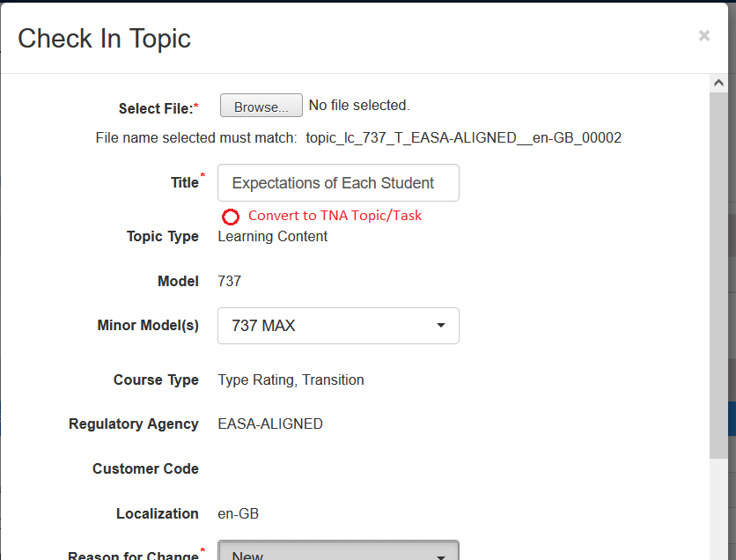
  - How to generate Unique TNAId?
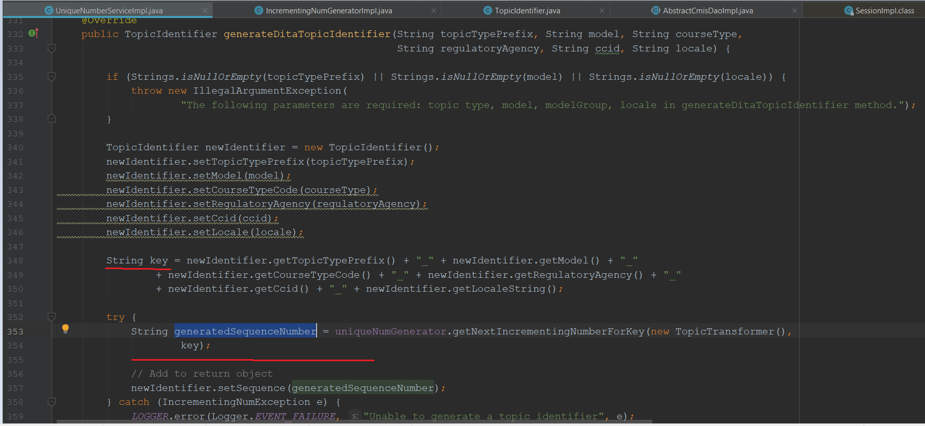
  - Implement button to create tasks in CACTUS if not exist. All together or one by one
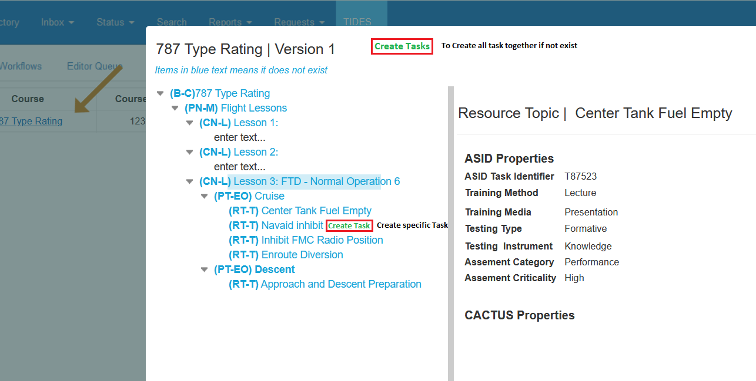
When user clicks on Crete Task: Implementation of api call to create Task along with TNAId, insert entry in SQL table and create task in alfresco and use the same path to store it (topic path)
- The user will be able to initiate the curriculum workflow
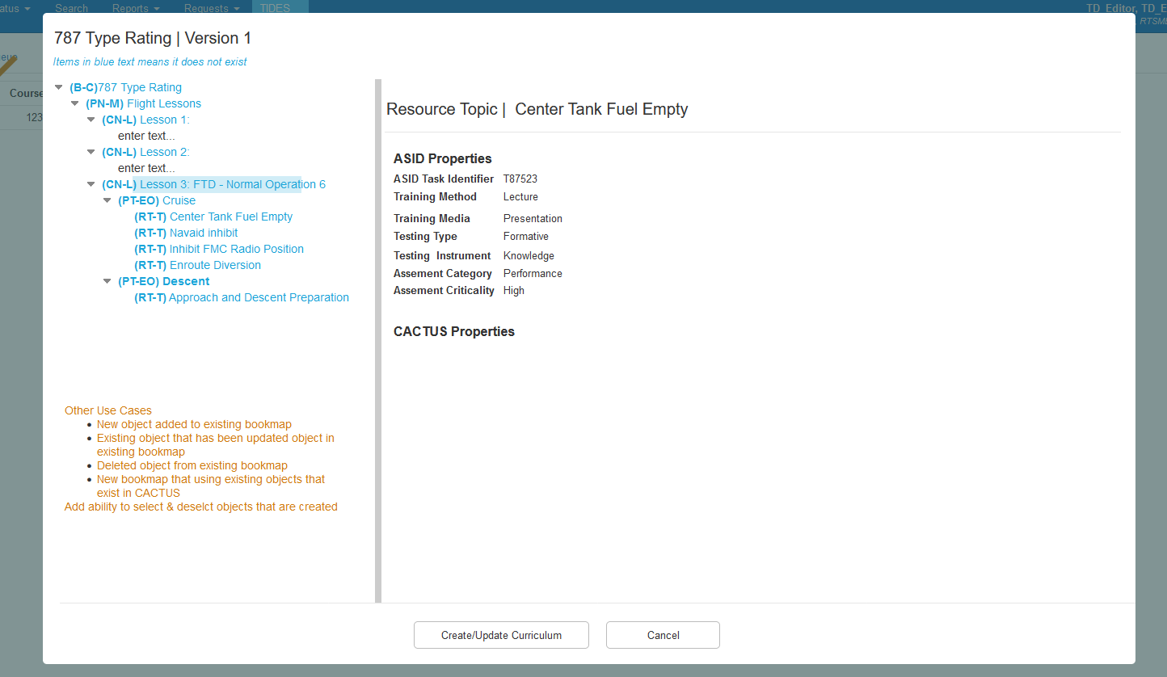
  - Collect all metadata and by using modularization initiate Curriculum workflow on click of Create/Update Curriculum button
Steps 5 to 10 : 5326065: [SPIKE] TD: TIDES: Book map/Map/Topic Automation
- The user will be able to manually add a topic/map file to the curriculum outline
  - Button/design to add Topic/Map manually
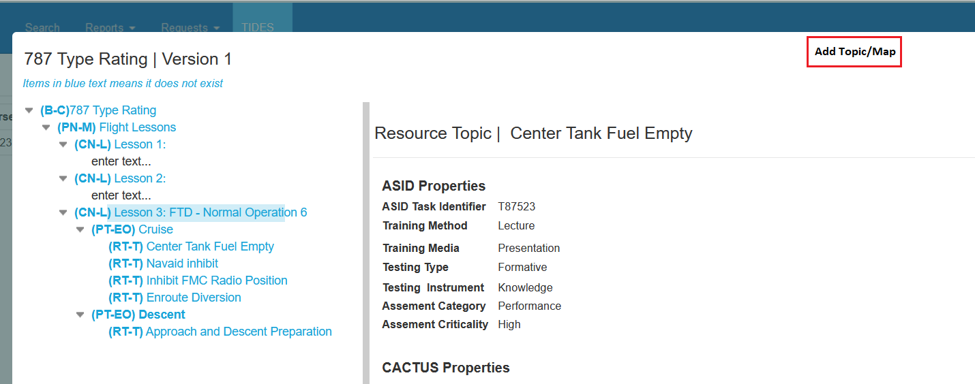
  - On click button: implement view to add topic/Map
design idea: User should have some input box on screen, when user enters keywords in test field then user will get suggestion based on keyword, user will select from any suggestion and clicks on Add button.
On click of Add: implement api call and insert row in sql table which should be associate to current course id
On success add: User should be able to add topic/map and that should be visible on curriculum outline detail view.

