To Create a portfolio:
- Open your GitHub repository in Cursor.
- Create a folder portfolio. We need to include a skill in this folder, so we need to create a .claude folder and then commands folder inside the portfolio folder. Portfolio/.claude/commands.
- Add skill under this folder structure.
- Create parse-resume.md file. And include the below code in the file. This file is used to convert resume into a json file.
The rule in one line: the folder you launch from must directly contain .claude. Not its parent, not its child.
=======================================================
You convert a résumé into a valid JSON Resume file.
## Input
The résumé to convert is at: $ARGUMENTS
(It may be .pdf, .docx, .md, or .txt.)
## Task
1. Read the résumé.
2. Extract every fact into the JSON Resume schema (https://jsonresume.org/schema):
`basics`, `work`, `education`, `skills`, `certificates`, `projects`.
3. For each `work` entry, write 2–4 achievement-focused `highlights` — start with a
verb, and include a number wherever the résumé provides one.
4. Use `"YYYY-MM"` for dates (or `"YYYY"` if only the year is known). Leave `endDate`
empty (`""`) for the current role.
5. Do NOT invent facts. If a field is missing, omit it — never guess a date, employer,
or metric.

## Output Contract
Output ONLY the JSON object — no preamble, no markdown fences, no commentary.
It must be valid JSON and parse on the first try.
## Usage
```
/parse-resume ~/Documents/Kiran_Lokhande_Technical_Writer.pdf > resume.json
======================================================
- Include the resume in a pdf format in .claude folder. Install pdf viewer extension if you cannot see pdf content (which you click it.) As PDF is a binary file.
- parse-resume @ <pdf file name>.
- Note that the pdf format was not recognized. So I had to include the details in .md file. And Paste in the commands folder.
- run “save that to resume.json”. This command converts the .md (resume) file into a json file resume.json file
- Create portfolio-builder.md file in commands folder. It picks up the json file creates 3 files.
Index.html
Apps: Read your json and put info in index.html file
Style.css file: Applies style
- The trainer said portfolio-builder.md is an agent. An agent has a front matter. Agent will work on the folder. If the portfolio-builder.md is put in commands folder it will run only once. Which means now the agent has access to the entire folder structure. If to does not find something, it can now for something else. It can specific set of tasks described in the .md file.
- He created a folder agents inside the .claude folder and pasted portfolio-builder.md file inside the agents folder.
- The content is inside the .md folder.
- Run “Use the portfolio-builder agent to build my site from resume.json”
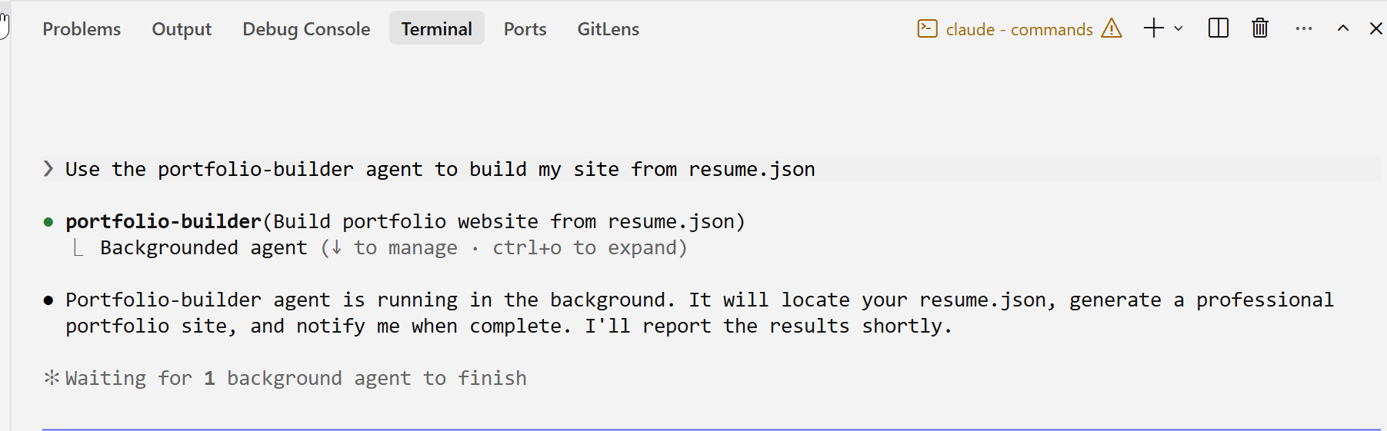
- Trainer says this server is launched using Python.
- Start the server and open it. This command creates a link, which displays the portfolio. http://localhost:8000/#work
- Run “Upload the file to the main branch on the https://kiran-lokhande123.github.io/portfolio repo”.

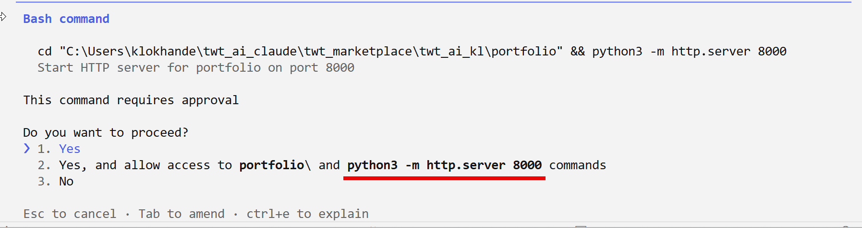

Upload the file to the main branch on the https://kiran-lokhande123.github.io/portfolio repo

Committed 85aa5cd, pusmands

Done. Portfolio files
- index.html — semantic HTML with hero + sections
- styles.css — respons
- app.js — renders resume.json dynamically
- resume.json — your p

Your site is now live .github.io/portfolio(GitHub Pages deploys automatically from the main branch).

✻ Brewed for 23s · 1 shell still running

● Background command "Start HTTP server on port 8000" was stopped

HTTP server stopped. Your portfolio is live (https://kiran-lokhande123.github.io/portfolio
) on GitHub Pages at
https://kiran-lokhande the local server againanytime with:

cd C:\Users\klokhande\twt_ai_claude\technical_portfolio\portfolio
python3 -m http.server

※ recap: Built your portfolio site from resume.json and deployed it to GitHub Pages—it's live at kiran-lokhande123.github.io/portfolio with your work history, skills, and education. Nothing pending. (disable recaps in /config)

Cursor / Folder Structure: C:\Users\klokhande\twt_ai_claude\technical_portfolio\portfolio
====================================
portfolio/
├── .claude/
│ ├── commands/parse-resume.md
│ └── agents/portfolio-builder.md
├── resume.md
├── resume.json
├── index.html
├── styles.css
└── app.js

=====================================
THIS IS THE LINK TO THE SITE

https://klokhande007.github.io/portfolio/

Personal GitHub

https://kiran-lokhande123.github.io/portfolio/

what is the logic of pipeline here??

Prashant annigeri

What is Agent plugin

"phone": "+91 95453 36988",

