To Create a portfolio:
- Open your GitHub repository in Cursor.
- Create a folder portfolio. We need to include a skill in this folder, but we need to create a .claude folder and then commands folder inside the portfolio folder. Portfolio/.claude/commands.
- Add skill under this folder structure.
- Create parse-resume.md file. And include the below code in the file.
=======================================================
You convert a résumé into a valid JSON Resume file.
## Input
The résumé to convert is at: $ARGUMENTS
(It may be .pdf, .docx, .md, or .txt.)
## Task
1. Read the résumé.
2. Extract every fact into the JSON Resume schema (https://jsonresume.org/schema):
`basics`, `work`, `education`, `skills`, `certificates`, `projects`.
3. For each `work` entry, write 2–4 achievement-focused `highlights` — start with a
verb, and include a number wherever the résumé provides one.
4. Use `"YYYY-MM"` for dates (or `"YYYY"` if only the year is known). Leave `endDate`
empty (`""`) for the current role.
5. Do NOT invent facts. If a field is missing, omit it — never guess a date, employer,
or metric.

## Output Contract
Output ONLY the JSON object — no preamble, no markdown fences, no commentary.
It must be valid JSON and parse on the first try.
## Usage
```
/parse-resume ~/Documents/Kiran_Lokhande_Technical_Writer.pdf > resume.json
======================================================
- Include the resume in a pdf format in .claude folder. Install pdf viewer extension if you cannot see pdf content (which you click it.) As PDF is a binary file.
- parse-resume @ <pdf file name>.
- Note that the pdf format was not recognized. So I had to include the details in .md file. And Paste in the commands folder.
- run “save that to resume.json”. This command converts the .md (resume) file resume.json file
- Create portfolio-builder.md file in commands folder. It picks up the json file creates 3 files.
Index.html
Apps: Read your json and put info in index.html file
Style.css file: Applies style
- The trainer said portfolio-builder.md is an agent. An agent has a front matter. Agent will work on the folder. If the portfolio-builder.md is put in commands folder it will run only once. Which means now the agent has access to the entire folder structure. If to does not find something, it can now for something else. It can specific set of tasks described in the .md file.
- He created a folder agents inside the .claude folder and pasted portfolio-builder.md file inside the agents folder.
- The content is inside the .md folder.
- Run “Use the portfolio-builder agent to build my site from resume.json”
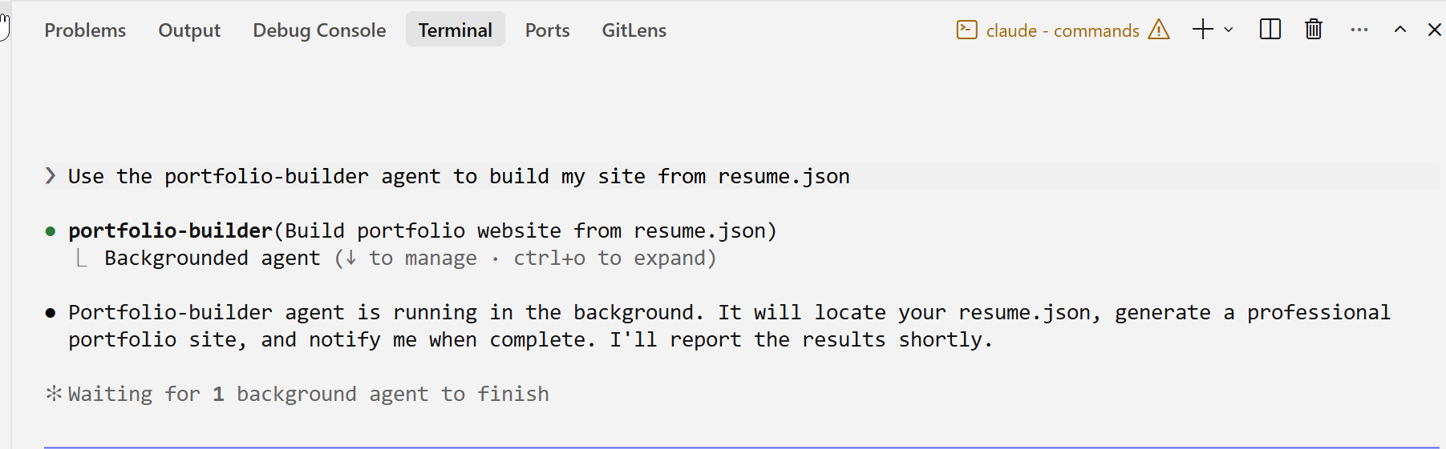
- Trainer says this server is launched using Python.
- Start the server and open it.
