Solution to Q3:

1. Installed Virtualbox

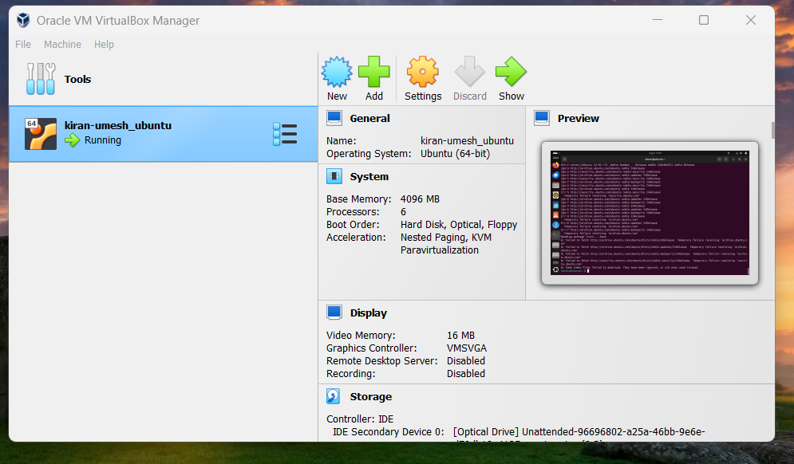

1. Installed ubuntu 24.04

3. Logged into Terminal on unbuntu running on VM:

4. installed and validated the nginx with the below commands

5.Installed net-tools:

6. Captured the ip using ifconfig:

7. Ensured that site is up within the VM:

8. Checked the status of the site from the local using nmap UI:

