Solution for Question 2:

Installed LFS:

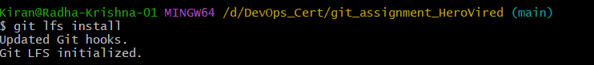

Track file types with lfs on git:

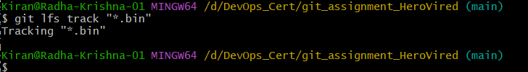

Commit the changes to .gitattributes and push it to remote:

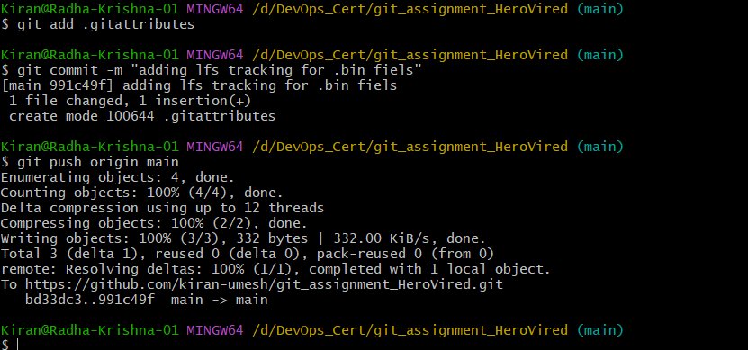

Added a big (300MB) bin file to main branch:

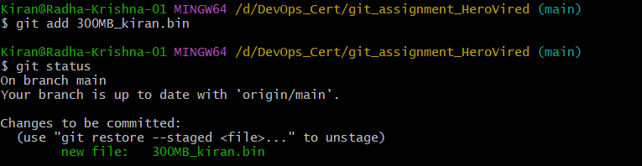

Committed and pushed the large file to remote repo:

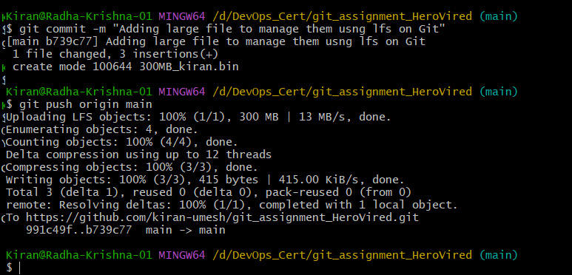

Clones a colleague’s repo with lfs file:

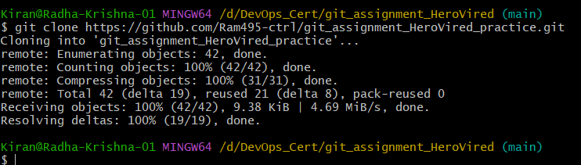

Pulled contents of his main branch from remote t local cloned repo that also had his binary files:

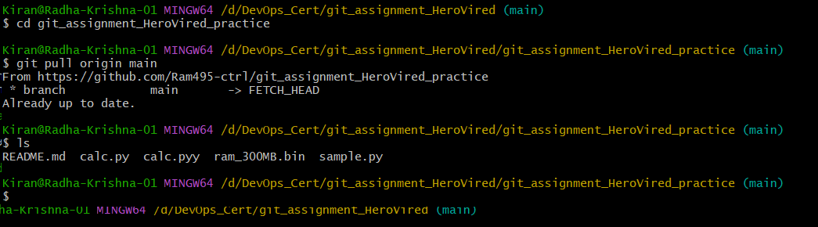

Validated the size and integrity of the friends bin file on my repo and found it to be good:

