1. Write a program to print the Fibonacci series using recursion.

def fibonacci(n):
if n==1:
return 0
elif n==2:
return 1
else:
return fibonacci(n-1)+fibonacci(n-2)

n=int(input("Enter the number of terms : "))
for i in range(1,n+1):
print(fibonacci(i),end=" ")
print()
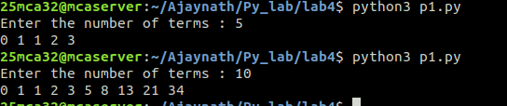

2. Write the to implement a menu-driven calculator. Use separate functions for
the different operations.

def add(a,b):
r=a+b
print("Sum is ",r)
def sub(a,b):
r=a-b
print("difference is ",r)
def div(a,b):
r=a/b
print("quotient is ",r)
def mult(a,b):
r=a*b
print("product is ",r)
def rem(a,b):
r=a%b
print("remainder is ",r)
i=1
while(i):
print("1.Add")
print("2.SUB")
print("3.DIV")
print("4.MULTIPLICATION")
print("5.REMAINDER")
print("6.EXIT")
n=int(input("Enter the choice : "))
if n==6:
i=0
continue
a=int(input("Enter the first number : "))
b=int(input("Enter the second number : "))
if n==1:
add(a,b)
elif n==2:
sub(a,b)
elif n==3:
div(a,b)
elif n==4:
mult(a,b)
elif n==5:
rem(a,b)
else:
print("Invalid choice")

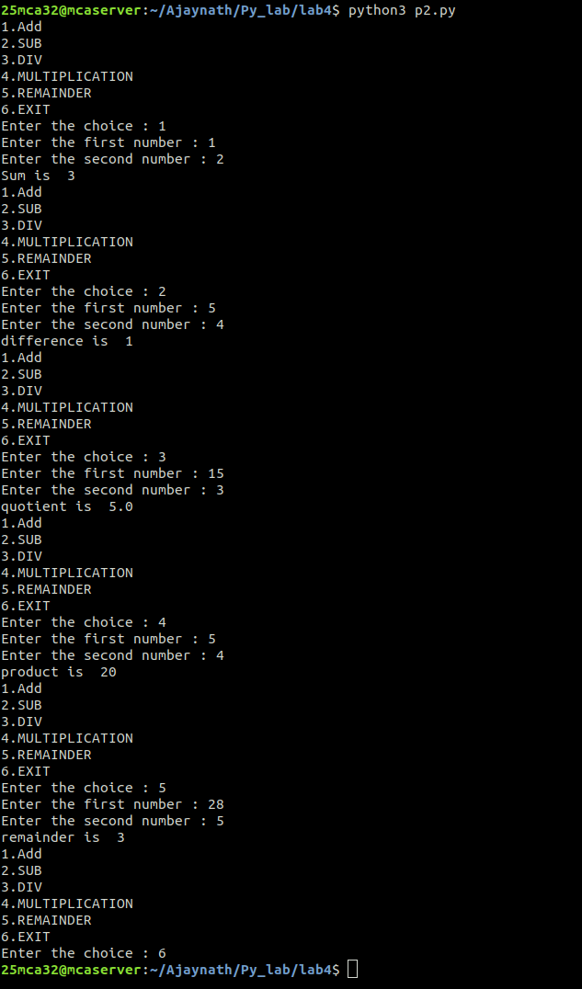

3. Write a program to print the n th prime number.

[Use function to check whether a number is prime or not]

def isprime(n):
limit=int(n**(1/2))
if n==2:
return 1
for i in range(2,limit+1):
if n%i==0:
return 0
else:
return 1

num=int(input("Enter the number to find the n th prime number : "))
i=2
j=0
while(1):
if isprime(i):
j+=1
if j==num:
print(f"prime number at {num} is {i}")
break
i+=1

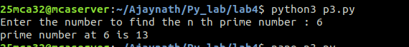

4. Write lambda functions to find the area of square, rectangle and triangle.

sarea=lambda s:s*s
rarea=lambda l,b:l*b
tarea=lambda b,h:0.5*b*h

s=float(input("Enter the side of square : "))
rlen=float(input("Enter the rectangle length : "))
rbreadth=float(input("Enter the rectangle width : "))
tbreadth=float(input("Enter the triangle breadth : "))
theight=float(input("Enter the triangle height : "))

print(f"Area of square is {sarea(s)}")
print(f"Area of rectangle is {rarea(rlen,rbreadth)}")
print(f"Area of triangle is {tarea(tbreadth,theight)}")

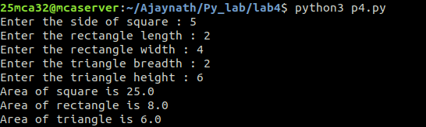

5. Write a program to display powers of 2 using anonymous function. [ Hint
use map and lambda function)

n=int(input("Enter the limit :"))
squares=list(map(lambda x:2**x,range(n)))
print(squares)

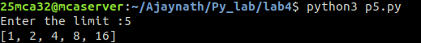

6. Write a program to display multiples of 3 using anonymous function. (Hint
use filter and lambda function)

n=int(input("Enter the range : "))
multi_of_three=list(filter(lambda x:x%3==0,range(1,n+1)))
print(multi_of_three)

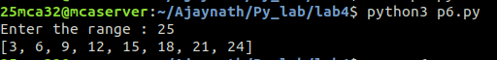

7. Write a program to sum the series 1/1! + 4/2! + 27/3! + ….. + nth term. [ Hint
Use a function to find the factorial of a number].

def fact(n):
if n==1:
return 1
else:
return n*fact(n-1)

n=int(input("(1/1!)+(4/2!)+(27/3!)+...\nEnter the limit : "))
list=[((i**i)/fact(i)) for i in range(1,n+1)]
print(sum(list))

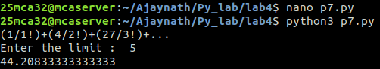

8. Write a function called compare which takes two strings S1 and S2 and an
integer n as arguments. The function should return True if the first n
characters of both the strings are the same else the function should return
False

def compare(str1,str2,n):
if str1[0:n]==str2[0:n]:
return True
else:
return False

str1=input("Enter the string 1 : ")
str2=input("Enter the string 2 : ")
num=int(input("Enter the number : "))
print(compare(str1,str2,num))

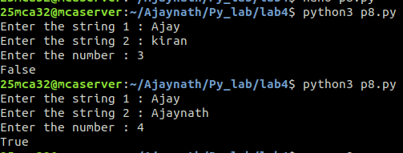

9. Write a program to add variable length integer arguments passed to the
function. [Also demo the use of docstrings]

def add_num(*num):
"""
This function accepts any number of integers and return its sum

parameters:
*num :variable length integer arguments

returns:
int : sum of all integers passed

"""
return sum(num)

print(add_num.__doc__)
print(f"add_num(1,2,3) = {add_num(1,2,3)}")
print(f"add_num(2,4) = {add_num(2,4)}")
print(f"add_num(1,3,5,7,9) = {add_num(1,3,5,7,9)}")
print(f"add_num(1,2,3,4,5,6,7,8,9) = {add_num(1,2,3,4,5,6,7,8,9)}")
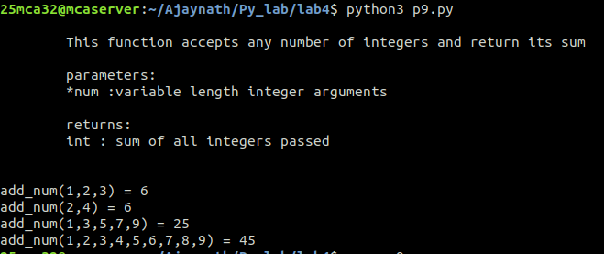

10. Write a program using functions to implement these formulae for
permutations and combinations.
The Number of permutations of n objects taken r at a time: p(n, r) = n!/(n −
r)!.
The Number of combinations of n objects taken r at a time is: c(n, r) = n!/(r! ∗
(n − r)!)

def fact(n):
if n==1:
return 1
else:
return n*fact(n-1)
def p(n,r):
return fact(n)/fact(n-r)

def c(n,r):
return p(n,r)/fact(r)

print("Enter the details to find permutation nPr :")
n=int(input("n: "))
r=int(input("r: "))
print(f"{n}p{r}={p(n,r)}")
print("Enter the details to find Combination nCr :")
n=int(input("n: "))
r=int(input("r: "))
print(f"{n}C{r}={c(n,r)}")
