LAB CYCLE 3(1-10)

Name :Kiran Benny Roll No:31

1. Write a program to find the factorial of a number

n=int(input("Enter a number...")) def fact(n):

if n==1:

return 1

else:

return n*fact(n-1)

print("factorial of ",n," is ",fact(n))



1. Generate Fibonacci series of N terms

n=int(input("Enter the Number...")) a=0

b=1 print(a) print(b)

for i in range(2,n): c=a+b; print(c)

a=b b=c

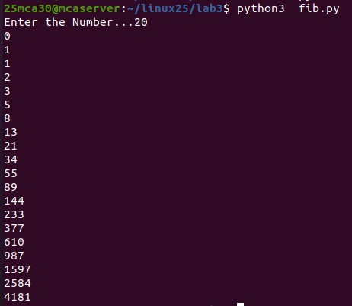

1. Write a program to find the sum of all items in a list. [Using for loop]

n=input("enter numbers comma separated ") numbers1=list(map(int,n.split(",")))

sum=0

for i in numbers1: sum=sum+i;

print("sum of the the items is ",sum)



1. Generate a list of four digit numbers in a given range with all their digits even and the number is a perfect square.

import math def even(n):

for digits in str(n):

if int(digits)%2!=0: return False

return True

perfect_square=[]

sran=int(input("Enter the start range...")) ran=int(input("Enter the end range...")) if ran>9999 or sran<1000:

print("range must be between 1000 --- 9999")

else:

for i in range(sran,ran): square=math.isqrt(i) if square*square==i:

if even(i):

perfect_square.append(i)

print(perfect_square)

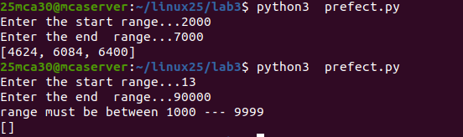

1. Write a program using a for loop to print the multiplication table of n, where n is entered by the user.

n=int(input("Enter the number ..."))

for i in range(1,11): print(i ,"*",n,"=",i*n)

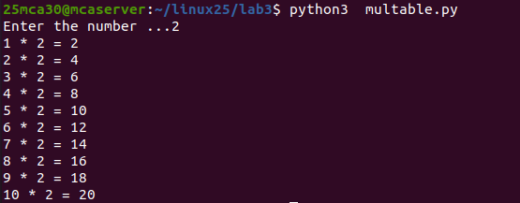

1. Write a program to display alternate prime numbers till N (obtain N from the user). def is_prime(num):

if num<=1:

return False

for i in range(2,int(num ** 0.5)+1): if num%i==0:

return False return True

def alt_prime(num): count=0

for i in range(2,num+1): if is_prime(i):

count+=1

if count%2!=0:

print(i,end=" ")

n=int(input("enter a Number Limit "))

print("The List of Alternative prime numbers ")

alt_prime(n)

print()

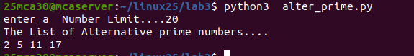

1. Write a program to compute and display the sum of all integers that are divisible by 6 but not by 4, and that lie below a user-given upper limit.

m=int(input("enter the lower limit...")) n=int(input("enter the upper limit...")) sum=0

for i in range(m,n):

if i%6==0 and i%4!=0: sum=sum+i

print("sum of integers divisible by 6 but not by 4 is ",sum)

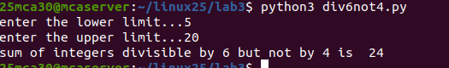

1. Calculate the sum of the digits of each number within a specified range (from 1 to a user-defined upper limit). Print the sum only if it is prime.

def is_prime(num): if num<=1:

return False

for i in range(2,int(num ** 0.5)+1): if num%i==0:

return False return True

n=int(input("Enter the upper limit "))

for i in range(1,n+1):

sum_digit=sum(int(j) for j in str(i)) if is_prime(sum_digit):

print(f"Number : {i},sum of digits is: {sum_digit} is prime")

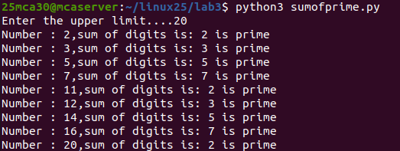

1. A number is input through the keyboard. Write a program to determine if it’s palindromic.

n=int(input("Enter a number ...."))

num=n

new_digit=0

while n!=0:

digit=n%10

new_digit=new_digit*10+digit

n=n//10

if num==new_digit:

print("the number ",num," is a palindrome...")

else:

print("the number ",num," is not a palindrome...")

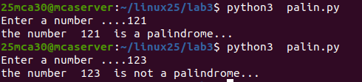

10.Write a program to generate all factors of a number. [use while loop]

n=int(input("enter a Number "))

factors=[] i=1

while i<=n:

if n%i==0:

factors.append(i) i=i+1

print("The factors of the number ",n," is ",factors)



11. Write a program to find whether the given number is an Armstrong

number or not. [use while loop]

num=int(input("Enter a number...."))

number=num

n=len(str(num))

sum=0

while num>0:

digit=num%10

sum=sum+digit**n

num=num//10

if number==sum:

print(number, " is a Armstrong number....")

else:

print(number," it is not a Armstrong.…")

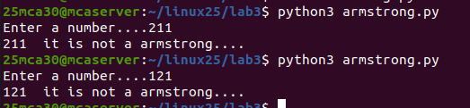

12. Display the given pyramid with the step number accepted from the

user. Eg: N=4

1

2 4

3 6 9

4 8 12 16

n=int(input("Enter a number......"))

for i in range(1,n+1):

for j in range(1,i+1):

print(j*i,end=" ")

print()

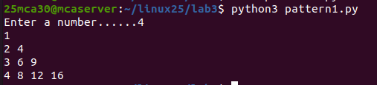

13. Construct following pattern using nested loop

*

* *

* * *

* * * *

* * * * *

* * * *

* * *

* *

*

n = int(input("Enter a number: "))

for i in range(1, n + 1):

for j in range(1, i + 1):

print("*", end=" ")

print()

for i in range(n - 1, 0, -1):

for j in range(1, i + 1):

print("*", end=" ")

print()

