In early 2020 when Covid-19 was in its starting phase.

I have created a visualization using R to visualize how different states are comparing the daily new cases and trend of overall cases in Australia.

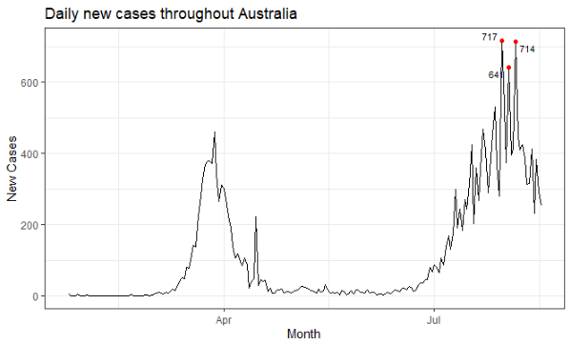

**Insights:**

Above is the first visualization made to show number of new confirmed cases spotted daily in the entire Australia since the first case reported on 25th January 2020. Daily new cases have been derived by adding new cases reported in every state on a particular day. The data is irregular and time series, so, chart type used is line chart to show daily cases. (Wong J., 2020). Points has been used to highlight top three days which has the greatest number of cases till now with the annotation of how many cases have been spotted at that day. Appropriate graph title and axis labels has been used to define what the graph is and what the axis are saying. In the graph it clearly shown two waves of corona in Australia where first one is seen around April and second one is seen after July.

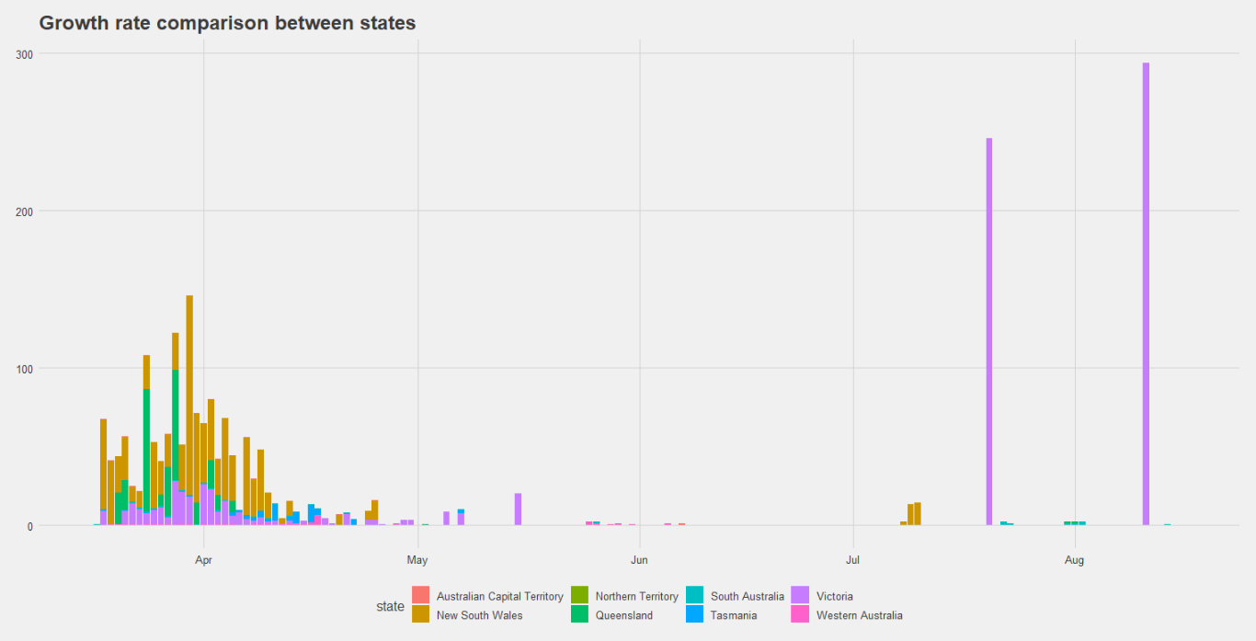

Above is the second visualization made to compare the growth rate across all the eight states in Australia since the first case reported on 25th January 2020. The growth rate is not present in the dataset so calculated it using the proper formula where all negative growth rates and infinite growth rate has been transformed to zero. Then the visualization has been made where comparison has to be made so used bar chart to compare the growth rate. (Wong J., 2020). Color has been used to differentiate between eight states growth factor. Appropriate title has been shown to give idea about the graph. In the graph initial days showed New South Wales has more growth rate than other states while after mid of July only Victoria has started to shown cases growing tremendously while all other have nearly zero new cases.