**UI Output**

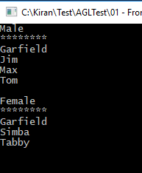

**Unit Test Output**

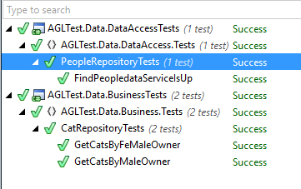

**GitHub URL**

**https://github.com/kiran2014/CodingChallenge.git**