Pediatric Lung Sound AI Simple Engineering Report
  - ESP32 S3 pipeline results microphone status and next steps
Date 6 October 2026

Main conclusion
The AI pipeline is running on the ESP32 S3. The model, preprocessing and quality checks fit and produce results. The remaining problem is the physical microphone to chest connection. The current live recording was too weak, so the device correctly asked for another recording instead of giving a false prediction.
Area | Status | Meaning
Firmware builds and flashes | DONE | Complete pipeline runs on the board
Classification model | DONE | INT8 model runs in 2.11 seconds
Noise and signal quality gate | DONE | Invalid audio returns RETRY
Microphone electrical capture | DONE | INMP441 produces nonzero audio
Chest sound quality | NEEDS WORK | Acoustic contact is too weak
Controlled PCB testing | READY | Engineering tests can start
Clinical or product release | NOT READY | Needs final hardware and patient validation

What the device reports
Output | Classes
Two class | Normal or abnormal
Three class | Normal crackle or wheeze
Recording problem | RETRY with a reason such as poor contact noise or clipping

End to end inference flow
This is the exact order used by the firmware. A failed quality check stops the process before classification.
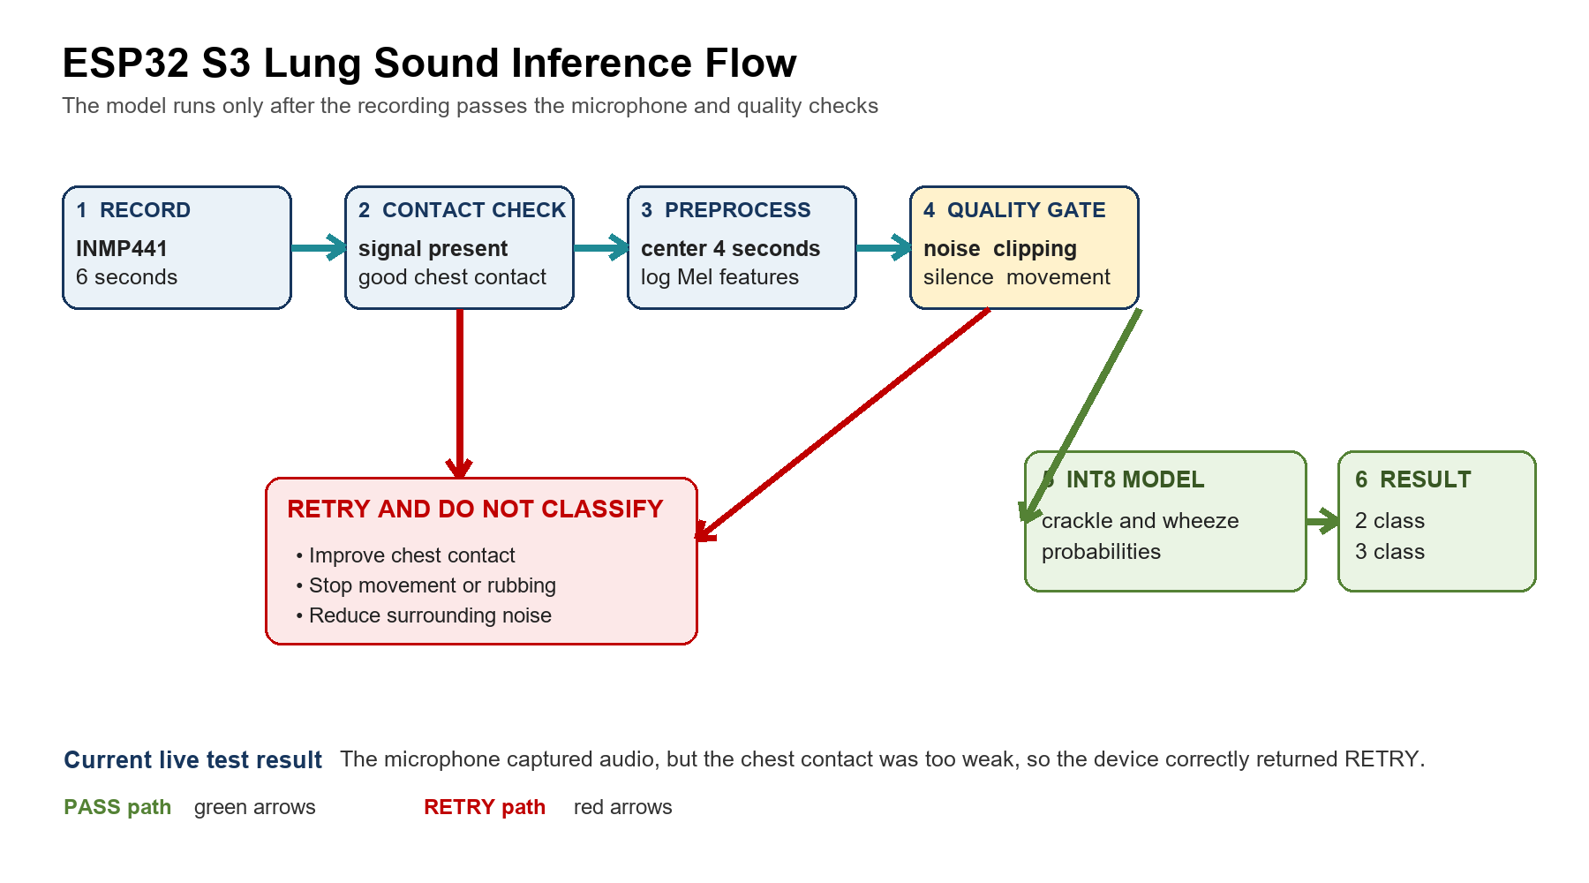
Step | Module | Action
1 | Record | Capture six seconds at 16 kHz from the INMP441
2 | Contact check | Confirm that the microphone works and touches the chest correctly
3 | Preprocess | Use the middle four seconds and create 64 by 401 log Mel features
4 | Quality gate | Check silence noise movement clipping and weak signal
5 | INT8 model | Calculate crackle and wheeze probabilities
6 | Result | Return two class and three class results

Model and ESP32 results

Accuracy comparison
Test set | Teacher two class | Student two class | Student three class
Held out stethoscope 1986 clips | 79.86% | 71.55% | 67.92%
External smartphone 9217 clips | 65.59% | 78.16% | 75.42%
All sources 33508 clips | 83.73% | 82.97% | 80.26%
ESP32 smoke test 20 clips | Not tested | 90.00% | 60.00% excluding both

Important The 20 clip ESP32 test proves that the complete hardware pipeline works. The larger desktop evaluation is the correct source for model accuracy.

Size memory and latency
Item | Measured result | Simple meaning
Student INT8 model | 188128 bytes 183.72 KiB | Small enough for this deployment
Tensor arena used | 117132 bytes 114.39 KiB | Runs in internal SRAM
Internal SRAM remaining | 41659 bytes 40.68 KiB | Works but has limited safety margin
Firmware image | 512032 bytes 500.03 KiB | Application partition remains 88% free
Model inference | 2.11 seconds | Classification only
Preprocess and quality gate | 1.20 seconds | Frontend gate and quantization
Total processing after recording | 3.31 seconds | From captured audio to final result
Full live use | About 9.7 seconds | Six second recording plus processing

Recommended memory placement
Memory | Put these modules here | Reason
Flash | INT8 model weights | Saves about 184 KiB of internal SRAM with almost no speed loss
Internal SRAM | Tensor arena FFT work buffers gate state DMA and task stacks | These items are used repeatedly and need fast access
PSRAM | Six second capture four second PCM log Mel buffer and saved audio | These are large buffers and do not need the fastest memory

Microphone decision
The current I2S configuration is correct. The board captured 96000 nonzero samples using WS GPIO 1 BCLK GPIO 2 and SD GPIO 4. The problem is weak sound transfer from the chest to the microphone.
Live measurement | Result | Meaning
Raw RMS | minus 58.8 dBFS | Chest signal is too weak
Digital gain | 32 times | Makes the signal louder but also makes noise louder
Quality decision | RETRY poor chest contact | Correct behavior because classification was skipped

Should we replace the INMP441
Option | Recommendation | Why
Keep INMP441 | Use for the current prototype | First improve the diaphragm seal cavity and chest contact
IM73D122 PDM microphone | Best first Rev B candidate | 73 dBA SNR 20 Hz response and direct PDM support on ESP32 S3 I2S0
IM73A135 analog microphone | Use as an A B performance reference | High performance but needs a separate low noise ADC and amplifier

Competitor design lessons
Product | Publicly described feature | Lesson for our product
StethoMe | Guided chest placement and bad recording feedback | Guide the user and repeat only bad chest points
Stemoscope Pro | 20 to 2000 Hz range and ambient noise cancellation | Use a wide lung sound band and control surrounding noise
Skeeper | MEMS microphone noise cancellation and 12 lung points | Use a repeatable multi point examination

Note The exact microphone part numbers used by these products are not publicly listed. We should compare our prototypes using measured chest sound quality rather than copy an unknown component.

Next steps before product testing
Step | Work | Required result
1 | Improve the chestpiece | Seal the microphone cavity align the microphone port add a gasket and reduce hand or cable vibration
2 | Test two microphone versions | Compare the improved INMP441 chestpiece with an IM73D122 PDM prototype
3 | Collect real quality data | Record good contact no contact movement clothing rub speech fan TV and hospital noise
4 | Calibrate the quality gate | Set thresholds using the final microphone and chestpiece then lock them
5 | Test real classification accuracy | Use patient disjoint labeled recordings captured by the final PCB
6 | Run reliability tests | Measure battery life temperature memory stability BLE transfer and at least 1000 recording cycles

Final readiness decision
Question | Answer | Explanation
Can we test the firmware on the PCB | YES | Use controlled engineering tests
Does the classification model run correctly | YES | Portable TFLM decisions matched the host for 20 of 20 samples
Does the microphone capture data | YES | The I2S stream is nonzero
Can we trust the current live chest prediction | NOT YET | The microphone to chest acoustic connection is too weak
Is the product ready for clinical use or sale | NO | Final hardware clinical safety usability and regulatory validation are still required

Immediate decision
Continue with PCB engineering tests. Do not spend more time reducing the model first. The priority is improving acoustic contact and collecting real recordings from the final chestpiece.

Main public references
- TDK INMP441 datasheet https://invensense.tdk.com/wp-content/uploads/2015/02/INMP441.pdf
- Espressif ESP32 S3 I2S documentation https://docs.espressif.com/projects/esp-idf/en/stable/esp32s3/api-reference/peripherals/i2s.html
- Infineon IM73D122 https://www.infineon.com/part/IM73D122
- StethoMe https://www.stethome.com/en-gb
- Stemoscope Pro https://stemoscope.com/products/stemoscope-pro-professional-smart-wireless-stethoscope-direct-connection-with-bluetooth-earphones-use-with-a-smartphone-fda-cleared
- Skeeper H1 https://ismartsound.com/human-healthcare/skeeper-h1/

