Goal Setting and Performance Tracking-1 Submission
Name- Kirandeep Kaur
Student ID= 3122707
Course: CMPT 3830

Goals:
As I joined this course late, I initially thought it would be difficult for me to keep up because I was already two weeks behind my peers. I didn’t have many expectations at first, as the material seemed a bit intimidating, especially knowing there was a project from the very beginning. However, the teachers reached out to me by email to check how I was doing as a late student and offered their support to help me get started with the course, which I was very grateful for. With their help, I was able to begin more easily and gradually found the course material interesting, as it focused on implementing our skills in real-world situations and included a project that solved real-time problems. So, based on this experience, I set the following goals for myself:
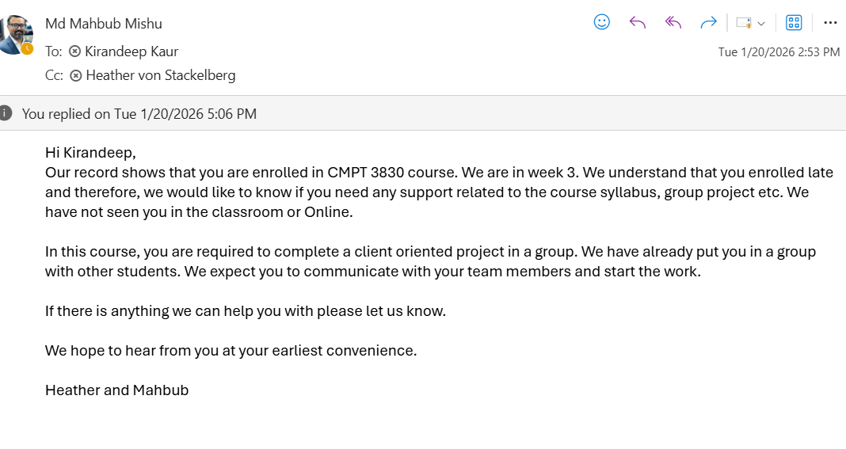
Goal 1: Complete The POPA Course
My first task in this course was to complete the POPA course, which was important to do to get the project data and to start the project.
Actions:
- The first was to access the course, as it was not available to me as a latecomer. So, for that, I reached out to the instructors, and they helped me gain access to the POPA course

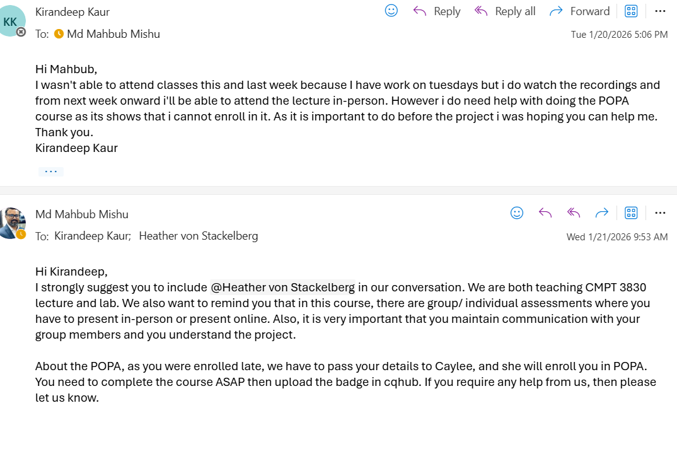
- Complete the course within the week after getting the access and uploading the badge on CQHub.
Result:
Hence, with the help of instructions and completing the course within a week, I was able to achieve this goal and start the project.
Goal 2: Implementing codes in real-life situations
My second goal is to develop a strong understanding of the course concepts and the coding skills we learn in class. I plan to practice these skills regularly at home so that I can confidently apply them on my own to solve real-world problems.
Actions:
- Practice at least 10 coding problems each week.
- Pay attention when codes are implemented in class and practice later.
Expected Result:
- Apply course concepts to solve at least one real-world problem independently by the end of the semester.

Goal 3: Passing the Course with good grades
My final goal is to successfully pass this course with a strong understanding of the material and achieve good grades as proof of my effort and commitment to learning.
Actions:
- Review previously covered topics before each class.
- Complete assignments and projects at least two days before the deadline.
- Attend the classes regularly.
Expected Result:
- Pass > 80% score at the end of the semester.

