
Product Dissection for Amazon

Company Overview:

Amazon, founded in 1994 by Jeff Bezos, has transformed global e-commerce and retail logstics. Originally an online bookstore, Amazon has evolved into a global marketplace and technological powerhouse, known for its customer-centric experience, efficient logistics infrastructure, and scalable data architecture. With a relentless focus on selection, convenience, and low prices, Amazon connects millions of buyers and independent third-party sellers across the globe daily.

Product Dissection and Real-World Problems Solved by Amazon:

Amazon addresses critical challenges in retail and online shopping through its scalable product offerings. By digitizing retail storefronts, Amazon bridges the gap between global seller inventory and local customer demand. The platform enables users to search, compare, purchase, and review millions of products with transparent pricing and fast delivery options, solving the challenge of fragmented retail experiences.
Amazon's automated recommendation engine, search filters, and one-click purchasing models have transformed how consumers browse catalog data. By addressing the challenge of choice overload, Amazon curates relevant options, helping users discover products aligned with their preferences. Furthermore, Amazon's rating and review system allows verified purchasers to share authentic feedback, effectively tackling the issue of product quality uncertainty online and instilling trust in third-party marketplace transactions.
In conclusion, Amazon’s product design successfully addresses real-world shopping problems by creating an ecosystem that simplifies fulfillment, ensures transactional transparency, and offers personalized discovery. Through its integrated features, Amazon provides practical, scalable solutions to the evolving requirements of a global consumer base.

Case Study: Real-World Problems and Amazon's Innovative Solutions

Problem 1: Split Logistics and Multi-Vendor Fulfillment
- Real-World Challenge: A single customer purchase often contains multiple products sourced from distinct sellers or geographically separated fulfillment centers. Combining these into a rigid, single shipment pipeline causes processing bottlenecks or unexpected delivery delays.
- Amazon's Solution: Amazon decouples overall customer orders from individual line-item fulfillments. By treating each purchased item as a discrete record connected to inventory units, Amazon can split one transaction into multiple tracking numbers and shipping schedules transparently, ensuring items arrive as fast as possible without confusing the buyer.

Problem 2: Inventory Variation Management at Mass Scale
- Real-World Challenge: Managing product listings with dozens of physical variations (such as sizes, colors, and material types) creates massive data redundancy if each variation requires a distinct catalog page.
- Amazon's Solution: Amazon separates generic parent Products from actionable child SKUs (Stock Keeping Units). The base product holds global metadata (brand, general description), while individual SKUs manage dynamic, variant-specific attributes (specific size, price, and real-time inventory count), resulting in clean search results and efficient database indexing.

Problem 3: Buyer Hesitation and Trust Verification
- Real-World Challenge: E-commerce shoppers hesitate to buy products online from unfamiliar third-party vendors due to worries about counterfeit or low-quality goods.
- Amazon's Solution: Amazon introduced verified customer reviews and aggregated star ratings tied directly to verified purchase records. This gives shoppers authentic social proof while filtering out fake feedback from unverified accounts.

Problem 4: Checkout Friction and Cart Abandonment
- Real-World Challenge: Multi-step checkout processes with repeated address and payment entry cause users to drop off before completing purchases.
- Amazon's Solution: Amazon stores pre-validated user shipping addresses and payment methods in decoupled secondary tables. This architecture powers features like "1-Click Ordering," automatically generating an order with default payment and delivery selections to eliminate checkout friction.

Conclusion
Amazon's journey from an online bookstore to a global marketplace is a testament to its ability to identify real-world shopping friction and provide scalable technological solutions. By managing split fulfillment logistics, catalog variants, buyer trust, and checkout automation, Amazon has addressed fundamental challenges that customers face in e-commerce. This case study highlights how Amazon's user-centric architecture and data design continue to position it as a leader in global online retail.

Top Features of Amazon:
- User Profiles & Address Book: Allows users to manage account credentials and maintain multiple default or gift shipping addresses.
- Product Catalog & SKUs: Houses detailed product pages structured into hierarchical categories with distinct price points, stock levels, and product options.
- Shopping Cart & Checkout: Enables buyers to aggregate products from multiple sellers, apply promotional discounts, and complete purchases in a single transaction.
- Order Tracking & Line Items: Provides real-time visibility into order status, payment receipts, individual item fulfillment stages, and tracking links.
- Customer Reviews & Star Ratings: Enables verified buyers to upload star ratings, written reviews, photos, and videos to evaluate seller and product performance.
- Wishlists & Saved Items: Allows buyers to bookmark items for future purchases, share public registries, and receive notifications when prices drop.

Schema Description:
The schema for Amazon involves multiple core entities that represent different aspects of the e-commerce transaction workflow. These entities include User, Address, Product, SKU, Order, OrderItem, and Review.

User Entity
Centralizes user credentials and account details:
- UserID (Primary Key): Unique identifier for each account.
- Full_Name: The user's name on record.
- Email: Account communication and login identifier.
- Password_Hash: Securely encrypted security credential.
- Created_At: Timestamp when the account was registered.

Address Entity
Manages multiple shipping destinations per user:
- AddressID (Primary Key): Unique identifier for each address entry.
- UserID (Foreign Key referencing User Entity): The user account owning the address.
- Street: Street and house number details.
- City: City or local municipality.
- Postal_Code: Zip or postal code.
- Is_Default: Flag designating primary delivery location.

Product Entity
Defines general parent product catalog listings:
- ProductID (Primary Key): Unique parent catalog identifier.
- Title: General product listing title.
- Description: Detailed product breakdown and specifications.
- Brand: Manufacturer or brand name.

SKU (Stock Keeping Unit) Entity
Tracks specific purchasable variations and physical stock:
- SKUID (Primary Key): Unique identifier for specific inventory items.
- ProductID (Foreign Key referencing Product Entity): Parent product link.
- Price: Unit selling price for this variation.
- Stock_Quantity: Units currently available across fulfillment centers.
- Variant_Attributes: JSON string detailing parameters (e.g., Size: Medium, Color: Blue).

Order Entity
Captures financial checkout transactions:
- OrderID (Primary Key): Unique checkout transaction record.
- UserID (Foreign Key referencing User Entity): Purchasing account.
- AddressID (Foreign Key referencing Address Entity): Delivery destination.
- Order_Date: Timestamp when payment was authorized.
- Total_Amount: Final charge total.
- Status: High-level workflow state (Pending, Processing, Shipped, Delivered).

OrderItem Entity (Junction)
Links purchases to exact inventory SKUs and locks in historical purchase prices:
- OrderItemID (Primary Key): Unique line-item transaction record.
- OrderID (Foreign Key referencing Order Entity): Associated checkout transaction.
- SKUID (Foreign Key referencing SKU Entity): Purchased variant item.
- Quantity: Number of units purchased.
- Price_At_Purchase: Locked unit price at checkout time (prevents historical order alteration when catalog prices change).

Review Entity
Stores customer rating feedback:
- ReviewID (Primary Key): Unique feedback entry.
- ProductID (Foreign Key referencing Product Entity): Reviewed product.
- UserID (Foreign Key referencing User Entity): Review author.
- Rating: Numeric score (1 to 5 stars).
- Comment: Written review text.
- Review_Date: Timestamp when posted.

Key Relationships:
- Users have Addresses – Each user can store multiple addresses; each address belongs to one user.
- Users place Orders – Each user can place multiple orders; each order belongs to one user.
- Orders link to OrderItems – An order contains one or more line items; each line item maps back to one order.
- SKUs populate OrderItems – Each SKU can be purchased across many order line items; an order line item refers to a single SKU.
- Products have SKUs – A parent product can have multiple variant SKUs (sizes/colors); each SKU maps back to one parent product.
- Users review Products – A user can submit reviews for multiple products, and each product accumulates reviews from multiple users.

ER Diagram:
Let's construct an ER diagram that vividly portrays the relationships and attributes of the entities within the Amazon schema. This ER diagram will serve as a visual representation, shedding light on the pivotal components of Amazon's data model. By employing this diagram, you'll gain a clearer grasp of the intricate interactions and connections that define the platform's dynamics.
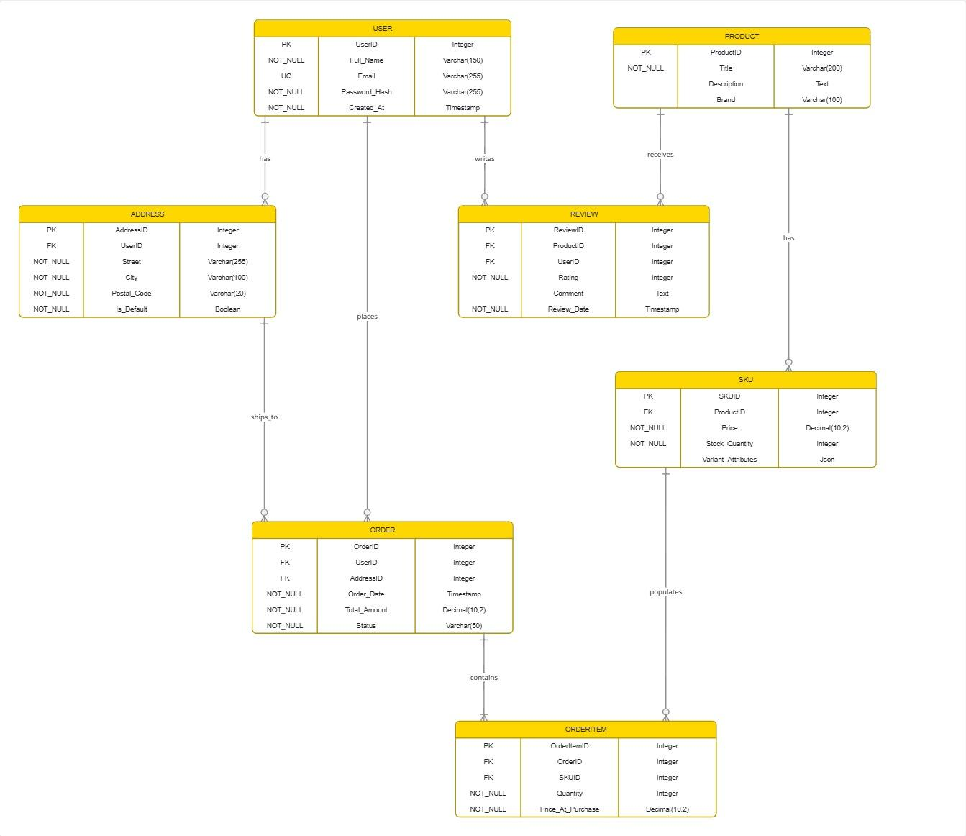

Conclusion
In this case study, we analyzed the product architecture and schema design powering Amazon's e-commerce marketplace. Amazon manages global product listings, variant stock counts, split fulfillment logistics, and verified review networks through a relational database model. By organizing data across entities like User, Address, Product, SKU, Order, OrderItem, and Review, Amazon maintains complete transactional integrity and historical purchase accuracy while serving a fast, dependable shopping experience to millions of users globally.

