Storage and Indexing:
UNIT-6

DBMS - Storage System :

Databases are stored in file formats, which contain records. At physical level, the actual data is stored in electromagnetic format on some device. These storage devices can be broadly categorized into three types −
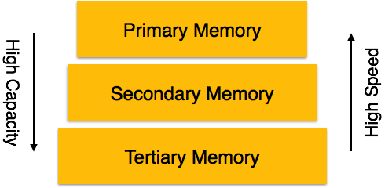

Primary Storage
It is the primary area that offers quick access to the stored data. We also know the primary storage as volatile storage. It is because this type of memory does not permanently store the data. As soon as the system leads to a power cut or a crash, the data also get lost. Main memory and cache are the types of primary storage.
- Main Memory: It is the one that is responsible for operating the data that is available by the storage medium. The main memory handles each instruction of a computer machine. This type of memory can store gigabytes of data on a system but is small enough to carry the entire database. At last, the main memory loses the whole content if the system shuts down because of power failure or other reasons.
- Cache: It is one of the costly storage media. On the other hand, it is the fastest one. A cache is a tiny storage media which is maintained by the computer hardware usually. While designing the algorithms and query processors for the data structures, the designers keep concern on the cache effects.

Secondary Storage
Secondary storage is also called as Online storage. It is the storage area that allows the user to save and store data permanently. This type of memory does not lose the data due to any power failure or system crash. That's why we also call it non-volatile storage.
There are some commonly described secondary storage media which are available in almost every type of computer system:
- Flash Memory: A flash memory stores data in USB (Universal Serial Bus) keys which are further plugged into the USB slots of a computer system. These USB keys help transfer data to a computer system, but it varies in size limits. Unlike the main memory, it is possible to get back the stored data which may be lost due to a power cut or other reasons. This type of memory storage is most commonly used in the server systems for caching the frequently used data. This leads the systems towards high performance and is capable of storing large amounts of databases than the main memory.
- Magnetic Disk Storage: This type of storage media is also known as online storage media. A magnetic disk is used for storing the data for a long time. It is capable of storing an entire database. It is the responsibility of the computer system to make availability of the data from a disk to the main memory for further accessing. Also, if the system performs any operation over the data, the modified data should be written back to the disk. The tremendous capability of a magnetic disk is that it does not affect the data due to a system crash or failure, but a disk failure can easily ruin as well as destroy the stored data.

Tertiary Storage
It is the storage type that is external from the computer system. It has the slowest speed. But it is capable of storing a large amount of data. It is also known as Offline storage. Tertiary storage is generally used for data backup. There are following tertiary storage devices available:
- Optical Storage: An optical storage can store megabytes or gigabytes of data. A Compact Disk (CD) can store 700 megabytes of data with a playtime of around 80 minutes. On the other hand, a Digital Video Disk or a DVD can store 4.7 or 8.5 gigabytes of data on each side of the disk.
- Tape Storage: It is the cheapest storage medium than disks. Generally, tapes are used for archiving or backing up the data. It provides slow access to data as it accesses data sequentially from the start. Thus, tape storage is also known as sequential-access storage. Disk storage is known as direct-access storage as we can directly access the data from any location on disk.

Storage Hierarchy
Besides the above, various other storage devices reside in the computer system. These storage media are organized on the basis of data accessing speed, cost per unit of data to buy the medium, and by medium's reliability. Thus, we can create a hierarchy of storage media on the basis of its cost and speed.
Thus, on arranging the above-described storage media in a hierarchy according to its speed and cost, we conclude the below-described image:
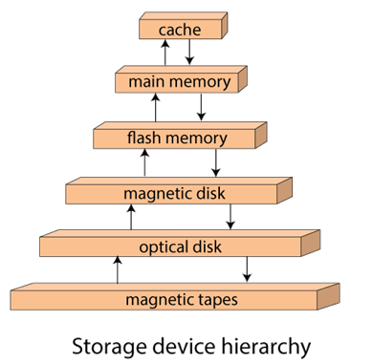
In the image, the higher levels are expensive but fast. On moving down, the cost per bit is decreasing, and the access time is increasing. Also, the storage media from the main memory to up represents the volatile nature, and below the main memory, all are non-volatile devices.

Magnetic Disks
Hard disk drives are the most common secondary storage devices in present computer systems. These are called magnetic disks because they use the concept of magnetization to store information. Hard disks consist of metal disks coated with magnetizable material. These disks are placed vertically on a spindle. A read/write head moves in between the disks and is used to magnetize or de-magnetize the spot under it. A magnetized spot can be recognized as 0 (zero) or 1 (one).
Hard disks are formatted in a well-defined order to store data efficiently. A hard disk plate has many concentric circles on it, called tracks. Every track is further divided into sectors. A sector on a hard disk typically stores 512 bytes of data.

Redundant Array of Independent Disks
RAID or Redundant Array of Independent Disks, is a technology to connect multiple secondary storage devices and use them as a single storage media.
RAID consists of an array of disks in which multiple disks are connected together to achieve different goals. RAID levels define the use of disk arrays.

RAID 0
In this level, a striped array of disks is implemented. The data is broken down into blocks and the blocks are distributed among disks. Each disk receives a block of data to write/read in parallel. It enhances the speed and performance of the storage device. There is no parity and backup in Level 0.
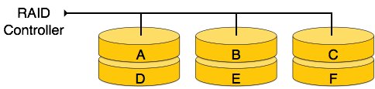

RAID 1
RAID 1 uses mirroring techniques. When data is sent to a RAID controller, it sends a copy of data to all the disks in the array. RAID level 1 is also called mirroring and provides 100% redundancy in case of a failure.
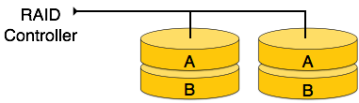

RAID 2
RAID 2 records Error Correction Code using Hamming distance for its data, striped on different disks. Like level 0, each data bit in a word is recorded on a separate disk and ECC codes of the data words are stored on a different set disks. Due to its complex structure and high cost, RAID 2 is not commercially available.
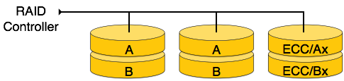

RAID 3
RAID 3 stripes the data onto multiple disks. The parity bit generated for data word is stored on a different disk. This technique makes it to overcome single disk failures.
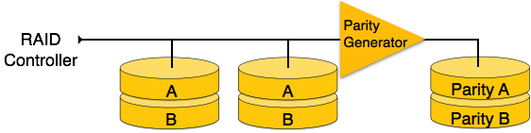

RAID 4
In this level, an entire block of data is written onto data disks and then the parity is generated and stored on a different disk. Note that level 3 uses byte-level striping, whereas level 4 uses block-level striping. Both level 3 and level 4 require at least three disks to implement RAID.
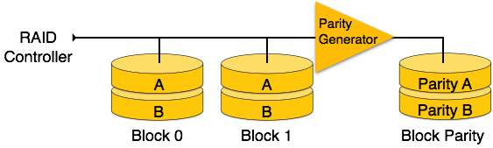

RAID 5
RAID 5 writes whole data blocks onto different disks, but the parity bits generated for data block stripe are distributed among all the data disks rather than storing them on a different dedicated disk.
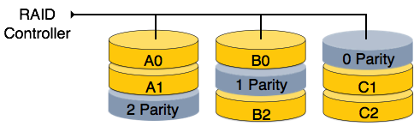

RAID 6
RAID 6 is an extension of level 5. In this level, two independent parities are generated and stored in distributed fashion among multiple disks. Two parities provide additional fault tolerance. This level requires at least four disk drives to implement RAID.
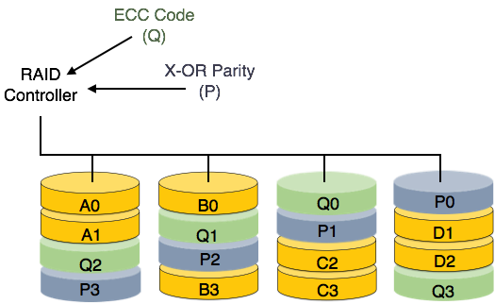

File Organization
File Organization defines how file records are mapped onto disk blocks. We have four types of File Organization to organize file records −

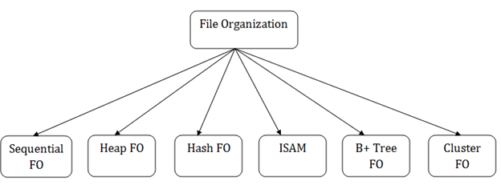

Sequential File Organization
Every file record contains a data field (attribute) to uniquely identify that record. In sequential file organization, records are placed in the file in some sequential order based on the unique key field or search key. Practically, it is not possible to store all the records sequentially in physical form.

Heap File Organization
When a file is created using Heap File Organization, the Operating System allocates memory area to that file without any further accounting details. File records can be placed anywhere in that memory area. It is the responsibility of the software to manage the records. Heap File does not support any ordering, sequencing, or indexing on its own.

Hash File Organization
Hash File Organization uses Hash function computation on some fields of the records. The output of the hash function determines the location of disk block where the records are to be placed.

Indexed sequential access method (ISAM)

ISAM method is an advanced sequential file organization. In this method, records are stored in the file using the primary key. An index value is generated for each primary key and mapped with the record. This index contains the address of the record in the file.
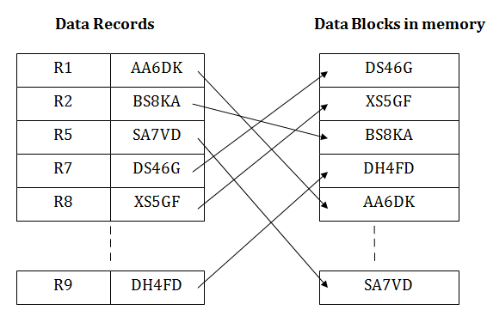

Clustered File Organization
Clustered file organization is not considered good for large databases. In this mechanism, related records from one or more relations are kept in the same disk block, that is, the ordering of records is not based on primary key or search key.
- When the two or more records are stored in the same file, it is known as clusters. These files will have two or more tables in the same data block, and key attributes which are used to map these tables together are stored only once.
- This method reduces the cost of searching for various records in different files.
- The cluster file organization is used when there is a frequent need for joining the tables with the same condition. These joins will give only a few records from both tables. In the given example, we are retrieving the record for only particular departments. This method can't be used to retrieve the record for the entire department.
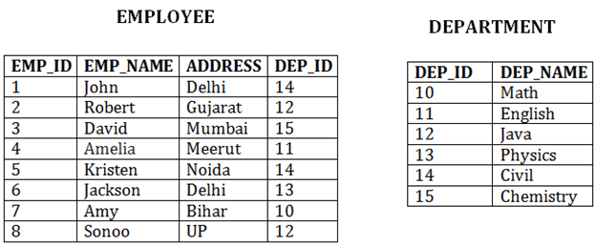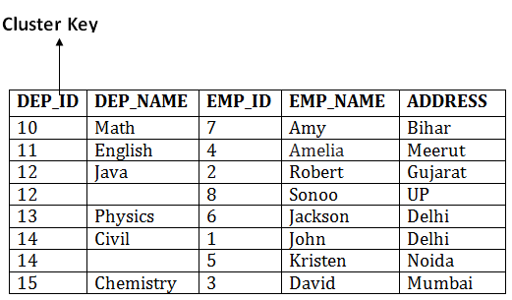
In this method, we can directly insert, update or delete any record. Data is sorted based on the key with which searching is done. Cluster key is a type of key with which joining of the table is performed.

Types of Cluster file organization:
Cluster file organization is of two types:

1. Indexed Clusters:
In indexed cluster, records are grouped based on the cluster key and stored together. The above EMPLOYEE and DEPARTMENT relationship is an example of an indexed cluster. Here, all the records are grouped based on the cluster key- DEP_ID and all the records are grouped.

2. Hash Clusters:
It is similar to the indexed cluster. In hash cluster, instead of storing the records based on the cluster key, we generate the value of the hash key for the cluster key and store the records with the same hash key value.

Pros of Cluster file organization
- The cluster file organization is used when there is a frequent request for joining the tables with same joining condition.
- It provides the efficient result when there is a 1:M mapping between the tables.

Cons of Cluster file organization
- This method has the low performance for the very large database.
- If there is any change in joining condition, then this method cannot use. If we change the condition of joining then traversing the file takes a lot of time.
- This method is not suitable for a table with a 1:1 condition.

File Operations
Operations on database files can be broadly classified into two categories −
- Update Operations
- Retrieval Operations
Update operations change the data values by insertion, deletion, or update. Retrieval operations, on the other hand, do not alter the data but retrieve them after optional conditional filtering. In both types of operations, selection plays a significant role. Other than creation and deletion of a file, there could be several operations, which can be done on files.
- Open − A file can be opened in one of the two modes, read mode or write mode. In read mode, the operating system does not allow anyone to alter data. In other words, data is read only. Files opened in read mode can be shared among several entities. Write mode allows data modification. Files opened in write mode can be read but cannot be shared.
- Locate − Every file has a file pointer, which tells the current position where the data is to be read or written. This pointer can be adjusted accordingly. Using find (seek) operation, it can be moved forward or backward.
- Read − By default, when files are opened in read mode, the file pointer points to the beginning of the file. There are options where the user can tell the operating system where to locate the file pointer at the time of opening a file. The very next data to the file pointer is read.
- Write − User can select to open a file in write mode, which enables them to edit its contents. It can be deletion, insertion, or modification. The file pointer can be located at the time of opening or can be dynamically changed if the operating system allows to do so.
- Close − This is the most important operation from the operating system’s point of view. When a request to close a file is generated, the operating system
  - removes all the locks (if in shared mode),
  - saves the data (if altered) to the secondary storage media, and
  - releases all the buffers and file handlers associated with the file.
The organization of data inside a file plays a major role here. The process to locate the file pointer to a desired record inside a file various based on whether the records are arranged sequentially or clustered.
Indexing
Indexing is a data structure technique to efficiently retrieve records from the database files based on some attributes on which the indexing has been done. Indexing in database systems is similar to what we see in books.
Indexing is defined based on its indexing attributes. Indexing can be of the following types −
- Primary Index − Primary index is defined on an ordered data file. The data file is ordered on a key field. The key field is generally the primary key of the relation.
- Secondary Index − Secondary index may be generated from a field which is a candidate key and has a unique value in every record, or a non-key with duplicate values.
- Clustering Index − Clustering index is defined on an ordered data file. The data file is ordered on a non-key field.

Primary Index
- If the index is created on the basis of the primary key of the table, then it is known as primary indexing. These primary keys are unique to each record and contain 1:1 relation between the records.
- As primary keys are stored in sorted order, the performance of the searching operation is quite efficient.
- The primary index can be classified into two types: Dense index and Sparse index.

Dense Index
In dense index, there is an index record for every search key value in the database. This makes searching faster but requires more space to store index records itself. Index records contain search key value and a pointer to the actual record on the disk.
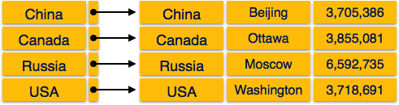

Sparse Index
In sparse index, index records are not created for every search key. An index record here contains a search key and an actual pointer to the data on the disk. To search a record, we first proceed by index record and reach at the actual location of the data. If the data we are looking for is not where we directly reach by following the index, then the system starts sequential search until the desired data is found.
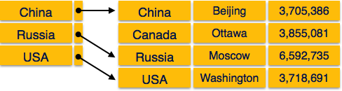

Multilevel Index
Index records comprise search-key values and data pointers. Multilevel index is stored on the disk along with the actual database files. As the size of the database grows, so does the size of the indices. There is an immense need to keep the index records in the main memory so as to speed up the search operations. If single-level index is used, then a large size index cannot be kept in memory which leads to multiple disk accesses.
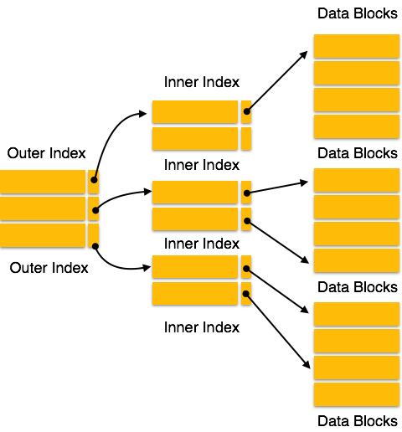
Multi-level Index helps in breaking down the index into several smaller indices in order to make the outermost level so small that it can be saved in a single disk block, which can easily be accommodated anywhere in the main memory.

Clustering Index
- A clustered index can be defined as an ordered data file. Sometimes the index is created on non-primary key columns which may not be unique for each record.
- In this case, to identify the record faster, we will group two or more columns to get the unique value and create index out of them. This method is called a clustering index.
- The records which have similar characteristics are grouped, and indexes are created for these group.
Example: suppose a company contains several employees in each department. Suppose we use a clustering index, where all employees which belong to the same Dept_ID are considered within a single cluster, and index pointers point to the cluster as a whole. Here Dept_Id is a non-unique key.
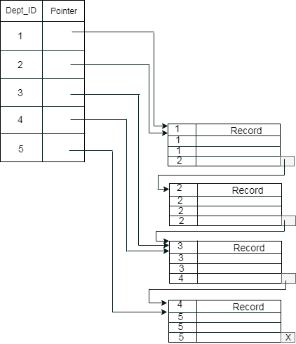
The previous schema is little confusing because one disk block is shared by records which belong to the different cluster. If we use separate disk block for separate clusters, then it is called better technique.
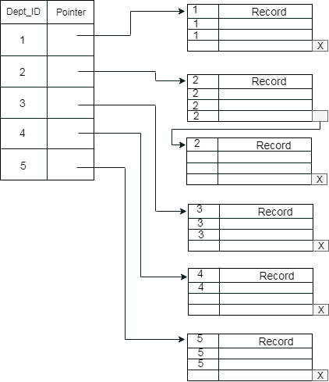

Secondary Index
In the sparse indexing, as the size of the table grows, the size of mapping also grows. These mappings are usually kept in the primary memory so that address fetch should be faster. Then the secondary memory searches the actual data based on the address got from mapping. If the mapping size grows then fetching the address itself becomes slower. In this case, the sparse index will not be efficient. To overcome this problem, secondary indexing is introduced.
In secondary indexing, to reduce the size of mapping, another level of indexing is introduced. In this method, the huge range for the columns is selected initially so that the mapping size of the first level becomes small. Then each range is further divided into smaller ranges. The mapping of the first level is stored in the primary memory, so that address fetch is faster. The mapping of the second level and actual data are stored in the secondary memory (hard disk).
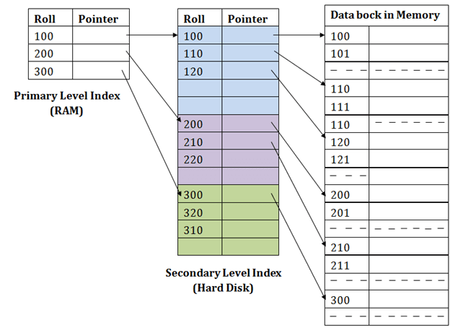
For example:
- If you want to find the record of roll 111 in the diagram, then it will search the highest entry which is smaller than or equal to 111 in the first level index. It will get 100 at this level.
- Then in the second index level, again it does max (111) <= 111 and gets 110. Now using the address 110, it goes to the data block and starts searching each record till it gets 111.
- This is how a search is performed in this method. Inserting, updating or deleting is also done in the same manne

Hash Organization
- Bucket − A hash file stores data in bucket format. Bucket is considered a unit of storage. A bucket typically stores one complete disk block, which in turn can store one or more records.
- Hash Function − A hash function, h, is a mapping function that maps all the set of search-keys K to the address where actual records are placed. It is a function from search keys to bucket addresses.

Static Hashing
In static hashing, when a search-key value is provided, the hash function always computes the same address. For example, if mod-4 hash function is used, then it shall generate only 5 values. The output address shall always be same for that function. The number of buckets provided remains unchanged at all times.
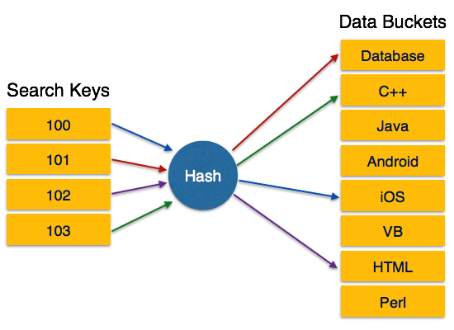

Operation
- Insertion − When a record is required to be entered using static hash, the hash function h computes the bucket address for search key K, where the record will be stored.
Bucket address = h(K)
- Search − When a record needs to be retrieved, the same hash function can be used to retrieve the address of the bucket where the data is stored.
- Delete − This is simply a search followed by a deletion operation.

Bucket Overflow
The condition of bucket-overflow is known as collision. This is a fatal state for any static hash function. In this case, overflow chaining can be used.
- Overflow Chaining − When buckets are full, a new bucket is allocated for the same hash result and is linked after the previous one. This mechanism is called Closed Hashing.
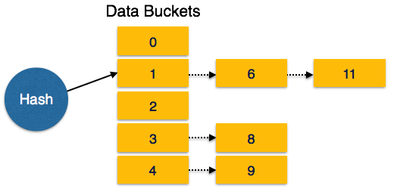
- Linear Probing − When a hash function generates an address at which data is already stored, the next free bucket is allocated to it. This mechanism is called Open Hashing.
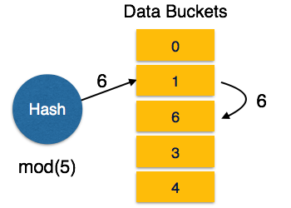

Dynamic Hashing
The problem with static hashing is that it does not expand or shrink dynamically as the size of the database grows or shrinks. Dynamic hashing provides a mechanism in which data buckets are added and removed dynamically and on-demand. Dynamic hashing is also known as extended hashing.
Hash function, in dynamic hashing, is made to produce a large number of values and only a few are used initially.
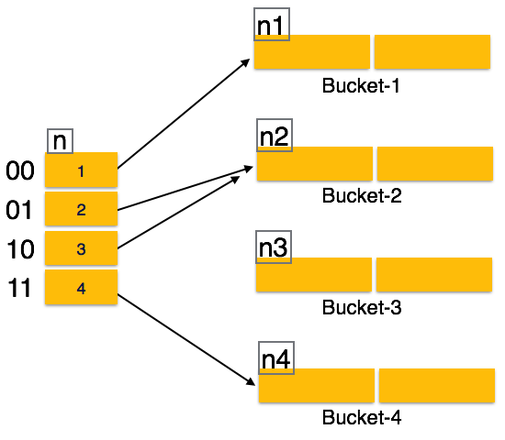

Organization
The prefix of an entire hash value is taken as a hash index. Only a portion of the hash value is used for computing bucket addresses. Every hash index has a depth value to signify how many bits are used for computing a hash function. These bits can address 2n buckets. When all these bits are consumed − that is, when all the buckets are full − then the depth value is increased linearly and twice the buckets are allocated.

Operation
- Querying − Look at the depth value of the hash index and use those bits to compute the bucket address.
- Update − Perform a query as above and update the data.
- Deletion − Perform a query to locate the desired data and delete the same.
- Insertion − Compute the address of the bucket
  - If the bucket is already full.
    - Add more buckets.
    - Add additional bits to the hash value.
    - Re-compute the hash function.
  - Else
    - Add data to the bucket,
  - If all the buckets are full, perform the remedies of static hashing.
Hashing is not favorable when the data is organized in some ordering and the queries require a range of data. When data is discrete and random, hash performs the best.
Hashing algorithms have high complexity than indexing. All hash operations are done in constant time.
We know that data is stored in the form of records. Every record has a key field, which helps it to be recognized uniquely.

B+ File Organization
- B+ tree file organization is the advanced method of an indexed sequential access method. It uses a tree-like structure to store records in File.
- It uses the same concept of key-index where the primary key is used to sort the records. For each primary key, the value of the index is generated and mapped with the record.
- The B+ tree is similar to a binary search tree (BST), but it can have more than two children. In this method, all the records are stored only at the leaf node. Intermediate nodes act as a pointer to the leaf nodes. They do not contain any records.
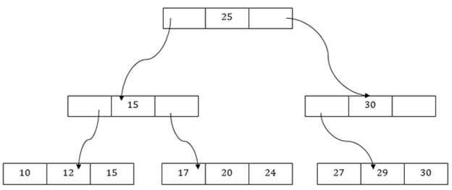

The above B+ tree shows that:
- There is one root node of the tree, i.e., 25.
- There is an intermediary layer with nodes. They do not store the actual record. They have only pointers to the leaf node.
- The nodes to the left of the root node contain the prior value of the root and nodes to the right contain next value of the root, i.e., 15 and 30 respectively.
- There is only one leaf node which has only values, i.e., 10, 12, 17, 20, 24, 27 and 29.
- Searching for any record is easier as all the leaf nodes are balanced.
- In this method, searching any record can be traversed through the single path and accessed easily.

Pros of B+ tree file organization
- In this method, searching becomes very easy as all the records are stored only in the leaf nodes and sorted the sequential linked list.
- Traversing through the tree structure is easier and faster.
- The size of the B+ tree has no restrictions, so the number of records can increase or decrease and the B+ tree structure can also grow or shrink.
- It is a balanced tree structure, and any insert/update/delete does not affect the performance of tree.

Cons of B+ tree file organization
- This method is inefficient for the static method.

Comparision of File Organisation
Difference between Sequential, heap/Direct, Hash, ISAM, B+ Tree, Cluster file organization in database management system (DBMS) as shown below:
