Transaction
Unit – 5 (Transaction Management and Concurrency Control)


A transaction can be defined as a group of tasks. A single task is the minimum processing unit which cannot be divided further.
Let’s take an example of a simple transaction. Suppose a bank employee transfers Rs 500 from A's account to B's account. This very simple and small transaction involves several low-level tasks.

A’s Account
Open_Account(A) Old_Balance = A.balance
New_Balance = Old_Balance - 500 A.balance = New_Balance Close_Account(A)
B’s Account
Open_Account(B) Old_Balance = B.balance
New_Balance = Old_Balance + 500 B.balance = New_Balance Close_Account(B)
ACID Properties
A transaction is a very small unit of a program and it may contain several lowlevel tasks. A transaction in a database system must maintain Atomicity, Consistency, Isolation, and Durability − commonly known as ACID properties − in order to ensure accuracy, completeness, and data integrity.
- Atomicity − This property states that a transaction must be treated as an atomic unit, that is, either all of its operations are executed or none. There must be no state in a database where a transaction is left partially completed. States should be defined either before the execution of the transaction or after the execution/abortion/failure of the transaction.
- Consistency − The database must remain in a consistent state after any transaction. No transaction should have any adverse effect on the data residing in the database. If the database was in a consistent state before the execution of a transaction, it must remain consistent after the execution of the transaction as well.
- Durability − The database should be durable enough to hold all its latest updates even if the system fails or restarts. If a transaction updates a chunk of data in a database and commits, then the database will hold the modified data. If a transaction commits but the system fails before the data could be written on to the disk, then that data will be updated once the system springs back into action.
- Isolation − In a database system where more than one transaction are being executed simultaneously and in parallel, the property of isolation states that all the transactions will be carried out and executed as if it is the only transaction in the system. No transaction will affect the existence of any other transaction.

1

Transaction Log
- In the field of databases in computer science, a transaction log (also transaction journal, database log, binary log or audit trail) is a history of actions executed by a database management system used to guarantee ACID properties over crashes or hardware failures. Physically, a log is a file listing changes to the database, stored in a stable storage format.
- If, after a start, the database is found in an inconsistent state or not been shut down properly, the database management system reviews the database logs for uncommittedtransactions and rolls back the changes made by these transactions. Additionally, all transactions that are already committed but whose changes were not yet materialized in the database are re-applied. Both are done to ensure atomicity and durability of transactions.

Anatomy of a general database log
A database log record is made up of:
- Log Sequence Number (LSN): A unique ID for a log record. With LSNs, logs can be recovered in constant time. Most LSNs are assigned in monotonically increasing order, which is useful in recovery algorithms, like ARIES.
- Prev LSN: A link to their last log record. This implies database logs are constructed in linked list form.
- Transaction ID number: A reference to the database transaction generating the log record.
- Type: Describes the type of database log record.
- Information about the actual changes that triggered the log record to be written.

Types of database log records
All log records include the general log attributes above, and also other attributes depending on their type (which is recorded in the Type attribute, as above).
- Update Log Record notes an update (change) to the database. It includes this extra information:
  - PageID: A reference to the Page ID of the modified page.
  - Length and Offset: Length in bytes and offset of the page are usually included.
  - Before and After Images: Includes the value of the bytes of page before and after the page change. Some databases may have logs which include one or both images.
- Compensation Log Record notes the rollback of a particular change to the database. Each corresponds with exactly one other Update Log Record (although the corresponding update log record is not typically stored in the Compensation Log Record). It includes this extra information:
  - undoNextLSN: This field contains the LSN of the next log record that is to be undone for transaction that wrote the last Update Log.
- Commit Record notes a decision to commit a transaction.
- Abort Record notes a decision to abort and hence roll back a transaction.
- Checkpoint Record notes that a checkpoint has been made. These are used to speed up recovery. They record information that eliminates the need to read a long way into

2
the log's past. This varies according to checkpoint algorithm. If all dirty pages are flushed while creating the checkpoint (as in PostgreSQL), it might contain:
  - redoLSN: This is a reference to the first log record that corresponds to a dirty page.
i.e. the first update that wasn't flushed at checkpoint time. This is where redo must begin on recovery.
  - undoLSN: This is a reference to the oldest log record of the oldest in-progress transaction. This is the oldest log record needed to undo all in-progress transactions.
- Completion Record notes that all work has been done for this particular transaction. (It has been fully committed or aborted)

Transaction Control
The following commands are used to control transactions.
  - COMMIT − to save the changes.
  - ROLLBACK − to roll back the changes.
  - SAVEPOINT − creates points within the groups of transactions in which to ROLLBACK.
  - SET TRANSACTION − Places a name on a transaction.

Transactional Control Commands
Transactional control commands are only used with the DML Commands such as - INSERT, UPDATE and DELETE only. They cannot be used while creating tables or dropping them because these operations are automatically committed in the database.

The COMMIT Command
The COMMIT command is the transactional command used to save changes invoked by a transaction to the database.
The COMMIT command is the transactional command used to save changes invoked by a transaction to the database. The COMMIT command saves all the transactions to the database since the last COMMIT or ROLLBACK command.
The syntax for the COMMIT command is as follows.
COMMIT;
Example
Consider the CUSTOMERS table having the following records −

+----+----------+-----+-----------+----------+

| ID | NAME | AGE | ADDRESS | SALARY |

+----+----------+-----+-----------+----------+

| | 1 | | | Ramesh | | | 32 | | | Ahmedabad | | | 2000.00 | |
| | 2 | | | Khilan | | | 25 | | | Delhi | | | 1500.00 | |
| | 3 | | | kaushik | | | 23 | | | Kota | | | 2000.00 | |
| | 4 | | | Chaitali | | | 25 | | | Mumbai | | | 6500.00 | |
| | 5 | | | Hardik | | | 27 | | | Bhopal | | | 8500.00 | |

3
| 6 | Komal | 22 | MP | 4500.00 |
| 7 | Muffy | 24 | Indore | 10000.00 |
+----+----------+-----+-----------+----------+
Following is an example which would delete those records from the table which have age = 25 and then COMMIT the changes in the database.
SQL> DELETE FROM CUSTOMERS WHERE AGE = 25;
SQL> COMMIT;
Thus, two rows from the table would be deleted and the SELECT statement would produce the following result.
+----+----------+-----+-----------+----------+
| ID | NAME | AGE | ADDRESS | SALARY |
+----+----------+-----+-----------+----------+

| | 1 | | | Ramesh | | | 32 | | | Ahmedabad | | | 2000.00 | |
| | 3 | | | kaushik | | | 23 | | | Kota | | | 2000.00 | |
| | 5 | | | Hardik | | | 27 | | | Bhopal | | | 8500.00 | |
| | 6 | | | Komal | | | 22 | | | MP | | | 4500.00 | |
| | 7 | | | Muffy | | | 24 | | | Indore | | | 10000.00 | |
+----+----------+-----+-----------+----------+

The ROLLBACK Command
The ROLLBACK command is the transactional command used to undo transactions that have not already been saved to the database. This command can only be used to undo transactions since the last COMMIT or ROLLBACK command was issued.
The syntax for a ROLLBACK command is as follows −
ROLLBACK;

Example
Consider the CUSTOMERS table having the following records −

+----+----------+-----+-----------+----------+

| ID | NAME | AGE | ADDRESS | SALARY |

+----+----------+-----+-----------+----------+

| | 1 | | | Ramesh | | | 32 | | | Ahmedabad | | | 2000.00 | |
| | 2 | | | Khilan | | | 25 | | | Delhi | | | 1500.00 | |
| | 3 | | | kaushik | | | 23 | | | Kota | | | 2000.00 | |

4
| | 4 | | | Chaitali | | | 25 | | | Mumbai | | | 6500.00 | |
| | 5 | | | Hardik | | | 27 | | | Bhopal | | | 8500.00 | |
| | 6 | | | Komal | | | 22 | | | MP | | | 4500.00 | |
| | 7 | | | Muffy | | | 24 | | | Indore | | | 10000.00 | |
+----+----------+-----+-----------+----------+
Following is an example, which would delete those records from the table which have the age = 25 and then ROLLBACK the changes in the database.
SQL> DELETE FROM CUSTOMERS WHERE AGE = 25;
SQL> ROLLBACK;
Thus, the delete operation would not impact the table and the SELECT statement would
produce the following result.
+----+----------+-----+-----------+----------+
| ID | NAME | AGE | ADDRESS | SALARY |
+----+----------+-----+-----------+----------+

| | 1 | | | Ramesh | | | 32 | | | Ahmedabad | | | 2000.00 | |
| | 2 | | | Khilan | | | 25 | | | Delhi | | | 1500.00 | |
| | 3 | | | kaushik | | | 23 | | | Kota | | | 2000.00 | |
| | 4 | | | Chaitali | | | 25 | | | Mumbai | | | 6500.00 | |
| | 5 | | | Hardik | | | 27 | | | Bhopal | | | 8500.00 | |
| | 6 | | | Komal | | | 22 | | | MP | | | 4500.00 | |
| | 7 | | | Muffy | | | 24 | | | Indore | | | 10000.00 | |
+----+----------+-----+-----------+----------+
The SAVEPOINT Command
A SAVEPOINT is a point in a transaction when you can roll the transaction back to a certain point without rolling back the entire transaction.
The syntax for a SAVEPOINT command is as shown below.
SAVEPOINT SAVEPOINT_NAME;
This command serves only in the creation of a SAVEPOINT among all the transactional
statements. The ROLLBACK command is used to undo a group of transactions. The syntax for rolling back to a SAVEPOINT is as shown below.
ROLLBACK TO SAVEPOINT_NAME;
Following is an example where you plan to delete the three different records from the
CUSTOMERS table. You want to create a SAVEPOINT before each delete, so that you can ROLLBACK to any SAVEPOINT at any time to return the appropriate data to its original state.

5

Example
Consider the CUSTOMERS table having the following records.
+----+----------+-----+-----------+----------+
| ID | NAME | AGE | ADDRESS | SALARY |

+----+----------+-----+-----------+----------+

| | 1 | | | Ramesh | | | 32 | | | Ahmedabad | | | 2000.00 | |
| | 2 | | | Khilan | | | 25 | | | Delhi | | | 1500.00 | |
| | 3 | | | kaushik | | | 23 | | | Kota | | | 2000.00 | |
| | 4 | | | Chaitali | | | 25 | | | Mumbai | | | 6500.00 | |
| | 5 | | | Hardik | | | 27 | | | Bhopal | | | 8500.00 | |
| | 6 | | | Komal | | | 22 | | | MP | | | 4500.00 | |
| | 7 | | | Muffy | | | 24 | | | Indore | | | 10000.00 | |

+----+----------+-----+-----------+----------+
The following code block contains the series of operations.
SQL> SAVEPOINT SP1;

Savepoint created.

SQL> DELETE FROM CUSTOMERS WHERE ID=1;

1 row deleted.

SQL> SAVEPOINT SP2;

Savepoint created.

SQL> DELETE FROM CUSTOMERS WHERE ID=2;

1 row deleted.

SQL> SAVEPOINT SP3;

Savepoint created.

SQL> DELETE FROM CUSTOMERS WHERE ID=3;

6
Now that the three deletions have taken place, let us assume that you have changed your mind and decided to ROLLBACK to the SAVEPOINT that you identified as SP2. Because SP2 was created after the first deletion, the last two deletions are undone −
1 row deleted.
SQL> ROLLBACK TO SP2;

Rollback complete.
Notice that only the first deletion took place since you rolled back to SP2.

SQL> SELECT * FROM CUSTOMERS;

+----+----------+-----+-----------+----------+

| ID | NAME | AGE | ADDRESS | SALARY |

+----+----------+-----+-----------+----------+

| | 2 | | | Khilan | | | 25 | | | Delhi | | | 1500.00 | |
| | 3 | | | kaushik | | | 23 | | | Kota | | | 2000.00 | |
| | 4 | | | Chaitali | | | 25 | | | Mumbai | | | 6500.00 | |
| | 5 | | | Hardik | | | 27 | | | Bhopal | | | 8500.00 | |
| | 6 | | | Komal | | | 22 | | | MP | | | 4500.00 | |
| | 7 | | | Muffy | | | 24 | | | Indore | | | 10000.00 | |

+----+----------+-----+-----------+----------+

6 rows selected.

The RELEASE SAVEPOINT Command
The RELEASE SAVEPOINT command is used to remove a SAVEPOINT that you have created.
The syntax for a RELEASE SAVEPOINT command is as follows.
RELEASE SAVEPOINT SAVEPOINT_NAME;
Once a SAVEPOINT has been released, you can no longer use the ROLLBACK command to
undo transactions performed since the last SAVEPOINT.

The SET TRANSACTION Command
The SET TRANSACTION command can be used to initiate a database transaction. This command is used to specify characteristics for the transaction that follows. For example, you can specify a transaction to be read only or read write.

7
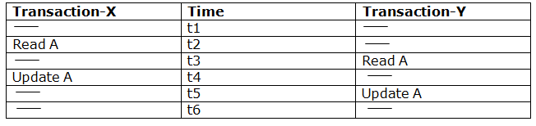
The syntax for a SET TRANSACTION command is as follows.
SET TRANSACTION [ READ WRITE | READ ONLY ];

Concurrency Control

In the concurrency control, the multiple transactions can be executed simultaneously.

It may affect the transaction result. It is highly important to maintain the order of execution of those transactions.

Problems of concurrency control
Several problems can occur when concurrent transactions are executed in an uncontrolled manner. Following are the three problems in concurrency control.
- Lost updates
- Dirty read
- Unrepeatable read

Lost update problem
  - When two transactions that access the same database items contain their operations in a way that makes the value of some database item incorrect, then the lost update problem occurs.
  - If two transactions T1 and T2 read a record and then update it, then the effect of updating of the first record will be overwritten by the second update.

Example:

Here,

  - At time t2, transaction-X reads A's value.
  - At time t3, Transaction-Y reads A's value.
  - At time t4, Transactions-X writes A's value on the basis of the value seen at time t2.
  - At time t5, Transactions-Y writes A's value on the basis of the value seen at time t3.
  - So at time T5, the update of Transaction-X is lost because Transaction y overwrites it without looking at its current value.
  - Such type of problem is known as Lost Update Problem as update made by one transaction is lost here.

Dirty Read
  - The dirty read occurs in the case when one transaction updates an item of the database, and then the transaction fails for some reason. The updated database item is accessed by another transaction before it is changed back to the original value.

8
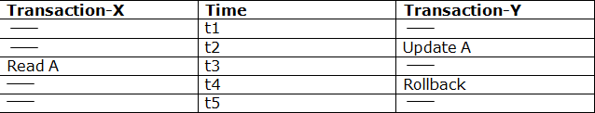
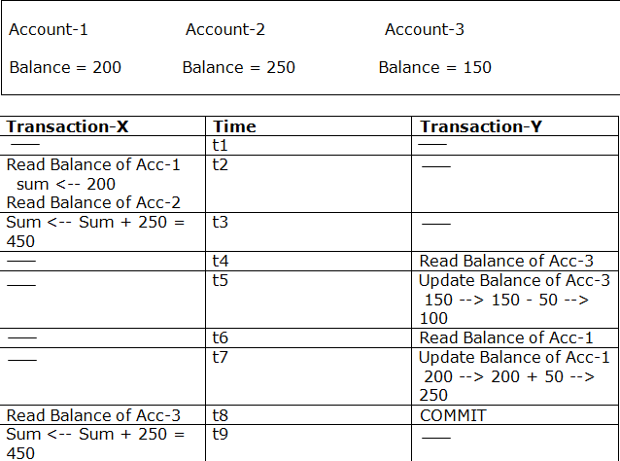
  - A transaction T1 updates a record which is read by T2. If T1 aborts then T2 now has values which have never formed part of the stable database.

Example:

  - At time t2, transaction-Y writes A's value.
  - At time t3, Transaction-X reads A's value.
  - At time t4, Transactions-Y rollbacks. So, it changes A's value back to that of prior to t1.
  - So, Transaction-X now contains a value which has never become part of the stable database.
  - Such type of problem is known as Dirty Read Problem, as one transaction reads a dirty value which has not been committed.

Inconsistent Retrievals Problem
  - Inconsistent Retrievals Problem is also known as unrepeatable read. When a transaction calculates some summary function over a set of data while the other transactions are updating the data, then the Inconsistent Retrievals Problem occurs.
  - A transaction T1 reads a record and then does some other processing during which the transaction T2 updates the record. Now when the transaction T1 reads the record, then the new value will be inconsistent with the previous value.
  - Example: Suppose two transactions operate on three accounts.

  - Transaction-X is doing the sum of all balance while transaction-Y is transferring an amount 50 from Account-1 to Account-3.

9
  - Here, transaction-X produces the result of 550 which is incorrect. If we write this produced result in the database, the database will become an inconsistent state because the actual sum is 600.
  - Here, transaction-X has seen an inconsistent state of the database.

Concurrency Control Protocol
Concurrency control protocols ensure atomicity, isolation, and serializability of concurrent transactions. The concurrency control protocol can be divided into three categories:
- Lock based protocol
- Time-stamp protocol
- Validation based protocol

Concurrency Control Problems
The coordination of the simultaneous execution of transactions in a multiuser database system is known as concurrency control. The objective of concurrency control is to ensure the serializability of transactions in a multiuser database environment. Concurrency control is important because the simultaneous execution of transactions over a shared database can create several data integrity and consistency problems. The three main problems are lost updates, uncommitted data, and inconsistent retrievals.

Lost Updates:
The lost update problem occurs when two concurrent transactions, T1 and T2, are updating the same data element and one of the updates is lost (overwritten by the other transaction). Consider the following PRODUCT table example.
One of the PRODUCT table’s attributes is a product’s quantity on hand (PROD_QOH). Assume that you have a product whose current PROD_QOH value is 35. Also assume that two concurrent transactions, T1 and T2, occur that update the PROD_QOH value for some item in the PRODUCT table.
The transactions are as follows.

Two concurrent transactions update PROD_QOH:

Transaction Operation
T1: Purchase 100 units PROD_QOH = PROD_QOH + 100 T2: Sell 30 units PROD_QOH = PROD_QOH – 30
The Following table shows the serial execution of those transactions under normal circumstances, yielding the correct answer PROD_QOH = 105.

10
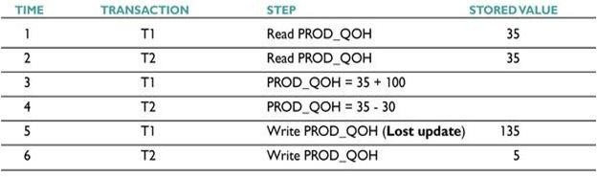
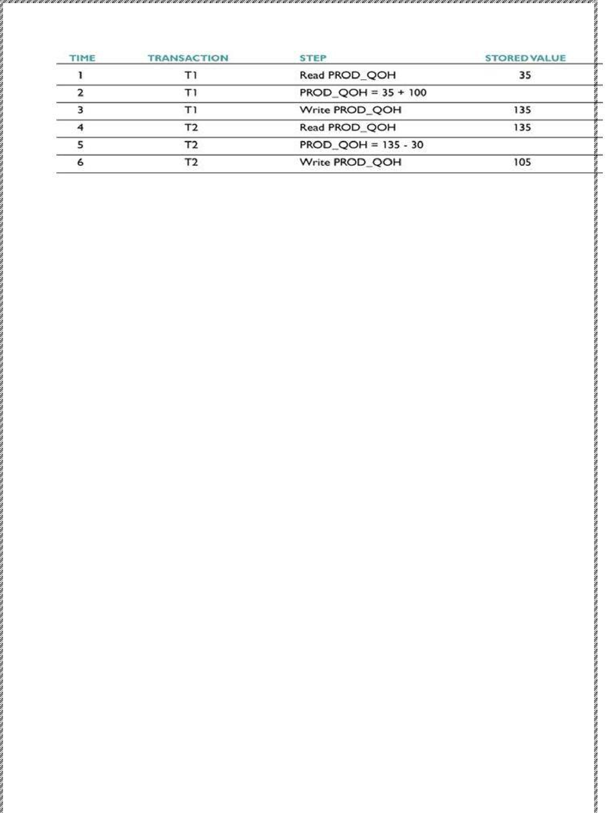

But suppose that a transaction is able to read a product’s PROD_QOH value from the table before a previous transaction (using the same product) has been committed.

The sequence depicted in the following Table shows how the lost update problem can arise. Note that the first transaction (T1) has not yet been committed when the second transaction (T2) is executed. Therefore, T2 still operates on the value 35, and its subtraction yields 5 in memory. In the meantime, T1 writes the value 135 to disk, which is promptly overwritten by T2. In short, the addition of 100 units is “lost” during the process.

Uncommitted Data:
The phenomenon of uncommitted data occurs when two transactions, T1 and T2, are executed concurrently and the first transaction (T1) is rolled back after the second transaction (T2) has already accessed the uncommitted data—thus violating the isolation property of transactions.

To illustrate that possibility, let’s use the same transactions described during the lost updates discussion. T1 has two atomic parts to it, one of which is the update of the inventory, the other possibly being the update of the invoice total (not shown). T1 is forced to roll back due to an error during the updating of the invoice’s total; hence, it rolls back all the way, undoing the inventory update as well. This time, the T1 transaction is rolled back to eliminate the addition of the 100 units. Because T2 subtracts 30 from the original 35 units, the correct answer should be 5.

Transaction Operation
T1: Purchase 100 units PROD_QOH = PROD_QOH + 100 (Rolled back) T2: Sell 30 units PROD_QOH = PROD_QOH – 30

11
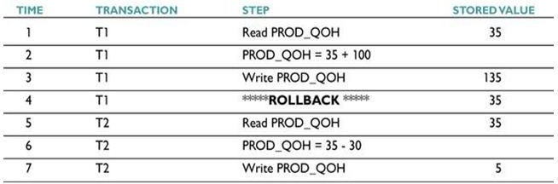
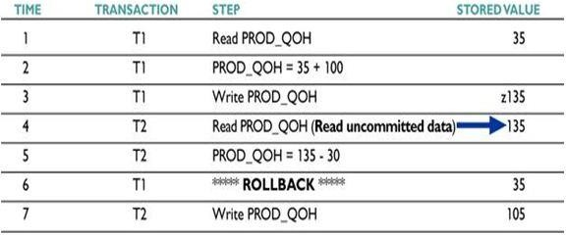
The following Table shows how, under normal circumstances, the serial execution of those transactions yields the correct answer.

The following Table shows how the uncommitted data problem can arise when the ROLLBACK is completed after T2 has begun its execution.

Inconsistent Retrievals:
Inconsistent retrievals occur when a transaction accesses data before and after another transaction(s) finish working with such data. For example, an inconsistent retrieval would occur if transaction T1 calculated some summary (aggregate) function over a set of data while another transaction (T2) was updating the same data. The problem is that the transaction might read some data before they are changed and other data after they are changed, thereby yielding inconsistent results.

To illustrate that problem, assume the following conditions:

- T1 calculates the total quantity on hand of the products stored in the PRODUCT table.

- At the same time, T2 updates the quantity on hand (PROD_QOH) for two of the PRODUCT table’s products.
The two transactions are shown in the following Table:

12
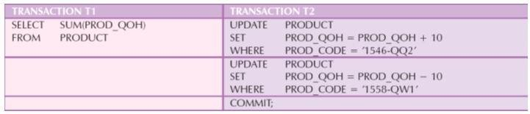
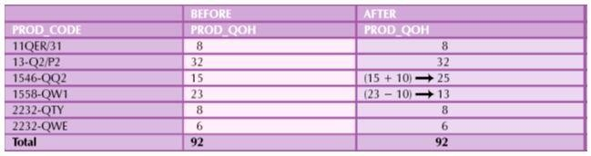
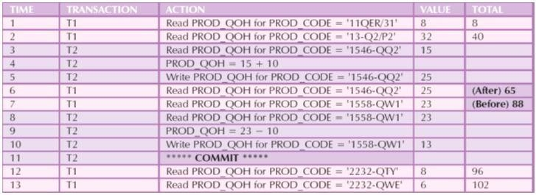

While T1 calculates the total quantity on hand (PROD_QOH) for all items, T2 represents the correction of a typing error: the user added 10 units to product 1558-QW1’s PROD_QOH but meant to add the 10 units to product 1546-QQ2’s PROD_QOH. To correct the problem, the user adds 10 to product 1546-QQ2’s PROD_QOH and subtracts 10 from product 1558- QW1’s PROD_QOH. The initial and final PROD_QOH values are reflected in the following Table

The following table demonstrates that inconsistent retrievals are possible during the transaction execution, making the result of T1’s execution incorrect. The “After” summation shown in Table 10.9 reflects the fact that the value of 25 for product 1546-QQ2 was read after the WRITE statement was completed. Therefore, the “After” total is 40 + 25 = 65. The “Before” total reflects the fact that the value of 23 for product 1558-QW1 was read before the next WRITE statement was completed to reflect the corrected update of 13. Therefore, the “Before” total is 65 + 23 = 88.

13
The computed answer of 102 is obviously wrong because you know from the previous Table that the correct answer is 92. Unless the DBMS exercises concurrency control, a multiuser database environment can create havoc within the information system.

The Scheduler and its Functions
You now know that severe problems can arise when two or more concurrent transactions are executed. You also know that a database transaction involves a series of database I/O operations that take the database from one consistent state to another. Finally, you know that database consistency can be ensured only before and after the execution of transactions.

  - A database always moves through an unavoidable temporary state of inconsistency during a transaction’s execution if such transaction updates multiple tables/rows. (If the transaction contains only one update, then there is no temporary inconsistency.) That temporary inconsistency exists because a computer executes the operations serially, one after another. During this serial process, the isolation property of transactions prevents them from accessing the data not yet released by other transactions.
  - The scheduler establishes the order in which the operations with in concurrent transactions are executed. The scheduler interleaves the execution of database operations to ensure serializability. To determine the appropriate order, the scheduler bases its actions on concurrency control algorithms, such as locking or time-stamping methods. The scheduler also makes sure that the computer’s CPU is used efficiently.
  - The DBMS determines what transactions are serializable and proceeds to interleave the execution of the transaction’s operations. Generally, transactions that are not serializable are executed on a first-come, first-served basis by the DBMS. The scheduler’s main job is to create a serializable schedule of a transaction’s operations.
  - A serializable schedule is a schedule of a transaction’s operations in which the interleaved execution of the transactions (T1, T2, T3, etc.) yields the same results as if the transactions were executed in serial order (one after another).
  - The scheduler also makes sure that the computer’s central processing unit (CPU) and storage systems are used efficiently. If there were no way to schedule the execution of transactions, all transactions would be executed on a first-come, first-served basis. The problem with that approach is that processing time is wasted when the CPU waits for a READ or WRITE operation to finish, thereby losing several CPU cycles.
  - The scheduler facilitates data isolation to ensure that two transactions do not update the same data element at the same time. Database operations might require READ and/or WRITE actions that produce conflicts. For example, The following Table shows the possible conflict scenarios when two transactions, T1 and T2, are executed concurrently over the same data. Note that in Table 10.11, two operations are in conflict when they access the same data and at least one of them is a WRITE operation.

14
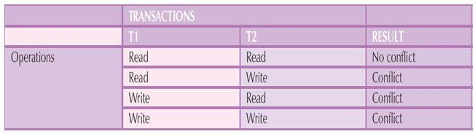

CONCURRENCY CONTROL WITH LOCKING METHODS

A lock guarantees exclusive use of a data item to a current transaction. In other words, transaction T2 does not have access to a data item that is currently being used by transaction T1. A transaction acquires a lock prior to data access; the lock is released (unlocked) when the transaction is completed so that another transaction can lock the data item for its exclusive use.

Most multiuser DBMSs automatically initiate and enforce locking procedures. All lock information is managed by a lock manager.
Lock Granularity

Indicates the level of lock use. Locking can take place at the following levels: database, table, page, row or even field.

LOCK TYPES

Regardless of the level of locking, the DBMS may use different lock types:

- Binary Locks

Have only two states: locked (1) or unlocked (0).

- Shared/Exclusive Locks

An exclusive lock exists when access is reserved specifically for the transaction that locked the object
.The exclusive lock must be used when the potential for conflict exists. A shared lock exists when concurrent transactions are granted read access on the basis of common lock. A shared lock produces no conflict as long as all the concurrent transactions are read only.

DEADLOCKS

A deadlock occurs when two transactions wait indefinitely for each other to unlock data.

15
The three basic techniques to control deadlocks are:

  - Deadlock preventation . A transaction requesting a new lock is aborted when there is the possibility that a deadlock can occur. if the transaction is aborted , all changes made by this transaction are rolled back and all locks obtained by the transaction are released .The transaction is then rescheduled for execution.
  - Deadlock detection. The DBMS periodically tests the database for deadlocks. if a deadlock is found one of the transactions is aborted (rolled back and restarted) and the other transaction are continues.
  - Deadlock avoidance. The transaction must obtain all of the locks it needs before it can be executed .This technique avoids the rollback of conflicting transactions by requiring that locks be obtained in succession

What is Two-Phase Locking (2PL)?

- Two-Phase Locking (2PL) is a concurrency control method which divides the execution phase of a transaction into three parts.
- It ensures conflict serializable schedules.
- If read and write operations introduce the first unlock operation in the transaction, then it is said to be Two-Phase Locking Protocol.

This protocol can be divided into two phases,
- In Growing Phase, a transaction obtains locks, but may not release any lock.
- In Shrinking Phase, a transaction may release locks, but may not obtain any lock.

- Two-Phase Locking does not ensure freedom from deadlocks.

Types of Two – Phase Locking Protocol

Following are the types of two – phase locking protocol:

- Strict Two – Phase Locking Protocol
- Rigorous Two – Phase Locking Protocol
- Conservative Two – Phase Locking Protocol

Strict Two-Phase Locking Protocol
- Strict Two-Phase Locking Protocol avoids cascaded rollbacks.
- This protocol not only requires two-phase locking but also all exclusive-locks should be held until the transaction commits or aborts.
- It is not deadlock free.
- It ensures that if data is being modified by one transaction, then other transaction cannot read it until first transaction commits.
- Most of the database systems implement rigorous two – phase locking protocol.

Rigorous Two-Phase Locking
- Rigorous Two – Phase Locking Protocol avoids cascading rollbacks.
- This protocol requires that all the share and exclusive locks to be held until the transaction commits.

Conservative Two-Phase Locking Protocol

16
- Conservative Two – Phase Locking Protocol is also called as Static Two – Phase Locking Protocol.
- This protocol is almost free from deadlocks as all required items are listed in advanced.
- It requires locking of all data items to access before the transaction starts.

Timestamp-based Protocols
The most commonly used concurrency protocol is the timestamp based protocol. This protocol uses either system time or logical counter as a timestamp.
Lock-based protocols manage the order between the conflicting pairs among transactions at the time of execution, whereas timestamp-based protocols start working as soon as a transaction is created.
Every transaction has a timestamp associated with it, and the ordering is determined by the age of the transaction. A transaction created at 0002 clock time would be older than all other transactions that come after it. For example, any transaction 'y' entering the system at 0004 is two seconds younger and the priority would be given to the older one.
In addition, every data item is given the latest read and write-timestamp. This lets the system know when the last ‘read and write’ operation was performed on the data item.

Concurrency control with time stamp ordering
The timestamp-ordering protocol ensures serializability among transactions in their conflicting read and write operations. This is the responsibility of the protocol system that the conflicting pair of tasks should be executed according to the timestamp values of the transactions.
  - The timestamp of transaction Ti is denoted as TS(Ti).
  - Read time-stamp of data-item X is denoted by R-timestamp(X).
  - Write time-stamp of data-item X is denoted by W-timestamp(X).

Timestamp ordering protocol works as follows −
  - If a transaction Ti issues a read(X) operation −
    - If TS(Ti) < W-timestamp(X)
      - Operation rejected.
    - If TS(Ti) >= W-timestamp(X)
      - Operation executed.
    - All data-item timestamps updated.
  - If a transaction Ti issues a write(X) operation −
    - If TS(Ti) < R-timestamp(X)
      - Operation rejected.
    - If TS(Ti) < W-timestamp(X)
      - Operation rejected and Ti rolled back.
    - Otherwise, operation executed.
Thomas' Write Rule
This rule states if TS(Ti) < W-timestamp(X), then the operation is rejected and Ti is rolled back.
Time-stamp ordering rules can be modified to make the schedule view serializable. Instead of making Ti rolled back, the 'write' operation itself is ignored.
Deadlock

17
In a multi-process system, deadlock is an unwanted situation that arises in a shared resource environment, where a process indefinitely waits for a resource that is held by another process.
For example, assume a set of transactions {T0, T1, T2, ...,Tn}. T0 needs a resource X to complete its task. Resource X is held by T1, and T1 is waiting for a resource Y, which is held by T2. T2 is waiting for resource Z, which is held by T0. Thus, all the processes wait for each other to release resources. In this situation, none of the processes can finish their task. This situation is known as a deadlock.
Deadlocks are not healthy for a system. In case a system is stuck in a deadlock, the transactions involved in the deadlock are either rolled back or restarted.
Deadlock Prevention
To prevent any deadlock situation in the system, the DBMS aggressively inspects all the operations, where transactions are about to execute. The DBMS inspects the operations and analyzes if they can create a deadlock situation. If it finds that a deadlock situation might occur, then that transaction is never allowed to be executed.
There are deadlock prevention schemes that use timestamp ordering mechanism of transactions in order to predetermine a deadlock situation.

Wait-Die Scheme
In this scheme, if a transaction requests to lock a resource (data item), which is already held with a conflicting lock by another transaction, then one of the two possibilities may occur −
  - If TS(Ti) < TS(Tj) − that is Ti, which is requesting a conflicting lock, is older than Tj − then Ti is allowed to wait until the data-item is available.
  - If TS(Ti) > TS(tj) − that is Ti is younger than Tj − then Ti dies. Ti is restarted later with a random delay but with the same timestamp.
This scheme allows the older transaction to wait but kills the younger one.

Wound-Wait Scheme
In this scheme, if a transaction requests to lock a resource (data item), which is already held with conflicting lock by some another transaction, one of the two possibilities may occur −
  - If TS(Ti) < TS(Tj), then Ti forces Tj to be rolled back − that is Tiwounds Tj. Tj is restarted later with a random delay but with the same timestamp.
  - If TS(Ti) > TS(Tj), then Ti is forced to wait until the resource is available.
This scheme, allows the younger transaction to wait; but when an older transaction requests an item held by a younger one, the older transaction forces the younger one to abort and release the item.
In both the cases, the transaction that enters the system at a later stage is aborted.
Deadlock Avoidance
Aborting a transaction is not always a practical approach. Instead, deadlock avoidance mechanisms can be used to detect any deadlock situation in advance. Methods like "wait- for graph" are available but they are suitable for only those systems where transactions are lightweight having fewer instances of resource. In a bulky system, deadlock prevention techniques may work well.

18
Crash Recovery
DBMS is a highly complex system with hundreds of transactions being executed every second. The durability and robustness of a DBMS depends on its complex architecture and its underlying hardware and system software. If it fails or crashes amid transactions, it is expected that the system would follow some sort of algorithm or techniques to recover lost data.
Failure Classification
To see where the problem has occurred, we generalize a failure into various categories, as follows −
Transaction failure
A transaction has to abort when it fails to execute or when it reaches a point from where it can’t go any further. This is called transaction failure where only a few transactions or processes are hurt.
Reasons for a transaction failure could be −
  - Logical errors − Where a transaction cannot complete because it has some code error or any internal error condition.
  - System errors − Where the database system itself terminates an active transaction because the DBMS is not able to execute it, or it has to stop because of some system condition. For example, in case of deadlock or resource unavailability, the system aborts an active transaction.
System Crash
There are problems − external to the system − that may cause the system to stop abruptly and cause the system to crash. For example, interruptions in power supply may cause the failure of underlying hardware or software failure.
Examples may include operating system errors. Disk Failure
In early days of technology evolution, it was a common problem where hard-disk drives or storage drives used to fail frequently.
Disk failures include formation of bad sectors, unreachability to the disk, disk head crash or any other failure, which destroys all or a part of disk storage.
Storage Structure
We have already described the storage system. In brief, the storage structure can be divided into two categories −
  - Volatile storage − As the name suggests, a volatile storage cannot survive system crashes. Volatile storage devices are placed very close to the CPU; normally they are embedded onto the chipset itself. For example, main memory and cache memory are examples of volatile storage. They are fast but can store only a small amount of information.
  - Non-volatile storage − These memories are made to survive system crashes. They are huge in data storage capacity, but slower in accessibility. Examples may include hard-disks, magnetic tapes, flash memory, and non-volatile (battery backed up) RAM.
Recovery and Atomicity
When a system crashes, it may have several transactions being executed and various files opened for them to modify the data items. Transactions are made of various operations, which are atomic in nature. But according to ACID properties of DBMS, atomicity of transactions as a whole must be maintained, that is, either all the operations are executed or none.
When a DBMS recovers from a crash, it should maintain the following −

19
  - It should check the states of all the transactions, which were being executed.
  - A transaction may be in the middle of some operation; the DBMS must ensure the atomicity of the transaction in this case.
  - It should check whether the transaction can be completed now or it needs to be rolled back.
  - No transactions would be allowed to leave the DBMS in an inconsistent state.
There are two types of techniques, which can help a DBMS in recovering as well as maintaining the atomicity of a transaction −
  - Maintaining the logs of each transaction, and writing them onto some stable storage before actually modifying the database.
  - Maintaining shadow paging, where the changes are done on a volatile memory, and later, the actual database is updated.
Log-based Recovery
Log is a sequence of records, which maintains the records of actions performed by a transaction. It is important that the logs are written prior to the actual modification and stored on a stable storage media, which is failsafe.
Log-based recovery works as follows −
  - The log file is kept on a stable storage media.
  - When a transaction enters the system and starts execution, it writes a log about it.
<Tn, Start>
  - When the transaction modifies an item X, it write logs as follows −
<Tn, X, V1, V2>
It reads Tn has changed the value of X, from V1 to V2.
  - When the transaction finishes, it logs −
<Tn, commit>
The database can be modified using two approaches −
  - Deferred database modification − All logs are written on to the stable storage and the database is updated when a transaction commits.
  - Immediate database modification − Each log follows an actual database modification. That is, the database is modified immediately after every operation.
Recovery with Concurrent Transactions
When more than one transaction are being executed in parallel, the logs are interleaved. At the time of recovery, it would become hard for the recovery system to backtrack all logs, and then start recovering. To ease this situation, most modern DBMS use the concept of 'checkpoints'.
Checkpoint
Keeping and maintaining logs in real time and in real environment may fill out all the memory space available in the system. As time passes, the log file may grow too big to be handled at all. Checkpoint is a mechanism where all the previous logs are removed from the system and stored permanently in a storage disk. Checkpoint declares a point before which the DBMS was in consistent state, and all the transactions were committed.
Recovery
When a system with concurrent transactions crashes and recovers, it behaves in the following manner −

20
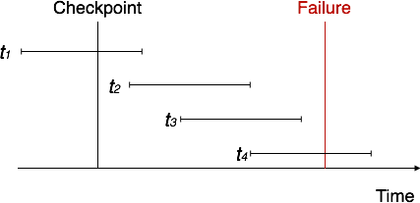

  - The recovery system reads the logs backwards from the end to the last checkpoint.
  - It maintains two lists, an undo-list and a redo-list.
  - If the recovery system sees a log with <Tn, Start> and <Tn, Commit> or just <Tn, Commit>, it puts the transaction in the redo-list.
  - If the recovery system sees a log with <Tn, Start> but no commit or abort log found, it puts the transaction in undo-list.
All the transactions in the undo-list are then undone and their logs are removed. All the transactions in the redo-list and their previous logs are removed and then redone before saving their logs.

21

