# Assignment No 8:

Write a C++ program that creates an output file, writes information to it, closes the file and open it again as an input file and read the information from the file.

**Aim:**

To understand concept of input output operation in c++.

**Description:**

We Write a C++ program that creates an output file, writes information to it, closes the file and open it again as an input file and read the information from the file.

**Oop Concepts Used:**

**Input/output with files:-**

C++ provides the following classes to perform output and input of characters to/from files:

* [**ofstream**](http://www.cplusplus.com/ofstream)**:** It represents output Stream and this is used for writing in files.
* [**ifstream**](http://www.cplusplus.com/ifstream)**:**  It represents input Stream and this is used for reading from files.
* [**fstream**](http://www.cplusplus.com/fstream)**:** It represents both output Stream and input Stream. So it can read from files and write to files.

These classes are derived directly or indirectly from the classes istream and ostream. We have already used objects whose types were these classes: cin is an object of class istream and cout is an object of class ostream. Therefore, we have already been using classes that are related to our file streams. And in fact, we can use our file streams the same way we are already used to use cin and cout, with the only difference that we have to associate these streams with physical files. Let's see an example:

**Program:**

#include<iostream>

#include<fstream>

using namespace std;

int main()

{

char ch;

fstream f;

f.open("first.txt",ios::out);

if(!f)

{

cout<<"Enter the opening file";

return 0;

}

cout<<"file name first.txt created !!!";

f<<"SY BTECH computer division A ,batch A-3,VIIT pune "<<endl;

f.close();

f.open("first.txt",ios::in);

if(!f)

{

cout<<"Error opening file";

return 0;

}

while(!f.eof())

{

f>>ch;

cout<<ch;

}

f.close();;

return 0;

}

**output:**

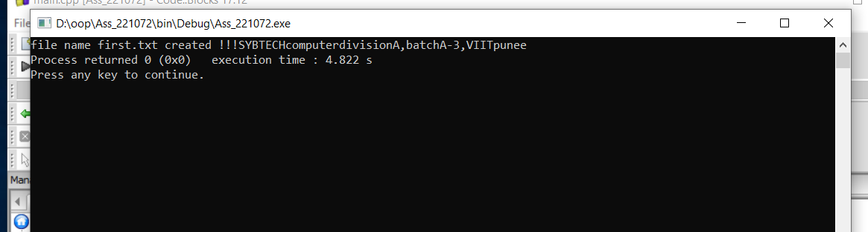

**conclusion:-**

Thus we have successfully done file operation in c++.