**Book-Store**

**Using MERN**

**Introduction:-**

* Welcome to the literary haven of the digital age—introducing our revolutionary Book-Store Application, a masterpiece crafted with precision using the powerful MERN (MongoDB, Express.js, React, Node.js) Stack. Immerse yourself in a world where the love for reading converges seamlessly with cutting-edge technology, redefining the way bibliophiles explore, discover, and indulge in their literary pursuits.
* Tailored for the modern book enthusiast, our MERN-based Book-Store Application seamlessly blends robust functionality with an intuitive user interface. From the joy of discovering new releases to the nostalgia of revisiting timeless classics, our platform promises an immersive reading experience customized to cater to your literary preferences.
* Fueling the backbone of our application is MongoDB, ensuring a scalable and efficient database infrastructure that facilitates swift access to an extensive collection of literary works. Express.js, with its streamlined web application framework, establishes a responsive and efficient server, while Node.js ensures high-performance, non-blocking I/O operations—resulting in a seamless and enjoyable user experience.
* At the heart of our Book-Store Application lies React, a dynamic and feature-rich JavaScript library. Dive into a visually enchanting and interactive interface where every click, search, and book selection feels like a literary journey. Whether you're exploring on a desktop, tablet, or smartphone, our responsive design ensures a consistent and delightful experience across all devices.

**Scenario Based Case Study:**

* Sarah is an avid reader with a passion for exploring new genres and authors. However, her busy schedule often leaves her with limited time to visit physical bookstores. Sarah is looking for a solution that allows her to discover and purchase books conveniently, without compromising her reading preferences or the joy of browsing through a bookstore.
* **User Registration and Authentication:** Allow users to register accounts securely, log in, and authenticate their identity to access the book store platform.
* **Book Listings:** Display a comprehensive list of available books with details such as title, author, genre, description, price, and availability status.
* **Book Selection:** Provide users with options to select their preferred books based on factors like genre, author, ratings, and popularity.
* **Purchase Process:** Allow users to add books to their cart, specify quantities, and complete purchases securely. Upon successful completion, an order is generated, and the inventory is updated accordingly.
* **Order Confirmation:** Provide users with a confirmation page or notification containing details of their order, including book information, total price, and order ID.
* **Order History:** Allow users to view their past and current orders, providing options to track shipments, review purchased books, and rate their shopping experience.

**Technical Architecture:**

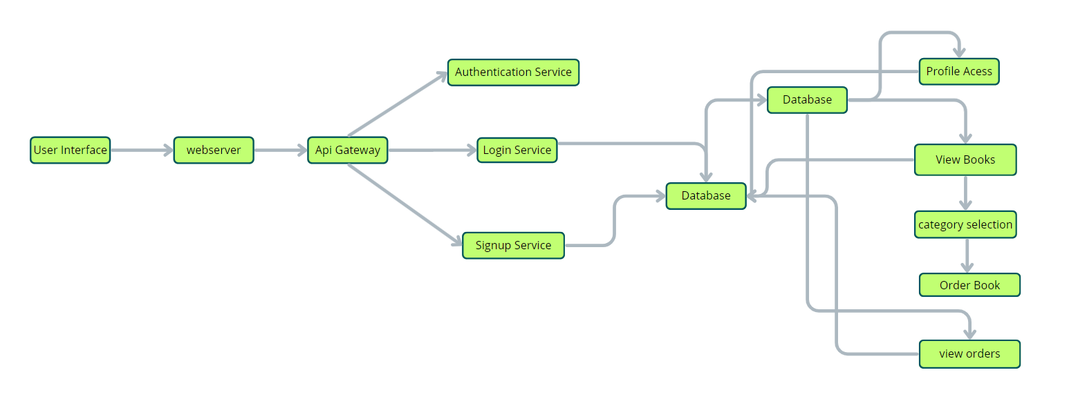

* **User Interface:** The user interface will serve as the platform where customers can browse books, search for specific titles or authors, read book descriptions, and make purchases. It should be intuitive and user-friendly, enabling easy navigation and exploration of available books.
* **Web Server:** The web server hosts the user interface of the book store app, serving dynamic web pages to users and ensuring a seamless browsing and shopping experience.
* **API Gateway:** Similar to the original architecture, the API gateway will serve as the central entry point for client requests, directing them to the relevant services within the system. It will handle requests such as fetching book information, processing orders, and managing user accounts.
* **Authentication Service:** The authentication service manages user authentication and authorization, ensuring secure access to the book store app and protecting sensitive user information during the browsing and purchasing process.
* **Database**: The database stores persistent data related to books, including information such as titles, authors, genres, descriptions, prices, and availability. It also stores user profiles, purchase history, and other essential entities crucial to the book store app.
* **View Books:** This feature allows users to browse through the available books. They can explore different categories and genres to discover books of interest.
* **Category Selection:** Users can select specific categories or genres to filter and refine their book browsing experience, making it easier to find books tailored to their preferences.
* **Inventory Management Service:** This service manages information about available books, including their availability, stock levels, and ratings. It ensures efficient management of the book inventory and seamless integration with the browsing and purchasing process.
* **Order Management Service:** This service facilitates the ordering process, allowing users to add books to their cart, specify quantities, and complete purchases securely. It also handles order tracking and status updates in real-time.

**Key Features:**

* **User Registration and Authentication:** Allow users to register accounts securely, log in, and authenticate their identity to access the book store platform.
* **Book Listings:** Display a comprehensive list of available books with details such as title, author, genre, description, price, and availability status.
* **Book Selection:** Provide users with options to select their preferred books based on factors like genre, author, ratings, and popularity.
* **Purchase Process:** Allow users to add books to their cart, specify quantities, and complete purchases securely. Upon successful completion, an order is generated, and the inventory is updated accordingly.
* **Order Confirmation:** Provide users with a confirmation page or notification containing details of their order, including book information, total price, and order ID.
* **Order History**: Allow users to view their past and current orders, providing options to track shipments, review purchased books, and rate their shopping experience.
* **Organizer Dashboard:** Offer administrators an interface to manage book listings, inventory levels, user accounts, orders, and other platform-related activities.
* **Create Item:** Organizer can create items and add new items and he can get the items and he can update items.
* **Admin Dashboard:** Offer administrators an interface to manage book listings, inventory levels, user accounts, orders, and other platform-related activities. Manage the users and organizers.
* **Reporting and Analytics:** Generate reports and analytics on book sales, popular genres, user demographics, and other relevant metrics to gain insights into platform usage and performance.
* **Integration with External APIs:** Integrate with third-party APIs for services like payment processing, shipping logistics, and book recommendations to enhance the functionality and user experience of the book store platform.

**Requirements:**

* IDE (Integrated Development Environment)
* Node JS
* Mongo DB
* React JS
* Express JS

**Application Flow:**

* **Start:** Users open the BookEase app to explore a vast collection of books.
* **Home Page:** Users land on the home page, which provides an overview of the book.
* **store's offerings:** From here, they can navigate to various sections of the app.
* **Access Profile:** Users have the option to access their profiles, allowing them to view or update personal information, preferences, and order history.
* **Book Selection:** After accessing their profiles, users proceed to browse and select books to purchase. The app presents a list of available books, along with details such as title, author, genre, and price.
* **Book Purchase:** Users navigate through the available book options and specify the quantity of each book they wish to purchase. They can also choose additional options such as e-book format or special editions.
* **View Orders:** Users have the option to view their current and past orders. This section provides details about ordered books, order status, and payment history.
* **Order Confirmation:** For new purchases, users can initiate the ordering process. This involves selecting books, specifying quantities, confirming the order, and receiving an order confirmation.
* **End:** The flow concludes as users have completed their desired actions within the BookEase app.

